UNITED STATES
SECURITIES AND EXCHANGE COMMISSION
Washington, D.C. 20549
FORM 8-K
CURRENT REPORT
Pursuant to Section 13 or 15(d) of the Securities Exchange Act of 1934
Date of report (Date of earliest event reported): June 4, 2026
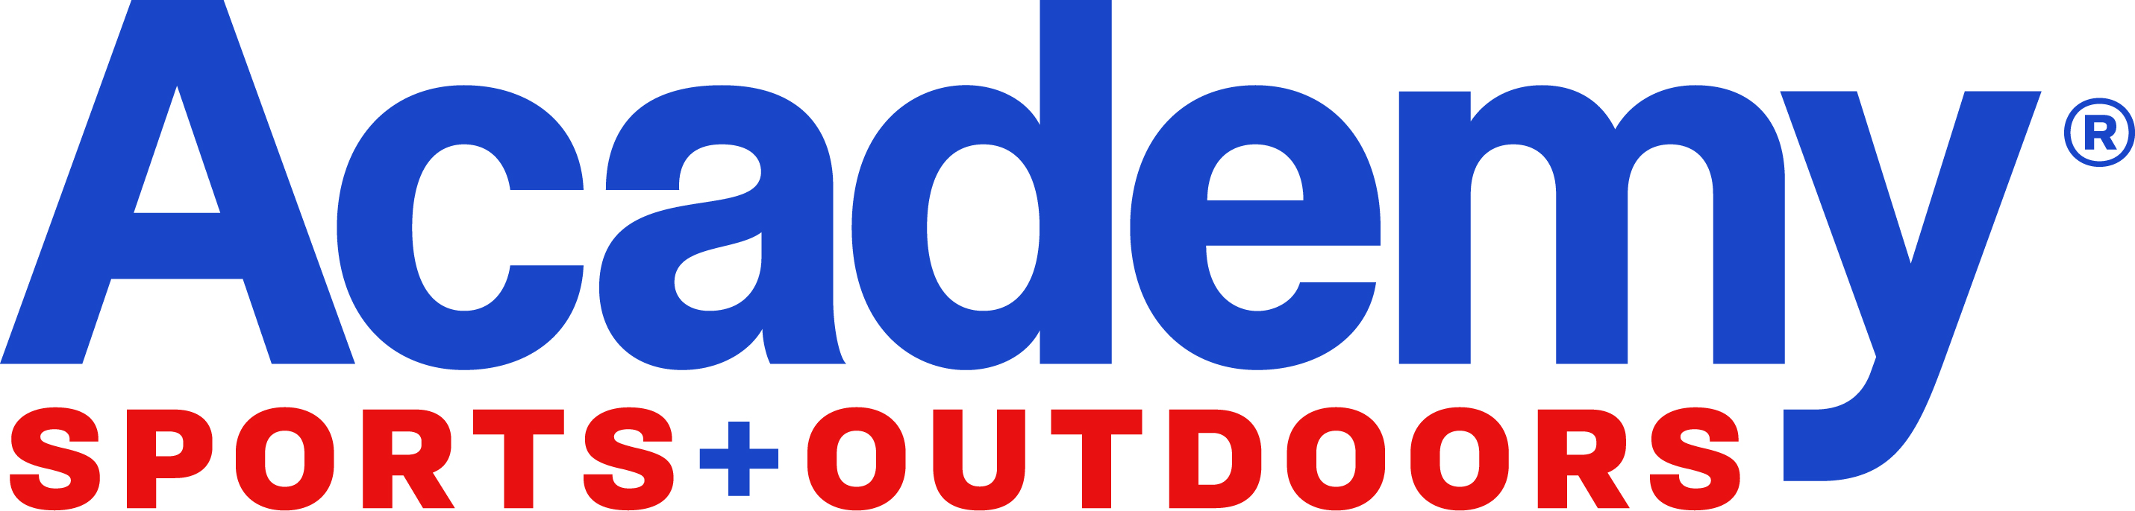
Academy Sports and Outdoors, Inc.
(Exact name of registrant as specified in its charter)
Delaware |  |  |  |  |  | 001-39589 |  |  | 85-1800912
(State or other jurisdiction of |  |  |  |  |  | (Commission |  |  | (I.R.S. Employer
incorporation ) |  |  |  |  |  | File No.) |  |  | Identification No.)
 |  |  | 1800 North Mason Road
 |  |  | Katy, Texas 77449
 |  |  | (Address of principal executive offices including Zip Code)
 |  |  | (281) 646-5200
 |  |  | (Registrant’s telephone number, including area code)
 |  |  | Not Applicable
 |  |  | (Former name or former address, if changed since last report)
Check the appropriate box below if the Form 8-K filing is intended to simultaneously satisfy the filing obligation of the registrant under any of the following provisions:
☐ Written communications pursuant to Rule 425 under the Securities Act (17 CFR 230.425)
☐ Soliciting material pursuant to Rule 14a-12 under the Exchange Act (17 CFR 240.14a-12)
☐ Pre-commencement communications pursuant to Rule 14d-2(b) under the Exchange Act (17 CFR 240.14d-2(b))
☐ Pre-commencement communications pursuant to Rule 13e-4(c) under the Exchange Act (17 CFR 240.13e-4(c))
Securities registered pursuant to Section 12(b) of the Act:
Title of each class |  |  |  |  |  | Trading Symbol(s) |  |  | Name of each exchange on which registered
Common Stock, $0.01 par value per share |  |  |  |  |  | ASO |  |  | The Nasdaq Stock Market LLC
Indicate by check mark whether the registrant is an emerging growth company as defined in Rule 405 of the Securities Act of 1933 (§230.405 of this chapter) or Rule 12b-2 of the Securities Exchange Act of 1934 (§240.12b-2 of this chapter).
Emerging Growth Company ☐
If an emerging growth company, indicate by check mark if the registrant has elected not to use the extended transition period for complying with any new or revised financial accounting standards provided pursuant to Section 13(a) of the Exchange Act. ☐

Item 5.07. Submission of Matters to a Vote of Security Holders.

On June 4, 2026, Academy Sports and Outdoors, Inc. (the “Company” or “Academy”) held its 2026 Annual Meeting of Stockholders (the “Annual Meeting”). At the Annual Meeting, the Company’s stockholders (i) elected three Class III directors, whose names appear below, to serve for a term of two years expiring at the Company’s 2028 Annual Meeting of Stockholders and until their successors shall be elected and qualified (the “Election of Class III Directors”), (ii) ratified the appointment of Deloitte & Touche LLP as the Company’s Independent Registered Public Accounting Firm for the fiscal year ending January 30, 2027 (“Auditor Ratification”), and (iii) approved, on a non-binding advisory basis, the fiscal year 2025 compensation paid to the Company’s named executive officers (“Say-on-Pay”). The final voting results for each of the matters submitted to a stockholder vote at the Annual Meeting are set forth below.

Election of Class III Directors |  |  |  |  |  | Votes For |  |  |  |  |  | Votes Withheld |  |  |  |  |  | Broker Non-Votes
Ken Hicks |  |  |  |  |  | 56,212,506 |  |  |  |  |  | 503,348 |  |  |  |  |  | 4,056,313
Beryl Raff |  |  |  |  |  | 56,390,582 |  |  |  |  |  | 325,272 |  |  |  |  |  | 4,056,313
Jeff Tweedy |  |  |  |  |  | 56,416,017 |  |  |  |  |  | 299,837 |  |  |  |  |  | 4,056,313

 |  |  |  |  |  | Votes For |  |  |  |  |  | Votes Against |  |  |  |  |  | Abstentions
Auditor Ratification |  |  |  |  |  | 59,714,421 |  |  |  |  |  | 1,025,028 |  |  |  |  |  | 32,718

 |  |  |  |  |  | Votes For |  |  |  |  |  | Votes Against |  |  |  |  |  | Abstentions |  |  |  |  |  | Broker  Non-Votes
Say-on-Pay |  |  |  |  |  | 56,136,547 |  |  |  |  |  | 533,746 |  |  |  |  |  | 45,561 |  |  |  |  |  | 4,056,313

Item 8.01 Other Events.

Committee Appointments

Also on June 4, 2026, the Board of Directors (the “Board”) appointed Shannon Hennessy to serve as a member of the Compensation Committee of the Board and Clay Johnson to serve as a member of the Audit Committee of the Board, in each case effective immediately.

Item 9.01 Financial Statements and Exhibits.

(d) Exhibits.
Exhibit No. |  |  |  |  |  |  |  |  |  |  |  |  |  |  |  |  |  | Description of Exhibit
 |  |  | 104 |  |  |  |  |  |  |  |  |  |  |  |  |  |  | Cover Page Interactive Data File (embedded within the Inline XBRL document).

Signatures

Pursuant to the requirements of the Securities Exchange Act of 1934, as amended, the registrant has duly caused this report to be signed on its behalf by the undersigned hereunto duly authorized.

ACADEMY SPORTS AND OUTDOORS, INC.

Date: June 4, 2026 |  |  |  |  |  | By: |  |  | /s/ |  |  | Brandy Treadway
 |  |  |  |  |  | Name: |  |  | Brandy Treadway
 |  |  |  |  |  | Title: |  |  | Executive Vice President, Chief Legal Officer, and Corporate Secretary

