

2023

Annual Report



Financial Highlights

Company Scorecard | FY 2021 |  | FY 2022 |  | FY 2023
Net Sales | $6.8B |  | $6.4B |  | $6.2B
Net Income % | 10% |  | 10% |  | 8%
Adjusted EBITDA %(1) | 16% |  | 16% |  | 14%
ROIC %(2) | 42% |  | 34% |  | 28%
Net Sales per Gross Square Foot | $370/GSF |  | $340/GSF |  | $313/GSF
.COM Penetration % | 9.3% |  | 10.7% |  | 10.7%

 |  | Net Sales (IN BILLIONS) |  |  |  |  |  |  |  |  |  |  |  |  |  |  |  |  |  |  |  |  |  |  |  |  |  | Comparable Sales
$6 |  |  |  | $6.8 |  |  |  |  |  |  |  |  |  |  |  |  |  |  |  |  |  |  | 20%
$6 |  |  |  |  |  |  |  |  |  |  | $6.4
$6 |  |  |  |  |  |  |  |  |  |  |  |  |  |  |  | $6.2
$6 |  |  |  |  |  |  |  |  |  |  |  |  |  |  |  |  |  |  |  |  |  |  |  |  |  |  |  |  |  | 18.9%
$4 |  |  |  |  |  |  |  |  |  |  |  |  |  |  |  |  |  |  |  |  |  |  | 15%
$4 |  |  |  |  |  |  |  |  |  |  |  |  |  |  |  |  |  |  |  |  |  |  | 10%
$2 |  |  |  |  |  |  |  |  |  |  |  |  |  |  |  |  |  |  |  |  |  |  | 5%
$2 |  |  |  |  |  |  |  |  |  |  |  |  |  |  |  |  |  |  |  |  |  |  | 0%
 |  |  |  |  |  |  |  |  |  |  |  |  |  |  |  |  |  |  |  |  |  |  |  |  |  |  |  |  |  |  |  |  |  | -6.4% |  |  |  |  |  |  |  |  | -6.5%
$0 |  |  |  |  |  |  |  |  |  |  |  |  |  |  |  |  |  |  |  |  |  |  | -5%
$0 |  |  |  | FY 2021 |  |  |  |  |  |  |  |  |  |  |  |  |  |  |  |  |  |  |  |  |  |  |  |  |  | FY 2021
 |  |  |  |  |  |  |  |  |  |  | FY 2022 |  |  |  |  | FY 2023 |  |  |  |  |  |  |  |  |  |  |  |  |  |  |  |  |  | FY 2022 |  |  |  |  |  |  |  |  | FY 2023
 | Pre-Tax Income |  |  |  |  |  |  |  |  |  |  |  |  |  |  |  | Earnings per |  |  |  |  |  |  |  |  |  |  |  |  |  |  |  |  |  | Adjusted Earnings
 | (IN MILLIONS) |  |  |  |  |  |  |  |  |  |  |  |  |  |  |  | Share – Diluted |  |  |  |  |  |  |  |  |  |  |  |  |  |  |  |  |  | per Share – Diluted(3)
 |  | $860 |  |  |  | $818
$800 |  |  |  |  |  |  |  |  |  |  |  |  |  |  | $8.00 |  |  |  |  |  |  |  |  |  |  |  |  |  |  |  |  |  | $8.00
$800 |  |  |  |  |  |  |  |  |  |  |  |  |  |  |  |  |  |  |  |  |  |  |  |  |  |  |  |  |  |  |  |  |  |  |  |  |  |  |  |  | $7.70
$800 |  |  |  |  |  |  |  |  |  |  |  |  |  |  |  |  |  |  |  |  |  |  |  |  |  |  |  |  |  |  |  |  |  |  |  | $7.60
$800 |  |  |  |  |  |  |  |  |  |  |  |  |  |  |  |  |  | $7.12 |  |  |  |  | $7.49
$600 |  |  |  |  |  |  |  |  |  | $663 |  |  |  |  | $6.00 |  |  |  |  |  |  |  |  |  |  |  | $6.70 |  |  |  |  |  | $6.00 |  |  |  |  |  |  |  |  |  |  |  |  | $6.96
$400 |  |  |  |  |  |  |  |  |  |  |  |  |  |  | $4.00 |  |  |  |  |  |  |  |  |  |  |  |  |  |  |  |  |  | $4.00
$200 |  |  |  |  |  |  |  |  |  |  |  |  |  |  | $2.00 |  |  |  |  |  |  |  |  |  |  |  |  |  |  |  |  |  | $2.00
$0 |  |  |  |  |  |  |  |  |  |  |  |  |  |  | $0.00 |  |  |  |  |  |  |  |  |  |  |  |  |  |  |  |  |  | $0.00
FY 2021 2022 |  |  |  |  |  |  |  |  |  | 2023 |  |  |  |  |  | FY 2021 |  |  |  |  |  |  | 2022 2023 |  |  |  |  |  |  |  |  |  |  | FY | 2021 |  |  |  |  | 2022 2023

1

2023 Annual

Report

- Adjusted earnings before interest, taxes, depreciation, and amortization (Adjusted EBITDA) excludes certain expenses that Management believes are not indicative of Academy’s underlying operating performance. Refer to our Annual Report on Form 10-K for the year ended February 3, 2024, for a full reconciliation and discussion of Adjusted EBITDA, which is a non-GAAP measure, to its closest comparable GAAP measure.

- Return on Invested Capital (ROIC) is calculated as follows:

(i) the numerator is defined as Adjusted EBITDA plus rent minus estimated taxes; and (ii) the denominator is defined as: (a) the sum of the 13-month average balances for: net receivables, inventory, prepaid expenses and other current assets, gross property and equipment, and other noncurrent assets, plus (b) total lease liabilities, minus (c) the sum of the 13-month average balances for: accounts payable, accrued liabilities, and income tax payable. Refer to our Annual Report on Form 10-K for the year ended February 3, 2024, for a full reconciliation and discussion of Adjusted EBITDA, which is a non-GAAP measure, to its closest comparable GAAP measure.

- Adjusted Earnings per Share - Diluted is defined as Adjusted Net Income (which excludes certain expenses that Management believes are not indicative of Academy’s underlying operating performance) divided by the diluted weighted average common shares outstanding during the period. Refer to our Annual Report on Form 10-K for the year ended February 3, 2024, for a full discussion and reconciliations of Adjusted Net Income and Adjusted Earnings per Share, which are non-GAAP measures, to their closest comparable GAAP measures.


2
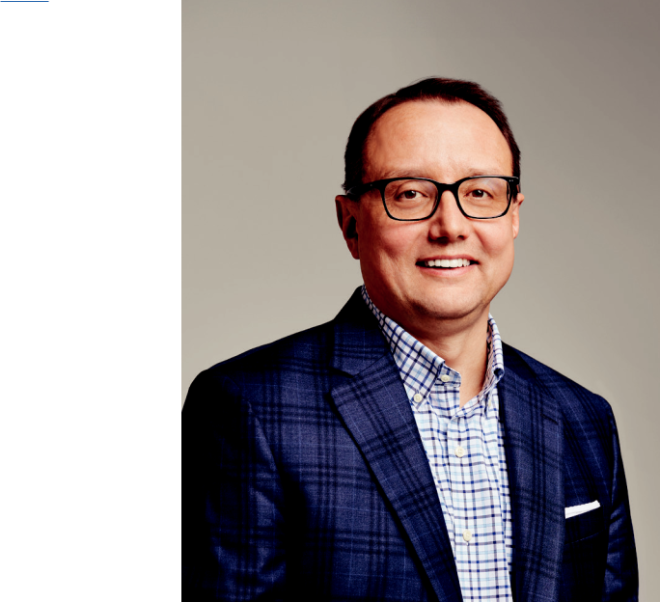

Outdoors+

SportsAcademy

Letter from our Chief

Executive Officer

I am excited to address our shareholders in my first letter as Chief Executive Officer of Academy Sports + Outdoors, and I want to express my appreciation for your confidence in our team and company. I am proud of the resiliency the ~22,000 members of the Academy team have shown over the past year as we navigated a leadership transition during a challenging macro-economic backdrop. In 2023, we embarked on our new long-range plan, and we made a lot of progress in putting in place the building blocks for our future.

The strength and durability of our business model was demonstrated by a number of achievements in 2023, which include opening 14 new stores, implementing our new customer data platform to help unlock greater consumer insights, and laying groundwork for improvements in our supply chain as we completed most of the work to support the implementation of our new warehouse management system that will go live in 2024. We also
We are focused on | solidified our executive team with the appointments of Carl
returning to growth and | Ford as Chief Financial Officer and Matt McCabe as Chief
returning to growth and | Merchandising Officer, while also strengthening the team
delivering long-term | with the additions of Chad Fox as our new Chief Customer
value to our customers | Officer and Rob Howell as our new Chief Supply Chain
value to our customers | Officer. The addition of these two experienced executives,
and investors. | Officer. The addition of these two experienced executives,
and investors. | coupled with combining supply chain and stores under
 | our President Sam Johnson, provides the right structure
and team to help accelerate our progress against our long-range goals. In addition to these business updates, Academy also proudly gave back to the communities we serve, distributing over $30 million to our customers and local and national charities through partnership support, merchandise discounts, and direct giving. 2023 was a busy year for us, and we made progress across multiple strategic fronts to generate further value for our shareholders.

Fiscal 2023 Financial and Operational Performance

For 2023, net sales were $6.2 billion, with comparable sales of negative 6.5% and e-commerce contributing 10.7% of total merchandise sales. Gross margin was 34.3%, marking the third consecutive year gross margin rate has exceeded 34%, which demonstrates that the merchandising and operational changes we have made over the last few years have structurally improved our margins for the longer term. We believe that the primary driver of our sales decline was underlying weakness in consumer spending due to a decline in overall consumer health. To address this, we are leaning into our position as the value leader in the sports and outdoors space by reinforcing and expanding our strong value messaging across a broad assortment of products. While our topline sales for the full year were impacted by customers being financially pressured, we diligently controlled inventory and operating costs, which enabled us to generate healthy free cash flow and profits as well as invest in future growth drivers. The work our team has done over the past couple of years has resulted in Academy being one of the top-ranked members of the class of 2020 IPOs in delivering value back to our shareholders.

Return to Growth

As we turn the page to a new year, we are focused on returning to growth and delivering long-term value to our customers and investors. We expect that discretionary consumer spending will remain under pressure during 2024, and our plan is to run the business as efficiently as possible through the short term while continuing to make longer term strategic investments that will support our future growth. Key focuses for 2024 will be on opening 15 to 17 new stores with a better balance between new markets and infilling our existing footprint, growing our omnichannel business, improving the effectiveness of our marketing investments, and modernizing and scaling our supply chain.

Let’s Have Fun Out There

In closing, I am proud of how the team pulled together and thoughtfully managed the business through a challenging 2023 while also executing against our long-range plan. A big part of Academy’s success is rooted in our Team Members, who are incredibly dedicated to providing a great shopping experience for our customers every time they visit one of our stores or website. It is this dedication to providing outstanding service, combined with our broad and complete assortment and our compelling everyday value proposition, that has built deep customer affinity for our brand in our existing markets. Our mission is to help active young families across the country enjoy sports and the outdoors by expanding into new markets. Our team is energized and optimistic about the future of Academy. We are committed to our long-range plan which will be instrumental in driving growth and unlocking value for our shareholders. Thank you to our Board of Directors – your strategic expertise and guidance is an invaluable asset. Lastly, to our shareholders, thank you for your loyalty and ongoing support of Academy Sports + Outdoors. Now let’s have fun out there!

My Sincerest Thanks,
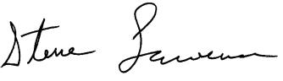

Steve Lawrence

Chief Executive Officer

3

2023 Annual

Report



UNITED STATES

SECURITIES AND EXCHANGE COMMISSION

Washington, D.C. 20549

FORM 10-K

(Mark One)

- ANNUAL REPORT PURSUANT TO SECTION 13 OR 15(d) OF THE SECURITIES EXCHANGE ACT OF 1934

For the Fiscal Year Ended February 3, 2024

or

- TRANSITION REPORT PURSUANT TO SECTION 13 OR 15(d) OF THE SECURITIES EXCHANGE ACT OF 1934 For the transition period from ___________ to ___________.

Commission File No. 001-39589
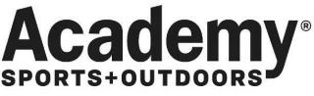

Academy Sports and Outdoors, Inc.

(Exact name of registrant as specified in its charter)

 | Delaware |  |  |  |  | 85-1800912
(State or other jurisdiction of incorporation or organization) |  |  |  |  |  | (I.R.S. Employer Identification No.)
 |  |  | 1800 North Mason Road
 |  |  | Katy, Texas 77449
 |  |  | (Address of principal executive offices) (Zip Code)
 |  |  | (281) 646-5200
 |  | (Registrant’s Telephone Number, including Area Code)
 |  | Securities registered pursuant to Section 12(b) of the Act:
 | Title of each class |  |  | Trading Symbol(s) |  | Name of each exchange on which registered
Common Stock, par value $0.01 per share |  |  |  | ASO |  | The Nasdaq Stock Market LLC

Indicate by check mark if the registrant is a well-known seasoned issuer, as defined in Rule 405 of the Securities Act.

Indicate by check mark if the registrant is not required to file reports pursuant to Section 13 or Section 15(d) of the Act.

Indicate by check mark whether the registrant (1) has filed all reports required to be filed by Section 13 or 15(d) of the Securities Exchange Act of 1934 during the preceding 12 months (or for such shorter period that the registrant was required to file such reports), and (2) has been subject to such filing requirements for the past 90 days.

Indicate by check mark whether the registrant has submitted electronically every Interactive Data File required to be submitted pursuant to Rule 405 of Regulation S-T (§232.405 of this chapter) during the preceding 12 months (or for such shorter period that the registrant was required to submit such files).

Yes ☑ No ☐

Yes ☐ No ☑

Yes ☑ No ☐

Yes ☑ No ☐

Indicate by check mark whether the registrant is a large accelerated filer, an accelerated filer, a non-accelerated filer, a smaller reporting company, or an emerging growth company.
See the definitions of “large accelerated filer”, “accelerated filer”, “smaller reporting company”, and “emerging growth company” in Rule 12b-2 of the Exchange Act.

Large accelerated filer | ☑ | Accelerated filer | ☐
Non-accelerated filer | ☐ | Smaller reporting company | ☐
 |  | Emerging growth company | ☐

If an emerging growth company, indicate by check mark if the registrant has elected not to use the extended transition period for complying with any new or revised financial accounting standards provided pursuant to Section 13(a) of the Exchange Act. ☐

Indicate by check mark whether the registrant has filed a report on and attestation to its management’s assessment of the effectiveness of its internal control over financial reporting under Section 404(b) of the Sarbanes-Oxley Act (15 U.S.C. 7262(b)) by the registered public accounting firm that prepared or issued its audit report. ☑

If securities are registered pursuant to Section 12(b) of the Act, indicate by check mark whether the financial statements of the registrant included in the filing reflect the correction of an error to previously issued financial statements. ☐

Indicate by check mark whether any of those error corrections are restatements that required a recovery analysis of incentive-based compensation received by any of the registrant’s executive officers during the relevant recovery period pursuant to §240.10D-1(b). ☐

Indicate by check mark whether the registrant is a shell company (as defined in Rule 12b-2 of the Exchange Act). Yes ☐ No ☑

The aggregate market value of the Common Stock held by non-affiliates of the registrant, based on the closing price of the Common Stock on the Nasdaq Stock Market LLC on July 29, 2023, the last business day of the registrant's most recently completed second fiscal quarter, was approximately $4.3 billion.

As of March 14, 2024, Academy Sports and Outdoors, Inc. had 74,405,351 shares of common stock, par value $0.01 per share, outstanding.

Documents Incorporated by Reference: Part III of this Annual Report on Form 10-K incorporates certain information from the registrant's definite proxy statement for its 2024 Annual Meeting of Stockholders, which shall be filed with the Securities and Exchange Commission pursuant to Regulation 14A of the Securities Exchange Act of 1934, as amended, within 120 days of the registrant's fiscal year end.

ACADEMY SPORTS AND OUTDOORS, INC.

TABLE OF CONTENTS

 |  |  | Page
CAUTIONARY STATEMENT REGARDING FORWARD-LOOKING STATEMENTS |  |  | 3
PART I |  |  | 6
Item 1. | Business |  | 6
Item 1A. |  | Risk Factors | 16
Item 1B. Unresolved Staff Comments |  |  | 40
Item 1C. |  | Cybersecurity | 41
Item 2. | Properties |  | 42
Item 3. | Legal Proceedings |  | 43
Item 4. | Mine Safety Disclosures |  | 43
PART II |  |  | 44
Item 5. Market for Registrant's Common Equity, Related Stockholder Matters and Issuer Purchases of Equity
Securities |  |  | 44
Item 6. Reserved |  |  | 45
Item 7. | Management's Discussion and Analysis of Financial Condition and Results of Operations |  | 46
Item 7A. |  | Quantitative and Qualitative Disclosures About Market Risk | 62
Item 8. | Financial Statements and Supplementary Data |  | 62
Item 9. | Changes in and Disagreements with Accountants on Accounting and Financial Disclosure |  | 62
Item 9A. |  | Controls and Procedures | 63
Item 9B. |  | Other Information | 65
Item 9C. |  | Disclosure Regarding Foreign Jurisdictions that Prevent Inspections | 67
PART III |  |  | 67
Item 10. |  | Directors, Executive Officers and Corporate Governance | 67
Item 11. Executive Compensation |  |  | 67
Item 12. |  | Security Ownership of Certain Beneficial Owners and Management and Related Shareholder Matters | 68
Item 13. |  | Certain Relationships and Related Transactions, and Director Independence | 68
Item 14. |  | Principal Accountant Fees and Services | 68
PART IV |  |  | 69
Item 15. |  | Exhibits and Financial Statement Schedules | 69
Item 16. Form 10-K Summary |  |  | 106
SIGNATURES |  |  | 112
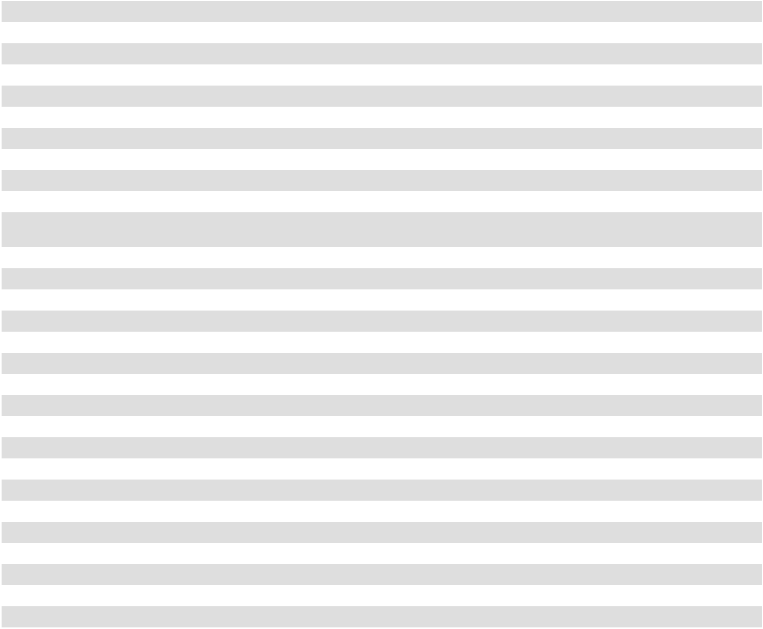

2

CAUTIONARY STATEMENT REGARDING FORWARD-LOOKING STATEMENTS

This Annual Report on Form 10-K (this "Annual Report") includes forward-looking statements within the meaning of Section 27A of the Securities Act of 1933, as amended (the "Securities Act"), and Section 21E of the Securities Exchange Act of 1934, as amended (the "Exchange Act"), which are subject to the "safe harbor" created by those sections. Forward-looking statements include all statements that are not historical facts, including statements reflecting our current views with respect to, among other things, our operations and financial performance. These forward-looking statements are included throughout this Annual Report, including in the section entitled "Management’s Discussion and Analysis of Financial Condition and Results of Operations" and in the section entitled "Risk Factors," and relate to matters such as our industry, business strategy, goals and expectations concerning our market position, future operations, margins, profitability, capital expenditures, liquidity and capital resources and other financial and operating information. We have used the words "anticipate," "assume," "believe," "continue," "could," "estimate," "expect," "intend," "may," "plan," "potential," "predict," "project," "future," "will," "seek," "foreseeable," the negative version of these words or similar terms and phrases to identify forward-looking statements in this Annual Report.

The forward-looking statements contained in this Annual Report are based on management’s current expectations and are not guarantees of future performance. The forward-looking statements are subject to various risks, uncertainties, assumptions or changes in circumstances that are difficult to predict or quantify. Our expectations, beliefs, and projections are expressed in good faith and we believe there is a reasonable basis for them. However, there can be no assurance that management’s expectations, beliefs and projections will result or be achieved. Actual results may differ materially from these expectations due to changes in global, regional or local economic, business, competitive, market, regulatory and other factors, many of which are beyond our control. We believe that these factors include but are not limited to those described under the section entitled "Risk Factors" in this Annual Report, as such risk factors may be updated from time to time in our periodic filings with the Securities and Exchange Commission, or SEC, and are accessible on the SEC's website at www.sec.gov.

Any forward-looking statement made by us in this Annual Report speaks only as of the date of this Annual Report and are expressly qualified in their entirety by the cautionary statements included in this Annual Report. Factors or events that could cause our actual results to differ may emerge from time to time, and it is not possible for us to predict all of them. We may not actually achieve the plans, intentions or expectations disclosed in our forward-looking statements and you should not place undue reliance on our forward-looking statements. Our forward-looking statements do not reflect the potential impact of any future acquisitions, mergers, dispositions, joint ventures, investments or other strategic transactions we may make. We undertake no obligation to publicly update or review any forward-looking statement, whether as a result of new information, future developments or otherwise, except as may be required by any applicable securities laws.

BASIS OF PRESENTATION

All references to "Academy", "we", "us," "our" or the "Company" in this Annual Report and the accompanying financial statements refer to Academy Sports and Outdoors, Inc., a Delaware corporation ("ASO, Inc.") and the current parent holding company of our operations, and its consolidated subsidiaries. We conduct our operations primarily through our parent holding company's indirect subsidiary, Academy, Ltd., a Texas limited partnership doing business as "Academy Sports + Outdoors", or Academy, Ltd. All of the Company’s sales and business operations occur at Academy, Ltd., and Academy, Ltd. is also the borrower and/or issuer of the Company’s long-term debt and lessee of facilities.

We operate on a retail fiscal calendar pursuant to which our fiscal year consists of 52 or 53 weeks, ending on the Saturday closest to January 31 (which such Saturday may occur on a date following January 31) each year. References to any year, quarter, or month mean our fiscal year, fiscal quarter, and fiscal month, respectively, unless the context requires otherwise. References to “2021,” “2022,” and “2023” relate to our fiscal years ended January 29, 2022, January 28, 2023, and February 3, 2024, respectively, unless the context requires otherwise.

Numerical figures included in this Annual Report have been subject to rounding adjustments. Accordingly, numerical figures shown as totals in various tables may not be arithmetic aggregations of the figures that precede them.

3

RISK FACTORS SUMMARY

Investing in our securities involves a high degree of risk. The following is a summary of the principal factors that make an investment in our securities speculative or risky, all of which are more fully described below in the section entitled “Risk Factors.” In addition to the following summary, you should consider the information set forth in the “Risk Factors” section and the other information contained in this Annual Report before investing in our securities.

Risks Related to Our Business and Industry

- overall decline in the health of the economy and consumer discretionary spending;

- our ability to predict or effectively react to changes in consumer tastes and preferences, to acquire and sell brand name merchandise at competitive prices and/or to manage our inventory balances;
- risks associated with our reliance on internationally manufactured merchandise;

- our ability to safeguard sensitive or confidential data relating to us and our customers, team members and vendors;

- intense competition in the sporting goods and outdoor recreation retail industries;

- our ability to operate, update or implement our information systems;

- risks associated with disruptions in our supply chain and losses of merchandise purchasing incentives;

- harm to our reputation;

- any failure of our third-party vendors of outsourced business services and solutions;

- our ability to successfully continue our store growth plans or manage our growth effectively, or any failure of our new stores to generate sales and/or achieve profitability;
- risks associated with our e-commerce business;

- risks related to our private label brand merchandise;

- any disruption in the operation of our distribution centers;

- quarterly and seasonal fluctuations in our operating results;

- the occurrence of severe weather events, catastrophic health events, natural or man-made disasters, social and political conditions or civil unrest;
- any failure to attract, train and retain quality team members in sufficient numbers, increases in wage and labor costs, and changes in laws and other labor issues;
- our ability to retain key personnel;

- the geographic concentration of our stores;

- fluctuations in merchandise (including raw materials) costs and availability;

- payment-related risks;

- the effectiveness of our marketing and advertising programs;

- our ability to protect against inventory shrink;

- our ability to successfully pursue strategic acquisitions and integrate acquired businesses.

Legal and Regulatory Risks

- our ability to comply with laws and regulations affecting our business, including those relating to the sale, manufacture and import of consumer products;
- risks related to climate change and other sustainability-related matters;

- claims, demands and lawsuits to which we are, and may in the future, be subject and the risk that our insurance or indemnities coverage may not be sufficient;
- risks related to product safety;

- our ability to protect our intellectual property and avoid the infringement of third-party intellectual property rights.

Risks Related to Our Indebtedness

- our level of indebtedness and related debt service payments and our ability to generate sufficient cash flow to satisfy all of our obligations under our indebtedness;
- our ability to incur substantially more debt;

- our variable rate indebtedness subjects us to interest rate risk;

- restrictions on our current and future operations imposed by the terms of our indebtedness;

- our ability to borrow under the ABL Facility (as defined below);

- our level of indebtedness may hinder our ability to negotiate favorable terms with our vendors.

4

Risks Related to the Ownership of Our Common Stock

- our stock price is volatile or may decline;

- our ability or decision to pay dividends on our common stock or conduct stock repurchases;

- anti-takeover provisions in our organizational documents could delay or prevent a change of control;

- our exclusive forum provision; and

- you may be diluted by any future issuances of shares by us.

These factors should not be construed as exhaustive and should be read in conjunction with the other cautionary statements that are included in this Annual Report. Should one or more of these risks or uncertainties materialize, or should any of our assumptions prove incorrect, our actual results may vary in material respects from those projected in our forward-looking statements.

5

PART I

Item 1. Business

The following discussion and analysis of our financial condition and results of operations should be read together with our financial statements and related notes included elsewhere in this Annual Report for the fiscal year ended February 3, 2024. This discussion contains forward-looking statements that involve risks and uncertainties. See the section of this Annual Report entitled "Cautionary Statement Regarding Forward-Looking Statements." When reviewing the discussion below, you should keep in mind the substantial risks and uncertainties that characterize our business. Known material factors that could affect our financial performance and actual results, and could cause actual results to differ materially from those expressed or implied in any forward-looking statements included in this discussion or otherwise made by our management, are described in the "Risk Factors" section of this Annual Report.

Who We Are

Academy Sports + Outdoors is a leading full-line sporting goods and outdoor recreation retailer in the United States. Originally founded in 1938 as a family business in Texas, we now operate 282 stores across 18 contiguous states. Our mission is to provide “Fun for All” and we fulfill this mission with a localized merchandising strategy and value proposition that deeply connect with a broad range of consumers. Our product assortment focuses on key categories of outdoor, apparel, sports & recreation and footwear (representing 28%, 28%, 24% and 20% of our 2023 net sales, respectively) through both leading national brands and a portfolio of 19 private label brands, which go well beyond traditional sporting goods and apparel offerings.

We believe the following attributes differentiate us from our competitors:

- Value-based assortment that enables our customers to participate and have fun, no matter their budget.

- Broad assortment that extends beyond sporting goods and apparel to outdoor recreation and is localized for individual stores.

- Emerging, growing and profitable omnichannel strategy that leverages our buy-online-pickup-in-store program ("BOPIS") and shipping fulfillment capabilities.

- Strong customer loyalty, with opportunities to increase penetration in existing markets.

- Regional focus in the southern United States with a growing presence in some of the fastest-growing Metropolitan Statistical Areas (or "MSAs").

- Core customers comprising active families that we support with one-stop shop convenience.

- Significant whitespace opportunity for new stores for both existing and adjacent geographies and new markets.

We believe we sit in a sweet-spot of consumer demand, offering a broad, value-based assortment of sporting goods and outdoor recreation products, so our customers can participate and have fun, no matter their budget. Sporting goods shoppers consistently rate us as the top retailer for offering sporting and outdoor recreation products for a wide range of customers and being a one-stop shop. We carefully curate our products to provide the right assortment that appeals to customers from beginners to experts, including families and casual participants.

Our access to national brand and private label brand merchandise creates a comprehensive portfolio of value-based and diversified products, spanning various price-points, that differentiates our assortment from our peers. Our category, brand and price-point mix is unique to Academy and difficult to replicate at other retailers. Approximately 80% of our 2023 merchandise sales was comprised of national brand products, with the remainder coming from exclusive products in our portfolio of private label brands. No single brand we carry accounted for more than 12% of our 2023 sales.

We endeavor to offer products for customers of all ages, incomes and aspirations across sporting and outdoor recreation activities, seasons and experience levels. As such, we have a balanced, year-round business and a large customer base. Our average customer visits our stores anywhere from two to three times per year.

6

Our Industry

The retail business is highly competitive based on many variables including price, product assortment, customer service, omnichannel experience and store locations.

The retail sporting goods and outdoor recreation retail industry comprises six principal categories of retailers:

- Mass general merchants (examples: Walmart, Kohl’s and Target) generally range in size from 50,000 to over 200,000 square feet and are typically located in shopping centers, free-standing sites or regional malls. Sporting goods merchandise and apparel and outdoor recreation products may represent a small portion of the total merchandise in these stores.

- Large format sporting goods stores (examples: Dick’s Sporting Goods and Scheels) generally range in size from 20,000 to over 100,000 square feet and offer a broad selection of sporting goods and outdoor recreation merchandise.

- Traditional sporting goods stores (examples: Hibbett Sports and Big 5 Sporting Goods) generally range in size from 5,000 to 20,000 square feet and are frequently located in regional malls and shopping centers and typically carry a varied assortment of primarily sporting goods merchandise.

- Specialty outdoor retailers (examples: Bass Pro Shop/Cabela’s and Sportsman’s Warehouse) generally range in size from 7,500 to over 100,000 square feet and typically focus on specific categories such as outdoor recreation.

- Specialty footwear retailers (examples: Foot Locker, Boot Barn and The Finish Line) generally range in size from 2,000 to 20,000 square feet and typically focus on specific categories such as athletic footwear.

- Catalogue & Internet retailers (examples: Amazon, eBay, and Fanatics) do not typically operate brick and mortar stores and primarily rely on delivery of goods. Sporting goods merchandise and apparel and outdoor recreation products may represent a small portion of the total merchandise on their websites.

Our primary competitors are large format sporting goods stores and mass general merchants that offer sporting goods, outdoor recreation products and other lifestyle and recreational merchandise.

Merchandising

Our merchandise consists of national brand products that we purchase and license from various vendors, private label brand products that we brand with our internal brands and exclusive license products that we purchase and license from vendors and carry exclusively. We have long-standing relationships with many of our suppliers and have partnered with them to grow our business over time. In 2023, we purchased merchandise from approximately 1,400 vendors. For 2023, 2022 and 2021 no vendor represented more than 11% of our total purchases.

We have preferred access to hundreds of well-recognized national brands, such as Nike, Under Armour, adidas, Winchester, Columbia Sportswear, Brooks, Skechers, Yeti and Carhartt, which are critical to our market penetration. These and some of our other national brands rely on us to broaden their consumer reach, which fosters a mutually beneficial relationship when it comes to pricing and assortment, and we play a critical role in delivering customer volume for these brands. Our national brand assortment spans across each brand’s price spectrum, which we complement with an assortment of our private label brands priced below the national brand price spectrum. As such, we receive favorable product allocations from leading suppliers.

Our private label brand portfolio consists of 19 brands, including Academy Sports + Outdoors, Magellan Outdoors, BCG, O'rageous, Game Winner, Outdoor Gourmet, Freely and R.O.W. Our private label brand strategy focuses on in-filling categories and price points that our national brand products may not satisfy. Our private label brand offerings support and complement our overall merchandising strategy due to limited price-point overlap with national brands. Additionally, our private label brands generate strong brand equity and drive significant customer loyalty. Approximately 55% of our customers purchased a private label brand from us in 2023.

7

As of February 3, 2024, we generally organized our merchandise in four divisions made up of sixteen categories as follows:

Division | Category | Primary product types
Outdoors | Camping | Coolers and drinkware, camping accessories and camping equipment
 | Fishing | Marine equipment and fishing rods, reels, baits and equipment
 | Hunting | Firearms, ammunition, archery and archery equipment, camouflage apparel,
 |  | waders, shooting accessories, gun safes, optics, airguns and hunting equipment
Sports and Recreation | Fitness | Fitness equipment, fitness accessories and nutrition supplies
 | Team sports | Team and specialty sports equipment, including baseball, football, basketball,
 |  | soccer, golf, racket sports, and volleyball, and backpacks and sports bags
 | Recreation | Patio furniture, outdoor cooking, wheeled goods (bicycles, skateboards and
 |  | other ride-on toys), trampolines, play sets, watersports and pet equipment
 | Front end | Electronics, watches, sunglasses and front-end (consumables, batteries, etc.)
Apparel | Outdoor and seasonal | Outdoor apparel, seasonal apparel, denim, work apparel, graphic t-shirts and
 | apparel | accessories
 | Youth apparel | Boys and girls outdoor and athletic apparel
 | Athletic apparel | Sporting apparel and apparel for fitness
 | Licensed apparel | Professional and collegiate team licensed apparel and accessories
Footwear | Casual and seasonal | Casual shoes, slippers, seasonal footwear and socks
 | footwear
 | Work footwear | Work and western boots, shoes and hunting footwear
 | Youth footwear | Boys and girls footwear
 | Athletic footwear | Running shoes, athletic lifestyle and training shoes
 | Team sports footwear | Team and specialty sports footwear and slides
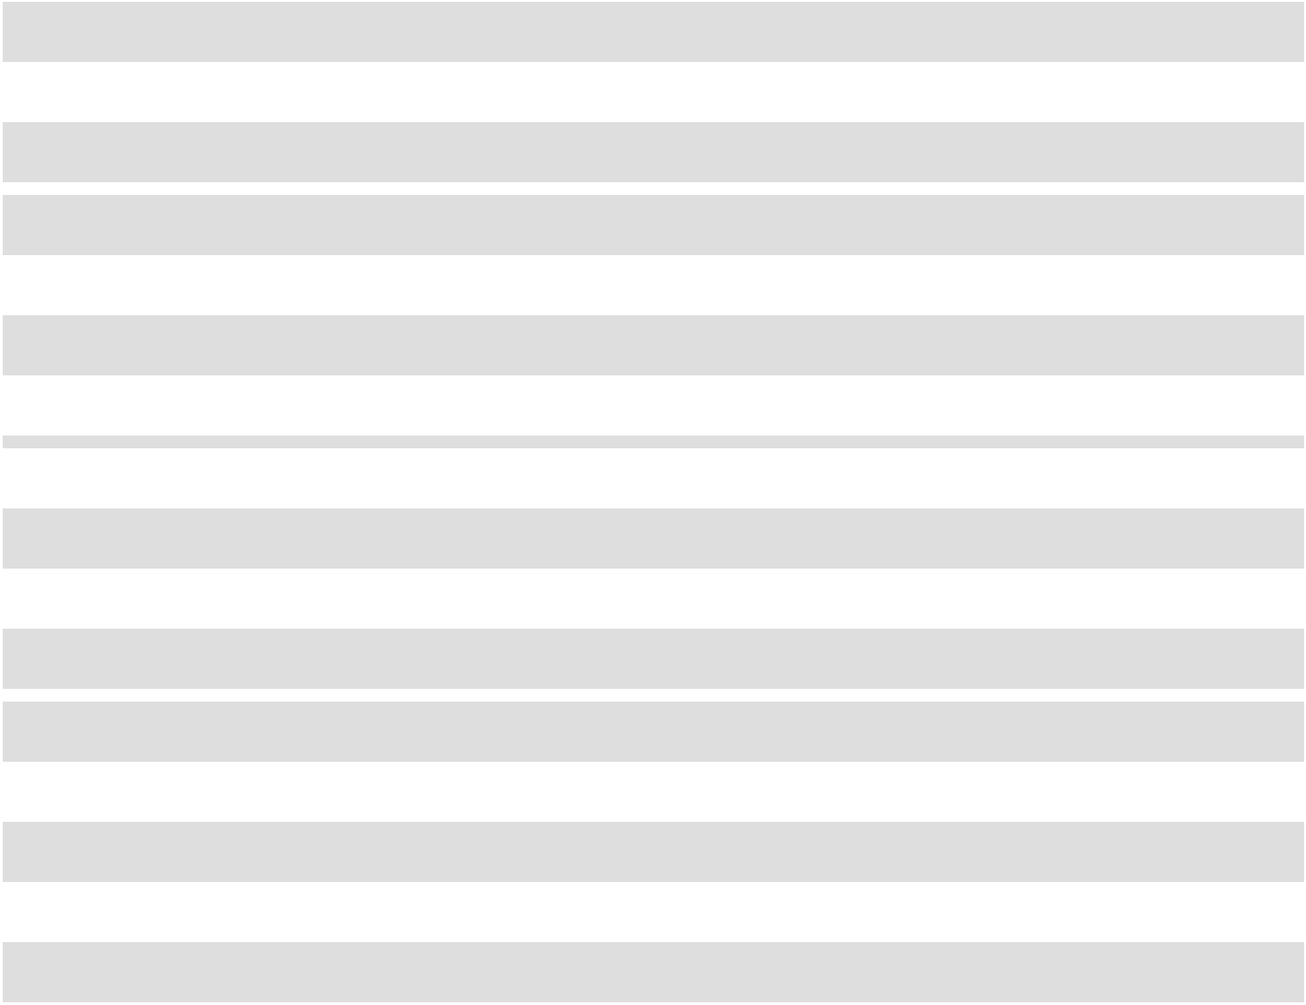

8

The following table sets forth the approximate amount of sales (all of which are based in the U.S.) by merchandise divisions for the periods presented (amounts in thousands):

 |  |  |  |  | Fiscal Year Ended
 |  | February 3, 2024 |  |  | January 28, 2023 |  |  | January 29, 2022
Merchandise sales ⁽¹⁾
Outdoors | $ | 1,727,018 | $ |  | 1,819,418 | $ |  | 2,060,046
Sports and recreation |  | 1,452,377 |  |  | 1,488,187 |  |  | 1,577,776
Apparel |  | 1,710,838 |  |  | 1,758,993 |  |  | 1,810,345
Footwear |  | 1,235,643 |  |  | 1,291,227 |  |  | 1,290,197
Total merchandise sales ⁽²⁾ |  | 6,125,876 |  |  | 6,357,825 |  |  | 6,738,364
Other sales ⁽³⁾ |  | 33,415 |  |  | 37,248 |  |  | 34,764
Net sales | $ | 6,159,291 | $ |  | 6,395,073 | $ |  | 6,773,128
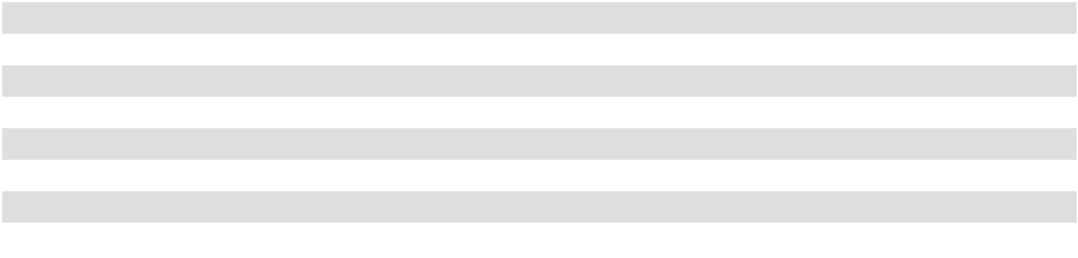

- Certain products and categories were re-categorized among various categories and divisions, respectively, during 2023 as compared to prior years in order to better align with our current merchandising strategy and view of the business. As a result, we have reclassified sales between divisions for 2022 and 2021 for comparability purposes. This reclassification is in divisional presentation only and did not impact the overall net sales balances previously disclosed.

- E-commerce sales consist of 10.7%, 10.7% and 9.3% of merchandise sales for 2023, 2022 and 2021, respectively.

- Other sales consists primarily of the gift card breakage income, credit card bounties and royalties, shipping income, net hunting and fishing license income, sales return allowance and other items.

Stores

Our stores, all of which are based in the U.S., are designed to provide our customers with an easy-in, easy-out shopping experience. The interior of most of our stores are built around a central “racetrack” aisle that allows customers to efficiently navigate our selling floor. Additionally, our stores generally have consistent store layouts providing our customers familiarity across our entire store base. We seek to offer our customers strong merchandise assortment and a localized customer experience, which is facilitated by various types of merchandise fixtures and our large selling floor. Our central “racetrack” aisle and adjacent end-cap merchandising space allows us to adjust our inventory presentations throughout our various selling seasons.

Our stores average approximately 70,000 gross square feet, of which approximately 85% is dedicated to selling space. Our store locations are typically positioned adjacent to major highways or thoroughfares, allowing customers to easily locate our stores. We seek to position our stores in areas with certain population densities, demographics and other characteristics to maximize sales. These markets consist of metropolitan, suburban and smaller cities. Additionally, our stores are typically placed in retail centers adjacent to co-tenants who drive significant traffic. At this time, no stores are connected to malls. We seek to lease all of our stores in long-term lease agreements with third-party landlords, which typically range from 15 to 20 years. Of the 282 stores operated as of February 3, 2024, 281 are leased from third parties and one store is owned by the Company.

We are active members of the communities in which we operate, and our long-time customers have grown up with Academy and passed their passion for us on to the next generation, enabling us to benefit from strong customer loyalty and shopping frequency.

9

As of February 3, 2024, the number of stores that we operated, exclusively in the U.S., by state was as follows:

State |  | Number of Stores
Texas | 111
Georgia | 20
Louisiana | 18
Florida | 16
Alabama | 15
North Carolina | 15
Tennessee | 13
Oklahoma | 13
Missouri | 11
South Carolina | 9
Arkansas | 8
Mississippi | 8
Kansas | 6
Kentucky | 6
Indiana | 6
Illinois | 3
Virginia | 3
West Virginia |  | 1
 | 282
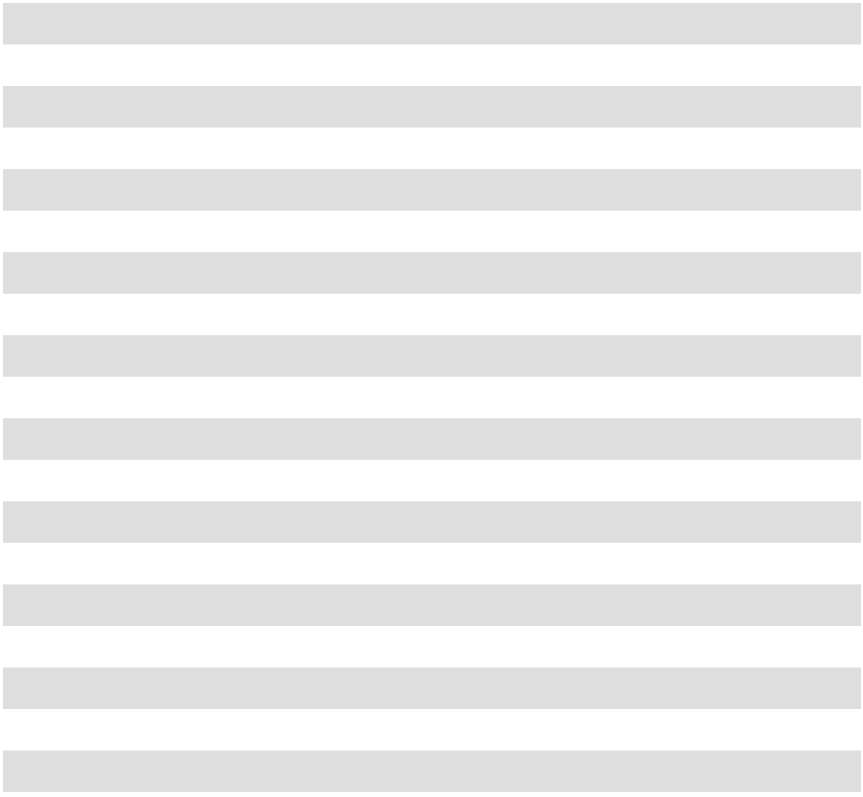

We believe our real estate strategy has positioned us well for further expansion, and our track record has demonstrated that we can open and operate stores profitably. We believe there is significant near-term opportunity for expansion in both new and existing markets.

Marketing

Our marketing approach is anchored in helping active minded families have fun in their pursuit of sports and outdoors activities. The strategy is designed to generate awareness and consideration for the Academy brand while improving intent to purchase across the broad selection of fun categories, top national and private brands at a compelling value within our sporting goods assortment. We analyze first party data from across our customer data platform and data science environments, customer insights studies and retail industry market share data sources to develop annual and seasonal go to market strategies that lead to creation of engaging content and customer experiences that are communicated across a diverse range of owned and paid media channels.

Additionally, we utilize the customer data platform to generate first party data audiences for targeted customer lifecycle management campaigns designed to retain current customers and encourage omnichannel shopping behaviors. First party data is also used to inform creation of third party data audiences across a mix of media channels to drive engagement and acquisition of new customers through the use of brand designed, influencer and customer created content. These campaigns are executed across a blend of digital and traditional, including paid search, email, text message, mobile app, digital advertising networks, affiliates, and social media along with linear and digital video, audio, print, outdoor and direct mail.

We are focused on implementing and continually improving our customer centric marketing technologies, omnichannel services and experiences to save customers time and money while improving the long term health of our customer portfolio. The Academy Credit Card program and Academy Sports + Outdoors app are foundational to build loyalty among customers while providing a seamless omnichannel shopping experience.

10

We are committed to making a positive impact on the communities we serve and partner with over 750 organizations, including youth sports leagues that reach approximately 400,000 participants. We also partner with school districts, Historically Black Colleges and Universities (HBCUs), collegiate and professional sports properties, local parks, hunting and fishing organizations, military bases and local first responders.

Distribution Centers

We operate three distribution centers in Katy, Texas; Twiggs County, Georgia; and Cookeville, Tennessee. The distribution centers receive and store products from vendors and use sophisticated sorting and logistical equipment to fill the product needs of the retail store locations they serve, as well as to fulfill e-commerce orders. Our distribution centers are leased under long-term agreements. Third-party trucking companies are used to disburse inventory from the distribution centers to and from our stores. These distribution centers are strategically located throughout our footprint to efficiently serve our retail locations and have the capacity to service up to approximately 120 stores per distribution center.

Information Systems

Our information systems are critical to our day-to-day operations as well as to our long-term growth strategies. Our technology is integrated across multiple functions throughout the organization, providing the data analysis, automation and solutions necessary to support our communications, inventory and supply chain management, store operations, distribution, point-of-sale, e-commerce, customer, financial reporting and accounting functions. Our technology is the foundation of our merchandising and marketing functions; it processes our customers’ orders and integrates our e-commerce sales with stores. We are leveraging our data to make more informed decisions around inventory, marketing, and store-level operations. We have agreements with third parties to provide hosting services and administrative support for portions of our infrastructure, and utilize cloud-based systems in addition to those hosted on premises.

Seasonality

Our business is subject to seasonal fluctuations. A significant portion of our net sales and profits is driven by summer holidays, such as Memorial Day, Father’s Day and Independence Day, during the second quarter. Our net sales and profits are also impacted by the August/September back-to-school selling season during the third quarter and November/December holiday selling season, and in part by the sales of cold weather sporting goods and apparel during the fourth quarter.

Our Team Members

Our mission is to provide “Fun for All” and a critical component to our success is our people. As of February 3, 2024, we employed approximately 22,000 team members in the U.S. and eleven team members in Hong Kong. Of those team members, approximately 50% were full-time and 50% were part-time. Our employment levels may fluctuate over the course of the year due to the seasonality of our business. None of our team members are covered by collective bargaining agreements. The Company believes that it has a good working relationship with its team members.

11

Culture and Core Values. We strive to provide rewarding careers, benefits, and a workplace culture where team members are empowered to be their authentic self—drawing on their unique perspectives, passions, skills, interests, and experiences in their day-to-day jobs. Our core values establish a strong foundation for our culture and represent the key expectations we have of our team members. These include the following:

- Customer focus and service

- Excellence in all we do

- Responsible leadership

- Initiative with urgency

- Students of the business

- Integrity always

- Positive impact on our communities

Diversity, Inclusion and Belonging. At Academy, we believe the diversity of our team members, customers, and all others with whom we interact enhances the quality of our work environment and our customers’ shopping experience. Academy encourages team members to work together and to value the strengths each team member brings to the team. Our strategy begins with attracting, recruiting, developing, and retaining team members with backgrounds that are representative of our diverse communities because it makes our company and communities stronger. We require all team members to complete unintentional bias training to help eliminate biases from recruiting, hiring, promotions, job assignments and opportunities, evaluations, compensation, and customer service.

In 2020, we established our Diversity, Inclusion and Belonging Committee, and they led the organization in the creation of our team member led Diversity, Inclusion and Belonging groups throughout the Company. These groups provide a forum for team members with common interests and/or backgrounds to connect, network, and provide input on issues related events while helping educate and celebrate our team members' diverse backgrounds and experiences.

Talent Management. We believe the best way to serve our customers is to invest in top talent, be open to innovation, and have the vision to succeed. We are focused on creating a winning team by recruiting and retaining great people, promoting teamwork, and fostering an enjoyable and rewarding work environment. We also strive to provide all team members with opportunities for personal growth, cross functional training, job opportunities and career advancement. We offer a mix of instructor-led, online, and blended courses in several key areas, including Career Development and Leadership Development. Our wide variety of courses ranges from job specific (i.e., functional) to broad based leadership training to safety, security, ethics, and compliance training. We also engage in regular and ongoing feedback, annual performance reviews and annual talent calibration conversations. Succession planning is conducted on an annual basis to identify suitable internal candidates for key positions within the Company.

Compensation and Benefits. We offer a competitive compensation and benefits package. Our benefits package is designed to allow team members the ability to pick and choose which benefits are the best for their and their family’s health and well-being. Depending on the team member’s employment and work status, they may be eligible for: medical, dental, and vision insurance; participation in the Company’s 401(k) Plan with a six percent dollar for dollar match up to the IRS deferral limit; participation in the Company’s Employee Stock Purchase Plan which provides a 15 percent discount on the lower of the stock price at the beginning or the end of each offering period; paid time off and paid vacations; the ability for team members to get a portion of their earnings paid daily; tuition reimbursement programs; professional license/certification reimbursement; medical, family, and bereavement leave; additional voluntary short/long term, life, legal, pet, and accident insurance; paid maternity and parental leave; and a 20 percent team member discount on most all of our merchandise, to name a few. We also provide, in all our distribution centers and our Katy corporate office, subsidized meals for all team members at our onsite café and an annual health and benefits fair. Specific to our Katy corporate office, we engage our team members through the opportunity to participate in intramural sport teams, 5K fun walk/run events, subsidized membership in the company gym and exercise classes (this is also open to our Katy distribution team members); “food truck Thursdays”; onsite dental and car wash service; and a company holiday party and other team member appreciation events.

Workplace, Health and Safety. The health and safety of our customers, team members, and communities is our top priority. We strive to ensure that a safe and hygienic working environment is provided and that occupational health and safety practices which prevent accidents and injury are promoted. Throughout our stores, distribution centers, and corporate headquarters, we employ policies, procedures, and training to promote safe and healthy work environments.

12

Our team member handbook outlines safety expectations, but we also empower our team members with knowledge and skills from various safety training courses during the onboarding process and on an ongoing basis through our learning engagement system with topics such as incident reporting, behavior-based safety, evacuation, active shooter response, hazardous materials, ergonomics, heat safety, electrical safety, industrial truck and pallet jack safety, confined space entry and parking lot and garage safety. We continue to focus on developing and driving our safety-first culture through awareness, training, and actions to reduce the frequency and severity of safety incidents.

Information about our Executive Officers

Below is a list of our executive officers, their respective ages as of March 21, 2024 and a brief account of the business experience of each of them.

Name |  | Age |  | Position
Ken C. Hicks | 71 |  |  | Executive Chairman
Steven (Steve) P. Lawrence | 56 |  |  | Chief Executive Officer
Samuel (Sam) J. Johnson | 57 |  |  | President
Earl Carlton (Carl) Ford IV | 46 |  |  | Executive Vice President and Chief Financial Officer
Matthew (Matt) M. McCabe | 53 |  |  | Executive Vice President and Chief Merchandising Officer
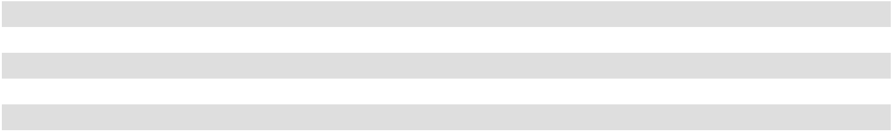

Ken C. Hicks has served as the Executive Chairman of the Board of Directors since June 1, 2023. Mr. Hicks served as Chairman of the Board and Chief Executive Officer from May 2018 to June 2023. Mr. Hicks has served as a member of the Board of Directors since June 2020 and served as a member of the Board of Managers of New Academy Holding Company, LLC from May 2017 to June 2020. Mr. Hicks previously served as President and Chief Executive Officer at Foot Locker, Inc. from August 2009 to February 2010, and also served as Chairman, President and Chief Executive Officer at Foot Locker, Inc. from February 2010 to November 2014, and as Executive Chairman at Foot Locker, Inc. from December 2014 to May 2015. Prior to joining Foot Locker, Inc., Mr. Hicks held senior positions at J.C. Penney Company, Inc., Payless ShoeSource, Home Shopping Network, May Department Stores Company, and McKinsey & Company. Mr. Hicks has served on the board of directors of Avery Dennison Corporation since July 2007, and as Chairman of the board of directors of Guitar Center Holdings, Inc. since October 2023. Previously, Mr. Hicks served on the board of directors and the Compensation Committee of Whole Foods Market, Inc. from May 2017 to August 2017. Mr. Hicks graduated from the United States Military Academy located in West Point, NY, and served in the U.S. Army. He also earned a Masters of Business Administration with highest distinction from Harvard Business School.

Steven (Steve) P. Lawrence has served as Chief Executive Officer and a member of the Board of Directors since June 2023. Mr. Lawrence joined the Company in February 2019 as Executive Vice President and Chief Merchandising Officer. Prior to joining the Company, Mr. Lawrence was President, Chief Executive Officer and served on the board of directors at francesca’s from October 2016 to January 2019. From May 2012 to September 2016, he served as Chief Merchandising Officer at Stage Stores. Mr. Lawrence also spent nearly 12 years working in various merchandising leadership roles at J.C. Penney after 10 years at Foley’s/May Co. Mr. Lawrence obtained his Bachelor of Business Administration in Finance from the University of Notre Dame.

Samuel (Sam) J. Johnson has served as President since October 2023. Mr. Johnson joined the Company in April 2017 as Executive Vice President, Retail Operations. Prior to joining the Company, Mr. Johnson spent seven years with hhgregg, Inc., where he most recently served as Chief Retail Officer. While at hhgregg, Inc., he led functions including store operations, customer relations, commercial sales, real estate and visual merchandising. Prior to hhgregg, Inc., he spent more than 20 years in various leadership roles with Sears Holdings Corporation, including Vice President of Small Stores.

Earl Carlton (Carl) Ford IV has served as Executive Vice President and Chief Financial Officer since July 2023. Mr. Ford joined the Company in January 2019, and served as the Senior Vice President, Finance, where he led the Financial Planning and Analysis function of the Company from January 2019 to July 2023 and the Loss Prevention and Inventory Control teams from February 2020 to July 2023. Prior to joining the Company, Mr. Ford served as the Vice President of Financial Planning & Analysis at Belk, Inc. He also served as the Vice President of Internal Audit and held other leadership roles in accounting and treasury during his 15 years at Belk, Inc. Prior to joining Belk, Inc., Mr. Ford worked for Deloitte & Touche in their Audit practice. Mr. Ford holds a master's degree in accounting from the University of Alabama, a bachelor's degree in accounting from the University of Southern Mississippi and is an active Certified Public Accountant.

13

Matthew (Matt) McCabe has served as the Executive Vice President and Chief Merchandising Officer since June 2023. Mr. McCabe joined the Company in December 2016 as the Vice President, Divisional Merchandise Manager of Athletic and Licensed Apparel and served as the Senior Vice President, General Merchandise Manager of Footwear from September 2017 to June 2023. In this role, he was responsible for setting the merchandising objectives and business strategy for the Footwear division. Prior to joining the Company, Mr. McCabe served as Vice President at Golfsmith International, where he led the apparel, footwear and soft consumables buying and private brand businesses. He has more than 25 years of experience in men's and women's apparel and footwear, and held various leadership roles at The Bon Ton Department Stores, Bachrach, Sears & Roebuck Co., and Mark Shale. Mr. McCabe holds a Bachelor of Science from Miami University.

Intellectual Property

Our trademarks, service marks, copyrights, patents, processes, trade secrets, domain names and other intellectual property, including our Academy Sports + Outdoors brand, our private label brands, such as Academy Sports + Outdoors, Magellan Outdoors, BCG, O’rageous, Game Winner, Outdoor Gourmet and Freely, and our designs, names, slogans, images and trade dress associated with these brands, are valuable assets that are critical to our success.

We also enter into intellectual property agreements whereby the Company receives the right to use third-party owned trademarks typically in exchange for royalties on sales. These agreements typically contain a one to three-year term and contractual payment amounts required to be paid by the Company.

Governmental Regulations

We operate in a complex regulatory and legal environment that exposes us to regulatory, compliance and litigation risks that could materially affect our operations and financial results. Specifically, we are subject to regulation by numerous federal, state and local regulatory agencies and authorities, including the U.S. Consumer Product Safety Commission, Equal Employment Opportunity Commission, Department of Labor, Occupational Safety and Health Administration, Department of Justice, Department of Treasury, Federal Trade Commission, Customs and Border Protection, Bureau of Alcohol, Tobacco, Firearms and Explosives, SEC, Internal Revenue Service, or IRS, and Environmental Protection Agency and comparable state and local agencies.

Laws and regulations affecting our business may change, sometimes frequently and significantly, as a result of political, economic, social or other events. Some of the federal, state or local laws and regulations that affect us include but are not limited to:

- consumer product safety, product liability or consumer protection laws;

- laws related to advertising, marketing, pricing and selling our products, including but not limited to firearms, ammunition, and related accessories;
- labor and employment laws, including wage and hour laws and forced labor prevention laws;

- tax laws or interpretations thereof, including collection of state sales tax on e-commerce sales;

- data protection and privacy laws and regulations;

- environmental laws and regulations;

- hazardous material laws and regulations;

- customs or import and export laws and regulations, including collection of tariffs on product imports;

- intellectual property laws;

- antitrust and competition regulations;

- banking and anti-money laundering regulations;

- Americans with Disabilities Act, or ADA, and similar state and local laws and regulations;

- website design and content regulations;

- U.S. Foreign Corrupt Practices Act, or FCPA, the U.K. Bribery Act, or UKBA, and other anti-corruption laws; and

- securities and exchange laws and regulations.

14

We are a federally licensed firearms dealer, and we sell firearms, ammunition, and related accessories. Firearms represented approximately 5% of our net sales in 2023. Numerous federal, state and local laws and regulations govern the procurement, transportation, storage, distribution and sale and marketing of firearms, ammunition, and related accessories, including the regulations governing the performance of federally and state mandated procedures for determining customer firearm purchase eligibility (such as age and residency verification, background checks and proper completion of required paperwork). In June 2021, the United States Department of Justice announced a new policy to underscore zero tolerance for willful violations of the law by federally licensed firearms dealers that put public safety at risk. In the future, there may be increased federal, state or local regulation and enforcement affecting the sale of firearms, ammunition, and related accessories, including taxation or restrictions on the type of firearms and ammunition available for retail sale, which could reduce our sales and profitability.

For additional information, see the risk factors herein in "Item 1A. Risk Factors" under the sub-caption "Legal and Regulatory Risks".

Available Information

Our website address is www.academy.com. We use our website as a channel of distribution for company information. We will make available free of charge on the Investor Relations section of our website our Annual Report on Form 10-K, Quarterly Reports on Form 10-Q, Current Reports on Form 8-K and all amendments to those reports as soon as reasonably practicable after such material is electronically filed with or furnished to the SEC pursuant to Section 13(a) or 15(d) of the Exchange Act. We will also make available through our website other reports filed with or furnished to the SEC under the Exchange Act, including our proxy statements and reports filed by officers and directors under Section 16(a) of the Exchange Act, as well as our Ethics and Code of Conduct Policy. Financial and other material information regarding the Company is routinely posted on our website and is readily accessible. We do not intend for information contained on our website to be part of this Annual Report on Form 10-K.

15

Item 1A. Risk Factors

Investing in our securities involves a high degree of risk. In addition to the other information contained in this Annual Report, you should consider the following risk factors before investing in our securities. Risks in this section are grouped in the following categories: (1) Risks Related to Our Business and Industry; (2) Legal and Regulatory Risks; (3) Risks Related to Our Indebtedness; and (4) Risks Related to the Ownership of Our Common Stock. Many risks affect more than one category, and the risks are not in order of significance or probability of occurrence because they have been grouped by categories.

Risks Related to Our Business and Industry

Our results of operations are highly dependent on the U.S. economy and U.S. consumer discretionary spending and an economic and financial downturn may cause a decline in U.S. consumer discretionary spending and may adversely affect our business, operations, liquidity, capital resources and financial results.

Our results of operations are affected by the relative condition of the U.S. economy. All of our sales are generated within the United States, making our results of operations highly dependent on the U.S. economy and U.S. consumer discretionary spending. A decline in discretionary spending by U.S. consumers could negatively affect our business and results of operations.

The general conditions that affect U.S. consumer discretionary spending in our markets include:

- health of the economy;

- consumer confidence in the economy;

- wages, jobs and unemployment trends;

- public health events (such as the COVID-19 pandemic) and their effect on our customers, team members, vendors/ suppliers and other stakeholders;

- the housing market, including real estate prices and mortgage rates;

- consumer credit availability;

- consumer debt levels;

- gasoline and fuel prices;

- interest rates and inflation;

- tax rates and tax policy;

- immigration policy;

- import and customs duties/tariffs and policy;

- impact of natural or man-made disasters;

- legislation and regulations;

- international unrest, trade disputes, labor shortages, and other disruptions to the supply chain;

- changes to raw material and commodity prices; and

- national and international security and safety concerns.

Increasing volatility in financial markets may cause some of the aforementioned conditions to change with even greater degree of frequency and magnitude.

Our comparable sales, net sales per square foot, customer traffic or average value per transaction may be adversely affected if, for example, our customers reduce their purchases with us due to continued high inflation, job losses, foreclosures, bankruptcies, higher consumer debt and interest rates, higher taxes, reduced access to credit, falling home prices and lower consumer confidence. A reduction in overall consumer spending which causes customers to shift their spending to products other than those sold by us or to products sold by us that are less profitable could result in lower net sales, decreases in inventory turnover or a reduction in profitability due to lower margins, which could make it more difficult for us to generate cash flow sufficient to satisfy our obligations under our indebtedness. A prolonged period of depressed consumer spending could have a material adverse effect on our business.

16

Additionally, if the U.S. or global economy experiences a crisis or downturn, including any capital markets volatility or government intervention in the financial markets, or if the U.S. or global economy experiences a prolonged period of decelerating or negative growth, then our liquidity, capital resources or results of operations could be materially and adversely impacted. For example, although we typically generate funds from our operations to pay our operating expenses and fund our capital expenditures, our ability to continue to meet these cash requirements over the long-term may require access to additional sources of funds, including our ABL Facility, incremental term loan facilities and the equity and debt capital markets. Adverse financial and economic conditions, including as a result of continued increases in interest rates, may adversely affect our ability to draw on our ABL Facility, the ability of banks to honor draws on our ABL Facility or our ability to obtain incremental term loan facilities or access the equity and debt capital markets. In addition, adverse economic conditions could adversely affect our suppliers’ access to the capital and liquidity required to maintain their inventory, production levels, timeliness and product quality and to operate their businesses, which could adversely affect our supply chain, or could reduce our suppliers’ offerings of trade credit, customer incentives, vendor allowances, cooperative marketing expenditures and product promotions, which could adversely affect our results of operations. Adverse economic conditions could also make it difficult for both us and our suppliers to accurately forecast future product demand trends, which could cause us to carry too much or too little merchandise in various product categories or could adversely affect our landlords and real estate developers of retail space, which may limit the availability of attractive leased store locations. The potential ongoing effects of an economic and financial crisis are difficult to forecast and mitigate. We may experience difficulties in operating and growing our operations to react to a U.S. or global financial or economic crisis or downturn. We may be unable, in such cases, to predict how robust a recovery of the U.S. or global economy will be or whether or not it will be sustained.

If we are unable to predict or effectively react to changes in consumer tastes and preferences, or if we fail to acquire and sell brand name merchandise at competitive prices, or if we are not successful in managing our inventory balances, then we may lose customers and our sales may decline and our results of operations may be negatively affected.

The level of success we achieve is dependent on, among other factors, the frequency of merchandise and service innovations, how accurately and timely we predict consumer tastes and preferences regarding sporting goods and outdoor recreation merchandise, the level of consumer demand, the availability of merchandise, the related impact on the demand for existing merchandise, and the competitive environment. Our products must appeal to a broad range of customers whose preferences cannot be predicted with certainty and are subject to change. We must identify, obtain supplies of, and offer to our customers, attractive, innovative and high-quality merchandise on a continuous basis. It is difficult to predict consistently and successfully the products and services our customers will demand as we often purchase products from our vendors several months in advance of the proposed delivery. Our failure to timely identify or effectively respond to changing consumer tastes, preferences and spending patterns could negatively affect our relationship with our customers, the demand for our merchandise and services and our market share, which could have a material adverse effect on our net sales and results of operations.

An unexpected major shift in consumer demand away from sporting goods, sports and casual apparel and footwear, and outdoor recreation products could have a material adverse effect on our business, results of operations and financial condition. Consumer spending on sporting goods, sports and casual apparel and footwear, and outdoor recreation products could decrease or be displaced by spending on other activities due to a number of factors, including:

- shifts in behavior away from team sports and outdoor activities in favor of travel, media (including social media) and electronics-driven leisure activities;

- state, local and federal government budget cuts on facilities and activities, such as school athletic budgets, parks, ball fields, recreational sports leagues, hunting and fishing services, etc.;

- weak economic conditions, recession, inflation or other factors, such as global or local pandemics;

- legal and regulatory changes in federal and state hunting and fishing seasons, bag limits and firearm and ammunition restrictions;

- consumer activism relating to controversial products we may carry, services we may perform, or our corporate philosophy, including those relating to firearms and ammunition, which could cause them to take their retail business elsewhere;

- escalating costs of sporting and outdoor activities due to adverse changes in economic conditions, including inflation, rising fuel prices, rising participation fees and rising sporting license fees; and

- severe weather and natural or man-made disasters (e.g., an oil spill closing large areas of hunting or fishing), including heat waves, freezes, hurricanes, tornadoes, large storms and floods, and the effects of such events on consumer demand for certain seasonal goods and the ability of large urban areas to continue spending on sporting goods and outdoor recreation products.

17

Total consumer spending may not continue to increase at historical rates due to slowed production growth and shifts in population demographics, and it may not increase in certain product categories given changes in consumer interests and participation rates. Our results of operations could be negatively affected if consumer spending on sporting goods and outdoor recreation products or sports participation rates decline.

Our business is highly dependent upon our ability to purchase brand name merchandise from our vendors at competitive prices. We cannot guarantee that we will be able to acquire such brand name merchandise at competitive prices or on competitive terms in the future. In this regard, brand name merchandise that is in high demand may be allocated by brand name vendors based upon the vendors’ internal criterion which is beyond our control. If we lose any of our brand name vendors or if any of our brand name vendors fail to supply us with their brand name merchandise, we may not be able to meet the demand of our customers for their brand names.

We must maintain sufficient inventory levels of merchandise that our customers desire to successfully operate our business. A shortage of popular merchandise could reduce our net sales. Conversely, we also must seek to avoid accumulating excess inventory to maintain appropriate in-stock levels. If we overstock unpopular merchandise, then we may be forced to take significant inventory markdowns or miss opportunities for the sale of other merchandise, both of which could have a negative impact on our profitability, and, in turn, our sales may decline or we may be required to sell the merchandise we have obtained at lower prices. For example, the popularity of much of the licensed apparel we offer is dependent on the performance of certain sporting teams throughout the course of the applicable sports seasons. If we overestimate or underestimate the projected success of a certain sports team, we may have to take significant mark-downs of our licensed apparel for that sports team or we may miss the opportunity to sell additional licensed apparel or other products with that sports team’s logo. The success of sporting teams is highly uncertain and difficult to predict. In addition, factors beyond our control, such as severe weather, local safety concerns, player-lockouts or strikes, may significantly affect whether or not certain sports leagues are able to host their games in their usual seasons, and if they are, whether or not spectators can or are able to attend. Our licensed apparel is significantly more popular when spectators are able to attend the games of the sports teams featured on such apparel. If we are not successful in managing our inventory balances, our results of operations may be negatively affected.

Intense competition in the sporting goods and outdoor recreation retail industries could limit our growth and reduce our profitability.

The market for sporting and outdoor recreation goods is highly fragmented, intensely competitive, and continually evolving. Our current and prospective competitors include many large companies, some of which have substantially greater market presence, name recognition and financial, marketing and other resources than us. We compete directly or indirectly with the following categories of companies:

- mass general merchants;

- department stores;

- large format sporting goods stores;

- traditional sporting goods stores;

- specialty outdoor retailers;

- specialty footwear retailers;

- catalogue and internet retailers;

- suppliers that sell directly to customers.

Pressure from our competitors could require us to reduce our prices or increase our spending for advertising and promotion. Traditional competitors have become increasingly promotional and, if our competitors reduce their prices, it may be difficult for us to reach our net sales goals without reducing our prices, which could impact our margins. Increased competition in markets in which we have stores or the adoption by competitors of innovative store formats, aggressive pricing, promotion or delivery strategies and retail sale methods, such as the Internet, could cause us to lose market share and could have a material adverse effect on our business, financial condition, results of operations and cash flows. In addition, as the popularity and use of Internet sites, free merchandise shipping, and suppliers selling directly to consumers continue to increase, our business faces increased competition from various domestic and international sources, including our suppliers. Additionally, the ability of consumers to compare prices on a real-time basis through the use of smartphones and digital technology puts additional pressure on us to maintain competitive prices vis-à-vis our competitors. We may require significant capital in the future to sustain or grow our business, including our store and e-commerce activities, due to increased competition, and there is no assurance that cash flow from operations will be sufficient to meet those needs or that additional sources of capital will be available on acceptable terms or at all.

18

Any failure to protect the integrity, confidentiality, and availability of our information systems (including our technology infrastructure and networks, third party services, and hosted and on-premises software) and data that we hold relating to us and our customers, team members, and partners (including vendors) could result in lost sales, fines, penalties, assessments, investigations, inquiries, and/or lawsuits, a loss of confidence in us, and harm to our reputation, business, results of operations, and financial condition.

The security of our information systems (including our technology infrastructure and networks, third party services, and hosted and on-premises software) and data (including from our customers, team members and partners) is critical to our business as a retailer, and we devote significant resources to protecting our information systems and data. In order to operate our business and to provide products and services to our customers, we collect, source, store, maintain, and process data that can be used to identify a person (i.e., personal data or personally identifiable information), including customers, partners, and team members, along with our intellectual property and proprietary business information. We share data with third parties for further processing consistent with applicable terms and conditions. Our retail stores and online operations depend on the secure transmission and processing of confidential information and the continued operation of information systems necessary to perform store operations and to process transactions. Our customers provide payment card and gift card information, alternative payment information, and other personal information to purchase products or services, enroll in promotional programs, apply for credit, create accounts and make purchases on our website or mobile applications, or otherwise communicate and interact with us. Job applicants provide personal information in connection with their employment application and our team members provide personal information in connection with their continued employment. We may share information about individual persons with partners assisting with certain aspects of our business. Some personal data and personally identifiable information may be deemed sensitive or otherwise protected under applicable laws or regulations and may be subject to specific requirements for collection, processing, security, and disposal.

We and our partners rely on commercially available information security technology and industry standard operational practices for collecting, storing, maintaining, transmitting, protecting, and processing data. Despite our security measures, we may not be able to anticipate, prevent, and stop future cybersecurity incidents, including attacks to our information systems and data and those of our partners. Threat actors may have the ability to defeat our security measures and may obtain access to data (including personal data or personally identifiable information) that we hold relating to us and our customers, team members, and vendors, or may cause operational harm. For example, ransomware events could cause key systems to be unavailable for use, or credential stuffing attacks of customer accounts on our website could cause customer privacy breaches and authorized charges to payment or gift cards, or phishing/smishing attacks, in which attackers masquerade as a trustworthy entity in an electronic communication (including email or text message), could gain control of a user's device and/or credentials. The techniques used by threat actors to attack or access systems and data evolve and may not be recognized until or after being launched against a target. We may not have the resources or technical sophistication to anticipate, prevent or stop new or evolving cybersecurity incidents, including attacks to our information systems and data and those of our partners. We may also be vulnerable to breaches due to human error or other disruptions, including data privacy breaches by employees, insiders or others with authorized access, or other cybersecurity incidents. As new and improved technologies and methodologies become available to threat actors (for example, artificial intelligence), increased risks and currently unknown vulnerabilities could result in significant future expenditures related to our information systems, technology infrastructure and operations. A future cybersecurity incident could also (1) result in unauthorized access, disclosure, loss, or misuse of our intellectual property, proprietary information, or team member, customer or supplier data, (2) attract substantial media attention, (3) damage our relationships with our customers, team members, and partners, (4) cause a loss of confidence in us or cause us to violate applicable privacy laws and obligations, (5) expose us to costly government enforcement actions or private litigation and financial liability (possibly beyond our insurance coverage), (6) increase the costs we incur to protect against or remediate cybersecurity incidents and vulnerabilities, (7) result in additional costs and operational activities to comply with consumer protection and data privacy laws and obligations, and/or (8) disrupt our operations and distract our management and other key personnel from performing their primary operational duties, any of which could adversely affect our reputation, competitiveness, business, results of operations, and financial condition. Any of the foregoing can be exacerbated by a delay or failure to detect a cybersecurity incident or the full extent of such incident.

We maintain cyber liability insurance in an amount and coverage we deem appropriate, taking into account the specific coverages and coverage requirements in the marketplace. There is no guarantee that our cyber liability insurance will cover a particular cyber incident, that such coverage will be sufficient, or that insurance proceeds will be paid in a timely manner. If an insurance carrier seeks to deny coverage of a particular loss, we may incur costs to dispute the denial of coverage, which could result in paying costs that otherwise would be recovered from insurance and delays in or ultimate denial of coverage.

19

The data privacy and cybersecurity regulatory environment is constantly changing, with new and increasingly rigorous or complex requirements. Consumer data privacy and cybersecurity laws and related regulations have been enacted and additional laws and regulations are under consideration by various state and federal legislatures and regulatory authorities. Maintaining compliance with those requirements may require significant effort, cost, new or improved technical capabilities, and changes to our business practices, and may limit our ability to obtain or use data to provide a personalized customer experience or to engage in certain marketing practices. In addition, any alleged or actual failure to comply with applicable requirements could subject us to fines, sanctions, governmental investigations, lawsuits, reputational damage, and other risks and costs that may be difficult to anticipate but could become material.

A significant portion of the merchandise that we sell is manufactured in foreign countries, including China, which exposes us to various international risks that could have a material adverse effect on our business and results of operations.

A significant portion of the merchandise that we sell, including merchandise we purchase from domestic suppliers and much of our private label brand merchandise, is manufactured in countries such as China, Vietnam, El Salvador and Bangladesh. Foreign imports subject us to the risks of changes in import duties, quotas, loss of “most favored nation” status with the United States for a particular foreign country, delays in shipment, shipping port and ocean carrier constraints, supply and demand constraints, labor strikes, work stoppages, supply chain disruptions including those caused by extreme weather, natural disasters, public health events (such as pandemics) or other disruptions, freight cost increases and economic uncertainties (including the United States imposing anti-dumping or countervailing duty orders, tariffs, safeguards, remedies or compensation and retaliation due to illegal foreign trade practices). To the extent that any foreign manufacturers from whom we purchase products directly or indirectly employ labor, environmental, corruption, workplace safety, or other business practices that vary from those commonly accepted in the United States, we could be hurt by any resulting negative publicity or, in some cases, potential claims of liability. For example, in late 2021, the United States Government enacted the Uyghur Forced Labor Prevention Act (“UFLPA”), which presumes goods produced in the Xinjiang Uyghur Autonomous Region of China, or with labor linked to specified Chinese government-sponsored labor programs, were produced using forced labor and prohibits importation of such goods into the United States absent clear and convincing evidence proving otherwise. Compliance with UFLPA could have a material adverse effect on our business, financial condition and results of operations. Merchandise or raw materials purchased from alternative sources may be of lesser quality or more expensive than the merchandise or raw materials we currently purchase abroad. If any of these or other factors were to cause a disruption of trade from the countries in which our suppliers are located, our inventory levels may be reduced or the costs of our merchandise may increase.

The political, health, safety, security, and economic environments of the countries in which we or our vendors obtain merchandise or raw materials have the potential to materially affect our operations. In the event of disruptions or delays in supply due to economic, political, health, safety or security conditions in foreign countries or their relations with the United States, such disruptions or delays could adversely affect our results of operations unless and until alternative supply arrangements could be made. Also, the imposition of trade tariffs, sanctions or other regulations against merchandise imported by us, or the loss of “normal trade relations” status with the countries in which we or our vendors obtain merchandise or raw materials, could significantly increase our cost of products imported into the United States and harm our business. The prices charged for the merchandise that we purchase by foreign manufacturers may be affected by the fluctuation of their local currency against the U.S. dollar.

In addition, the federal government periodically considers other restrictions on the importation of products obtained by our vendors and us. If the United States were to withdraw from or materially modify any international trade agreements to which it is a party, or if tariffs were raised on the foreign-sourced goods that we sell, or if border taxes were implemented, then the goods we import may become more expensive or may no longer be available at a commercially attractive price or at all, each of which in turn could have a material adverse effect on our business, financial condition and results of operations.

A significant amount of our merchandise is produced in China. The ongoing COVID-19 pandemic in China has led to, and may continue to lead to, significant governmental measures being implemented in China to control the spread of the virus, including, among others, restrictions on manufacturing and the movement of team members in many regions of the country. These measures in China have resulted in, and may result in further, disruptions to our supply chain, including the temporary closure of third-party manufacturer facilities, interruptions in labor and/or product supply, or restrictions on the export or shipment of our products. As a result, our third-party manufacturers may not have the materials, capacity, or capability to manufacture our products according to our schedule and specifications. If our third-party manufacturers' operations are again curtailed, we may need to seek alternate manufacturing sources, which may be more expensive. Alternate sources may not be available or may result in delays in shipments to us from our supply chain and subsequently to our customers, each of which would affect our results of operations. The duration of the production and supply chain disruption, and related financial impact, cannot be estimated at this time. Should such production and distribution closures continue or be re-imposed, the impact on our supply chain in China and globally could have a material adverse effect on our results of operations and cash flows.

20

In addition, the increases in the costs of labor and other costs of doing business in China could significantly increase our costs to produce our merchandise and could have a negative impact on our net sales, operating income and net income. Factors that could negatively affect our business include a potential significant revaluation of the Chinese Yuan, which may result in an increase in the cost of producing products in China, labor shortages and increases in labor costs in China, and difficulties in moving products manufactured in China through the ports on the western coast of North America, whether due to port congestion, labor disputes, product regulations and/or inspections or other factors, and natural disasters or health pandemics impacting China.

General trade tensions between the United States and China began escalating in 2018, with the Trump administration ultimately imposing multiple rounds of tariffs on imports from China, where we and many of our vendors source commodities. As a result, we have experienced rising inventory costs on private label brand products we directly source from China, as well as national brand products from China that we source through our vendors. These higher inventory costs have resulted in higher prices and/or lower margins, thus resulting in a negative impact to sales and/or gross margin. Additionally, these tariffs have resulted in and could result in further retaliatory tariff actions by China and could ultimately result in further tariffs on merchandise that we, and many of our vendors, import from China. These tariffs have had an adverse effect on our business, financial condition and results of operations. In response, we have sought alternative suppliers or vendors, raised prices, and made changes to our operations. The continuation of this situation could have further adverse effects on our sales and profitability, results of operations and financial condition. Since the date of our last annual report, no significant modifications have been enacted relative to the escalated tariffs which impact our business.

Problems with operating, updating or implementing our information systems could disrupt our operations and negatively impact our business operations and materially and adversely affect our financial results.

The efficient operation of our business is dependent on the successful integration and operation of our information systems, some of which require interoperability to perform the intended function or are dependent on services managed or provided by third-parties. For example, we rely on our information systems to manage merchandise planning and replenishment, warehousing and distribution, store operations, customer relationships, e-commerce, and customer transactions, optimize our overall inventory levels, process financial information and sales transactions, pay and receive funds, prevent security breaches and fraud, communicate internally and externally, provide support services, and comply with legal and regulatory obligations.

Our information systems, if not functioning properly or if failing to function altogether, could disrupt our ability to track, record, and analyze sales and inventory and could cause disruptions of operations, including, among other things, our ability to order, process and ship inventory, process financial information including credit card transactions, prepare financial statements, prevent data breaches and credit card fraud, process payrolls or vendor payments or engage in other similar normal business activities. Our information systems, including our back-up systems, are subject to damage or interruption from power outages, computer and telecommunications failures, computer viruses, worms, other malicious computer programs, denial-of-service attacks, security breaches or other cybersecurity incidents, catastrophic events and severe weather such as fires, floods, tornadoes, earthquakes and hurricanes, and usage or coding errors by our team members or partners. From time to time we have experienced, and we may in the future further experience, interruptions, damages, or failures of our information systems, some of which disrupt our business and cause us to expend additional resources to rectify. Although we attempt to mitigate the risk of possible business interruptions by employing customary strategies, any material disruption, malfunction or any other similar problem in or with our information systems could negatively impact our business operations and materially and adversely affect our financial results.

From time to time, our information systems may require repair, upgrade, enhancement, integration and/or replacement for us to maintain successful current operations and achieve future sales and store growth.

21

Updating our existing information systems subjects us to numerous risks, including:

- loss of information;

- disruption of normal operations;

- changes in accounting or other operating procedures;

- changes in internal control over financial reporting or general computer controls;

- problems maintaining accuracy of historical data;

- allocation and dedication of key business resources to the updating of existing systems;

- ability to attract and retain adequate experienced technical resources and third-party contractors for the updating of existing systems;

- unknown impact on remaining systems;

- adequacy of training and change management to address critical changes in business processes and job functions; and

- updated information system ultimately does not meet the needs of the business.

Any failure to successfully update and maintain our information systems, and any missteps, delays, cost overruns, vendor disputes, technical challenges or other similar issues that may arise during the updating of our information systems, could have a material impact on our business, financial condition, results of operations, internal controls over financial reporting and ability to manage our business effectively.

From time to time, we may undertake initiatives involving numerous information systems to improve and enhance our capabilities, whether for operational, financial or risk reduction purposes. Any failure to timely, properly or adequately implement these information systems initiatives could result in increased costs or risks, the diversion of our management’s and team members’ attention and resources and could materially adversely affect our results of operations, our internal controls over financial reporting or general computer controls, our ability to manage our business effectively and possible disruption of our business operations or financial reporting.

We depend on approximately 1,400 suppliers to supply us with the merchandise we purchase for resale and our significant dependence on these suppliers exposes us to risks associated with disruption in supply and losses of merchandise purchasing incentives that could have a material adverse effect on our business and results of operations.

We depend on approximately 1,400 suppliers to supply us in a timely and efficient manner with the merchandise we sell. Our significant dependence on these suppliers exposes us to various risks that could have a material adverse effect on our business and results of operations. In 2023, purchases from our largest vendor represented approximately 11% of our total inventory purchases. The merchandise we sell is sourced from a wide variety of domestic and international suppliers and our ability to find qualified suppliers and access merchandise in a timely and efficient manner is often challenging, particularly with respect to merchandise sourced outside the United States. We generally do not have long-term written contracts with our suppliers that would require them to continue supplying us with merchandise, particular payment terms or the extension of credit. As a result, these suppliers could modify the terms of these relationships due to general economic conditions or otherwise. If there is a disruption in supply from a principal supplier (which can occur for various reasons in or out of the control of these suppliers, including as a result of public health emergencies, such as the COVID-19 pandemic, and measures taken by the Chinese government or other governments in response to such events), we may experience merchandise out-of-stocks, delivery delays or increased delivery costs, or otherwise be unable to obtain the same merchandise from other suppliers in a timely and efficient manner and on acceptable terms, or at all, which could materially affect our results of operations and our customers’ confidence in us. For example, during fiscal 2021, we began to see increased competition across the industry for resources throughout the supply chain, which resulted in disruptions to the flow of products from our vendors, labor shortages, reduced shipping container availability, and longer delays at the port. As a result, we experienced a period of decreased or delayed supply and high inflation which negatively impacted transportation and inventory costs. Over the past year, we have seen improvement to these constraints, resulting in decreased freight costs. Fluctuations in the supply chain or changes in our relationships with our suppliers (which can occur for various reasons in or out of our control) have the potential to increase our expenses and adversely affect our results of operations. The formation and/or strengthening of business partnerships between our suppliers and our competitors could directly alter the available supply of merchandise we desire to sell, which could have a material adverse effect on the level of customers purchasing merchandise from us and, thus, our results of operations. Further, vendors increasingly sell their products directly to customers or through broadened or alternative distribution channels, such as department stores, family footwear stores, or e-commerce companies. Moreover, many of our suppliers provide us with merchandise purchasing incentives, such as return privileges, volume purchasing allowances and cooperative advertising, and a decline or discontinuation of these incentives could severely impact our results of operations.

22

Harm to our reputation could adversely impact our ability to attract and retain customers, team members, vendors and/or other partners.

Negative publicity or perceptions involving us or our brands, products, team members, operations, vendors, spokespersons, or marketing and other partners may negatively impact our reputation and adversely impact our ability to attract and retain customers, team members, vendors and/or other partners. Failure to detect, prevent or mitigate issues that might give rise to reputational risk or failure to adequately address negative publicity or perceptions could adversely impact our reputation, business, results of operations, and financial condition. Issues that might pose a reputational risk include failure of our cybersecurity measures to protect against cybersecurity incidents, product liability and product recalls, our social media activity, our handling of issues relating to corporate responsibility matters, including our response to such matters, failure to comply with applicable laws and regulations or enforce our own policies, our policies related to the sale of firearms, ammunition and accessories, our policies relating to public health, public stances on controversial social or political issues, concerns surrounding labor, environmental, workplace safety and other practices that may vary from U.S. standards in any of our foreign manufacturers, whether directly or indirectly, and any of the other risks enumerated in these risk factors. As part of our marketing efforts, we rely on social media platforms and other digital marketing to attract and retain customers. A variety of risks are associated with our social media activity and digital marketing, including the improper disclosure of proprietary information, negative comments about or negative incidents regarding us, exposure of personally identifiable information, fraud or out-of-date information. The inappropriate use of social media and digital marketing vehicles by us, our customers, team members or others could increase our costs, lead to litigation or result in negative publicity that could damage our reputation. Many social media platforms immediately publish the content, videos and/or photographs created or uploaded by their subscribers and participants, often without filters or checks on accuracy of the content posted. Information posted on such platforms at any time may be adverse to our interests and/or may be inaccurate. The dissemination of negative information related to us or our brands, products, team members, operations, vendors, spokespersons or partners could harm our business, results of operations and financial condition, regardless of the information’s accuracy, and the harm may be immediate without affording us an opportunity for redress or correction. Furthermore, the prevalence of news coverage, the internet, and social media may accelerate and increase the potential scope of any negative publicity we might receive and could increase the negative impact of these issues on our reputation, business, results of operations, and financial condition.

A failure of our third-party vendors of outsourced business services and solutions to meet our performance standards and expectations could adversely affect our operations.

As part of our long-term strategy, we look for opportunities to cost-effectively enhance the capabilities of our business services. In some cases, we outsource certain business services and solutions, and rely on the third-party vendors of these business services and solutions, to support a variety of our business functions, including portions of our information technology and management information systems, data security and credit card fraud detection, supply chain (including product manufacturers, logistics service providers or independent distributors), retail operations, administrative services and other core business functions. In some cases, we rely on a single vendor for such services. While we believe we conduct appropriate due diligence before entering into agreements with these third-parties, if we fail to properly manage these vendors or if they fail to meet, or are prevented from meeting, our performance standards and expectations, then our reputation, sales, and results of operations could be adversely affected. Any significant interruption in the operations of these service providers, over which we have no control, could also have an adverse effect on our business. In addition, we could face increased costs or incur substantial time in finding and implementing replacement service vendors or, alternatively, hiring new team members, making additional technology purchases, and changing information systems configurations to provide these business services and solutions in-house.

23

We may not be able to continue our store growth plans successfully or continue to manage our growth effectively, and our new stores may not generate sales levels necessary to achieve store-level sales or profitability comparable to that of our existing stores, which could materially and adversely affect our business, financial condition and results of operations.

Our strategy includes opening stores in existing markets and, from time to time, new markets. We must successfully choose our store sites, execute favorable real estate transactions on terms that are acceptable to us, construct and equip the stores with furnishings and appropriate merchandise, hire and train competent personnel and effectively open and operate these new stores and integrate the stores into our operations, and we may need to expand our distribution infrastructure, including the addition of new distribution centers. Our plans to increase our number of retail stores will depend in part on the availability of existing vacant retail stores or developable store sites. The availability of second-generation retail store space and developable store sites (i.e., land and redevelopment sites) that meet our criteria is very low. In addition, land prices and lease rents have continued to increase due to various macroeconomic factors. Further, a lack of available financing on terms acceptable to real estate developers or a tightening credit market may adversely affect the retail sites available to us. We cannot expect that stores or sites will be available to us, or that they will be available on terms acceptable to us. If additional retail store sites are unavailable on acceptable terms, we may not be able to carry out a significant part of our growth strategy. Rising real estate costs and acquisition, construction and development costs, available credit to landlords and developers and landlord bankruptcies could also inhibit our ability to grow. If we fail to locate desirable sites, obtain lease rights to these sites on terms acceptable to us, hire adequate personnel and open and effectively operate these new stores, our financial performance could be adversely affected.

We typically lease our stores under operating leases with initial terms of 15 to 20 years, and we generally cannot cancel these leases at our option. If a store is not profitable, and we decide to close it, we may nonetheless be committed to perform our obligations under the applicable lease including, among other things, paying the base rent for the balance of the lease term. Similarly, we may be committed to perform our obligations under the applicable leases even if current locations of our stores become unattractive as demographic patterns change. In addition, as each of our leases expire, we may fail to negotiate renewals, either on commercially acceptable terms or at all, which could require us to close stores in desirable locations.

In addition, our expansion in new and existing markets may present competitive, merchandising, marketing, human resources, distribution and regulatory challenges that differ from our current challenges, including expanding and improving our operating capabilities, competition among our stores, diminished novelty of our store design and concept, added strain on our distribution centers, maintaining our levels of customer service, training our store team members, additional information to be processed by our management information systems and diversion of our management’s attention from operations, such as the control of inventory levels in our stores. New stores in new markets, where we are less familiar with the target customer and less well-known by the target customer, may face different or additional risks and increased costs compared to stores operated in existing markets or new stores in existing markets. Expansion into new markets could also bring us into direct competition with retailers with whom we have no past experience as direct competitors. As a result of our anticipated growth, we may become increasingly reliant on entry into new markets to grow, we may face additional risks and our results of operations could suffer. To the extent that we are not able to meet new challenges, our sales could decrease and our operating costs could increase.

There also can be no assurance that we will be able to continue our expansion plans successfully or continue to manage our growth effectively, or that our new stores will generate sales levels necessary to achieve store-level profitability or profitability comparable to that of our existing stores. Our continued growth also depends in large part, upon our ability to open new stores in a timely manner and to operate them profitably. In 2020 and 2021, in response to the then-current retail environment, we temporarily stopped new store openings, before resuming in 2022 and continuing through the date of this Annual Report. A slower than expected pace of new store openings may negatively impact our net sales growth and operating income. New stores also may face greater competition and have lower anticipated sales volumes relative to previously opened stores during their comparable years of operation. We may not be able to advertise cost-effectively in new or large markets in which we have less store density, which could slow sales growth at such stores. We also cannot guarantee that we will be able to obtain and distribute adequate product supplies to our new stores or maintain adequate warehousing and distribution capability to support our new stores at acceptable costs. Furthermore, the success of our stores depends on several factors including the sustained success of the shopping center where the store is located, consumer demographics, and consumer shopping habits and patterns. Changes in consumer shopping habits and patterns, reduced customer traffic in the shopping centers where our stores are located, financial difficulties of our landlords, or the shopping center operators, anchor tenants or a significant number of other retailers, and shopping center vacancies or closures, could impact the profitability of our stores and increase the likelihood that our landlords or the shopping centers operators fail to fulfill their obligations and conditions under our lease agreements or governing documents. Thus, our failure to achieve our expansion plans could materially and adversely affect our business, financial condition and results of operations.

24

Our e-commerce activities expose us to various risks that could have a material adverse impact on our overall results of operations.

Our customers are increasingly using computers, tablets, mobile phones and other devices to shop in our stores and on-line for our products. Our business has become increasingly omnichannel as we strive to deliver a seamless shopping experience to our customers through both online and in-store shopping experiences. We utilize our own e-commerce platform that allows us to control our customer experience without relying on a single third-party provider. Maintaining and continuing to improve our e-commerce platform involves substantial investment of capital and resources, integrating a number of information and management systems from different vendors, increasing supply chain and distribution capabilities, attracting, developing and retaining qualified personnel with relevant subject matter expertise, and effectively managing and improving the customer experience. Our e-commerce operations are subject to numerous risks that could have a material adverse impact on our overall results of operations, including:

- expansion of our sales across the United States, thereby, subjecting us to the regulatory and other requirements of the 50 states;

- website operating issues, including website availability, system reliability, website operation, Internet connectivity, website errors, computer viruses, telecommunication failures, electronic break-ins or similar disruptions;

- the need to keep pace with rapid technological change and investments from competitors, and maintain investments necessary for our e-commerce operation;

- legal compliance issues related to the online sale of merchandise;

- intellectual property litigation related to the enforcement of patent rights;

- privacy and personal data security;

- protection against credit card and gift card fraud;

- fulfillment, inventory control and shipping issues for e-commerce transactions;

- tax issues, including state sales tax collection for e-commerce transactions;

- hiring, retention and training of personnel qualified to conduct our e-commerce operation;

- ability to procure adequate computer hardware and software and technology services and solutions from third-party providers; and

- reduction in visits to, diversion and/or cannibalization of sales from, existing retail stores.

Our e-commerce activities also carry challenges such as identifying our e-commerce customer, marketing our website, establishing a profitable on-line merchandising mix, managing shipping costs to our customers, setting prices to compete against other on-line retailers, maintaining website content, timely and accurately fulfilling orders, integrating our e-commerce business with our store operations, and growing the operation as part of our overall strategic plan. In addition, offering different products through each channel could cause conflicts and cause some of our current or potential e-commerce customers to consider our competitors. Offering products through our e-commerce platform could also cause some of our current or potential vendors to consider competing internet or mobile offerings of their products either on their own or through competing distributors. If we do not successfully manage the risks and navigate the challenges associated with our e-commerce activities, it could have a material adverse effect on our results of operations. Further, governmental regulation of e-commerce continues to evolve in such areas as marketing and advertising, taxation, privacy, data protection and privacy, pricing, content, copyrights, distribution, mobile communications, electronic contracts and other communications, consumer protection, the provision of online payment services, the design and operation of websites and the characteristics and quality of products and services. Unfavorable changes to regulations in these areas could have a material adverse impact on our e-commerce activities.

25

Our private label brand merchandise exposes us to various risks generally encountered by companies that source, manufacture, market and retail exclusive private label brand merchandise.

In addition to national brand merchandise, we offer customers private label brand merchandise, most of which is sold exclusively by Academy. The sale of private label brand merchandise subjects us to certain risks, including:

- our ability to successfully and profitably conduct sourcing and manufacturing activities internally or with third-party agents, manufacturers and distributors;

- our failure or our manufacturers’ failure to comply with federal, state and local regulatory requirements, including product safety, working age and conditions, anti-corruption, import and customs and retail sale restrictions;

- potential mandatory or voluntary product recalls;

- claims and lawsuits resulting from injuries associated with the use of our private label brand merchandise;

- our ability to successfully protect our intellectual property or other proprietary rights (e.g., defending against counterfeit, knock-offs, grey-market, infringing or otherwise unauthorized goods);

- our ability to successfully navigate and avoid claims related to the intellectual property or other proprietary rights of third parties;

- our ability to successfully administer and comply with the obligations under license agreements that we have with the licensors of brands, including in some instances certain sales minimums that if not met could cause us to lose the licensing rights or pay damages;

- sourcing and manufacturing outside the United States, including foreign laws and regulations, political unrest, disruptions or delays in cross-border shipments, changes in economic conditions in foreign countries, exchange rate and import duty fluctuations and conducting activities with third-party manufacturers; and

- increases in the price of raw materials used in the manufacturing of our private label brand merchandise and other risks generally encountered by entities that source, manufacture, market and retail private label brand merchandise.

Our failure to adequately address some or all of these risks could have a material adverse effect on our business, results of operations and financial condition.

A disruption in the operation of our distribution centers would affect our ability to deliver merchandise to either our stores or customers, which could adversely impact our revenues and harm our business and financial results.

We operate three distribution centers located in Katy, Texas; Twiggs County, Georgia; and Cookeville, Tennessee, to manage the receipt, storage, sorting, packing and distribution of our merchandise to the appropriate stores or to the customer directly. We depend in large part on the orderly operation of our receiving and distribution process, which depends, in turn, on adherence to shipping schedules, proper functioning of our information technology and inventory control systems and overall effective management of our distribution centers. As a result of damage to, or prolonged interruption of, operations or inventory at any of these facilities, or with respect to third-party transportation providers, due to a work stoppage, labor shortage, operations significantly below historical efficiency levels, supply chain disruption, public health events (such as pandemics), severe weather (such as tornadoes) or natural or man-made disasters (including events that may be caused or exacerbated by climate change), system failures or cyber incidents, slowdowns or strikes, acts of terror or other unforeseen events in the areas or regions of these facilities could impair our ability to adequately stock our stores, process returns of products to vendors and ship product to our e-commerce customers, thereby adversely affecting our sales and profitability. In addition, we could incur significantly higher costs and longer lead times associated with distributing our products to our stores and customers during the time it takes for us to reopen or replace these distribution centers.

Although we maintain business interruption and property insurance for these facilities, there can be no assurance that our insurance coverage will be sufficient, or that insurance proceeds will be timely paid to us, if our distribution centers are shut down or interrupted for any unplanned reason.

26

Our quarterly operating results and comparable sales may fluctuate due to seasonality and other factors outside of our control.

We have historically experienced and expect to continue to experience seasonal fluctuations in our net sales, operating income and net income. A significant portion of our net sales and profits is driven by summer holidays, such as Memorial Day, Father’s Day and Independence Day, during the second quarter. Our net sales and profits are also impacted by the November/December holiday selling season, and in part by the sales of cold weather sporting goods and apparel during the fourth quarter. We must carry a significant amount of inventory, particularly before these selling periods. If we miscalculate the demand for our products generally or for our product mix during certain holiday or sporting seasons, our net sales could decline resulting in lower margins, higher labor costs as a percentage of sales and excess inventory, which would harm our financial performance. If we are not successful in selling our inventory during these periods, we may be forced to rely on markdowns or promotional sales to dispose of the excess inventory or may not be able to sell the inventory at all, which could have a material adverse effect on our business, financial condition and results of operations.

Our quarterly results of operations and comparable sales have historically fluctuated, and may continue to fluctuate, as a result of factors outside our control, including:

- general regional and national economic conditions;

- consumer confidence in the economy;

- unseasonal or extreme weather conditions, natural or man-made disasters or public health emergencies (such as snow storms, hurricanes, tornadoes, floods, pandemics, and civil disturbances);

- catastrophic or tragic events (such as tragedies involving firearms);

- changes in demand for the products that we offer in our stores;

- lack of new product introduction;

- lockouts or strikes involving professional sports teams;

- retirement of sports superstars used in marketing various products;

- sports scandals, including those involving leagues, associations, teams or athletes with ties to us or our markets;

- costs related to the closure of existing stores;

- litigation;

- the success or failure of college and professional sports teams in our markets;

- expansion of existing or entry of new competitors into our markets;

- consolidation of competitors in our markets;

- shift in consumer tastes and fashion trends;

- calendar shifts or holiday or seasonal periods;

- the timing of income tax refunds to customers;

- changes in laws and regulations, politics or consumer advocacy affecting our business, including sentiment relating to the sale of firearms and ammunition;

- cancellations of tax-free holidays in certain states;

- pricing, promotions or other actions taken by us or our existing or possible new competitors; and

- changes in other tenants or landlords or surrounding geographic circumstances in the shopping centers in which we are located.

Our quarterly operating results and comparable sales may also be affected by the timing of new store openings and the relative proportion of new stores to mature stores, the level of pre-opening expenses associated with new stores and the amount and timing of net sales contributed by new stores. Furthermore, our operating margins may be impacted in periods in which incremental expenses are incurred as a result of upcoming new store openings.

27

The occurrence of severe weather events, catastrophic public health events, natural or man-made disasters, social and political conditions or civil unrest could significantly damage or destroy our retail locations, could prohibit consumers from traveling to our retail locations or could prevent us from resupplying or staffing our stores or distribution centers or fulfilling our e-commerce orders, especially during peak shopping seasons.

Unforeseen events, including public health events, such as pandemics, natural disasters, such as earthquakes, hurricanes, tornadoes, freezes, snow or ice storms, floods and heavy rains, heatwaves, and man-made disasters, such as an oil spill closing large areas of hunting or fishing, could disrupt our operations or the operations of our suppliers, as well as the behavior of our consumers. For example, frequent or unusually heavy snowfall, ice storms, rainstorms or other extreme weather conditions over a prolonged period could make it difficult for our customers to travel to our stores and thereby reduce our sales and profitability. In addition, extreme weather conditions could result in disruption or delay of production and delivery of materials and products in our supply chain and cause staffing shortages in our stores. Global climate change may result in significant natural disasters occurring more frequently or with greater intensity, such as drought, wildfires, storms, sea-level rise, and flooding. Socio-political factors, such as foreign wars, civil unrest or other economic or political uncertainties that contribute to consumer unease or harm to our supply chain or store base, may also result in decreased discretionary spending, property damage and/or business interruption losses. For example, we may face losses related to the civil unrest in the United States, such as that which occurred in late May 2020 in response to reported incidents of police violence. To the extent these events result in the closure of one or more of our distribution centers, a significant number of stores, or our corporate headquarters or impact one or more of our key suppliers, our operations and financial performance could be materially adversely affected through an inability to support our business, resupply or staff our stores, distribution centers or corporate headquarters or fulfill our e-commerce orders, especially during peak shopping seasons, and through lost sales and any precautions that we may take may not be adequate to mitigate the impact of such events. If these events impact areas in which we have our corporate headquarters, distribution centers, a concentration of retail stores or vendor sources or foreign and/or U.S. ports, such events could have a material adverse effect on our business, financial condition and results of operations.

Our failure to attract, train and retain quality team members in sufficient numbers, increases in wage and labor costs, and changes in laws and other labor issues could adversely affect our business.

The success of our business depends significantly on our ability to hire and retain quality team members, including store managers, Enthusiasts and other store team members, distribution center team members and corporate directors, managers and other personnel. We plan to expand our team member base to manage our anticipated growth. Competition for non-entry-level personnel, particularly for team members with retail experience, is highly competitive. Additionally, our ability to maintain consistency in the quality of customer service in our stores is critical to our success. Many of our store team members are in entry-level or part-time positions that historically have high rates of turnover, which can lead to increased training and retention costs, particularly if employment opportunities increase. We are also dependent on the team members who staff our distribution centers, many of whom are skilled. We may be unable to meet our labor needs and control our costs due to external factors such as the availability of a sufficient number of qualified persons in the work force of the markets in which we operate, competition, unemployment levels, demand for certain labor expertise, prevailing wage rates, wage inflation, changing demographics, health and other insurance costs, adoption of new or revised employment and labor laws and regulations, and the impacts of man-made or natural disasters, such as tornadoes, hurricanes, and public health events, such as the COVID-19 pandemic. We have experienced, and expect to continue to experience, a shortage of labor for certain functions, which has increased our labor costs and negatively impacted our profitability. The extent and duration of the effect of these labor market challenges are subject to numerous factors, including availability of qualified persons in the markets where we and our contracted service providers operate and unemployment levels within these markets, behavioral changes, prevailing wage rates and other benefits, inflation, adoption of new or revised employment and labor laws and regulations (including increased minimum wage requirements) or government programs, safety levels of our operations, and our reputation within the labor market.

Recent or potential future legislative initiatives may seek to increase the federal minimum wage in the United States, as well as the minimum wage in a number of individual states or markets. As federal or state minimum wage rates increase, we may need to increase not only the wage rates of our minimum wage team members, but also the wages paid to our other hourly team members as well. Further, should we fail to increase our wages competitively in response to increasing wage rates, the quality of our workforce could decline, causing our customer service to suffer. Additionally, the U.S. Department of Labor has proposed rules that we continue to monitor which may have salary and wage impact for “exempt” team members, which could result in a substantial increase in store payroll expense. Any increase in the cost of our labor could have an adverse effect on our operating costs, financial condition and results of operations. If we are unable to hire and retain store-level team members capable of providing a high level of customer service, skilled distribution center team members or other qualified personnel, our business could be materially adversely affected.

28

Although none of our team members are currently covered under collective bargaining agreements, we cannot guarantee that our team members will not elect to be represented by labor unions in the future. If some or our entire workforce were to become unionized and collective bargaining agreement terms were significantly different from our current compensation arrangements or work practice, it could have a material adverse effect on our business, financial condition and results of operations.

We depend on key personnel in order to support our existing business and future initiatives and may not be able to retain or replace these team members, recruit additional qualified personnel or effectively manage succession.

Our future success may be adversely impacted if we are not able to attract, retain and develop talent and future leaders, including our senior executives and team members. Our senior executive team closely supervises all major aspects of our business, including the design and development of our strategy, and procurement of merchandise; operation of our information technology platforms, supply chain, and store network; development and retention of critical talent; and financial planning, reporting and compliance. Our senior executive team has substantial experience and expertise in our retail business, and serves an integral role in the growth and support of our various initiatives. If we were to lose the leadership of senior executives or other key team members without appropriate successors in place, our business could be adversely affected. In addition, if significant unexpected turnover occurs at the team member level, the loss of the services of these individuals, or any resulting negative perceptions of our business, could damage our reputation and our business. Competition for such qualified talent is significant, and we cannot be sure we will be able to find suitable successors promptly, or at all, or to successfully integrate any successors, or that we will be able to attract, retain, and develop a sufficient number of qualified individuals in future periods.

Our stores are located primarily in the southern United States which could subject us to regional risks.

Because our stores are located primarily in the southern United States, we are subject to regional risks, such as the regional economy, weather conditions and natural disasters such as floods, droughts, tornadoes and hurricanes. Man-made disasters, such as an oil spill in the Gulf of Mexico, a nuclear power plant crisis or other events, may also impact our regional area. We sell a significant amount of merchandise related to outdoor activities which can be adversely affected by such events that may postpone the start of or shorten sports seasons or inhibit participation in other outdoor activities or otherwise have a significant impact on our operations. Several of our competitors operate stores across the United States and thus are not as vulnerable to the risks of operating in one region. If a region of our stores’ footprint suffers an economic downturn or any other adverse regional event, there could be an adverse impact on our net sales and results of operations and our ability to implement our planned expansion program.

Fluctuations in merchandise costs and availability due to fuel price uncertainty, demand changes, increases in commodity prices, labor shortages and other factors could negatively impact our consolidated and combined results of operations.

The cost of our merchandise is affected, in part, by the price of raw materials. A substantial rise in the price of raw materials could dramatically increase the costs associated with manufacturing the merchandise that we purchase from our suppliers, which could cause the price of our merchandise to increase and could have a negative impact on our sales and profitability. In addition, increases in commodity prices could also adversely affect our results of operations. If we increase the price for our products in order to maintain gross margins for our products, such increase may adversely affect demand for, and sales of, our products, which could have a material adverse effect on our financial condition and results of operations.

We rely upon various means of transportation, including ships and trucks, to deliver products from vendors to our distribution centers and from our distribution centers to our stores. Consequently, our results can vary depending upon numerous factors affecting transportation, including the price of fuel and the availability of trucks and ships. The price of fuel and demand for transportation services has fluctuated significantly over the last few years, and has resulted in increased costs for us and our vendors. For example, during fiscal 2021, we began to see increased competition across the industry for resources throughout the supply chain, which resulted in disruptions to the flow of products from our vendors, labor shortages, reduced shipping container availability, and longer delays at the port. As a result, we experienced a period of decreased or delayed supply and high inflation which negatively impacted transportation and inventory costs. Over the past year, we have seen improvement to these constraints, resulting in decreased freight costs. In addition, changes in regulations may result in higher fuel costs through taxation, transportation restrictions or other means. Fluctuations in transportation costs and availability could adversely affect our results of operations.

Labor shortages in the transportation industry have historically had and could potentially continue to negatively affect transportation costs and our ability to supply our stores in a timely manner. In particular, our business is highly dependent on the shipping and trucking industry to deliver products to our distribution centers and our stores. Our results of operations may be adversely affected if we, or our vendors, are unable to secure adequate transportation resources at competitive prices to fulfill our delivery schedules to our distribution centers or our stores.

29

Difficulties in moving products manufactured overseas and through the ports of North America, whether due to port congestion, government shutdowns, labor disputes, product regulations and/or inspections or other factors, including man-made or natural disasters and public health events, could negatively affect our business.

We are subject to payment-related risks that could increase our operating costs, expose us to fraud or theft, subject us to potential liability and potentially disrupt our business.

For our sales to our customers, we accept a variety of payment methods, including credit cards, debit cards, electronic funds transfers and electronic payment systems. Accordingly, we are, and will continue to be, subject to significant and evolving regulations and compliance requirements, including obligations to implement enhanced authentication processes that could result in increased costs and liability, and reduce the ease of use of certain payment methods. For certain payment methods, including credit and debit cards, as well as electronic payment systems, we pay interchange and other fees, which may increase over time. We rely on independent service providers for payment processing, including credit and debit cards. If these independent service providers become unwilling or unable to provide these services to us or if the cost of using these providers increases, our business could be harmed. The payment methods that we offer also subject us to potential fraud and theft by criminals, who are becoming increasingly sophisticated, seeking to obtain unauthorized access to or exploit weaknesses that may exist in the payment systems. We are also subject to payment card association operating rules and agreements, including data security rules and agreements, certification requirements and rules governing electronic funds transfers, which could change or be reinterpreted to make it difficult or impossible for us to comply. If we fail to comply with these rules or requirements, or if our data security systems are breached or compromised, we may be liable for losses incurred by card issuing banks or customers, subject to fines and higher transaction fees, lose our ability to accept credit or debit card payments from our customers, or process electronic fund transfers or facilitate other types of payments. Any failure to comply could harm our brand, reputation, business and results of operations.

Our success depends on the effectiveness of our marketing and advertising programs.

Brand marketing and advertising significantly affect sales at our locations, as well as e-commerce sales. Our marketing and advertising programs may not be successful, which may prevent us from attracting new customers and retaining existing customers. If sales decline, we will have fewer funds available for marketing and advertising, which could materially and adversely affect our revenues, business and results of operations. As part of our marketing efforts, we rely on print, television and radio advertisements, as well as search engine marketing, web advertisements, social media platforms and other digital marketing to attract and retain customers. These efforts may not be successful, resulting in expenses incurred without the benefit of higher revenues or increased customer or team member engagement. Customers are increasingly using internet sites and social media to inform their purchasing decisions and to compare prices, product assortment, and feedback from other customers about quality, responsiveness and customer service before purchasing our services and products. If we are unable to continue to develop successful marketing and advertising strategies, especially for online and social media platforms, or if our competitors develop more effective strategies, we could lose customers and sales could decline.

If we are unable to protect against inventory shrink, our results of operations and financial condition could be adversely affected.

Our business depends on our ability to effectively manage our inventory. We have historically experienced loss of inventory (also called shrink) due to damage, theft (including from organized retail crime), and other causes. We continue to experience elevated levels of inventory shrink relative to historical levels, which has adversely affected, and could continue to adversely affect, our results of operations and financial condition. To protect against rising inventory shrink, we have taken, and may continue to take, certain operational and strategic actions that could adversely affect our reputation, customer experience, and results of operations. In addition, sustained high rates of inventory shrink at certain stores could impact the profitability of those stores and result in the impairment of long-term assets.

We may pursue strategic acquisitions, which could have an adverse impact on our business, as could assimilation of companies following acquisition.

Although we have never done so in the past, we may from time to time acquire companies or businesses in the future. Acquisitions may result in difficulties in assimilating acquired companies, and may result in the diversion of our capital and our management’s attention from other business issues and opportunities. We may not be able to successfully integrate companies or businesses that we acquire, including their personnel, financial systems, distribution, operations and general store opening procedures. If we fail to successfully integrate acquisitions, our business could suffer. In addition, the integration of any acquired business and their financial results may adversely affect our results of operations.

30

Legal and Regulatory Risks

We are subject to costs and risks associated with laws and regulations affecting our business, including those relating to the sale, manufacture and import of consumer products and other matters, and the substance or enforcement of such laws may change or become more stringent.

We operate in a complex regulatory and legal environment that exposes us to regulatory, compliance and litigation risks that could materially affect our operations and financial results. We are subject to regulation by numerous federal, state and local regulatory agencies and authorities, including the U.S. Consumer Product Safety Commission, Equal Employment Opportunity Commission, Department of Labor, Occupational Safety and Health Administration, Department of Justice (DOJ), Department of Treasury, Federal Trade Commission, Customs and Border Protection, Bureau of Alcohol, Tobacco, Firearms and Explosives (ATF), SEC, Internal Revenue Service, or IRS, and Environmental Protection Agency and comparable state and local agencies.

Laws and regulations affecting our business may change, sometimes frequently and significantly, as a result of political, economic, social or other events. Some of the federal, state or local laws and regulations that affect us include but are not limited to:

- consumer product safety, product liability or consumer protection laws;

- laws related to advertising, marketing, pricing and selling our products, including but not limited to firearms, ammunition, and related accessories;

- labor and employment laws, including wage and hour laws;

- tax laws or interpretations thereof, including collection of state sales tax on e-commerce sales;

- data protection and privacy laws and regulations;

- environmental laws and regulations;

- hazardous material laws and regulations;

- customs or import and export laws and regulations, including collection of tariffs on product imports;

- intellectual property laws;

- antitrust and competition regulations;

- banking and anti-money laundering regulations;

- Americans with Disabilities Act, or ADA, and similar state and local laws and regulations;

- website design and content regulations; and

- securities and exchange laws and regulations.

We are a federally licensed firearms dealer and we sell firearms, ammunition, and related accessories. Firearms represented approximately 5% of our net sales in 2023. Numerous federal, state and local laws and regulations govern the procurement, transportation, storage, distribution and sale and marketing of firearms, ammunition, and related accessories, including the regulations governing the performance of federally and state mandated procedures for determining customer firearm purchase eligibility (such as age and residency verification, background checks and proper completion of required paperwork). In June 2021, the DOJ announced a new policy to underscore zero tolerance for willful violations of the law by federally licensed firearms dealers that put public safety at risk. Since announcing this policy, ATF (a law enforcement agency in the DOJ) revoked 157 federal firearms licenses in 2023, compared to 88 licenses revoked in 2022 and five in the last six months of 2021. In the future, there may be increased federal, state or local regulation or enforcement affecting the sale of firearms, ammunition, and related accessories, including taxation or restrictions on the type of firearms and ammunition available for retail sale, which could reduce our sales and profitability. A failure by us to follow these laws or regulations may subject us to claims, lawsuits, fines, penalties, adverse publicity and government action (up to and including the possible revocation of licenses and permits allowing the sale of firearms and ammunition), which could have a material adverse effect on our business and results of operations.

Another significant risk relating to our operations is compliance with the FCPA, the UKBA, and other anti-corruption laws applicable to our international operations. In many foreign countries, particularly in those with developing economies, it may be a local custom that businesses operating in such countries engage in bribery and other business practices that are prohibited by the FCPA, the UKBA or other U.S. and foreign laws and regulations applicable to us.

31

We have internal policies, procedures and standards that we require all of our team members, agents and vendors to meet. Although we have implemented policies, procedures and standards of conduct designed to ensure compliance with the laws or regulations affecting our business, there can be no assurance that all of our team members, agents and vendors will comply with such laws, policies, procedures and standards of conduct. If we or one of our domestic or foreign agents or vendors fails to comply with a law or regulation, including any of the foregoing laws or regulations, or if we or one of our domestic or foreign agents or vendors fails to comply with our required policies, procedures or standards of conduct, then we may be forced to discontinue conducting business with the agent or vendor and we or they may be subject to claims, lawsuits, fines, penalties, loss of a license or permit and adverse publicity or other consequences that could have a material adverse effect on our business, results of operations and financial condition.

We are subject to risks associated with climate change and other sustainability-related matters, or legal, regulatory or market expectations and responses.

Climate change resulting from increased concentrations of carbon dioxide and other greenhouse gases in the atmosphere, including increases in global temperatures, changes in weather patterns and increasingly frequent and/or prolonged extreme weather and climate related events, could present risks to our operations. The potential impacts of climate change present a variety of risks. The physical effects of climate change, such as extreme weather conditions, drought, and rising sea levels, could adversely affect our results of operations, including by increasing our energy costs, disrupting our supply chain, negatively impacting our workforce, damaging our stores, distribution centers, and inventory, and threatening the habitability of the locations in which we operate.

We have significant operations in certain states where natural disasters are more prevalent. Natural disasters in those states or in other areas where we operate could result in significant physical damage to or closure of one or more of our stores, distribution centers, facilities, or key vendors. In addition, weather conditions, natural disasters, and other catastrophic events in areas where we or our vendors operate, or depend upon for continued operations, could adversely affect the availability and cost of certain products within our supply chain, affect consumer purchasing power, and reduce consumer demand. Any of these events could adversely affect our results of operations. For additional information, see also our risk factor related to the impact of severe weather under “Risks Related to Our Business and Industry” above.

Climate change could exacerbate challenges relating to the availability and quality of water and raw materials, including those used in the production of the private label and other merchandise that we sell, may lead to increased energy usage and costs, and may result in changes in regulations or consumer preferences that could have a material adverse effect on our business, results of operations and financial condition. Uncharacteristic or significant weather conditions, including the physical impacts of climate change, can affect consumer shopping patterns, particularly in apparel and seasonal items, which could lead to lower sales or greater than expected markdowns and adversely affect our results of operations. There has been an increased focus by governmental and non-governmental organizations, customers, team members and other stakeholders on products that are sustainably made and other sustainability matters, including responsible sourcing, the use of plastic, conservation, energy and water, the recyclability of packaging and materials transparency, all of which may require us to incur increased costs for additional transparency, due diligence, and reporting. Additionally, recent proposed legislative and regulatory changes related to climate change and reporting at both the federal and state levels could increase the complexity of, and compliance costs associated with, such regulations, which could have a material adverse effect on our business, results of operations and financial condition.

32

We are, and may in the future, be subject to claims, demands and lawsuits, and our insurance or indemnities may not be sufficient to cover damages related to those claims and lawsuits.

From time to time we may be involved in lawsuits, demands or other claims arising in the ordinary course of business. For example, we are, and may in the future, be subject to claims, demands and lawsuits, and we may suffer losses and adverse effects to our reputation, related to:

- injuries or crimes associated with merchandise we sell, that has been associated with an increased risk of injury, including but not limited to firearms, ammunition, firearm accessories, air pistols, crossbows and other archery equipment, knives, deer stands and other hunting equipment, trampolines, wheeled goods such as bicycles and ride-on toys, certain merchandise qualifying as hazardous material and other products;

- product liability claims from customers or actions required or penalties assessed by government agencies relating to products we sell, including but not limited to products that are recalled, defective or otherwise alleged to be harmful;

- the design, purchase, manufacture, import, distribution and sale of our private label brand products;

- the procurement, transportation, storage, distribution and sale of firearms and ammunition, including improper performance of federally mandated procedures for determining customer firearm purchase eligibility (such as age and residency verification, background checks and proper completion of required paperwork);

- municipalities or other organizations attempting to recover costs from firearm manufacturers and retailers, relating to the use of firearms and ammunition;

- the operations of a fleet of trucks for distribution purposes, including transportation of hazardous materials by such fleet;

- the procurement and ownership, leasing or operation of property for retail stores, distribution centers and other corporate needs;

- the alleged infringement upon intellectual property rights to merchandise we sell or technology or services we use, including information technology, marketing and advertising services;

- global sourcing, including international, customs and trade issues;

- real estate issues, including construction, leasing, zoning and environmental issues;

- employment issues, including actions by team members, the Equal Employment Opportunity Commission, the Department of Labor, the Occupational Safety and Health Administration and other federal and state employment agencies;

- commercial disputes, including contractual and business disputes with vendors, landlords, or competitors;

- tort, personal injury and property damage claims related to our stores, e-commerce, distribution centers or corporate headquarters;

- unauthorized access to our information systems or facilities that results in a breach of data security or privacy; and

- regulatory compliance, including relating to consumer protection, marketing and advertising, product safety, workplace safety, firearms, ammunition and related accessories, knives, import/export customs, taxes, tariffs, duties, and surcharges, data security and privacy, food and other regulated products, accounting, labor and employment, environmental matters, and hazardous materials.

We sell firearms, ammunition, and related accessories. These products are associated with an increased risk of injury and related lawsuits with respect to our compliance with federal and state laws and regulations covering such products. Any improper or illegal use by our customers of firearms, ammunition, or related accessories sold by us could have a negative impact on our reputation and business. We are, and may in the future also be, subjected to claims and lawsuits, including potential class actions, relating to our policies and practices on the sale of firearms, ammunition, or related accessories. We are, and may in the future also be, subjected to claims and lawsuits relating to the improper use of firearms, ammunition, or related accessories sold by us, including lawsuits by victims or municipalities or other organizations attempting to recover losses or costs from manufacturers and retailers of firearms, ammunition, and related accessories.

Due to the inherent uncertainties of claims and lawsuits, we cannot accurately predict the ultimate outcome of any such matters. These claims and lawsuits could cause us to incur significant expenses and devote substantial resources to defend against them and, in some cases, we could incur significant losses in the form of settlements, judgments, fines, penalties, injunctions or other orders, as well as negative publicity, that could have a material adverse effect on our business, results of operations and financial condition. Even if a claim is unsuccessful or is not fully pursued, the negative publicity surrounding any such assertions could adversely affect our reputation.

33

We maintain insurance coverage with third-party insurers. However, not every risk or liability is or can be protected by insurance, and, for those risks we insure, the limits of coverage we purchase or that are reasonably obtainable in the market may not be sufficient to cover all actual losses or liabilities incurred. Liability insurance coverage is expensive and there is a risk that commercially available liability insurance will not continue to be available to us at a reasonable cost, if at all. If we or other industry participants sustain significant losses or make significant insurance claims, our ability to obtain future insurance coverage at commercially reasonable rates could be materially adversely affected. An inability to obtain liability insurance, significant increases in the cost of insurance we obtain, or losses in excess of our liability insurance coverage could have a material adverse effect on us.

Any insurance we carry, including the aforementioned insurance coverage, reflects deductibles, self-insured retentions, limits of liability and similar provisions that we believe are prudent based on our operations. To offset negative insurance market trends, we may elect to self-insure, accept higher insurance deductibles or reduce the amount of insurance coverage in response to market changes. Additionally, we self-insure a portion of expected losses under our workers’ compensation, general liability, Academy, Ltd. Texas Work Injury Benefit Plan, and group health insurance programs. We use the services of independent actuaries for loss adjustment expense reserve analyses for the aforementioned lines of insurance. Liabilities associated with these lines of insurance are based on actual claim data and estimates of incurred but not reported claims, developed using actuarial methodologies, and may be based on historical claim trends, industry factors, claim development, as well as other actuarial assumptions. Unanticipated changes in any applicable actuarial assumptions and management estimates underlying our recorded liabilities for these losses, variability in inflation rates, changes in the nature and method of claims settlement, benefit level changes due to changes in applicable laws, insolvency of insurance carriers, and changes in discount rates could result in materially different expenses than expected under these programs, which could have a material adverse effect on our results of operations and financial condition.

We require many of our vendors to carry their own insurance, and we have indemnity agreements with many of our vendors, but we cannot be assured that (1) any specific claim or lawsuit will be subject to a vendor’s insurance or indemnity agreement, (2) our vendors will carry or maintain such insurance coverage or meet their indemnity obligations or (3) we will be able to collect payments from our vendors sufficient to offset liability losses or, in the case of our private label brand products, where almost all of the manufacturing occurs outside the United States, that we will be able to collect anything at all.

With all claims and lawsuits, however, there is a risk that liabilities, fines and losses may not be covered by insurance or indemnity or may exceed insurance or indemnity coverage.

Our sales and operating results could be adversely affected by product safety concerns.

If the products that we offer, including from both national brands and our private label brands, do not meet applicable safety standards or our customers’ expectations regarding safety, we could experience decreased sales, increased costs, and/or be exposed to legal and reputational risk. All of our vendors must comply with applicable product safety laws, and we rely on our vendors to ensure that the products we buy comply with all federal, state, and local requirements for sale, including product safety, labeling, and testing requirements. Negative customer perceptions and publicity regarding the safety and sourcing of the products we sell, and events that give rise to actual, potential, or perceived product safety concerns could expose us to government enforcement action and/ or private litigation. Furthermore, reputational damage caused by real or perceived product safety concerns could have a negative impact on our sales and operating results.

Our failure to protect our intellectual property or avoid the infringement of third-party intellectual property rights could be costly and have a negative impact on our results of operations.

We believe that our trademarks, service marks, copyrights, patents, processes, trade secrets, domain names and other intellectual property, including our Academy Sports + Outdoors brand, our private label brands, such as Academy Sports + Outdoors, Magellan Outdoors, BCG, O'rageous, Game Winner, Outdoor Gourmet, Freely and R.O.W., and our goodwill, designs, names, slogans, images and trade dress associated with these brands, are valuable assets, and are essential to our success and our competitive position due to their name recognition with customers. The unauthorized use or other misappropriation of our intellectual property could diminish the value of our brands or goodwill and cause a decline in our sales. In addition, any infringement or other intellectual property claim made by or against us, whether or not it has merit, could be time-consuming, result in costly litigation, cause product delays, cause us to discontinue affected products, distract key resources from our core business or require us to enter into royalty or licensing agreements. As a result, any such claim made by or against us or our failure to protect our intellectual property could have an adverse effect on our results of operations.

34

Risks Related to Our Indebtedness

Our level of indebtedness requires that we dedicate a portion of our cash flows to debt service payments and reduces the funds that would otherwise be available for other general corporate purposes and other business opportunities, which could adversely affect our operating performance, growth, profitability and financial condition, which in turn could make it more difficult for us to generate cash flow sufficient to satisfy all of our obligations under our indebtedness.

As of February 3, 2024, we had approximately $91.8 million outstanding under the Term Loan and $400.0 million outstanding under the Notes, all of which is secured. As of February 3, 2024, we had no borrowings outstanding under the ABL Facility (as defined in Note 4 of the accompanying financial statements), an available borrowing capacity under the ABL Facility of approximately $881.4 million (which is subject to customary borrowing conditions, including a borrowing base), and outstanding letters of credit of $11.6 million, all of which were issued under the ABL Facility.

Our overall level of indebtedness requires that we dedicate a portion of our cash flows to debt service payments. The Term Loan (as defined in Note 4 of the accompanying financial statements) requires quarterly principal payments through September 30, 2027, and monthly cash interest payments through maturity. The ABL Facility, under which we had no borrowings as of February 3, 2024, matures on November 6, 2025. The Notes (as defined in Note 4 of the accompanying financial statements) require semi-annual payments of interest (in arrears) and matures on November 15, 2027.

Our indebtedness reduces the funds that would otherwise be available for operations, future business opportunities and payments of our debt obligations and limits our ability to:

- obtain additional financing, if necessary, for working capital and operations, or such financing may not be available on favorable terms;

- make needed capital expenditures;

- make strategic acquisitions or investments or enter into joint ventures;

- react to changes or withstand a future downturn in our business, the industry or the economy in general;

- meet store growth, distribution center expansion, e-commerce growth, budget targets and forecasts of future results;

- engage in business activities, including future opportunities that may be in our interest; and

- react to competitive pressures or compete with competitors with less debt.

These limitations could adversely affect our operating performance, growth, profitability and financial condition, which would make it more difficult for us to generate cash flow sufficient to satisfy our obligations under our indebtedness.

Our ability to make scheduled payments on our debt obligations also depends on our financial condition, results of operations and capital resources, which are subject to, among other things: the business, financial, economic, industry, competitive, regulatory and other factors discussed in these risk factors, and on other factors, some of which are beyond our control, including: the level of capital expenditures we make, including those for acquisitions, if any; our debt service requirements; fluctuations in our working capital needs; our ability to borrow funds and access capital markets; and restrictions on debt service payments and our ability to make working capital borrowings for debt service payments contained in our debt instruments.

If we are unable to generate sufficient cash flow to permit us to make scheduled service payments on our debt, then we will be in default and holders of that debt could declare all outstanding principal and interest to be due and payable. If our existing indebtedness were to be accelerated, there can be no assurance that we would have, or be able to obtain, sufficient funds to repay such indebtedness in full. In addition, in the event of a default, the lenders under the ABL Facility could terminate their further commitments to loan money and our secured lenders under the Term Loan and the ABL Facility and/or holders of the Notes could foreclose against the assets securing their borrowings, and we could be forced into bankruptcy or liquidation.

35

Despite our level of indebtedness, we may still be able to incur substantially more debt, which could further increase the risks to our financial condition described above.

Despite our level of indebtedness, we may be able to incur significant additional indebtedness in the future, including off-balance sheet financings, trade credit, contractual obligations and general and commercial liabilities. Although the credit agreements governing the Term Loan and the ABL Facility and the indenture governing the Notes contain restrictions on the incurrence of additional indebtedness, these restrictions are subject to a number of qualifications and exceptions, and the additional indebtedness incurred in compliance with these restrictions could be substantial. These restrictions also will not prevent us from incurring obligations that do not constitute indebtedness, and additionally we have further borrowing capacity under the ABL Facility. As of February 3, 2024, we had no borrowings outstanding under the ABL Facility, and an available borrowing capacity under the ABL Facility of approximately $881.4 million (which is subject to customary borrowing conditions, including a borrowing base). We may be able to increase the commitments under the ABL Facility by $250.0 million, subject to certain conditions. We may also be able to increase the capacity under the Term Loan by up to the greater of (x) $480.0 million and (y) 100% of the Consolidated EBITDA (as defined in the Term Loan), plus an additional amount, subject to certain conditions, which borrowings would be secured indebtedness. The addition of new debt to our current debt levels could further exacerbate the related risks to our financial condition that we now face.

If we are unable to generate sufficient cash to service all of our indebtedness, we may be forced to take other actions to fund the satisfaction of our obligations under our indebtedness, which may not be successful.

If our cash flow is insufficient to fund our debt service obligations, we could face substantial liquidity problems and could be forced to reduce or delay investments and capital expenditures or to dispose of material assets or operations, raise additional debt or equity capital or restructure or refinance our indebtedness. However, we may not be able to implement any such alternative measures on commercially reasonable terms or at all and, even if successful, those alternative actions may not allow us to meet our scheduled debt service obligations. Even if new financing were available, it may be on terms that are less attractive to us than our then existing indebtedness or it may not be on terms that are acceptable to us. In addition, the credit agreements governing the Term Loan and the ABL Facility and the indenture governing the Notes restrict our ability to dispose of assets and use the proceeds from those dispositions and may also restrict our ability to raise debt or equity capital to be used to repay other indebtedness when it becomes due. Thus, we may not be able to consummate those dispositions or to obtain proceeds in an amount sufficient to meet any debt service obligations then due.

If we cannot generate sufficient cash flow to permit us to make scheduled payments on our debt, then we will be in default and holders of that debt could declare all outstanding principal and interest to be due and payable. If our existing indebtedness were to be accelerated, there can be no assurance that we would have, or be able to obtain, sufficient funds to repay such indebtedness in full. In addition, in the event of a default, the lenders under the ABL Facility could terminate their further commitments to loan money and our secured lenders under the Term Loan and the ABL Facility and/or holders of the Notes could foreclose against the assets securing their borrowings and we could be forced into bankruptcy or liquidation.

The terms of our outstanding indebtedness may restrict our current and future operations, particularly our ability to respond to changes or to take certain actions.

The credit agreements governing the Term Loan and the ABL Facility and the indenture governing the Notes contain restrictive covenants that impose significant operating and financial restrictions on us and may limit our ability to engage in acts that may be in our best interest, including restrictions on our ability to:

- incur additional indebtedness and guarantee indebtedness;

- pay dividends or make other distributions in respect of, or repurchase or redeem, capital stock;

- prepay, redeem or repurchase certain debt;

- make loans, investments and other restricted payments;

- sell or otherwise dispose of assets;

- incur liens;

- enter into transactions with affiliates;

- alter the businesses we conduct;

- enter into agreements restricting our subsidiaries’ ability to pay dividends; and

- consolidate, merge or sell all or substantially all of our assets.

36

Additionally, at certain times, the ABL Facility requires maintenance of a certain minimum adjusted fixed charge coverage ratio. Our ability to comply with the covenants and restrictions contained in our credit agreements and indenture may be affected by events beyond our control. If market or other economic conditions deteriorate, our ability to comply with these covenants and restrictions may be impaired.

A breach of the covenants under one of these agreements could result in an event of default under the applicable indebtedness, which, if not cured or waived, could have a material adverse effect on our business, results of operations and financial condition. Such a default, if not cured or waived, may allow the creditors to accelerate the related debt principal and/or related interest payments and may result in the acceleration of any other debt to which a cross-acceleration or cross-default provision applies. If our existing indebtedness were to be accelerated, there can be no assurance that we would have, or be able to obtain, sufficient funds to repay such indebtedness in full. In addition, an event of default under the credit agreement governing our ABL Facility would permit the lenders under our ABL Facility to terminate all commitments to extend further credit under that facility. Furthermore, if we were unable to repay the amounts due and payable under secured indebtedness, the lenders/holders of such indebtedness could proceed against the collateral granted to them to secure that indebtedness, and we could be forced into bankruptcy or liquidation.

Our variable rate indebtedness subjects us to interest rate risk, which could cause our debt service obligations to increase significantly.

Borrowings under the Term Loan and ABL Facility are at variable rates of interest and expose us to interest rate risk. If interest rates increase, our debt service obligations on the variable rate indebtedness will increase even though the amount borrowed will remain the same, and our net income and operating cash flows, including cash available for servicing our indebtedness, will correspondingly decrease. In the past we have used, and in the future we may again use interest rate swap agreements to hedge market risks relating to possible adverse changes in interest rates with the intent of reducing volatility in our cash flows due to fluctuations in interest rates. However, we may not maintain interest rate swaps with respect to all of our variable rate indebtedness, and any swaps we enter into may not fully mitigate our interest rate risk, may prove disadvantageous, or may create additional risks. In addition, our hedging activities are subject to the risks that a counterparty may not perform its obligations under the applicable derivative instrument.

Secured Overnight Financing Rate (“SOFR”) and other interest rates that are indices deemed to be “benchmarks” are the subject of recent and ongoing national, international and other regulatory guidance and proposals for reform. Some of these reforms are already effective, while others are still to be implemented. These reforms may cause such benchmarks to perform differently than in the past, or to disappear entirely, or have other consequences that cannot be predicted. Any such consequence could have a material adverse effect on our existing facilities or our future debt linked to such a “benchmark” and our ability to service debt that bears interest at floating rates of interest.

If the financial institutions that are lenders under the ABL Facility fail to extend credit under the facility or reduce the borrowing base, our liquidity and results of operations may be adversely affected.

One of our sources of liquidity is the ABL Facility. Each financial institution that is a lender under the ABL Facility is responsible on a several but not joint basis for providing a portion of the loans to be made under the facility. If any participant or group of participants with a significant portion of the commitments under the ABL Facility fails to satisfy its or their respective obligations to extend credit under the facility and we are unable to find a replacement for such participant or participants on a timely basis (or at all), our liquidity may be adversely affected. In addition, the lenders under the ABL Facility may reduce the borrowing base under the facility in certain circumstances, which could adversely impact our liquidity and results of operations.

Our level of indebtedness may hinder our ability to negotiate favorable terms with our landlords, vendors and suppliers, which could negatively impact our operating performance and, thus, could make it more difficult for us to generate cash flow sufficient to satisfy all of our obligations under our indebtedness.

Our new store profitability is partially attributable to our ability to negotiate attractive rental rates with our landlords and, in the future, to secure sale-leaseback financing at attractive cap rates. Our level of indebtedness may adversely affect our credit profile or rating, which may adversely affect our ability to negotiate favorable rental rates for our new store locations or expiring existing store leases or secure sale-leaseback financing. This could negatively impact the profitability of new and existing stores and potentially limit the number of viable new store locations or replacement store locations for expiring store leases.

37

Our successful retail strategy is partially attributable to our ability to negotiate favorable trade terms with our vendors. Our level of indebtedness may adversely affect our credit profile or rating, which may adversely affect our ability to negotiate favorable trade terms from our current or future merchandise vendors, including pricing, payment, delivery, inventory, transportation, defective and marketing allowances and other terms, and may increase our need to support merchandise purchases with letters of credit. We may also be unable to negotiate favorable trade terms for our current or future service and non-merchandise vendors, including vendors that assist us in critical aspects of the business such as real estate, transportation and logistics, customs, hazardous material and firearm compliance, warehousing and storage, insurance and risk management, procurement, marketing and advertising, store and online operations and information technology. This could negatively impact the profitability of our business and our ability to effectively compete against other retailers. Thus, our level of indebtedness could adversely affect the profitability of our business, which could make it more difficult for us to generate cash flow sufficient to satisfy our obligations under our indebtedness.

Risks Related to the Ownership of Our Common Stock

Our stock price may be highly volatile or may decline regardless of our operating performance, and you may not be able to resell shares of our common stock at or above the price you paid or at all, and you could lose all or part of your investment as a result.

The trading price of our common stock may be highly volatile and may be adversely affected due to a number of factors, many of which are beyond our control, including without limitation those listed elsewhere under this “Risk Factors” section, and the following:

- results of operations that vary from the expectations of securities analysts and investors;

- results of operations that vary from those of our competitors;

- changes in expectations as to our future financial performance, including financial estimates and investment recommendations by securities analysts and investors;

- changes in economic conditions for companies in our industry;

- changes in market valuations of, or earnings and other announcements by, companies in our industry;

- declines in the market prices of stocks generally, particularly those of sporting goods and outdoor recreation retail companies;

- additions or departures of key management personnel;

- strategic actions by us or our competitors;

- announcements by us, our competitors, our suppliers of significant contracts, price reductions, new products or technologies, acquisitions, dispositions, joint marketing relationships, joint ventures, other strategic relationships or capital commitments;

- changes in preference of our customers and our market share;

- changes in general economic or market conditions or trends in our industry or the economy as a whole;

- changes in governmental fiscal policy or interest rate regulation;

- changes in business or regulatory conditions;

- future sales of our common stock or other securities, or the perception that such sales may occur;

- investor perceptions of or the investment opportunity associated with our common stock relative to other investment alternatives;

- changes in the way we are perceived in the marketplace, including due to negative publicity or campaigns on social media to boycott certain of our products, our business or our industry;

- the public’s response to press releases or other public announcements by us or third parties, including our filings with the SEC;

- changes or proposed changes in laws or regulations or differing interpretations or enforcement thereof affecting our business;

- announcements relating to litigation or governmental investigations;

- guidance, if any, that we provide to the public, any changes in this guidance or our failure to meet this guidance;

- the development and sustainability of an active trading market for our common stock;

- changes in accounting principles; and

- other events or factors, including those resulting from informational technology system failures and disruptions, epidemics, pandemics, natural disasters, acts of terrorism, civil unrest, wars or responses to these events.

38

Furthermore, the stock market may experience extreme volatility that, in some cases, may be unrelated or disproportionate to the operating performance of particular companies. These broad market and industry fluctuations may adversely affect the market price of our common stock, regardless of our actual operating performance. In addition, price volatility may be greater if the public float and trading volume of our common stock is low.

In the past, following periods of market volatility, stockholders have instituted securities class action litigation against various issuers. If we were to become involved in securities litigation, it could have a substantial cost and divert resources and the attention of executive management from our business regardless of the outcome of such litigation, which may adversely affect the market price of our common stock.

We cannot provide any guaranty of future dividend payments or that we will repurchase our common stock pursuant to our share repurchase program, and our indebtedness could limit our ability to pay future dividends on our common stock.

We declared and paid our first quarterly cash dividend for the fourth quarter for fiscal 2021 and have paid a quarterly cash dividend consistently thereafter. However, we are not required to declare dividends. Any determination to pay future dividends to holders of our common stock will be at the discretion of our Board of Directors and will depend upon many factors, including our financial condition, results of operations, projections, liquidity, earnings, business strategy, legal requirements, covenant compliance, restrictions in our existing and any future debt agreements and other factors that our Board of Directors deems relevant. Therefore, there can be no assurance that we will pay any dividends to holders of our common stock or as to the amount of any such dividends. In addition, our historical results of operations, including cash flow, are not indicative of future financial performance, and our actual results of operations could differ significantly from our historical results of operations. We have not adopted, and do not currently expect to adopt, a separate written dividend policy. Furthermore, although our Board of Directors has authorized a share repurchase program, the timing, manner, price and amount of any common stock repurchases will be determined by the Company in its discretion and will depend on a variety of factors, including legal requirements, price and economic and market conditions. We are not obligated to make any purchases under the program, and we may discontinue it at any time.

Additionally, our operations are conducted through our wholly owned subsidiaries and our ability to generate cash to meet our debt service obligations or to make future dividend payments or conduct share repurchases, if any, is highly dependent on the earnings of, and the receipt of funds from, our subsidiaries via dividends or intercompany loans. In addition, Delaware law may impose requirements that may restrict our ability to pay dividends to holders of our common stock or our ability to repurchase our common stock.

Anti-takeover provisions in our organizational documents could delay or prevent a change of control.

Certain provisions of our amended and restated certificate of incorporation and amended and restated bylaws may have an anti-takeover effect and may delay, defer or prevent a merger, acquisition, tender offer, takeover attempt, or other change of control transaction that a stockholder might consider in its best interest, including those attempts that might result in a premium over the market price for the shares held by our stockholders.

These provisions provide for, among other things:

- a classified Board of Directors, as a result of which our Board of Directors is divided into three classes, with each class serving for staggered three-year terms;

- the ability of our Board of Directors to issue one or more series of preferred stock without stockholder approval;

- advance notice requirements for nominations of directors by stockholders and for stockholders to include matters to be considered at our annual meetings;

- certain limitations on convening special stockholder meetings;

- the removal of directors only for cause and only upon the affirmative vote of the holders of at least 66 2/3% of the shares of common stock entitled to vote generally in the election of directors; and

- that certain provisions may be amended only by the affirmative vote of at least 66 2/3% of shares of common stock entitled to vote generally in the election of directors.

These anti-takeover provisions could make it more difficult for a third party to acquire us, even if the third party’s offer may be considered beneficial by many of our stockholders. As a result, our stockholders may be limited in their ability to obtain a premium for their shares.

39

Our amended and restated certificate of incorporation provides, subject to limited exceptions, that the Court of Chancery of the State of Delaware will be the exclusive forum for substantially all disputes between us and our stockholders and the federal district courts will be the exclusive forum for Securities Act claims, which could limit our stockholders’ ability to bring a suit in a different judicial forum than they may otherwise choose for disputes with us or our directors, officers, team members or stockholders.

Our amended and restated certificate of incorporation provides, subject to limited exceptions, that unless we consent to the selection of an alternative forum, the Court of Chancery of the State of Delaware will, to the fullest extent permitted by law, be the sole and exclusive forum for any (i) derivative action or proceeding brought on behalf of our company, (ii) action asserting a claim of breach of a fiduciary duty owed by any director, officer, or other employee or stockholder of our company to the Company or our stockholders, creditors or other constituents, (iii) action asserting a claim against the Company or any director or officer of the Company arising pursuant to any provision of the Delaware General Corporation Law, or the DGCL, or our amended and restated certificate of incorporation or our amended and restated bylaws or as to which the DGCL confers jurisdiction on the Court of Chancery of the State of Delaware, or (iv) action asserting a claim against the Company or any director or officer of the Company governed by the internal affairs doctrine; provided that, the exclusive forum provision will not apply to suits brought to enforce any liability or duty created by the Exchange Act, which already provides that such claims must be bought exclusively in the federal courts. Our amended and restated certificate of incorporation also provides that, unless we consent in writing to the selection of an alternative forum, the U.S. federal district courts will be the exclusive forum for the resolution of any actions or proceedings asserting claims arising under the Securities Act. While the Delaware Supreme Court has upheld the validity of similar provisions under the DGCL, there is uncertainty as to whether a court in another state would enforce such a forum selection provision. Our exclusive forum provision does not relieve us of our duties to comply with the federal securities laws and the rules and regulations thereunder, and our stockholders are not deemed to have waived our compliance with these laws, rules and regulations.

Any person or entity purchasing or otherwise acquiring any interest in shares of our capital stock is deemed to have notice of and consented to the forum provisions in our amended and restated certificate of incorporation. This choice of forum provision may limit a stockholder’s ability to bring a claim in a judicial forum that it finds favorable for disputes with us or any of our directors, officers, other team members or stockholders. Alternatively, if a court were to find the choice of forum provision contained in our amended restated certificate of incorporation to be inapplicable or unenforceable in an action, we may incur additional costs associated with resolving such action in other jurisdictions, which could harm our business, results of operations and financial conditions.

You may be diluted by the future issuance of additional common stock in connection with our incentive plans, acquisitions or otherwise.

We have approximately 226 million shares of common stock authorized but unissued. Our amended and restated certificate of incorporation authorizes us to issue these shares of common stock, options and other equity awards relating to common stock for the consideration and on the terms and conditions established by our Board of Directors in its sole discretion, whether in connection with acquisitions or otherwise. We have reserved shares for issuance under our New Academy Holding Company, LLC 2011 Unit Incentive Plan (the "2011 Equity Plan"), our 2020 Omnibus Incentive Plan (the "2020 Equity Plan"), and our 2020 Employee Stock Purchase Plan (the "ESPP"). Any common stock that we issue, including under our 2011 Equity Plan, 2020 Equity Plan, ESPP or other equity incentive plans that we may adopt in the future, would dilute the percentage ownership held by the investors who purchase common stock in this offering. In the future, we may also issue our securities in connection with investments or acquisitions. The amount of shares of our common stock issued in connection with an investment or acquisition could constitute a material portion of our then-outstanding shares of our common stock. Any issuance of additional securities in connection with investments or acquisitions may result in additional dilution to you.

Item 1B. Unresolved Staff Comments

None.

40

Item 1C. Cybersecurity

The security of our information systems and data is critical to our business as a retailer, and we devote significant resources to protecting our information systems and data. We continue to invest in people, technology, and processes to protect data and systems against evolving cybersecurity threats. We have implemented a cybersecurity program that we believe is reasonably designed to manage risks from cybersecurity threats, including those that may result in adverse effects on the confidentiality, integrity, and availability of our information systems, and impact the security of information we create, maintain, and process on our information systems. Our program is designed to enable us to prevent, monitor, identify, detect, investigate, respond to, mitigate, and report on cybersecurity threats and incidents.

Cybersecurity Governance

The Company has adopted a cross-functional and multi-management level approach to assessing and managing risks arising from cybersecurity threats. The audit committee of our Board of Directors (the “Audit Committee”) oversees the Company’s enterprise risk management program. As part of this oversight, the Audit Committee has primary responsibility for overseeing risks related to cybersecurity, although the full Board of Directors retains ultimate oversight over these risks. Cybersecurity is a standing agenda item of the Audit Committee’s regular quarterly meetings, where the Audit Committee reviews and discusses cybersecurity risks along with the Company’s cybersecurity programs and strategy with management. The Audit Committee receives reports and presentations from our Chief Information Officer (CIO) and our General Counsel at its quarterly meetings on a range of topics, including our cybersecurity program and processes, our information systems, risk identification and mitigation strategies, the evolving cybersecurity threat landscape, regulatory developments, board education, and notable incidents or threats affecting the Company. From time to time between quarterly meetings, our CIO and General Counsel or other members of management may hold additional cybersecurity-related discussions with the Audit Committee. The Audit Committee regularly reports on its cybersecurity program oversight to the Board of Directors.

Our CIO is the primary executive responsible for leading the Company’s cybersecurity risk management program and has over 20 years of experience in various technology-related roles, including responsibilities related to managing information security, developing cybersecurity strategy, and implementing cybersecurity programs. Our cybersecurity team is responsible for the operations of our cybersecurity program, including implementing, monitoring, and maintaining cybersecurity and data protection solutions and practices across the enterprise. The team is led by our Director of IT Security and Compliance (our “Security Director”), who reports to our CIO. Our Security Director has over 20 years of IT experience and over 12 years of cybersecurity experience, and holds a Master of Science in Cybersecurity and Information Assurance. Our cybersecurity team works with our crisis management team and cybersecurity advisors we may engage to respond to and manage the resolution of cybersecurity incidents. Our CIO, Security Director, and cybersecurity team also work closely with our legal team on various aspects of our cybersecurity program. We also periodically engage assessors, consultants, Payment Card Industry-Data Security Standards (PCI-DSS) auditors, or other third parties to assist with our cybersecurity program. When appropriate, we engage forensic investigators and legal counsel to investigate cybersecurity threats and incidents.

Our Cyber Security Committee is a management committee chartered to oversee our cybersecurity program. The Cyber Security Committee meets at least quarterly and more frequently as appropriate to review and discuss the Company’s cybersecurity program. Our CIO and Security Director provide reports at each Cyber Security Committee meeting on cybersecurity program matters and initiatives. The Cyber Security Committee reviews any significant cybersecurity threats or incidents reported by the Security Director. The Cyber Security Committee elevates cybersecurity threats and incidents to the Audit Committee, CEO and CFO, Disclosure Committee, and crisis management team, as appropriate. Our Disclosure Committee, a cross-functional group consisting of accounting, legal, finance, investor relations, internal audit, and IT management personnel, is responsible for disclosures concerning material cybersecurity incidents and the Company’s cybersecurity practices.

41

Risk Management and Strategy

Our cybersecurity program is based on the National Institute of Standards and Technology (NIST) Cybersecurity Framework and applies, as appropriate, to the Company’s internal and external information systems, applications, networks, and operations. We conduct scanning, testing, and assessments designed to identify risks from cybersecurity threats, assess controls, and calibrate planning in response to rapidly evolving cybersecurity risks, and use the results from this testing to adjust our cybersecurity program roadmap to mitigate cybersecurity risks as they evolve. Our internal audit team performs audits on various aspects of cybersecurity and reports the results of these audits in its quarterly reports to management, the Cyber Security Committee, and the Audit Committee. Our internal auditors assess the sufficiency of security controls for relevant systems. Leaders from our risk management and internal audit teams administer our enterprise risk management program, which is designed to identify, assess and manage our top enterprise risks, including risks arising from cybersecurity threats.

We employ a risk-based approach to secure access to our networks, systems, and applications by partners and vendors. We have implemented risk assessment processes for partners and vendors receiving access to our environment and data. Our partners and vendors with whom we share information to conduct our business are required to safeguard it by appropriate means, including elevated contractual commitments when appropriate. We provide cybersecurity training to our team members during onboarding and regularly thereafter. We maintain a software vulnerability management program supported by internal personnel and third-party service providers. We deploy technologies to automate and enhance our operational security capabilities. We also use third-party managed security services to augment our cybersecurity team’s capabilities.

We have adopted a Cyber Security Incident Response Plan (the “CSIRP”) to provide a standardized framework for responding to cybersecurity incidents. The CSIRP is a coordinated approach to investigate, contain, mitigate, and document cybersecurity incidents, including reporting and escalating findings as appropriate (including to the crisis management team).

To date, risks from cybersecurity threats, including as a result of any previous cybersecurity incidents, have not materially affected us, including our business strategy, results of operations or financial condition, and we do not believe that such risks are reasonably likely to have such an effect over the long term. However, due to evolving cybersecurity threats, despite our security measures, we may not able to anticipate, prevent, and stop future cybersecurity incidents, including attacks to our information systems and data and those of our partners. Additional information on cybersecurity risks we face is discussed in Item 1A of Part I, “Risk Factors”, which should be read in conjunction with the foregoing.

Item 2. Properties

We are headquartered at 1800 North Mason Road, Katy, Texas, 77449. The following table sets forth the location, use and size of our corporate and distribution center facilities:

Location | Use | Approximate Square
Location | Use | Footage
Katy, Texas | Corporate Office Building 1 | 400,000
Katy, Texas | Corporate Office Building 2 | 200,000
Katy, Texas | Bulk Warehouse | 200,000
Katy, Texas | Distribution Center | 1,400,000
Twiggs County, Georgia | Distribution Center | 1,600,000
Cookeville, Tennessee | Distribution Center | 1,600,000
Kowloon, Hong Kong | Global Sourcing Office | 5,000
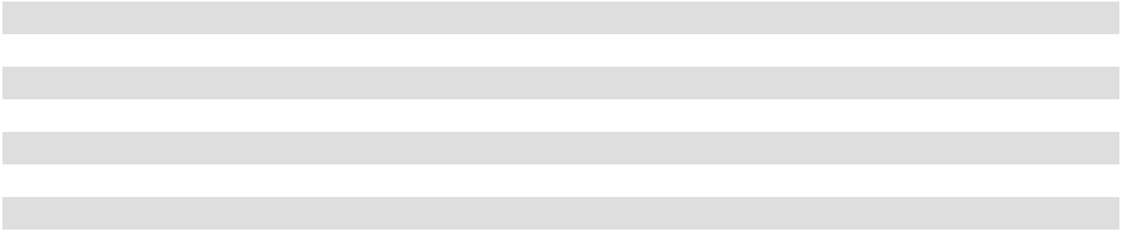

(1)

(2)

(3)

(4)

(5)

(6)

(7)

- 20 year lease entered in 2007.

- 20 year lease entered in 2015.

- 15 year lease entered in 2012.

- 20 year lease entered in 2007. Five year extension to original term entered in 2020.

- 20 year lease entered in 2012. Five year lease extension to original term entered in 2020.

- 20 year lease entered in 2016. Three year lease extension to original term entered in 2020.

- Three year lease entered in 2022.

We lease all but one of our stores. Our initial store lease terms are typically 15 to 20 years with various renewal options and lease escalation structures. We believe that all of our leases are entered into at then-prevailing market lease rates. As of February 3, 2024, our combined leased and owned store square footage was approximately 19.7 million square feet.

42

Item 3. Legal Proceedings

We are a defendant or co-defendant in lawsuits, claims and demands brought by various parties relating to matters normally incident to our business. No individual case, or group of cases against us, presenting substantially similar issues of law or fact, is expected to have a material effect on the manner in which we conduct our business or on our consolidated results of operations, financial position or liquidity. The majority of these cases are alleging product, premises, employment and/or commercial liability. Reserves have been established that we believe to be adequate based on our current evaluations and experience in these types of claim situations; however, the ultimate outcome of these cases cannot be determined at this time. We believe, taking into consideration our indemnities, defenses, insurance and reserves, the ultimate resolution of these matters will not have a material impact on our financial position, results of operations or cash flows. In addition, government agencies and self-regulatory organizations have the ability to conduct periodic examinations of and administrative proceedings regarding our business. In May and December 2023, U.S. Customs and Border Protection ("CBP") notified us that we owed additional duties relating to certain products that we imported from China that CBP believes are subject to certain anti-dumping and/or countervailing duties. We do not believe that these products are subject to such duties and are contesting CBP’s determination vigorously. While we contest CBP’s determination, we were required to deposit with CBP an amount of duties relating to these products, which are included in prepaid expenses and other current assets on the Company’s consolidated balance sheet while this matter is pending. We anticipate that this matter will be resolved without a material adverse effect on our financial position, results of operations or cash flows. However, the ultimate outcome of this matter cannot be determined at this time, and we cannot assure you that we will be successful in contesting CBP's determination or that we will not need to accrue or pay additional amounts in the future.

During 2023, the Company settled a legal matter pertaining to the overcharge of interchange feeds with certain financial institutions for prior periods dating back to 2004. In connection with this settlement, we recognized a net gain of approximately $15.9 million in Other (income), net on the Consolidated Statements of Income, when the gain became realizable.

We are not currently party to any other legal proceedings that we believe would have a material adverse effect on our financial position, results of operations or cash flows.

Item 4. Mine Safety Disclosures

Not applicable.

43

PART II

Item 5. Market for Registrant's Common Equity, Related Stockholder Matters and Issuer Purchases of Equity Securities

Market Information

Academy's common stock began trading on the Nasdaq Stock Market LLC, or Nasdaq, under the symbol "ASO" on October 2, 2020. Prior to that date, there was no public market for our common stock.

Performance Graph

This performance graph shall not be deemed “soliciting material” or “filed” with the SEC for purposes of Section 18 of the Exchange Act, or otherwise subject to the liabilities under that Section, and shall not be deemed to be incorporated by reference into any of our filings under the Securities Act or the Exchange Act. The graph below presents the Company’s cumulative total stockholder returns relative to the performance of the Nasdaq US Benchmark Retail Index and the Russell 3000 Index commencing October 2, 2020 (the Company’s initial day of trading) through February 2, 2024. All values assume a $100 initial investment at the opening price of the Company’s common stock on Nasdaq and assumes all dividends were reinvested on the date paid. The points on the graph represent fiscal quarter-end values based on the last trading day of each fiscal quarter. The comparisons are based on historical data and are not indicative of, nor intended to forecast, the future performance of our common stock.

$600.00
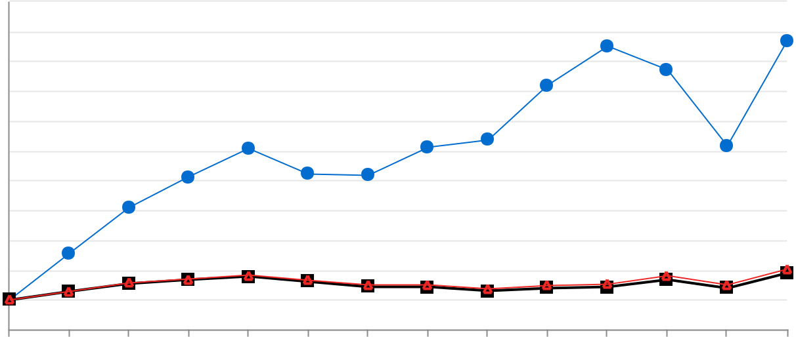

$550.00

$500.00

$450.00

$400.00

$350.00

$300.00

$250.00

$200.00

$150.00

$100.00

$50.00
10/2/20201/29/20214/30/20217/30/2021 |  |  | 1/28/20224/29/20227/29/2022 |  |  | 1/27/20234/28/20237/28/2023 |  | 2/2/2024
10/29/2021 |  |  |  |  | 10/28/2022 |  | 10/27/2023 | 2/2/2024
 |  | ASO, Inc. |  | Nasdaq US Benchmark Retail Index |  |  | Russell 3000 Index

44

Issuer Purchases of Equity Securities

The following table summarizes the repurchases and cancellations of our common stock during the fourth quarter of 2023:

 |  |  |  |  |  |  | Total Number |  | Dollar Value of
 |  |  |  |  |  |  | of Share
 |  |  |  |  |  |  | Purchased as |  |  | Shares that
 |  | Total Number |  |  |  |  | Part of Publicly |  |  | May Yet be
 |  | Total Number |  | Average Price |  |  | Announced |  |  | Purchased
Period |  | of Shares |  |  |  |  | Plans or |  | Under the Plans
Period |  | Purchased (a) |  | Paid per Share |  |  | Programs (b) |  | or Programs (b)
October 29, 2023 to November 25, 2023 |  | — | $ |  | — |  | — | $ |  | 99,411,688
November 26, 2023 to December 30, 2023 |  | — |  |  | — |  | — |  |  | 699,411,688
December 31, 2023 to February 3, 2024 |  | 43,526 |  | $ | 62.57 |  | 43,526 |  |  | 696,688,936
Total | 43,526 |  | $ |  | 62.57 | 43,526 |  | $ |  | 696,688,936
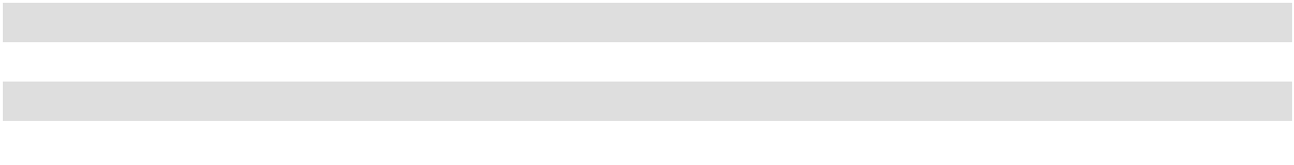
- The total number of shares purchased excludes shares which were net-settled, and therefore not issued, to cover employee withholding related to the vesting of certain restricted stock awards and exercise of certain stock option awards.

- On June 2, 2022, the Board of Directors of the Company authorized a share repurchase program (the "2022 Share Repurchase Program") under which the Company may purchase up to $600 million of its outstanding shares during the three-year period ending June 2, 2025. On November 29, 2023, the Board of Directors of the Company authorized a share repurchase program (the "2023 Share Repurchase Program") under which the Company may purchase up to $600 million of its outstanding shares during the three-year period ending November 29, 2026. The 2022 Share Repurchase Program and the 2023 Share Repurchase Program are collectively referred to as the "Share Repurchase Programs". As of February 3, 2024, approximately $696.7 million remained available for share repurchases pursuant to the Share Repurchase Programs (see Note 2 to the accompanying financial statements). The Share Repurchase Programs do not obligate the Company to acquire any particular number of common shares, and the programs may be suspended, extended, modified or discontinued at any time.

Holders

As of March 14, 2024, there were 12 holders of record of ASO, Inc.'s common stock. The number of holders of record is based upon the actual number of holders registered at such date and does not include holders of shares in "street name" or persons, partnerships, associates, corporations or other entities identified in security position listing maintained by depositories.

Dividends

On March 7, 2024, the Company issued a press release announcing that the Board of Directors declared a quarterly cash dividend with respect to the quarter ended February 3, 2024 of $0.11 per share of common stock, payable on April 18, 2024, to stockholders of record as of the close of business on March 26, 2024. The declaration, timing, amount and payment of any future cash dividends will be subject to the discretion and approval of the Board of Directors, taking into account such considerations as the Board of Directors may deem relevant at the time, including, among others, the Company’s results, financial condition and capital allocation plans.

Item 6. Reserved

45

Item 7. Management’s Discussion and Analysis of Financial Condition and Results of Operations

The following discussion and analysis of our financial condition and results of operations should be read together with our consolidated financial statements and related notes included elsewhere in this Annual Report for the fiscal year ended February 3, 2024 (this "Annual Report").

This discussion contains forward-looking statements that involve risks and uncertainties. See the section of this Annual Report entitled "Cautionary Statement Regarding Forward-Looking Statements." When reviewing the discussion below, you should keep in mind the substantial risks and uncertainties that characterize our business. Known material factors that could affect our financial performance and actual results, and could cause actual results to differ materially from those expressed or implied in any forward-looking statements included in this discussion or otherwise made by our management, are described in the "Risk Factors" section of this Annual Report.

Any reference in this Annual Report to "year" or any year in particular refers to our fiscal year, which represents the fifty-two or fifty-three week period ending on the Saturday closest to January 31. Unless otherwise specified, all comparisons or changes regarding 2023 are made to 2022.

All references in this discussion and analysis to "2023", "2022" and "2021" or like terms relate to our fiscal years as follows:

Fiscal Year |  | Ended |  | Weeks
2023 |  | February 3, 2024 | 53
2022 |  | January 28, 2023 | 52
2021 |  | January 29, 2022 | 52

Overview

We are a leading full-line sporting goods and outdoor recreation retailer in the United States. Our mission is to provide “Fun for All” and we fulfill this mission with a localized merchandising strategy and value proposition that deeply connect with a broad range of consumers. Our product assortment focuses on key categories of outdoors, apparel, sports & recreation and footwear (representing 28%, 28%, 24% and 20% of our 2023 net sales, respectively) through both leading national brands and a portfolio of private label brands, which go well beyond traditional sporting goods and apparel offerings.

Our business is subject to seasonal fluctuations. A significant portion of our net sales and profits is driven by summer holidays, such as Memorial Day, Father’s Day and Independence Day, during the second quarter. Our net sales and profits are also impacted by the November/December holiday selling season, and in part by the sales of cold weather sporting goods and apparel during the fourth quarter.

As of February 3, 2024, we operated 282 stores that range in size from approximately 40,000 to 130,000 gross square feet, with an average size of approximately 70,000 gross square feet, throughout 18 contiguous states located primarily in the southern United States. Our stores are supported by approximately 22,000 team members, three distribution centers, and our e-commerce platform, which includes our website at www.academy.com and our mobile app. Additionally, we are deepening our customer relationships, further integrating our e-commerce platform with our stores and driving operating efficiencies by developing our omnichannel capabilities, such as our mobile app, optimizing the website experience and upgrading our fulfillment capabilities.

46

The following table summarizes store activity for the periods indicated:

 |  |  | Fiscal Year Ended
 | February 3, 2024 |  | January 28, 2023 |  | January 29, 2022
Beginning stores | 268 | 259 |  | 259
Q1 new stores | 1 | 1 |  |  | —
Q2 new stores | 1 | 1 |  |  | —
Q3 new stores | 5 | 4 |  |  | —
Q4 new stores | 7 | 3 |  |  | —
Closed | — |  | — |  | —
Ending stores | 282 |  | 268 |  | 259
Relocated stores | — |  | — | 1
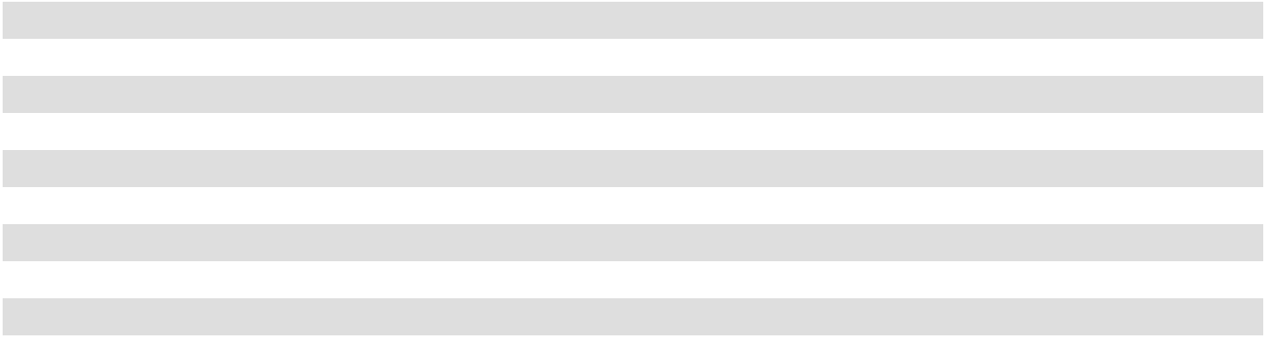

How We Assess the Performance of Our Business and Recent Trends

Our management considers a number of financial and operating metrics, including the following key metrics, to evaluate our business, measure our performance, identify trends affecting our business, determine the allocation of resources, make decisions regarding corporate strategies and evaluate projections. These metrics include operational measures and non-GAAP metrics supplemental to our GAAP results.

Comparable Sales. We define comparable sales as the percentage of period-over-period net sales increase or decrease, in the aggregate, for stores open after thirteen full fiscal months, as well as for all e-commerce sales. There may be variations in the way in which some of our competitors and other retailers calculate comparable sales. As a result, data in this Annual Report regarding our comparable sales may not be comparable to similar data made available by other retailers. Stores which have been significantly remodeled or relocated are removed from this calculation until the new store has been in operation for substantially all of the periods being compared. Stores which have been closed for an extended period of time due to circumstances beyond our control are also removed from the calculation. Any sales made through our website or mobile app are allocated to e-commerce sales for the purpose of measuring comparable sales, regardless of how those sales are fulfilled, whether shipped to home or picked up in-store or curbside through our buy-online-pickup-in-store program ("BOPIS"). For example, all BOPIS transactions, which are originated by our website, are allocated to e-commerce sales for the purpose of comparable sales, despite the fact that our customers pick-up these purchases from a specific store.

Increases or decreases in e-commerce between periods being compared directly impact the comparable sales results. Various factors affect comparable sales, including consumer preferences, buying trends and overall economic trends; our ability to identify and respond effectively to customer preferences and local and regional trends; our ability to provide an assortment of high quality/ value oriented product offerings that generate new and repeat visits to our stores and our website; the customer experience and unique services we provide in our stores; our ability to execute our omnichannel strategy, including the growth of our e-commerce business; changes in product mix and pricing, including promotional activities; the number of items purchased per visit and average order value; a shift in the timing of a holiday between comparable periods; and the number of stores that have been in operation for more than 13 months.

The comparable sales metric for 2023 (53 week fiscal year) compares the 52 weeks ended January 27, 2024, against the 52 weeks ended January 28, 2023 (52 week fiscal year). The 2023 53rd week ended February 3, 2024, is not included in comparable sales for 2023. Merchandise net sales for the 2023 53rd week ended February 3, 2024, were $73.3 million. We have seen significant comparable sales fluctuations in recent years from increases of 16.1% and 18.9% in 2020 and 2021, respectively, followed by decreases of 6.4% and 6.5% in 2022 and 2023, respectively. See the discussion on Net Sales below for some contributing factors to the recent changes.

Transactions and average ticket. We define transactions as the number of customer transactions for stores and e-commerce during a given period on a comparable sales basis. Transactions are influenced by customer traffic, the amount of customers that visited our stores or website, and sales conversion, the percent of those customers that made a purchase. We define average ticket as total comparable sales divided by the number of transactions during a given period, which tells us the average amount the customer is spending on a purchase.

47

Adjusted EBITDA, Adjusted EBIT, Adjusted Net Income, Adjusted Earnings per Share and Adjusted Free Cash Flow.

Management uses Adjusted EBITDA, Adjusted EBIT, Adjusted Net Income, Adjusted Earnings per Share and Adjusted Free Cash Flow to supplement GAAP measures of performance in the evaluation of the effectiveness of our business strategies, to make budgeting decisions, and to compare our performance against that of other peer companies using similar measures. Management also uses Adjusted EBIT as a performance target to establish and award discretionary annual incentive compensation. See "Non-GAAP Measures" below.

Components of Our Results of Operations. Our profitability is primarily influenced by fluctuations in net sales, gross margin and our ability to leverage selling, general and administrative expenses.

Net Sales. Net sales are derived from in-store and e-commerce merchandise sales, net of sales tax and an allowance for merchandise returns.

Net sales fluctuations can be driven by new store openings, comparable sales increases or decreases including e-commerce sales, our ability to adjust inventory based on sales fluctuations, our management of vendor relations and meeting customer demand, allowances and logistics, seasonality, unseasonal or extreme weather, changes in consumer shopping preferences, consumer discretionary spending, and market and sales promotions.

We must maintain sufficient inventory levels of merchandise that our customers desire to successfully operate our business. A shortage of popular merchandise could reduce our net sales. Conversely, we also must seek to avoid accumulating excess inventory to avoid markdowns and clearance, which negatively impact sales and gross margin. We have deployed several new tools over recent years to improve inventory handling and vendor management, including third-party programs to analyze our inventory stock and execute a disciplined markdown strategy throughout the year at every location. This implementation, along with other factors, has allowed us to improve our inventory management in stores over the past few years. We have coupled these tools with the data we have been able to collect from our Academy Credit Card program, our customer database and targeted customer surveys, so that we can better estimate future inventory requirements. It is imperative that we continue to find innovative ways to strengthen our inventory management if we are to remain competitive and expand our margins on a go-forward basis.

Our broad assortment gives us an advantage over mass general merchants who typically do not carry the leading national brands sold at Academy. We have also continued to add private label brand products to our assortment of products, which we generally price lower than the national brand products of comparable quality that we also offer. A shift in our sales mix in which we sell more units of our private label brand products and fewer units of the national brand products would generally have a positive impact on our gross margin but an adverse impact on our total net sales. Furthermore, our softgoods merchandise divisions, which consist of apparel and footwear, have higher margins than our hardgoods merchandise divisions, which consist of outdoors and sports and recreation. A shift in sales mix toward softgoods would generally have a positive impact on gross margin and a shift in sales mix towards hardgoods would generally have a negative impact on gross margin. In recent years, we have experienced higher sales related to the outdoors and sports and recreation merchandise divisions, as our customers turned to us for isolated recreation and outdoor and leisure activities during the pandemic. As our business has normalized, we have experienced a shift in our sales mix from the outdoors and sports and recreation merchandise divisions to the footwear and apparel merchandise divisions, which has generally had a positive impact on our gross margin rate.

The expansion and enhancement of our omnichannel capabilities has resulted in increased sales in recent years. We continue to invest in initiatives that will increase traffic to our stores and e-commerce platform, which includes our website and mobile app, and drive increased sales conversion. These initiatives include investments in our new customer data platform and the development of strategies, which focus on customer segmentation with the intention of improving customer identification and increasing customer engagement. Additionally, we recently implemented several innovative website features to enhance the customer online shopping experience, including a redesigned home page, additional BOPIS features, and enhanced shipping notifications. Our improved e-commerce platform supports our stores with digital marketing and our BOPIS and ship-to-store programs. These platforms allow us to connect further with our customers for marketing and product education and assists us in introducing customers to the Academy brand by reaching customers outside of our current store footprint. During 2023, stores facilitated approximately 95% of our total sales, including ship-from-store, BOPIS and in-store retail sales. We expect to continue to invest in expanding and enhancing our omnichannel capabilities, including our mobile app, optimizing the web site experience and upgrading our fulfillment capabilities, which will continue to require further investments by us.

48

We expect that new stores will be a key driver of growth in our net sales and gross margin in the future as we execute our new store opening growth plans. Our results of operations have been and will continue to be materially affected by the timing and number of new store openings. We are continually assessing the number of locations available that could accommodate our preferred size of stores in markets we would consider, and during 2023 we opened 14 new stores. We believe our real estate strategy has positioned us well for further expansion.

Gross Margin. Gross margin is our net sales less cost of goods sold. Our cost of goods sold includes the direct cost of merchandise and costs related to procurement, warehousing and distribution, which consist primarily of payroll and benefits, distribution center occupancy costs and freight and are generally variable in nature relative to our sales volume.

Our gross margin depends on a number of factors, such as net sales increases or decreases, our promotional activities, product mix including private label brand merchandise sales, and our ability to control cost of goods sold, such as inventory and logistics cost management. Our gross margin is also impacted by variables including commodity costs, freight costs, shrinkage (discussed below) and inventory processing costs and e-commerce shipping costs. We track and measure gross margin as a percentage of net sales in order to evaluate our performance against profitability targets.

During 2021, we began to see increased competition across the industry for resources throughout a constrained supply chain, which resulted in disruptions to the flow of products from our vendors, labor shortages, reduced shipping container availability, and longer delays at the port. As a result, we experienced a period of decreased or delayed supply and high inflation which negatively impacted transportation and inventory costs. Over the past year, we have seen improvement to these constraints, resulting in decreased freight costs.

We refer to loss or theft of inventory as "shrinkage" or "shrink". Over recent years, the United States retail industry, including Academy, has experienced a significant increase in inventory shrink, which has resulted in a negative impact to our gross margins. A prolonged period of significant increased shrink could have a material negative impact on our gross margin and results of operations.

Selling, General and Administrative Expenses. Selling, general and administrative ("SG&A") expenses include store and corporate administrative payroll and payroll benefits, store and corporate headquarters occupancy costs, advertising, credit card processing, information technology, pre-opening costs and other store and administrative expenses. These expenses are both variable and fixed in nature. SG&A expenses as a percentage of sales increased from 21.4% in 2022 to 23.3% in 2023. The majority of the increase in SG&A from the prior year was driven by investments in our growth initiatives, including costs related to new stores (such as additional property and facility fees, employee compensation costs and advertising costs). We track and measure operating expenses as a percentage of net sales in order to evaluate our performance against profitability targets. Management of SG&A expenses depends on our ability to balance a control of operating costs, such as store and corporate headcount, information technology infrastructure and marketing and advertising expenses, while efficiently and effectively servicing our customers.

Pre-opening expenses represent non-capital expenditures associated with the opening of new stores and distribution centers prior to sales generation or start of operations, which consist primarily of occupancy costs, marketing, payroll and recruiting costs, and are expensed as incurred. As we execute our new store opening growth plans, we expect our pre-opening expenses to increase and result in a negative impact to SG&A as a percentage of sales. The following table summarizes our pre-opening expense activity for the periods presented:

 |  |  |  |  | Fiscal Year Ended
 |  | February 3, 2024 |  |  | January 28, 2023 |  |  | January 29, 2022
Number of new stores opened |  | 14 |  |  | 9 |  |  | —
Pre-opening expenses (in millions) | $ | 8.3 | $ |  | 5.5 | $ |  | 0.2

Interest Expense. Interest expense includes regular interest payable related to our Term Loan, Notes and ABL Facility (see Note 4 to the accompanying financial statements) and the amortization of our deferred loan costs and original issuance discounts associated with the acquisition of the debt. In May of 2021, we entered into an amendment to our Term Loan which reduced the applicable margin on our LIBOR rate by 1.25%, and paid down $99 million. In December of 2022, we utilized cash on hand to voluntarily prepay $100 million of outstanding borrowings on our Term Loan. However, this prepayment in principal on our Term Loan was largely offset by increases made by the Federal Reserve to the federal funds benchmark rate during 2022 and 2023, resulting in a small decrease in interest expense in 2023 compared to 2022. In February of 2024, we made an additional prepayment of $100 million on our Term Loan, which we anticipate will result in decreased interest expense in fiscal 2024.

49

Income Tax Expense. ASO, Inc. is treated as a U.S. corporation for U.S. federal, state, and local income tax purposes and accordingly, a provision for income taxes has been recorded for the anticipated tax consequences of our reported results of operations for federal, state and local income taxes. Recent fluctuations in income tax expense have been primarily as a result of changes in income before income taxes.

Results of Operations

A discussion regarding Results of Operations and Analysis of Financial Condition for the fiscal year ended January 28, 2023, as compared to the fiscal year ended January 29, 2022, is included in “Part II – Item 7. Management’s Discussion and Analysis of Financial Condition and Results of Operations” to our Annual Report on Form 10-K for the fiscal year ended January 28, 2023.

2023 (53 weeks) Compared to 2022 (52 weeks)

The following table sets forth amounts and information derived from our consolidated statements of income for the periods indicated as follows (dollar amounts in thousands):

 |  |  |  | Fiscal Year Ended |  |  |  |  |  |  |  | Change
 |  | February 3, 2024 |  |  |  |  | January 28, 2023 |  |  |  |  | Dollars | Percent
Net sales | $ | 6,159,291 | 100.0 % |  | $ |  | 6,395,073 | 100.0 % |  | $ |  | (235,782) | (3.7)%
Cost of goods sold |  | 4,049,080 |  | 65.7 % |  |  | 4,182,571 |  | 65.4 % |  |  | (133,491) | (3.2)%
Gross margin |  | 2,110,211 |  | 34.3 % |  |  | 2,212,502 | 34.6 % |  |  |  | (102,291) | (4.6)%
Selling, general and administrative |  | 1,432,356 |  | 23.3 % |  |  | 1,365,953 |  | 21.4 % |  |  | 66,403 | 4.9 %
expenses |  | 1,432,356 |  | 23.3 % |  |  | 1,365,953 |  | 21.4 % |  |  | 66,403 | 4.9 %
Operating income |  | 677,855 |  | 11.0 % |  |  | 846,549 | 13.2 % |  |  |  | (168,694) | (19.9)%
Interest expense, net |  | 46,051 | 0.7 % |  |  |  | 46,441 | 0.7 % |  |  |  | (390) | (0.8)%
Loss on early retirement of debt |  | 1,525 | 0.0 % |  |  |  | 1,963 | 0.0 % |  |  |  | (438) | (22.3)%
Other (income), net |  | (32,877) |  | (0.5)% |  |  | (20,175) |  | (0.3)% |  |  | (12,702) | 63.0 %
Income before income taxes |  | 663,156 |  | 10.8 % |  |  | 818,320 | 12.8 % |  |  |  | (155,164) | (19.0)%
Income tax expense |  | 143,966 |  | 2.3 % |  |  | 190,319 |  | 3.0 % |  |  | (46,353) | (24.4)%
Net income | $ | 519,190 |  | 8.4 % | $ |  | 628,001 | 9.8 % |  | $ |  | (108,811) | (17.3)%
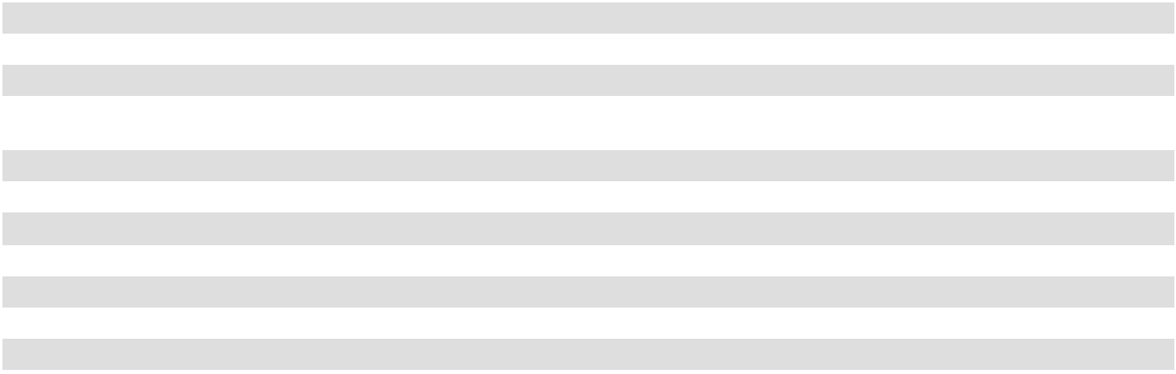
* Percentages in table may not sum properly due to rounding.

Net Sales. Net sales decreased $235.8 million, or 3.7%, in 2023 over the prior year as a result of decreased comparable sales of 6.5%, which were partially offset by additional net sales generated by new locations. As of the end of 2023, we operated 14 additional stores as compared to the end of 2022, and the full benefit of nine stores opened during 2022. Collectively, these stores accounted for a $113.5 million increase in net sales for 2023, which does not include e-commerce sales fulfilled from these locations. Additionally, merchandise net sales from the 53rd week, which is not included in comparable sales for 2023, increased net sales by $73.3 million in 2023.

The decrease of 6.5% in comparable sales was driven by lower sales across all merchandise divisions as a result of fewer transactions of 7.0%, partially offset by an increase in average ticket of 0.5%. The outdoors merchandise division sales declines were primarily as a result of the hunting category, driven by decreases in firearms and ammunition sales over the prior year. The apparel division sales decreased due to lower sales in athletic and outdoor apparel. The footwear merchandise division sales decreased due to lower sales in the athletic footwear and work footwear categories, partially offset by increased sales in the casual and seasonal footwear categories. The sports and recreation merchandise division decrease was a result of decreased sales in fitness equipment and bikes.

E-commerce sales represented 10.7% of merchandise sales for 2023 and 2022.

50

Gross Margin. Gross margin for 2023 decreased $102.3 million, or 4.6%, when compared to 2022. Our gross margin, as a percentage of net sales, was 34.3% in 2023 compared to 34.6% in 2022, a decrease of 30 basis points. This decrease is primarily due to:

- 57 basis points of unfavorability in merchandise margin as a result of increased planned promotional activity compared to the prior year;

- 41 basis points of unfavorability as a result of increased inventory shrink;

- 21 basis points of unfavorability in inventory overhead expenditures as a result of higher absorption rates from slower inventory turnover; partially offset by

- 73 basis points of favorability in import and domestic freight due to lower freight costs per unit.

Selling, General and Administrative Expenses. SG&A expenses increased $66.4 million, or 4.9%, to $1,432.4 million in 2023 from $1,366.0 million in 2022. As a percentage of net sales, SG&A expenses increased 1.9% to 23.3% in 2023 compared to 21.4% in 2022. The increase of 190 basis points is partially attributable to deleverage from decreased sales. SG&A costs also increased $66.4 million primarily as a result of:

- Property and facility fees increase of $34.7 million primarily due to investments in long-term growth initiatives, which includes the addition of 14 new stores since the end of the prior year and increased technology expense;

- Employee compensation costs increased $22.7 million primarily due to increased wages expense over the prior year, partially attributable to the addition of new stores; and

- Advertising spend increase of $9.4 million.

Loss on early retirement of debt. We utilized cash on hand to voluntarily prepay $100 million of outstanding borrowings under the Term Loan in February of 2024. In December of 2022, we also voluntarily prepaid $100 million of outstanding borrowings under the Term Loan. These prepayments resulted in losses on early retirement of debt of $1.5 million and $2.0 million for 2023 and 2022, respectively.

Interest Expense. Interest expense decreased $0.4 million, or 0.8%, to $46.1 million in 2023 from $46.4 million in 2022 resulting primarily from higher capitalized interest due to increased construction of new stores and a lower outstanding balance on our long-term debt, driven by a voluntary prepayment of $100.0 million made in December 2022, partially offset by an increase in interest rates on our Term Loan.

Other (Income), net. Other income increased $12.7 million in 2023, primarily driven by the recognition of a $15.9 million gain pertaining to the settlement of a credit card company litigation matter, which occurred in the fourth quarter of 2023, and higher interest rates on money market investments in the current year, both of which were partially offset by the receipt of $7.2 million in business interruption insurance proceeds relative to a winter storm in 2022 and $3.7 million in proceeds relative to a sale in which we factored rights to pursue a legal matter pertaining to the overpayment of certain tariffs.

Income Tax Expense. Income tax expense decreased $46.4 million to $144.0 million in 2023 as compared to $190.3 million in 2022, resulting primarily from a decrease in pre-tax income. ASO, Inc.'s effective tax rate for 2023 was 21.7% compared to 23.3% in 2022. The decrease in effective tax rate was largely driven by the inclusion of certain research and development tax credits relative to 2022 and 2023 in the current year results, as well as increased permanent adjustments resulting from the vesting of a higher number of stock compensation awards during 2023.

51

Non-GAAP Measures

Adjusted EBITDA, Adjusted EBIT, Adjusted Net Income, Adjusted Earnings per Share and Adjusted Free Cash Flow, as shown below, have been presented in this Annual Report as supplemental measures of financial performance that are not required by, or presented in accordance with, accounting principles generally accepted in the United States of America ("GAAP"). We define Adjusted EBITDA as net income (loss) before interest expense, net, income tax expense and depreciation, amortization and impairment and other adjustments included in the table below. We define Adjusted EBIT as Adjusted EBITDA less depreciation and amortization. We describe these adjustments reconciling net income (loss) to Adjusted EBITDA and to Adjusted EBIT in the applicable table below. We define Adjusted Net Income as net income (loss), plus other adjustments included in the table below, less the tax effect of these adjustments. We define basic Adjusted Earnings per Share as Adjusted Net Income divided by the basic weighted average common shares outstanding during the period and diluted Adjusted Earnings per Share as Adjusted Net Income divided by the diluted weighted average common shares outstanding during the period. We describe these adjustments by reconciling net income (loss) to Adjusted Net Income and Adjusted Earnings per Share in the applicable table below. We describe Adjusted Free Cash Flow as net cash provided by (used in) operating activities less net cash used in investing activities. We describe this adjustment by reconciling net cash provided by operating activities to Adjusted Free Cash Flow in the applicable table below.

We believe Adjusted EBITDA, Adjusted EBIT, Adjusted Net Income and Adjusted Earnings per Share assist investors and analysts in comparing our operating performance across reporting periods on a consistent basis by excluding items that we do not believe are indicative of our core operating performance. Management believes Adjusted EBITDA, Adjusted EBIT, Adjusted Net Income and Adjusted Earnings per Share are useful to investors in highlighting trends in our operating performance, while other measures can differ significantly depending on long-term strategic decisions regarding capital structure, the tax jurisdictions in which we operate and capital investments. Management believes Adjusted Free Cash Flow is a useful measure of liquidity and an additional basis for assessing our ability to generate cash. Management uses Adjusted EBITDA, Adjusted EBIT, Adjusted Net Income, Adjusted Earnings per Share and Adjusted Free Cash Flow to supplement GAAP measures of performance in the evaluation of the effectiveness of our business strategies, to make budgeting decisions and to compare our performance against that of other peer companies using similar measures. Management has also historically used Adjusted EBIT as a performance target to establish and award discretionary annual incentive compensation.

Management supplements GAAP results with non-GAAP financial measures to provide a more complete understanding of the factors and trends affecting the business than GAAP results alone. Adjusted EBITDA, Adjusted EBIT, Adjusted Net Income, Adjusted Earnings per Share and Adjusted Free Cash Flow are not recognized terms under GAAP and should not be considered as an alternative to net income (loss) as a measure of financial performance or net cash provided by operating activities as a measure of liquidity, or any other performance measures derived in accordance with GAAP. Additionally, these measures are not intended to be a measure of free cash flow available for management’s discretionary use as they do not consider certain cash requirements such as interest payments, tax payments and debt service requirements. Adjusted EBITDA, Adjusted EBIT, Adjusted Net Income and Adjusted Earnings per Share should not be construed to imply that our future results will be unaffected by unusual or non-recurring items. In evaluating Adjusted EBITDA, Adjusted EBIT, Adjusted Net Income, Adjusted Earnings per Share and Adjusted Free Cash Flow, you should be aware that in the future we may incur expenses that are the same as or similar to some of the adjustments in this presentation. Our presentation of Adjusted EBITDA, Adjusted EBIT, Adjusted Net Income, Adjusted Earnings per Share and Adjusted Free Cash Flow should not be construed to imply that our future results will be unaffected by any such adjustments.

52

Our Adjusted EBITDA, Adjusted EBIT, Adjusted Net Income, Adjusted Earnings per Share and Adjusted Free Cash Flow measures have limitations as analytical tools, and you should not consider them in isolation, or as a substitute for analysis of our results as reported under GAAP. Some of these limitations are:

- Adjusted EBITDA, Adjusted EBIT, Adjusted Net Income and Adjusted Earnings per Share do not reflect costs or cash outlays for capital expenditures or contractual commitments;

- Adjusted EBITDA, Adjusted EBIT, Adjusted Net Income and Adjusted Earnings per Share do not reflect changes in, or cash requirements for, our working capital needs;

- Adjusted EBITDA and Adjusted EBIT do not reflect the interest expense, or the cash requirements necessary to service interest or principal payments, on our debt, and Adjusted Free Cash Flow does not reflect the cash requirements necessary to service principal payments on our debt;

- Adjusted EBITDA and Adjusted EBIT do not reflect period to period changes in taxes, income tax expense or the cash necessary to pay income taxes;

- Adjusted EBITDA, Adjusted EBIT, Adjusted Net Income and Adjusted Earnings per Share do not reflect the impact of earnings or charges resulting from matters we consider not to be indicative of our ongoing operations;

- although depreciation and amortization are non-cash charges, the assets being depreciated and amortized will often have to be replaced in the future, and Adjusted EBITDA and Adjusted Free Cash Flow do not reflect cash requirements for such replacements; and

- other companies in our industry may calculate these measures differently than we do, limiting their usefulness as comparative measures.

Because of these limitations, Adjusted EBITDA, Adjusted EBIT, Adjusted Net Income, Adjusted Earnings per Share and Adjusted Free Cash Flow should not be considered as measures of discretionary cash available to invest in business growth or to reduce indebtedness. Management compensates for these limitations by primarily relying on our GAAP results in addition to using Adjusted EBITDA, Adjusted EBIT, Adjusted Net Income, Adjusted Earnings per Share and Adjusted Free Cash Flow supplementally.

53

Adjusted EBITDA and Adjusted EBIT

The following table provides reconciliations of net income to Adjusted EBITDA and to Adjusted EBIT for the periods presented (amounts in thousands):

 |  |  |  | Fiscal Year Ended
 | February 3, 2024 |  |  | January 28, 2023 |  |  | January 29, 2022
Net income (a) | $ | 519,190 | $ |  | 628,001 | $ |  | 671,381
Interest expense, net |  | 46,051 |  |  | 46,441 |  |  | 48,989
Income tax expense |  | 143,966 |  |  | 190,319 |  |  | 188,159
Depreciation and amortization |  | 110,936 |  |  | 106,762 |  |  | 105,274
Equity compensation (b) |  | 24,377 |  |  | 21,175 |  |  | 39,264
Loss on early retirement of debt |  | 1,525 |  |  | 1,963 |  |  | 2,239
Payroll taxes associated with the 2021 Vesting Event (c) |  | — |  |  | — |  |  | 15,418
Other (d) |  | — |  |  | — |  |  | 3,118
Adjusted EBITDA | $ | 846,045 | $ |  | 994,661 | $ |  | 1,073,842
Less: Depreciation and amortization |  | (110,936) |  |  | (106,762) |  |  | (105,274)
Adjusted EBIT | $ | 735,109 | $ |  | 887,899 | $ |  | 968,568
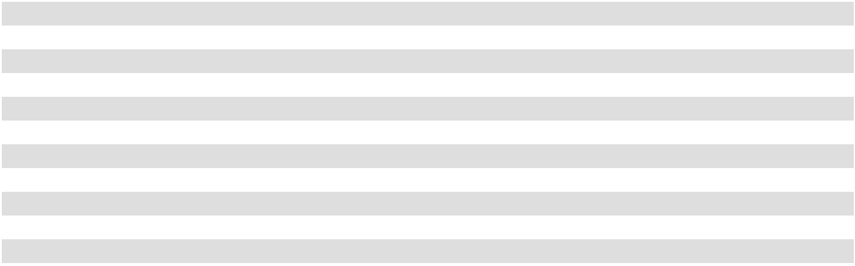

- Net income for the year ended February 3, 2024, includes a $15.9 million net gain relative to a credit card fee litigation settlement which occurred in the fourth quarter of 2023. Net income for the year ended January 28, 2023, included a $7.2 million gain from a business interruption insurance recovery and a $3.7 million gain from the sale of a tariff relief litigation claim, both of which occurred in the fourth quarter of 2022. All of these items are included in their respective years within Other (income), net on the Consolidated Statements of Income and are disclosed within Note 2 of the accompanying financial statements.

- Represents non-cash charges related to equity based compensation, which vary from period to period depending on certain factors such as the 2021 Vesting Event (see Note 1 to the accompanying financial statements), timing and valuation of awards, achievement of performance targets and equity award forfeitures.

- Represents cash expenses related to taxes on equity-based compensation resulting from the 2021 Vesting Event.

- Other adjustments include (representing deductions or additions to Adjusted EBITDA and Adjusted EBIT) amounts that management believes are not representative of our operating performance, including installation costs for energy savings associated with our profitability initiatives.

54

Adjusted Net Income and Adjusted Earnings per Share

The following table provides a reconciliation of net income to Adjusted Net Income and Adjusted Earnings per Share for the periods presented (amounts in thousands, except per share data):

 |  |  |  | Fiscal Year Ended
 |  | February 3, 2024 |  |  | January 28, 2023 |  |  | January 29, 2022
Net income (a) | $ | 519,190 | $ |  | 628,001 | $ |  | 671,381
Equity compensation (b) |  | 24,377 |  |  | 21,175 |  |  | 39,264
Loss on early retirement of debt |  | 1,525 |  |  | 1,963 |  |  | 2,239
Payroll taxes associated with the 2021 Vesting Event (c) |  | — |  |  | — |  |  | 15,418
Other (d) |  | — |  |  | — |  |  | 3,118
Tax effects of these adjustments (e) |  | (5,621) |  |  | (5,382) |  |  | (14,884)
Adjusted Net Income | $ | 539,471 | $ |  | 645,757 | $ |  | 716,536
Earnings per common share:
Basic | $ | 6.89 | $ |  | 7.70 | $ |  | 7.38
Diluted | $ | 6.70 | $ |  | 7.49 | $ |  | 7.12
Adjusted Earnings per Share:
Basic | $ | 7.16 | $ |  | 7.91 | $ |  | 7.88
Diluted | $ | 6.96 | $ |  | 7.70 | $ |  | 7.60
Weighted average common shares outstanding:
Basic |  | 75,389 |  |  | 81,590 |  |  | 90,956
Diluted |  | 77,469 |  |  | 83,895 |  |  | 94,284
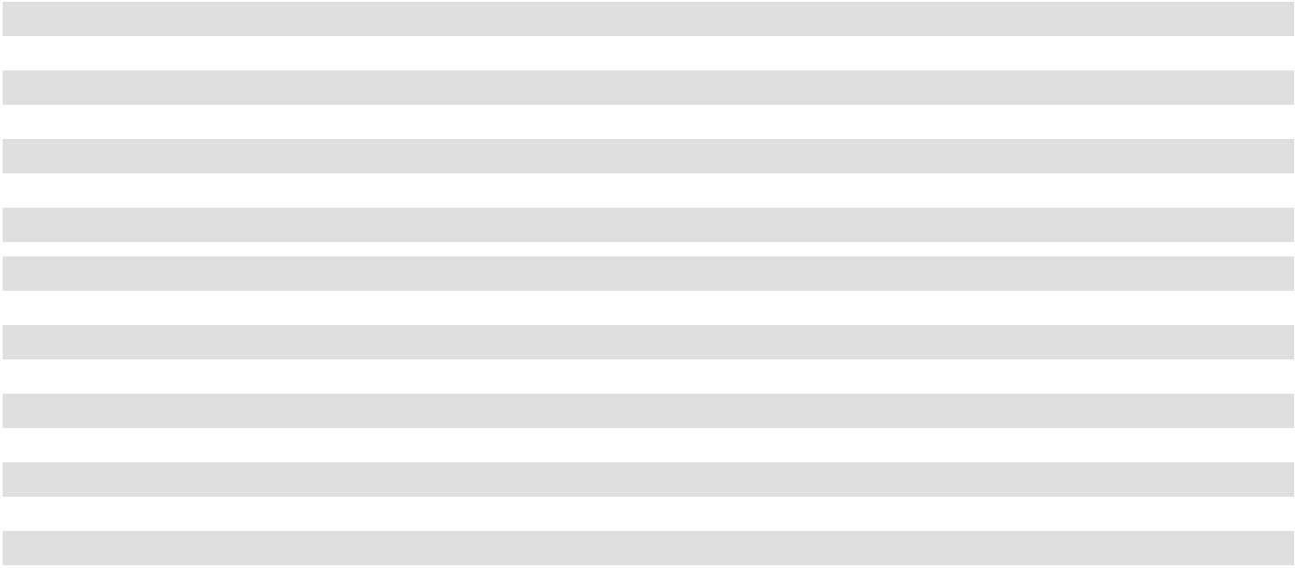

- Net income for the year ended February 3, 2024, includes a $15.9 million net gain relative to a credit card fee litigation settlement which occurred in the fourth quarter of 2023. Net income for the year ended January 28, 2023, included a $7.2 million gain from a business interruption insurance recovery and a $3.7 million gain from the sale of a tariff relief litigation claim, both of which occurred in the fourth quarter of 2022. All of these items are included in their respective years within Other (income), net on the Consolidated Statements of Income and are disclosed within Note 2 of the accompanying financial statements.

- Represents non-cash charges related to equity based compensation, which vary from period to period depending on certain factors such as the 2021 Vesting Event, timing and valuation of awards, achievement of performance targets and equity award forfeitures.

- Represents cash expenses related to taxes on equity-based compensation resulting from the 2021 Vesting Event.

- Other adjustments include (representing deductions or additions to Adjusted Net Income) amounts that management believes are not representative of our operating performance, including installation costs for energy savings associated with our profitability initiatives.

- Represents the tax effect of the total adjustments made to arrive at Adjusted Net Income at our historical tax rate.

Adjusted Free Cash Flow

The following table provides a reconciliation of net cash provided by operating activities to Adjusted Free Cash Flow for the periods presented (amounts in thousands):

 |  |  |  | Fiscal Year Ended
 | February 3, 2024 |  |  | January 28, 2023 |  |  | January 29, 2022
Net cash provided by operating activities | $ | 535,779 | $ |  | 552,005 | $ |  | 673,265
Net cash used in investing activities |  | (206,139) |  |  | (108,806) |  |  | (76,017)
Adjusted Free Cash Flow | $ | 329,640 | $ |  | 443,199 | $ |  | 597,248

55

Liquidity and Capital Resources

Sources and Uses of Liquidity

Our principal liquidity requirements are for working capital, capital expenditures and cash used to pay our debt obligations and related interest expense. We also use cash to pay dividends and occasionally use cash to repurchase common stock. We may fund our liquidity requirements through cash and cash equivalents, cash generated from operating activities, issuances of debt (such as the Notes) and borrowings under our ABL Facility. On February 3, 2024, our cash and cash equivalents totaled $347.9 million. We believe our cash and cash equivalents, as well as our availability under the ABL Facility, will be sufficient to fund our cash requirements for at least the next 12 months.

Long-Term Debt

As of February 3, 2024, the Company's long-term debt and interest rates consists of:

- Notes - 6.00% fixed rate senior secured notes with $400 million in principal outstanding and full principal maturing November 15, 2027;

- Term Loan - 9.19% variable rate term-loan with $91.8 million in principal outstanding maturing November 6, 2027 and quarterly principal payments of $750 thousand; and

- ABL Facility - $1.0 billion commitment on a variable rate secured asset-based revolving credit facility with no principal outstanding maturing November 6, 2025.

See Note 4 to the accompanying financial statements for further disclosure regarding our debt agreements. The following table summarizes our current debt obligations by fiscal year (amounts in thousands):

 | 2024 |  | 2025 |  | 2026 |  | 2027 |  | Total
Term Loan and related interest ⁽¹⁾ | $ 10,835 | $ | 9,595 | $ | 9,159 | $ | 87,725 | $ | 117,314
Notes and related interest ⁽²⁾ | 24,000 |  | 24,000 |  | 24,000 |  | 424,000 |  | 496,000
ABL Facility and related interest ⁽³⁾ | 2,500 |  | 1,909 |  | — |  | — |  | 4,409

- Interest payments do not include amortization of discount and debt issuance costs and are approximated based on projected interest rates and assume no unscheduled principal payments.
- Interest payments do not include amortization of debt issuance costs and assumes Notes are paid in full at maturity date.

- Assumes a minimum revolving credit commitment of $1.0 billion and no balances drawn on our ABL Facility.

Liquidity information related to the ABL Facility is as follows for the periods shown (dollar amounts in thousands):
 |  |  |  |  | Fiscal Year Ended
 | February 3, 2024 |  |  |  | January 28, 2023 |  |  | January 29, 2022
Average funds drawn | $ | — | $ |  |  | — | $ |  | —
Number of days with outstanding balance |  | — |  |  |  | — |  |  | —
Maximum daily amount outstanding | $ | — | $ |  |  | — | $ |  | —
Minimum available borrowing capacity | $ | 881,445 | $ |  |  | 935,550 | $ |  | 780,945
Liquidity information related to the ABL Facility (amounts in thousands) as of:
 |  |  |  |  | February 3, 2024 |  |  | January 28, 2023
Outstanding borrowings |  |  | $ |  |  | — | $ |  | —
Outstanding letters of credit |  |  | $ |  |  | 11,553 | $ |  | 13,878
Available borrowing capacity |  |  | $ |  |  | 881,445 | $ |  | 947,764
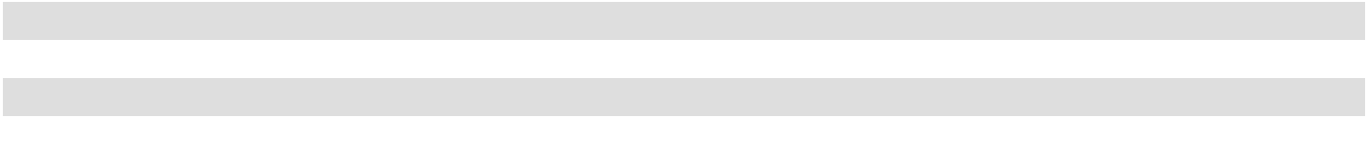

On March 8, 2024, the Company issued a press release announcing that the Company entered into an amendment which among other things, extended the maturity of Academy’s asset-based revolving credit facility to March 8, 2029. See Note 17 to the accompanying financial statements.

56

Leases

We predominantly lease store locations, distribution centers, office space and certain equipment under operating leases expiring between fiscal years 2024 and 2044. Operating lease obligations include future minimum lease payments under all of our non-cancelable operating leases at February 3, 2024. In the fiscal year ended February 3, 2024, we opened 14 new locations. The following table summarizes our operating lease obligations by fiscal year:

 | 2024 |  | 2025 |  | 2026 |  | 2027 |  | 2028 | After 2028 | Total
Operating lease payments ⁽¹⁾ ⁽²⁾ | $ 206,111 | $ | 224,177 | $ | 215,877 | $ | 201,825 | $ | 183,797 | $ 924,267 | $ 1,956,054

- Minimum lease payments have not been reduced by sublease rentals of $2.3 million due in the future under non-cancelable subleases.

- These balances include stores where we have an executed contract but have not taken possession of the location as of February 3, 2024.

Share Repurchases

On June 2, 2022, the Board of Directors of the Company authorized a share repurchase program (the "2022 Share Repurchase Program") under which the Company may purchase up to $600 million of its outstanding shares during the three-year period ending June 2, 2025. On November 29, 2023, the Board of Directors authorized a new share repurchase program (the "2023 Share Repurchase Program") under which the Company may purchase up to $600 million of its outstanding shares during the three-year period ending November 29, 2026. The 2022 Share Repurchase Program and the 2023 Share Repurchase Program are collectively referred to as the "Share Repurchase Programs". The Share Repurchase Programs do not obligate the Company to acquire any particular number of common shares, and the programs may be suspended, extended, modified or discontinued at any time. As of February 3, 2024, the Company had $696.7 million remaining for share repurchases under the Share Repurchase Programs.

The following table summarizes our share repurchases for the fiscal year ended February 3, 2024 (dollar amounts in thousands, except per share amounts):

 | Total Number of |  |  | Average Price |  |  | Total Amount
 | Shares Purchased |  | Paid per Share ⁽¹⁾ |  |  |  | Repurchased ⁽¹⁾
First Quarter (January 29, 2023 to April 29, 2023) | 750,010 | $ |  | 66.69 | $ |  | 50,015
Second Quarter (April 30, 2023 to July 29, 2023) | 1,994,064 |  |  | 53.37 |  |  | 106,432
Third Quarter (July 30, 2023 to October 28, 2023) | 863,631 |  |  | 50.51 |  |  | 43,625
Fourth Quarter (October 29, 2023 to February 3, 2024) ⁽²⁾ | 43,526 |  |  | 62.57 |  |  | 2,724
Total Shares Repurchased | 3,651,231 | $ |  | 55.54 | $ |  | 202,796
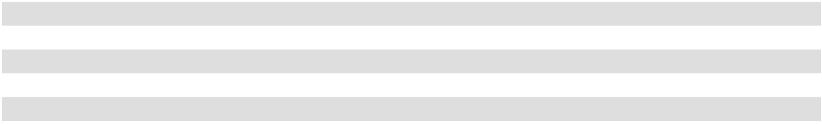

- Excludes the impact of excise taxes.

- See Part II, Item 5 - Market for Registrant's Common Equity, Related Stockholder Matters and Issuer Purchases of Equity Securities for further detail on the 2023 fourth quarter share repurchases.

Dividends

The following table summarizes our quarterly dividend payments for the fiscal year ended February 3, 2024 (amounts in thousands, except per share amounts):

 |  | Dividends Paid |  |  | Total Dividends |  | Stockholder Date
 |  | per Share |  |  | Paid |  | of Record
First Quarter (January 29, 2023 to April 29, 2023) | $ | 0.09 | $ |  | 6,929 |  | March 23, 2023
Second Quarter (April 30, 2023 to July 29, 2023) | $ | 0.09 |  |  | 6,896 |  | June 15, 2023
Third Quarter (July 30, 2023 to October 28, 2023) | $ | 0.09 |  |  | 6,718 |  | September 13, 2023
Fourth Quarter (October 29, 2023 to February 3, 2024) | $ | 0.09 |  |  | 6,675 |  | December 13, 2023
Total Dividends Paid |  |  | $ |  | 27,218

57

On March 7, 2024, the Company issued a press release announcing that the Board of Directors declared a quarterly cash dividend with respect to the quarter ended February 3, 2024 of $0.11 per share of common stock, payable on April 18, 2024, to stockholders of record as of the close of business on March 26, 2024.

Capital Expenditures
The following table summarizes our capital expenditures for the periods shown (amounts in thousands):
 |  |  |  | Fiscal Year Ended
 | February 3, 2024 |  |  | January 28, 2023 |  |  | January 29, 2022
New stores and relocations | $ | 100,419 | $ |  | 42,735 | $ |  | 1,955
Corporate, e-commerce, information technology programs and |  | 81,992 |  |  | 50,019 |  |  | 44,967
other |  | 81,992 |  |  | 50,019 |  |  | 44,967
Updates for existing stores and distribution centers |  | 25,359 |  |  | 15,550 |  |  | 28,880
Total capital expenditures | $ | 207,770 | $ |  | 108,304 | $ |  | 75,802
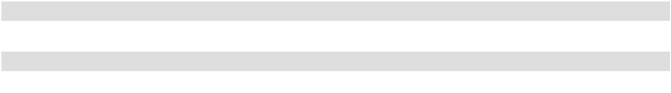

We expect capital expenditures for fiscal year 2024 to be between $225 million and $275 million. The following table

summarizes our forecasted allocation of capital expenditures for fiscal year 2024:
 | 2024
New stores | 55 %
Corporate, e-commerce, information technology programs and other | 25 %
Updates for existing stores and distribution centers | 20 %

We review forecasted capital expenditures throughout the year and will adjust our capital expenditures based on business conditions at that time.

Cash Flows

Our consolidated statements of cash flows are summarized as follows (in thousands):

 |  |  |  | Fiscal Year Ended
 | February 3, 2024 |  |  | January 28, 2023 |  |  | January 29, 2022
Net cash provided by operating activities | $ | 535,779 | $ |  | 552,005 | $ |  | 673,265
Net cash used in investing activities |  | (206,139) |  |  | (108,806) |  |  | (76,017)
Net cash used in financing activities |  | (318,865) |  |  | (592,052) |  |  | (488,854)
Net increase (decrease) in cash and cash equivalents | $ | 10,775 | $ |  | (148,853) | $ |  | 108,394
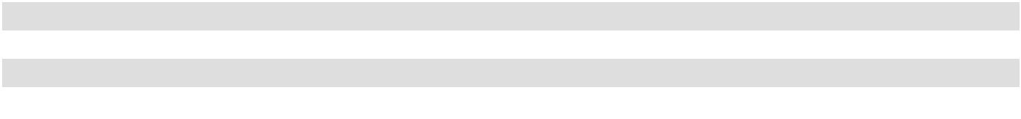

Operating Activities. Cash flows from operating activities are seasonal in our business. Typically, cash flows from operations are used to build inventory in advance of peak selling seasons, with the fourth quarter pre-holiday inventory increase being the most significant.

Cash provided by operating activities in 2023 decreased $16.2 million compared to 2022. This decrease is attributable to:

- $108.8 million decrease in net income;

- $23.1 million net decrease in non-cash charges;

- $115.7 million net increase in cash flows provided by operating assets and liabilities.

58

The increase in cash flows from operating assets and liabilities was primarily attributable to:

- $201.1 million increase in cash flows from merchandise inventories, net related to a reduction in inventory replenishment to align with 2023 sales patterns when compared to the prior year; partially offset by a

- $86.9 million decrease in cash flows from accounts payable, primarily driven by a reduction in inventory replenishment and lower import and domestic freight costs relative to the prior year fourth quarter.

Investing Activities. Cash used in investing activities increased $97.3 million in 2023 compared to 2022. The increase in cash used in investing activities is primarily related to:

- $99.5 million higher capital expenditures, primarily driven by increased investments in new stores in 2023.

Financing Activities. Cash used in financing activities decreased $273.2 million in 2023, compared to 2022. The primary driver of the decrease was a:

- $286.7 million decrease in cash outflows caused by a reduction in repurchases and retirement of common stock in the current year.

Future Liquidity

We expect our existing cash balances, internally generated cash flows and available borrowings under our ABL Facility will fulfill anticipated obligations such as capital expenditures, dividends, stock repurchases, working capital needs and scheduled debt maturities over at least the next twelve months. As of February 3, 2024, we had $881.4 million of available capacity under our ABL Facility and $347.9 million of cash and cash equivalents.

Critical Accounting Policies and Estimates

This discussion and analysis of financial condition and results of operations is based upon the Company's consolidated financial statements, which have been prepared in accordance with U.S. generally accepted accounting principles (U.S. GAAP). The preparation of these financial statements requires the Company to make estimates, judgments, and assumptions that can have a meaningful effect on the reporting of consolidated financial statements. See Note 2 to the accompanying financial statements for additional information.

Critical accounting estimates are defined as those reflective of significant judgments, estimates and uncertainties, which may result in materially different results under different assumptions and conditions. The Company believes the following are its critical accounting estimates:

Merchandise Inventories, net

Description: Merchandise inventories are stated at the lower of weighted average cost and net realizable value. Merchandise inventories include the direct cost of merchandise and capitalized costs related to procurement, warehousing and distribution and are reflected net of shrinkage, vendor allowances and other valuation reserves.

Judgments and Uncertainties: We record an inventory reserve for the estimated shrinkage between physical inventories on a by location basis. We generally perform a full physical inventory count for each store at least once a year, throughout the year, after which our shrinkage accrual rate to sales for each store is updated based on historical results. For vendor allowances based on contractual provisions, we develop accrual rates for receivables as determined by the agreements, which are typically linked to purchase volumes. Other non-contractual vendor allowances received are applied upon receipt. We regularly review inventories and record a valuation adjustment when necessary such as for inventory that has a carrying value in excess of the net realizable value or for slow moving or obsolete inventory.

59

Impact of Assumptions: For inventory shrinkage, our reserves may be inaccurate if our historical physical inventory shrinkage rates, used in our assumptions, differ significantly from actual rates due to consistent misses to our accrual. However, due to the frequency with which we perform full physical inventory counts, our assumptions are regularly updated, and we constantly analyze the physical inventory results to our accruals and, where necessary, adjust our store accruals to compensate for consistent patterns identified. We have not had a history of significant differences to our reserves for vendor allowances, and the assumptions generally do not have a significant impact on reserves since they are typically short-term and contractual in nature. We book a reserve for inventory permanently marked down below the inventory’s historical cost. Additionally, for slow moving or obsolete inventory, we book reserves based on historical margins received for marked down inventory with similarly slow historical sell-through rates. A twenty percent decrease in assumed margins would not have a material impact to our financial statements. We believe our long history of operations has given us sufficient data to enable us to accurately predict these reserves.

Impairment of long-lived assets

Description: We review the carrying value of long-lived assets, including property and equipment at our stores, for indicators of impairment regularly and whenever events and circumstances indicate that the carrying value of an asset may not be recoverable.

Judgments and Uncertainties: We test stores operating over a long enough time span, based on our previous store history for similar locations, to allow for meaningful analysis of future operating results. Recoverability of long-lived assets is measured by a comparison of the carrying amount of the assets to the estimated undiscounted future cash flows expected to be generated by the use of the assets, which is generally projected based on historical results. If such assets are considered to be impaired, the impairment loss recognized is the amount by which the carrying amount of the assets exceeds its estimated fair value, which is calculated using discounted expected future cash flows.

Impact of Assumptions: The assumptions used to project store impairment loss is based on projected future store income and considers variables such as historical and current trends, macroeconomic conditions, store location and local economy and supply chain factors. Additionally, the long-term store income projections also contain a projection of future store specific costs such as store wages and advertising. Actual long-term income results could vary significantly from our projections due to a variety of reasons such as changes in the local retail environment or macroeconomic factors not used in our assumptions. In addition to variables considered in developing projected long-term store income, assumptions are made to develop the assumed discount rate based on company specific factors. There is significant judgment used in determining these assumptions used in the assessment of store impairment and variability in the assumptions could cause us to reach a materially different conclusion on impairment, however, we do not believe the net book value of any individual store assets are material to the Company’s operations.

Goodwill

Description: Goodwill represents the excess of the purchase price of an acquired business over the amounts assigned to assets acquired and liabilities assumed in a business combination. Goodwill is tested for impairment annually or more frequently if events or circumstances indicate that the carrying value of goodwill may not be recoverable. We test for goodwill at the reporting unit level, which is the operating segment level. We operate in one operating segment with one reporting unit.

Judgments and Uncertainties: The annual goodwill impairment test provides for the option of first performing a qualitative assessment to evaluate the existence of events and circumstances that would lead to a determination that it is more likely than not that the fair value of a reporting unit is less than its carrying amount. If such a conclusion is reached, we would then be required to perform a quantitative impairment assessment of goodwill. However, if the qualitative assessment leads to a determination that it is more likely than not that the fair value of a reporting unit is greater than its carrying amount, then no further assessments are required.

Our quantitative assessment for determining the fair value of our reporting unit includes using an estimated discounted cash flow model (income approach) and market value approach. The output of this assessment is an estimated fair value for our reporting unit that is compared to its carrying value to determine whether an impairment charge is necessary. The income approach uses a discounted cash flow analysis of our projected long-term future company income, and the market value approach is based on earnings multiples for a comparable set of public companies. These approaches use key input assumptions such as our projected future operating results, the discount rate, the weighting for each valuation approach and the comparable set of companies.

60

Impact of Assumptions: The assumptions used to project long-term company income consider variables such as historical and current trends, macroeconomic conditions, supply chain factors, projections consistent with the Company’s operating strategy, such as the future development of e-commerce and our assumptions used on future store openings, and other variables expected to impact future sales. Additionally, the long-term company income projections also contain a projection of future company costs such as wages, freight and transportation, and advertising. Actual long-term company income results could vary significantly from our projections due to a variety of reasons such as changes in the retail environment or macroeconomic factors not used in our assumptions. In addition to variables considered in developing projected long-term company income, assumptions are made to develop the discount rate, which is based on an assumed risk-free rate, and an equity risk premium developed from general historical market data and comparable companies. The earnings multiples used in the market approach can vary dependent on which companies are selected in our comparable set. A history of declining trends in our operating results such as comparable sales, gross margin, net income and cash flow from operations could impact these assumptions and serve as indicators of future impairment. There is significant judgment used in determining these assumptions used in the assessment of goodwill impairment and variability in the assumptions could cause us to reach a different conclusion on impairment. In 2023, we performed a qualitative impairment assessment and determined a quantitative assessment was not necessary.

Intangible Assets

Description: Intangible assets primarily consists of the trade name "Academy Sports + Outdoors" (the "Trade Name"). The Trade Name is expected to generate cash flows indefinitely and, therefore, is accounted for as an indefinite-lived asset not subject to amortization. The Trade Name is tested for impairment annually or whenever events or circumstances indicate that the carrying amount of the Trade Name may not be recoverable.

Judgments and Uncertainties: The annual Trade Name impairment test provides for the option of first performing a qualitative assessment to evaluate the existence of events and circumstances that would lead to a determination that it is more likely than not that the fair value of an intangible asset is less than its carrying amount. If such a conclusion is reached, we would then be required to perform a quantitative impairment assessment for the Trade Name. However, if the qualitative assessment leads to a determination that it is more likely than not that the fair value of an intangible asset is greater than its carrying amount, then no further assessments are required.

Impairment is calculated as the excess of the Trade Name’s carrying value over its fair value. The fair value of the Trade Name is determined using the relief-from-royalty method, a variation of the income approach. This method assumes that, in lieu of ownership, a third party would be willing to pay a royalty in order to exploit the related benefits of these types of assets. Once a supportable royalty rate is determined, the rate is then applied to the projected long-term sales over the expected remaining life of the intangible assets to estimate the royalty savings. This approach is dependent on a number of factors, including projections of long-term sales, royalty rates, discount rates and other variables.

Impact of Assumptions: The assumptions used to project long-term company sales consider variables such as historical and current trends, macroeconomic conditions, supply chain factors, projections consistent with the Company’s operating strategy, such as the future development of e-commerce and our assumptions used on future store openings, and other variables expected to impact future sales. Actual long-term income results could vary significantly from our projections due to a variety of reasons such as changes in the retail environment or macroeconomic factors not used in our assumptions. In addition to variables considered in developing projected long-term sales, assumptions are made to develop the royalty rates and discount rates. The royalty rates are based on market data where royalty rates are applicable and the discount rates are based on an assumed risk-free rate, and an equity risk premium based on general historical market data and comparable companies. A history of declining trends in our operating results such as comparable sales, gross margin, net income and cash flow from operations could impact these assumptions and serve as indicators of future impairment. There is significant judgment used in determining these assumptions on intangible asset impairment and variability in the assumptions could cause us to reach a different conclusion on impairment. In 2023, we performed a qualitative impairment assessment and determined a quantitative assessment was not necessary.

Recent Accounting Pronouncements

For discussion of recent accounting pronouncements, see Note 2 to the accompanying financial statements.

61

Item 7A. Quantitative and Qualitative Disclosures About Market Risk

Interest Rate Risk

Our exposure to changes in interest rates primarily results from our Term Loan and ABL Facility, as these borrowings have variable interest rates. When appropriate, we also enter into fixed interest rate debt, such as the Notes, to limit the floating interest rate exposure on our long term debt or historically we have used derivative financial instruments to mitigate the risk from such exposure. A discussion of our accounting policies for derivative financial instruments is included in Note 5. “Derivative Financial Instruments” and Note 6. “Fair Value Measurements” to our accompanying financial statements included in Part IV. Item 15 of this Annual Report. As of February 3, 2024, we do not have any derivative financial instruments outstanding. The detrimental effect of a hypothetical 100 basis point increase in interest rates on current borrowings under the Term Loan and ABL Facility would increase our interest expense by approximately $0.9 million.

Interim Results and Seasonality

Our business is subject to seasonal fluctuations. A significant portion of our net sales and profits is driven by summer holidays, such as Memorial Day, Father’s Day and Independence Day, during the second quarter. Our net sales and profits are also impacted by the November/December holiday selling season, and in part by the sales of cold weather sporting goods and apparel during the fourth quarter.

Item 8. Financial Statements and Supplementary Data

The financial statements required to be filed hereunder are set forth on pages 69 through 106 of this Annual Report on Form 10-K.

Item 9. Changes in and Disagreements With Accountants on Accounting and Financial Disclosure

None.

62

Item 9A. Controls and Procedures

Evaluation of Disclosure Controls and Procedures

We maintain disclosure controls and procedures (as that term is defined in Rules 13a-15(e) and 15d-15(e) of the Securities Exchange Act of 1934, as amended (the "Exchange Act")) that are designed to ensure that information required to be disclosed in our reports under the Exchange Act, is recorded, processed, summarized and reported within the time periods specified in the SEC’s rules and forms, and that such information is accumulated and communicated to our management, including our Chief Executive Officer ("CEO") and our Chief Financial Officer ("CFO"), as appropriate, to allow timely decisions regarding required disclosures. Any controls and procedures, no matter how well designed and operated, can provide only reasonable assurance of achieving the desired control objectives.

Our management, with the participation of our CEO and our CFO, evaluated the effectiveness of the design and operation of our disclosure controls and procedures as of the end of the period covered by this Annual Report. Based on such evaluation, our CEO and CFO have concluded that, as of the end of the period covered by this Annual Report, the design and operation of the Company's disclosure controls and procedures were effective to accomplish their objectives at the reasonable assurance level.

Management's Annual Report on Internal Control over Financial Reporting

The Company’s management is responsible for establishing and maintaining adequate internal control over financial reporting (as defined in Rules 13a-15(f) and 15d-15(f) under the Exchange Act). Internal control over financial reporting is a process to provide reasonable assurance regarding the reliability of our financial reporting for external purposes in accordance with accounting principles generally accepted in the United States of America. The Company's internal control over financial reporting includes:

- maintaining records that in reasonable detail accurately and fairly reflect our transactions;

- providing reasonable assurance that transactions are recorded as necessary for preparation of our financial statements;

- providing reasonable assurance that receipts and expenditures of Company assets are made in accordance with management authorization; and

- providing reasonable assurance that unauthorized acquisition, use or disposition of Company assets that could have a material effect on our financial statements would be prevented or detected on a timely basis.

Because of its inherent limitations, internal control over financial reporting may not prevent or detect misstatements. Therefore, even those systems determined to be effective can provide only reasonable assurance of achieving their control objectives. Also projections of any evaluation of effectiveness to future periods are subject to risk that controls may become inadequate because of change in conditions, or that the degree of compliance with the policies or procedures may deteriorate.

The Company’s management conducted an evaluation of the effectiveness of our internal control over financial reporting based on the framework and criteria established in Internal Control—Integrated Framework (2013), issued by the Committee of Sponsoring Organizations of the Treadway Commission. This evaluation included review of the documentation of controls, evaluation of the design effectiveness of controls, testing of the operating effectiveness of controls and a conclusion on this evaluation. Based on this evaluation, management concluded that the Company’s internal control over financial reporting was effective as of the end of the period covered by this Annual Report.

Deloitte & Touche LLP, an independent registered public accounting firm, has issued an attestation report on the Company’s internal control over financial reporting which is set forth herein.

Changes in Internal Control over Financial Reporting

We rely extensively on information systems to manage our business and report operating results. During the 2023 second quarter, we completed the implementation of our new Enterprise Resource Planning ("ERP") system, which resulted in considerable changes to our processes and control environment, including modifications to existing applications and reports. The new ERP replaced our legacy system, in which our business transactions are processed and recorded. The new ERP is intended to facilitate transactional processing and enhance management tools and is expected to improve internal controls over financial reporting.

Other than as described above, no changes in our internal control over financial reporting (as defined in Rules 13a-15(f) and 15d-15(f) under the Exchange Act) occurred during the Company's most recently completed fiscal quarter that have materially affected, or are reasonably likely to materially affect, our internal control over financial reporting.

63

REPORT OF INDEPENDENT REGISTERED PUBLIC ACCOUNTING FIRM

To the stockholders and the Board of Directors of Academy Sports and Outdoors, Inc.

Opinion on Internal Control over Financial Reporting

We have audited the internal control over financial reporting of Academy Sports and Outdoors, Inc. and subsidiaries (the “Company”) as of February 3, 2024, based on criteria established in Internal Control — Integrated Framework (2013) issued by the Committee of Sponsoring Organizations of the Treadway Commission (COSO). In our opinion, the Company maintained, in all material respects, effective internal control over financial reporting as of February 3, 2024, based on criteria established in Internal Control — Integrated Framework (2013) issued by COSO.

We have also audited, in accordance with the standards of the Public Company Accounting Oversight Board (United States) (PCAOB), the consolidated financial statements as of and for the year ended February 3, 2024, of the Company and our report dated March 21, 2024, expressed an unqualified opinion on those financial statements.

Basis for Opinion

The Company’s management is responsible for maintaining effective internal control over financial reporting and for its assessment of the effectiveness of internal control over financial reporting, included in the accompanying Management's Annual Report on Internal Control over Financial Reporting. Our responsibility is to express an opinion on the Company’s internal control over financial reporting based on our audit. We are a public accounting firm registered with the PCAOB and are required to be independent with respect to the Company in accordance with the U.S. federal securities laws and the applicable rules and regulations of the Securities and Exchange Commission and the PCAOB.

We conducted our audit in accordance with the standards of the PCAOB. Those standards require that we plan and perform the audit to obtain reasonable assurance about whether effective internal control over financial reporting was maintained in all material respects. Our audit included obtaining an understanding of internal control over financial reporting, assessing the risk that a material weakness exists, testing and evaluating the design and operating effectiveness of internal control based on the assessed risk, and performing such other procedures as we considered necessary in the circumstances. We believe that our audit provides a reasonable basis for our opinion.

Definition and Limitations of Internal Control over Financial Reporting

A company’s internal control over financial reporting is a process designed to provide reasonable assurance regarding the reliability of financial reporting and the preparation of financial statements for external purposes in accordance with generally accepted accounting principles. A company’s internal control over financial reporting includes those policies and procedures that (1) pertain to the maintenance of records that, in reasonable detail, accurately and fairly reflect the transactions and dispositions of the assets of the company; (2) provide reasonable assurance that transactions are recorded as necessary to permit preparation of financial statements in accordance with generally accepted accounting principles, and that receipts and expenditures of the company are being made only in accordance with authorizations of management and directors of the company; and (3) provide reasonable assurance regarding prevention or timely detection of unauthorized acquisition, use, or disposition of the company’s assets that could have a material effect on the financial statements.

Because of its inherent limitations, internal control over financial reporting may not prevent or detect misstatements. Also, projections of any evaluation of effectiveness to future periods are subject to the risk that controls may become inadequate because of changes in conditions, or that the degree of compliance with the policies or procedures may deteriorate.

/s/ Deloitte & Touche LLP

Houston, Texas

March 21, 2024

64

Item 9B. Other Information

(a) Board of Directors Update

Appointment of Monique Picou to Board of Directors

On March 18, 2024, the Board of the Company approved an increase of the size of the Board of Directors from nine to ten directors and appointed Monique Picou, age 57, as an independent Class II director, effective immediately, to fill the vacancy created by such increase. Mrs. Picou’s initial term will expire on the date of the Company’s 2025 Annual Meeting of Stockholders and until her successor shall be elected and qualified or until her earlier death, resignation, retirement, disqualification or removal.

Mrs. Picou serves as Global Executive - Vice President, Google Cloud Supply Chain and Operations at Alphabet, Inc. since March 2023, and also served as Vice President, Google Product, Technology Strategy and Global Server Operations at Alphabet, Inc. from February 2021 to April 2023. Prior to Alphabet, Inc., Mrs. Picou served as Senior Vice President, Sam’s Club Chief Strategy and Supply Chain Officer from March 2020 to February 2021, as Sam’s Club Senior Vice President Supply Chain Flow from February 2019 to February 2020, and Vice President, Supply Chain at Walmart, Inc. from August 2018 to January 2019. Mrs. Picou held other senior leadership positions at Voyant Beauty, LLC and Procter & Gamble Company, where she spent more than 25 years and served in various positions, including Senior Vice President – Product Supply Global Health Care from December 2016 to August 2017. Since November 2021, Mrs. Picou has served on the board of directors of Ryan Companies US, Inc., a commercial real estate services company. She is a graduate of Southern University with a Bachelor of Science in Electrical Engineering and earned a Master of Business Administration from Florida Institute of Technology.

The Board of Directors selected Mrs. Picou because of her supply chain, logistics, strategic planning, operations, digital/ technology, and engineering experience at technology, retail and manufacturing companies.

The Board of Directors has determined that Mrs. Picou qualifies as an independent director under the corporate governance standards of Nasdaq, and that there are no arrangement or understanding between Mrs. Picou and any other person pursuant to which she was elected as a director. There are no transactions in which Mrs. Picou has an interest requiring disclosure under Item 404(a) of Regulation S-K.

As compensation for her service on the Board, Mrs. Picou will receive the cash and equity compensation provided by the Company’s Non-Employee Director Compensation Policy, as it may be adjusted by the Board of Directors from time to time, a copy of which is filed as Exhibit 10.66 to this Annual Report on Form 10-K.

In addition, the Company and Mrs. Picou will enter into the Company’s standard form of indemnification agreement for directors.

Transition of Ken C. Hicks to Chairman of the Board of Directors

In connection with a planned transition process, on March 19, 2024, the Company and Ken C. Hicks, Executive Chairman of the Board of Directors of the Company, mutually agreed that Mr. Hicks’s Amended and Restated Employment Agreement, dated April 26, 2023 would not be extended beyond its initial one-year term and that Mr. Hicks will transition from Executive Chairman of the Board to non-employee Chairman of the Board of Directors, effective on June 1, 2024.

As compensation for his service as non-employee Chairman of the Board of Directors, Mr. Hicks will receive annual cash retainers totaling $175,000 and equity compensation in the form of restricted stock units with an annualized grant value totaling $285,000, each as provided by the Company’s Non-Employee Director Compensation Policy, a copy of which is filed as Exhibit 10.66 to this Annual Report on Form 10-K.

65

(b) Trading Plans

During the quarter ended February 3, 2024, the following trading plan(s) intended to satisfy the affirmative defense conditions of

Rule 10b5-1(c) that are required to be disclosed under Item 408 of Regulation S-K was/were adopted or terminated:

Name |  | Title |  | Date Plan |  | Duration of Plan |  | Common Shares to be
Name |  | Title |  | Adopted/Terminated |  | Duration of Plan |  | Purchased or Sold
Jeff C. Tweedy |  | Director |  | Adopted January 19, 2024 |  | April 19, 2024 |  | Sell up to 2,400 common
 |  |  |  |  |  | through December |  | shares, subject to certain
 |  |  |  |  | 31, 2024 |  |  | conditions set forth in the
 |  |  |  |  |  |  |  | trading plan.
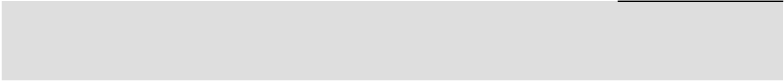

Comments

Mr. Tweedy's previously disclosed trading plan was completed pursuant to the terms set forth in that trading plan.

66

Item 9C. Disclosure Regarding Foreign Jurisdictions that Prevent Inspections

None.

PART III

Item 10. Directors, Executive Officers and Corporate Governance

The information concerning our executive officers is set forth under the heading “Information about our Executive Officers” in Part I of this report. Further information required by this item will be included in our definitive proxy statement for the 2024 Annual Meeting of Stockholders and is incorporated herein by reference.

Item 11. Executive Compensation

The information required by this item will be included in our definitive proxy statement for the 2024 Annual Meeting of Stockholders and is incorporated herein by reference.

67

Item 12. Security Ownership of Certain Beneficial Owners and Management and Related Stockholder Matters

The following table gives information about the Company's common stock that may be issued upon the exercise of options, warrants and rights under all of the Company's equity compensation plans as of February 3, 2024. The table includes the 2011 Unit Incentive Plan, the 2020 Omnibus Incentive Plan and the 2020 Employee Stock Purchase Plan.
 | (a) |  | (b) | (c)
 | Number of securities | Weighted average |  | Number of securities remaining
 | to be issued upon |  | exercise price of | available for future issuance
 | exercise of |  | outstanding | under equity compensation
Plan Category | outstanding options, | options, warrants |  | plans (excluding securities
Plan Category | warrants and rights |  | and rights | reflected in column (a))
Service-Based Stock Options | 2,615,798 | $ | 27.99 | (1)
Performance-Based Stock Options | 122,562 |  | 16.55 | (1)
Service-Based Restricted Stock Units | 564,863 |  | N/A | (1)
Performance-Based Restricted Stock Units | 311,822 |  | N/A | (1)
2020 Employee Stock Purchase Plan | — |  | N/A | (1)
Total | 3,615,045 | $ | 27.48 | (2)
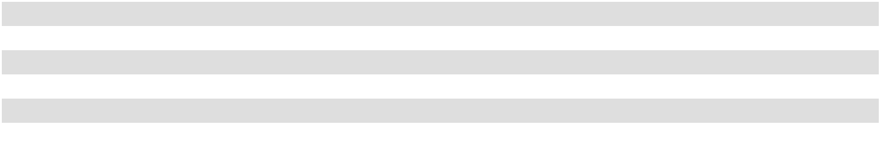

- Of the plans listed above, only 2020 Omnibus Incentive Plan and the 2020 Employee Stock Purchase Plan allows for future grants of securities. The maximum number of shares that may be granted under the 2020 Omnibus Incentive Plan (inclusive of unissued shares that were carried over from the 2011 Unit Incentive Plan) is approximately 5,738,738. Stock options and restricted stock units are counted on a one-for-one basis. Total shares available for future issuance under the 2020 Omnibus Incentive Plan is 4,534,051. The total shares available for issuance under the 2020 Employee Stock Purchase Plan is 1,593,760.

- Weighted average exercise price of outstanding options only.

Additional information required by this item will be included in our definitive proxy statement for the 2024 Annual Meeting of Stockholders and is incorporated herein by reference.

Item 13. Certain Relationships and Related Transactions, and Director Independence

The information required by this item will be included in our definitive proxy statement for the 2024 Annual Meeting of Stockholders and is incorporated herein by reference.

Item 14. Principal Accountant Fees and Services

The information required by this item will be included in our definitive proxy statement for the 2024 Annual Meeting of Stockholders and is incorporated herein by reference.

68

PART IV

Item 15. Exhibits and Financial Statement Schedules

- The following documents are filed as part of this Annual Report on Form 10-K:

  - Financial Statements. The consolidated Financial Statements required to be filed hereunder are listed in the Index to Consolidated Financial Statements on page 70 of this Annual Report on Form 10-K.

  - Financial Statement Schedule. The consolidated financial statement schedule to be filed hereunder is included on page 113 of this Annual Report on Form 10-K. Other schedules have not been included because they are not applicable or because the information is included elsewhere in this report.

  - Exhibits. The Exhibits listed in the Index to Exhibits, which appears on pages 107 to 111 and is incorporated herein by reference, are filed as part of this Annual Report on Form 10-K. Certain Exhibits are incorporated by reference from documents previously filed by the Company with the SEC pursuant to Rule 12b-32 under the Securities Exchange Act of 1934, as amended.

69

INDEX TO CONSOLIDATED FINANCIAL STATEMENTS
 | Page
Report of Independent Registered Public Accounting Firm (PCAOB ID No. 34) | 71
Consolidated Balance Sheets as of February 3, 2024 and January 28, 2023 | 73
Consolidated Statements of Income for the fiscal years ended February 3, 2024, January 28, 2023 and January 29,
2022 | 74
Consolidated Statements of Comprehensive Income for the fiscal years ended February 3, 2024, January 28, 2023
and January 29, 2022 | 75
Consolidated Statements of Stockholders' Equity for the fiscal years ended February 3, 2024, January 28, 2023
and January 29, 2022 | 76
Consolidated Statements of Cash Flows for the fiscal years ended February 3, 2024, January 28, 2023 and January
29, 2022 | 77
Notes to the Consolidated Financial Statements | 78
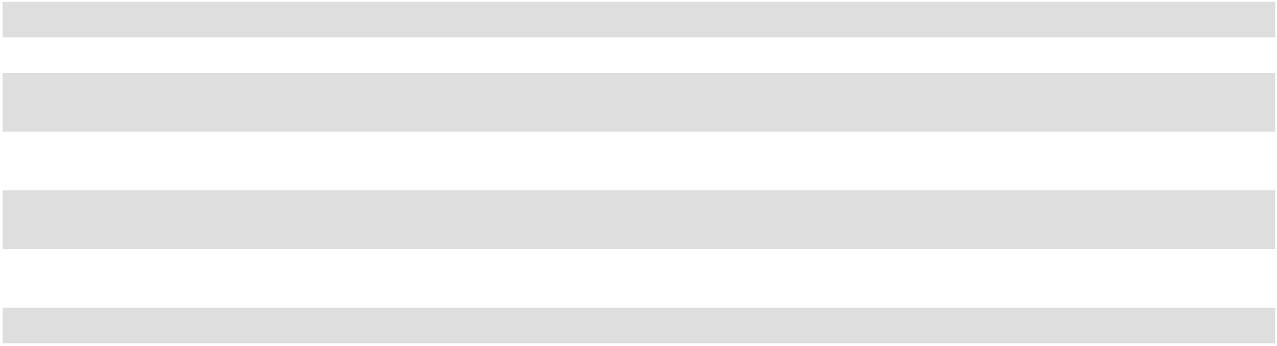

70

REPORT OF INDEPENDENT REGISTERED PUBLIC ACCOUNTING FIRM

To the stockholders and the Board of Directors of Academy Sports and Outdoors, Inc.

Opinion on the Financial Statements

We have audited the accompanying consolidated balance sheets of Academy Sports and Outdoors, Inc. and subsidiaries (the "Company") as of February 3, 2024 and January 28, 2023, the related consolidated statements of income, comprehensive income, stockholders' equity, and cash flows, for each of the three years in the period ended February 3, 2024, and the related notes and schedule listed in the Index at Item 15 (collectively referred to as the "financial statements"). In our opinion, the financial statements present fairly, in all material respects, the financial position of the Company as of February 3, 2024 and January 28, 2023, and the results of its operations and its cash flows for each of the three years in the period ended February 3, 2024, in conformity with accounting principles generally accepted in the United States of America.

We have also audited, in accordance with the standards of the Public Company Accounting Oversight Board (United States) (PCAOB), the Company's internal control over financial reporting as of February 3, 2024, based on criteria established in Internal Control — Integrated Framework (2013) issued by the Committee of Sponsoring Organizations of the Treadway Commission and our report dated March 21, 2024 expressed an unqualified opinion on the Company's internal control over financial reporting.

Basis for Opinion

These financial statements are the responsibility of the Company's management. Our responsibility is to express an opinion on the Company's financial statements based on our audits. We are a public accounting firm registered with the Public Company Accounting Oversight Board (United States) (PCAOB) and are required to be independent with respect to the Company in accordance with the U.S. federal securities laws and the applicable rules and regulations of the Securities and Exchange Commission and the PCAOB.

We conducted our audits in accordance with the standards of the PCAOB. Those standards require that we plan and perform the audit to obtain reasonable assurance about whether the financial statements are free of material misstatement, whether due to error or fraud. Our audits included performing procedures to assess the risks of material misstatement of the financial statements, whether due to error or fraud, and performing procedures that respond to those risks. Such procedures included examining, on a test basis, evidence regarding the amounts and disclosures in the financial statements. Our audits also included evaluating the accounting principles used and significant estimates made by management, as well as evaluating the overall presentation of the financial statements. We believe that our audits provide a reasonable basis for our opinion.

Critical Audit Matter

The critical audit matter communicated below is a matter arising from the current-period audit of the financial statements that was communicated or required to be communicated to the audit committee and that (1) relates to accounts or disclosures that are material to the financial statements and (2) involved especially challenging, subjective, or complex judgments. The communication of critical audit matters does not alter in any way our opinion on the financial statements, taken as a whole, and we are not, by communicating the critical audit matter below, providing a separate opinion on the critical audit matter or on the accounts or disclosures to which it relates.

71

Critical Audit Matter Description

As described in Note 14 of the Consolidated Financial Statements, as of February 3, 2024, the Company is involved in a regulatory matter with the U.S. Customs and Border Protection Agency (“CBP”) regarding additional duties relating to certain products that the Company imported from China which CBP believes are subject to certain anti-dumping and/or countervailing duties, as well as a legal matter regarding payment card interchange fees charged by financial institutions (the defendants) to the Company (the plaintiff). The Company records a liability for legal proceedings and regulatory matters when management determines it is probable that a loss has been incurred and the amount of the loss can be reasonably estimated. The Company also discloses when it is reasonably possible that a material loss may be incurred. In assessing the probability of occurrence and whether an estimate of loss can be reasonably estimated for a particular legal proceeding, management exercises judgment on matters relevant to each proceeding, such as whether sufficient participation in settlement proceedings will occur, or whether it can predict the number of claims that may be filed. Similarly, the Company will record a contingency that might result in a gain when it is the plaintiff, when the gain is realized or realizable. Auditing management's accounting for, and disclosure of, contingencies was complex and highly judgmental as it involved our assessment of the significant judgments made by management when assessing the probability of occurrence for loss contingencies, determining whether an estimate of the amount of contingencies could be made, and assessing whether a gain contingency was realized or realizable.

How the Critical Audit Matter Was Addressed in the Audit

Our audit procedures related to the management’s judgment included the following, among others:

- We obtained an understanding, evaluated the design and tested the operating effectiveness of controls over management’s identification, monitoring and evaluation of contingencies.

- We read documents provided to the Company by outside legal counsel, read letters received directly by us from internal and outside legal counsel, and evaluated the current status of contingencies based on discussions with internal and outside legal counsel.

- We inspected minutes of the meetings of the Board of Directors and committees of the Board of Directors to search for any contradictory evidence, which may indicate that the accounting and disclosures for contingencies might not be appropriate.

- We made inquiries of management, including the Company’s internal legal counsel, regarding the status of these contingencies and whether any settlement discussions had been held.

- We evaluated management's assumptions and calculations by, among other things, comparing those assumptions to underlying legal documents and to payments made during the year. We also assessed the adequacy of the related disclosures.

- We tested the amounts of the gain contingency realizable as of year end, including consideration of any contrary evidence for events subsequent to year end.

- With the assistance of professionals in our firm having experience in accounting for contingencies, we evaluated the reasonableness of the judgements and accounting guidance utilized by the Company to record the gain contingency that was realizable as of year end.

/s/ Deloitte & Touche LLP

Houston, Texas
March 21, 2024

We have served as the Company's auditor since 1996.

72

ACADEMY SPORTS AND OUTDOORS, INC.

CONSOLIDATED BALANCE SHEETS

(Dollar amounts in thousands, except per share data)

 | February 3, 2024 |  |  | January 28, 2023
ASSETS
CURRENT ASSETS:
Cash and cash equivalents | $ | 347,920 | $ |  | 337,145
Accounts receivable - less allowance for doubtful accounts of $2,217 and $2,004, |  | 19,371 |  |  | 16,503
respectively |  | 19,371 |  |  | 16,503
Merchandise inventories, net |  | 1,194,159 |  |  | 1,283,517
Prepaid expenses and other current assets |  | 83,450 |  |  | 47,747
Assets held for sale |  | — |  |  | 1,763
Total current assets |  | 1,644,900 |  |  | 1,686,675
PROPERTY AND EQUIPMENT, NET |  | 445,209 |  |  | 351,424
RIGHT-OF-USE ASSETS |  | 1,111,237 |  |  | 1,100,085
TRADE NAME |  | 578,236 |  |  | 577,716
GOODWILL |  | 861,920 |  |  | 861,920
OTHER NONCURRENT ASSETS |  | 35,211 |  |  | 17,619
Total assets | $ | 4,676,713 | $ |  | 4,595,439
LIABILITIES AND STOCKHOLDERS' EQUITY
CURRENT LIABILITIES:
Accounts payable | $ | 541,077 | $ |  | 686,472
Accrued expenses and other current liabilities |  | 217,932 |  |  | 240,169
Current lease liabilities |  | 117,849 |  |  | 109,075
Current maturities of long-term debt |  | 3,000 |  |  | 3,000
Total current liabilities |  | 879,858 |  |  | 1,038,716
LONG-TERM DEBT, NET |  | 484,551 |  |  | 584,456
LONG-TERM LEASE LIABILITIES |  | 1,091,294 |  |  | 1,072,192
DEFERRED TAX LIABILITIES, NET |  | 254,796 |  |  | 259,043
OTHER LONG-TERM LIABILITIES |  | 11,564 |  |  | 12,726
Total liabilities |  | 2,722,063 |  |  | 2,967,133
COMMITMENTS AND CONTINGENCIES (NOTE 14)
STOCKHOLDERS' EQUITY:
Preferred stock, $0.01 par value, authorized 50,000,000 shares; none issued and |  | — |  |  | —
outstanding |  | — |  |  | —
Common stock, $0.01 par value, authorized 300,000,000 shares; 74,349,927 and
76,711,720 issued and outstanding as of February 3, 2024 and January 28, 2023, |  | 743 |  |  | 767
respectively |  | 743 |  |  | 767
Additional paid-in capital |  | 242,098 |  |  | 216,209
Retained earnings |  | 1,711,809 |  |  | 1,411,330
Stockholders' equity |  | 1,954,650 |  |  | 1,628,306
Total liabilities and stockholders' equity | $ | 4,676,713 | $ |  | 4,595,439


See Notes to Consolidated Financial Statements

73

ACADEMY SPORTS AND OUTDOORS, INC.

CONSOLIDATED STATEMENTS OF INCOME

(Amounts in thousands, except per share data)

 |  |  |  | Fiscal Year Ended
 | February 3, 2024 |  |  | January 28, 2023 |  |  | January 29, 2022
NET SALES | $ | 6,159,291 | $ |  | 6,395,073 | $ |  | 6,773,128
COST OF GOODS SOLD |  | 4,049,080 |  |  | 4,182,571 |  |  | 4,422,033
GROSS MARGIN |  | 2,110,211 |  |  | 2,212,502 |  |  | 2,351,095
SELLING, GENERAL AND ADMINISTRATIVE EXPENSES |  | 1,432,356 |  |  | 1,365,953 |  |  | 1,443,148
OPERATING INCOME |  | 677,855 |  |  | 846,549 |  |  | 907,947
INTEREST EXPENSE, NET |  | 46,051 |  |  | 46,441 |  |  | 48,989
LOSS ON EARLY RETIREMENT OF DEBT |  | 1,525 |  |  | 1,963 |  |  | 2,239
OTHER (INCOME), NET |  | (32,877) |  |  | (20,175) |  |  | (2,821)
INCOME BEFORE INCOME TAXES |  | 663,156 |  |  | 818,320 |  |  | 859,540
INCOME TAX EXPENSE |  | 143,966 |  |  | 190,319 |  |  | 188,159
NET INCOME | $ | 519,190 | $ |  | 628,001 | $ |  | 671,381
EARNINGS PER COMMON SHARE:
BASIC | $ | 6.89 | $ |  | 7.70 | $ |  | 7.38
DILUTED | $ | 6.70 | $ |  | 7.49 | $ |  | 7.12
WEIGHTED AVERAGE COMMON SHARES OUTSTANDING:
BASIC |  | 75,389 |  |  | 81,590 |  |  | 90,956
DILUTED |  | 77,469 |  |  | 83,895 |  |  | 94,284
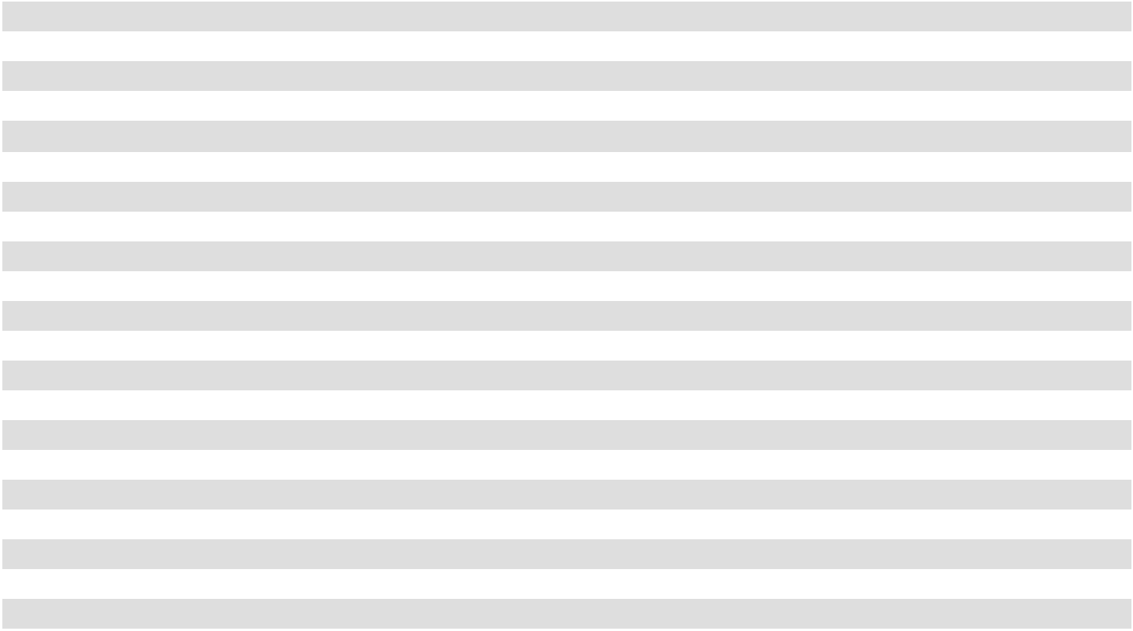

See Notes to Consolidated Financial Statements

74

ACADEMY SPORTS AND OUTDOORS, INC. CONSOLIDATED STATEMENTS OF COMPREHENSIVE INCOME (Amounts in thousands)

 |  |  |  | Fiscal Year Ended
 | February 3, 2024 |  |  | January 28, 2023 |  |  | January 29, 2022
COMPREHENSIVE INCOME:
Net income | $ | 519,190 | $ |  | 628,001 | $ |  | 671,381
Recognized interest expense on interest rate swaps |  | — |  |  | — |  |  | 2,344
Tax benefit |  | — |  |  | — |  |  | 980
Total comprehensive income | $ | 519,190 | $ |  | 628,001 | $ |  | 674,705
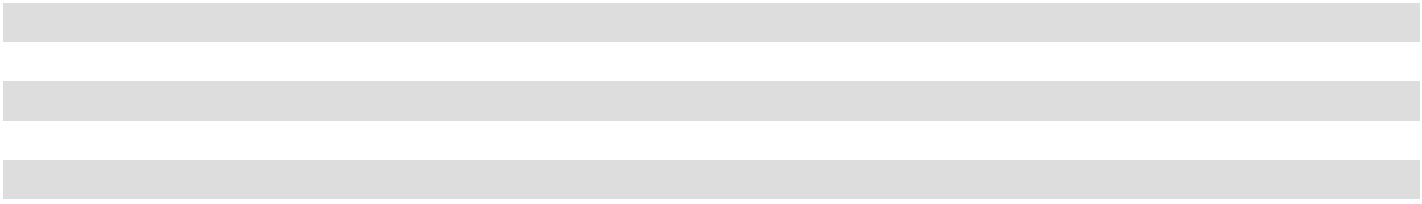

See Notes to Consolidated Financial Statements

75

76

ACADEMY SPORTS AND OUTDOORS, INC.

CONSOLIDATED STATEMENTS OF STOCKHOLDERS' EQUITY

(Amounts in thousands)

 |  |  |  |  |  |  |  |  |  |  |  |  | Accumulated |  |  | Total
 |  |  |  |  |  |  | Additional |  |  | Retained |  |  | Other |  |  | Total
 | Common Stock |  |  |  |  |  | Additional |  |  | Retained |  | Comprehensive |  |  |  | Stockholders'
 |  |  |  |  |  | Paid-In Capital |  |  |  | Earnings |  | Income (Loss) |  |  |  | Equity
 | Shares |  |  | Amount |  |  | Amount |  |  | Amount |  |  | Amount |  |  | Amount
Balances as of January 30, 2021 | 91,114 |  | $ | 911 |  | $ | 127,228 |  | $ | 987,168 |  | $ | (3,324) |  | $ | 1,111,983
Net income | — |  |  | — |  |  | — |  |  | 671,381 |  |  | — |  |  | 671,381
Equity compensation | — |  |  | — |  |  | 39,264 |  |  | — |  |  | — |  |  | 39,264
Repurchase of common stock for retirement | (10,567) |  |  | (106) |  |  | (20,814) |  |  | (390,489) |  |  | — |  |  | (411,409)
Settlement of vested Restricted Stock Units | 923 |  |  | 9 |  |  | (9) |  |  | — |  |  | — |  |  | —
Share-Based Award Payments adjustment for forfeitures | — |  |  | — |  |  | 39 |  |  | — |  |  | — |  |  | 39
Issuance of common stock under employee stock purchase plan | 114 |  |  | 1 |  |  | 3,776 |  |  | — |  |  | — |  |  | 3,777
Stock option exercises | 5,495 |  |  | 55 |  |  | 48,532 |  |  | — |  |  | — |  |  | 48,587
Recognized interest expense on interest rate swaps (net of tax benefit of | — |  |  | — |  |  | — |  |  | — |  |  | 3,324 |  |  | 3,324
$980) | — |  |  | — |  |  | — |  |  | — |  |  | 3,324 |  |  | 3,324
Balances as of January 29, 2022 | 87,079 |  | $ | 870 |  | $ | 198,016 |  | $ | 1,268,060 |  | $ | — |  | $ | 1,466,946
Net income | — |  |  | — |  |  | — |  |  | 628,001 |  |  | — |  |  | 628,001
Equity compensation | — |  |  | — |  |  | 21,175 |  |  | — |  |  | — |  |  | 21,175
Repurchase of common stock for retirement | (11,904) |  |  | (119) |  |  | (29,258) |  |  | (460,098) |  |  | — |  |  | (489,475)
Settlement of vested Restricted Stock Units | 100 |  |  | 1 |  |  | (1) |  |  | — |  |  | — |  |  | —
Issuance of common stock under employee stock purchase plan | 168 |  |  | 2 |  |  | 5,041 |  |  | — |  |  | — |  |  | 5,043
Stock option exercises | 1,269 |  |  | 13 |  |  | 21,236 |  |  | — |  |  | — |  |  | 21,249
Cash dividends declared, $0.075 per share | — |  |  | — |  |  | — |  |  | (24,633) |  |  | — |  |  | (24,633)
Balances as of January 28, 2023
Balances as of January 28, 2023 | 76,712 |  | $ | 767 |  | $ | 216,209 |  | $ | 1,411,330 |  | $ | — |  | $ | 1,628,306
Net income | — |  |  | — |  |  | — |  |  | 519,190 |  |  | — |  |  | 519,190
Equity compensation | — |  |  | — |  |  | 24,377 |  |  | — |  |  | — |  |  | 24,377
Repurchase of common stock for retirement | (3,652) |  |  | (36) |  |  | (12,625) |  |  | (191,493) |  |  | — |  |  | (204,154)
Settlement of vested Restricted Stock Units, net of shares withheld | 227 |  |  | 2 |  |  | (5,538) |  |  | — |  |  | — |  |  | (5,536)
Issuance of common stock under employee stock purchase plan | 124 |  |  | 1 |  |  | 5,483 |  |  | — |  |  | — |  |  | 5,484
Stock option exercises, net of shares withheld | 939 |  |  | 9 |  |  | 14,192 |  |  | — |  |  | — |  |  | 14,201
Cash dividends declared, $0.09 per share | — |  |  | — |  |  | — |  |  | (27,218) |  |  | — |  |  | (27,218)
Balances as of February 3, 2024
Balances as of February 3, 2024 | 74,350 |  | $ | 743 |  | $ | 242,098 |  | $ | 1,711,809 |  | $ | — |  | $ | 1,954,650
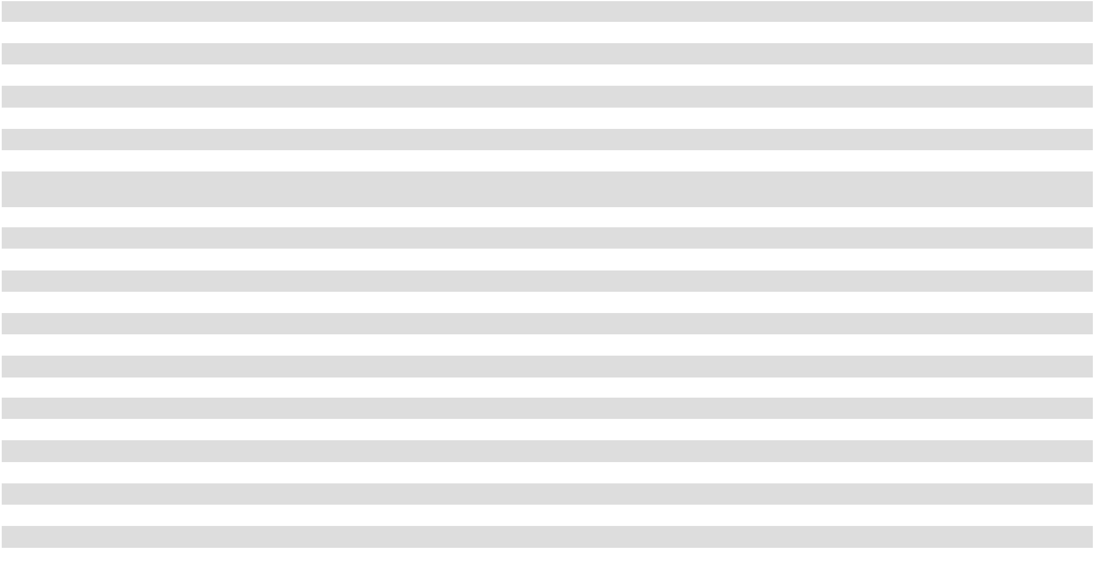

See Notes to Consolidated Financial Statements

ACADEMY SPORTS AND OUTDOORS, INC.

CONSOLIDATED STATEMENTS OF CASH FLOWS

(Amounts in thousands)

 |  |  |  | Fiscal Year Ended
 |  | February 3, 2024 |  |  | January 28, 2023 |  |  | January 29, 2022
CASH FLOWS FROM OPERATING ACTIVITIES:
Net income | $ | 519,190 | $ |  | 628,001 | $ |  | 671,381
Adjustments to reconcile net income to net cash provided by operating activities:
Depreciation and amortization |  | 110,936 |  |  | 106,762 |  |  | 105,274
Non-cash lease expense |  | 16,723 |  |  | (16) |  |  | (5,528)
Equity compensation |  | 24,377 |  |  | 21,175 |  |  | 39,264
Amortization of deferred loan, terminated interest rate swaps and other costs |  | 2,739 |  |  | 3,054 |  |  | 5,524
Deferred income taxes |  | (4,247) |  |  | 41,831 |  |  | 79,490
Non-cash loss on early retirement of debt |  | 1,525 |  |  | 1,963 |  |  | 2,239
Gain on disposal of property and equipment |  | (388) |  |  | — |  |  | —
Changes in assets and liabilities:
Accounts receivable, net |  | (2,868) |  |  | 3,215 |  |  | (2,412)
Merchandise inventories, net |  | 89,358 |  |  | (111,709) |  |  | (181,774)
Prepaid expenses and other current assets |  | (50,225) |  |  | (11,287) |  |  | (8,147)
Other noncurrent assets |  | (18,761) |  |  | (14,088) |  |  | 2,759
Accounts payable |  | (142,346) |  |  | (55,400) |  |  | (50,627)
Accrued expenses and other current liabilities |  | (26,712) |  |  | (58,395) |  |  | 31,935
Income taxes payable |  | 17,640 |  |  | (3,407) |  |  | (14,129)
Other long-term liabilities |  | (1,162) |  |  | 306 |  |  | (1,984)
Net cash provided by operating activities |  | 535,779 |  |  | 552,005 |  |  | 673,265
CASH FLOWS FROM INVESTING ACTIVITIES:
Capital expenditures |  | (207,770) |  |  | (108,304) |  |  | (75,802)
Purchases of intangible assets |  | (520) |  |  | (502) |  |  | (215)
Proceeds from the sale of property and equipment |  | 2,151 |  |  | — |  |  | —
Net cash used in investing activities |  | (206,139) |  |  | (108,806) |  |  | (76,017)
CASH FLOWS FROM FINANCING ACTIVITIES:
Repayment of Term Loan |  | (103,000) |  |  | (103,000) |  |  | (102,250)
Debt issuance fees |  | — |  |  | — |  |  | (927)
Share-Based Award Payments |  | — |  |  | — |  |  | (11,214)
Proceeds from exercise of stock options |  | 16,636 |  |  | 21,249 |  |  | 48,587
Proceeds from issuance of common stock under employee stock purchase program |  | 5,484 |  |  | 5,043 |  |  | 3,777
Taxes paid related to net share settlement of equity awards |  | (7,971) |  |  | (1,236) |  |  | (15,418)
Repurchase of common stock for retirement |  | (202,796) |  |  | (489,475) |  |  | (411,409)
Dividends paid |  | (27,218) |  |  | (24,633) |  |  | —
Net cash used in financing activities |  | (318,865) |  |  | (592,052) |  |  | (488,854)
NET INCREASE (DECREASE) IN CASH AND CASH EQUIVALENTS |  | 10,775 |  |  | (148,853) |  |  | 108,394
CASH AND CASH EQUIVALENTS AT BEGINNING OF PERIOD |  | 337,145 |  |  | 485,998 |  |  | 377,604
CASH AND CASH EQUIVALENTS AT END OF PERIOD | $ | 347,920 | $ |  | 337,145 | $ |  | 485,998
SUPPLEMENTAL DISCLOSURES OF CASH FLOW INFORMATION:
Cash paid for interest | $ | 45,446 | $ |  | 43,250 | $ |  | 44,710
Cash paid for income taxes | $ | 132,126 | $ |  | 168,180 | $ |  | 125,040
NON-CASH INVESTING AND FINANCING ACTIVITIES:
Non-cash capital expenditures | $ | 6,687 | $ |  | 4,046 | $ |  | 2,951
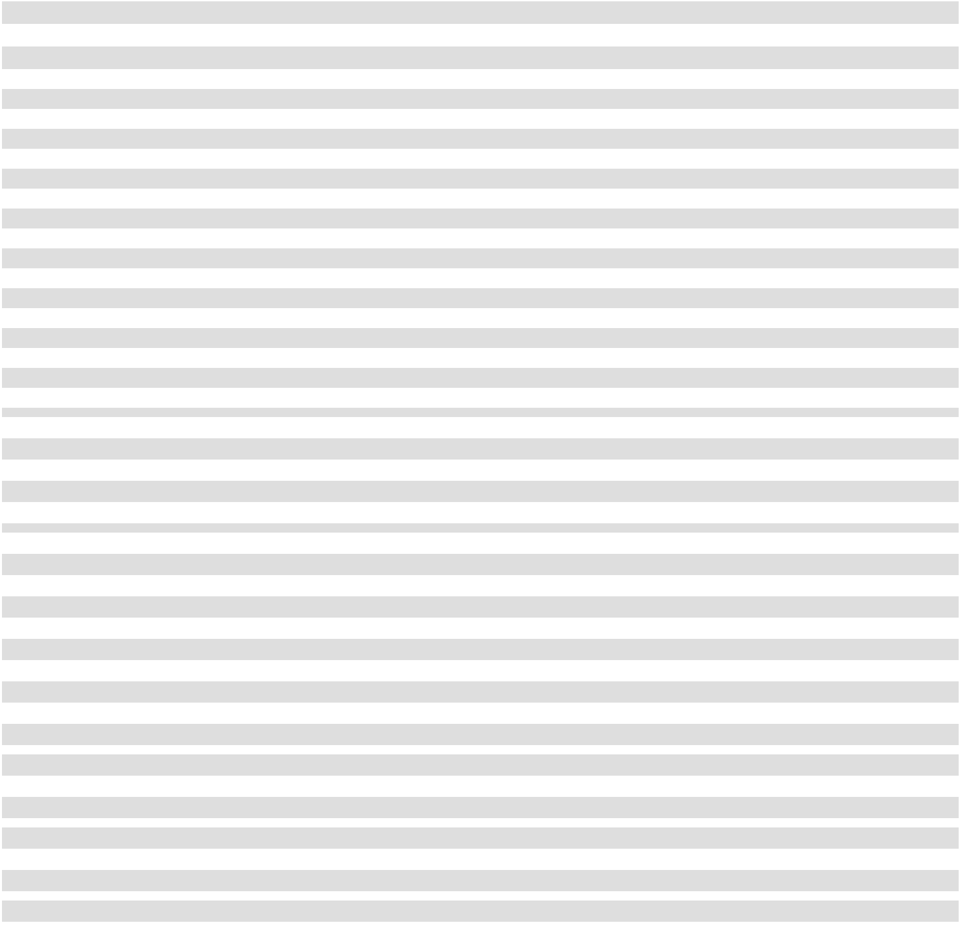

See Notes to Consolidated Financial Statements

77

ACADEMY SPORTS AND OUTDOORS, INC.

NOTES TO CONSOLIDATED FINANCIAL STATEMENTS

- Nature of Operations

The Company

All references to "we", "us", "our" or the "Company" in the financial statements refer to Academy Sports and Outdoors, Inc., a Delaware corporation ("ASO, Inc.") and the current parent holding company of our operations, and its consolidated subsidiaries. We conduct our operations primarily through our parent holding company's indirect subsidiary, Academy, Ltd., a Texas limited partnership doing business as "Academy Sports + Outdoors", or Academy, Ltd. All of the Company’s sales and business operations occur at Academy, Ltd., and Academy, Ltd. is also the borrower and/or issuer of the Company’s long-term debt and lessee of facilities. On August 3, 2011, an investment entity owned by investment funds and other entities affiliated with Kohlberg Kravis Roberts & Co. L.P. (collectively, "KKR"), acquired a majority interest in the Company. The Company completed an initial public offering (the "IPO") on October 6, 2020, and upon completion of the September 2021 Secondary Offering (as defined below), KKR no longer holds an ownership interest in the Company.

The Company is a leading full-line sporting goods and outdoor recreational products retailer in the United States in terms of net sales. As of February 3, 2024, we operated 282 "Academy Sports + Outdoors" retail locations in 18 states and three distribution centers located in Katy, Texas, Twiggs County, Georgia and Cookeville, Tennessee. Our distribution centers receive, store and ship merchandise to our stores and customers. We also sell merchandise to customers across most of the United States via our academy.com website.

Fiscal Year

The Company’s fiscal year represents the 52 or 53 weeks ending on the Saturday closest to January 31 each year. References herein to 2023 relate to the 53-week fiscal year ended February 3, 2024, and references herein to 2022 and 2021 relate to the 52-week fiscal years ended January 28, 2023, and January 29, 2022, respectively.

May 2021 Secondary Offering and Stock Repurchase

On May 5, 2021, ASO, Inc. entered into an underwriting agreement (the “May 2021 Underwriting Agreement”), by and among ASO, Inc., Allstar LLC, Allstar Co-Invest Blocker L.P., KKR 2006 Allstar Blocker L.P., MSI 2011 LLC and MG Family Limited Partnership (collectively, the “May 2021 Selling Stockholders”), and Credit Suisse Securities (USA) LLC and J.P. Morgan Securities LLC, as representatives of the several underwriters named therein (the “May 2021 Underwriters”), relating to an underwritten offering of 14,000,000 shares of common stock at $30.96 per share (the “May 2021 Secondary Offering”), pursuant to the Company’s Registration Statement on Form S-1 (File No. 333-255720), filed on May 3, 2021. The May 2021 Selling Stockholders granted the May 2021 Underwriters the option to purchase, within 30 days from the date of the May 2021 Underwriting Agreement, an additional 2,100,000 shares of common stock. On May 6, 2021, the May 2021 Underwriters exercised in full their option to purchase the additional shares. The May 2021 Secondary Offering also included the Company's repurchase and simultaneous retirement of 3,229,974 shares out of the 14,000,000 shares at $30.96 per share, the same price granted to the May 2021 Underwriters, which was at a discount to the prevailing market price at the time of repurchase (see "Share Repurchases" in Note 2). The May 2021 Secondary Offering was completed on May 10, 2021. The Company did not receive any proceeds from the May 2021 Secondary Offering.

The May 2021 Secondary Offering reduced the KKR ownership interest in the Company, resulting in a vesting event (the "2021 Vesting Event") for awards granted under the 2011 Unit Incentive Plan, whereby unvested time awards and performance-based awards which had previously met their performance targets vested and unvested performance-based awards which had not previously met their performance targets were forfeited. As a result, we incurred approximately $24.9 million in non-cash expenses related to equity-based compensation and approximately $15.4 million of cash expenses related to taxes on equity-based compensation. Additionally, approximately $8.2 million of Share-Based Award Payments (see Note 9) for equity-based compensation distributions were accelerated during the 2021 second quarter.

78

September 2021 Secondary Offering and Stock Repurchase

On September 14, 2021, ASO, Inc. entered into an underwriting agreement (the “September 2021 Underwriting Agreement”), by and among ASO, Inc., Allstar LLC, Allstar Co-Invest Blocker L.P. and KKR 2006 Allstar Blocker L.P. (collectively, the “September 2021 Selling Stockholders”), and Credit Suisse Securities (USA) LLC, as representative of the several underwriters named therein (the “September 2021 Underwriters”), relating to an underwritten offering (the “September 2021 Secondary Offering”) of 18,645,602 shares of common stock at approximately $43.52 per share, pursuant to the Company’s Registration Statement on Form S-1 (File No. 333-259477), filed on September 13, 2021. The September 2021 Secondary Offering also included the Company’s repurchase and simultaneous retirement of 4,500,000 shares out of the 18,645,602 shares of common stock at approximately $43.52, the same price granted to the September 2021 Underwriters, which was at a discount to the prevailing market price at the time of repurchase (see "Share Repurchases" in Note 2). The September 2021 Secondary Offering was completed on September 17, 2021. The Company did not receive any proceeds from the September 2021 Secondary Offering.

- Summary of Significant Accounting Policies

Basis of Presentation and Principles of Consolidation

These consolidated financial statements include the accounts of ASO, Inc. and its subsidiaries, New Academy Holding Company, LLC ("NAHC"), Academy Managing Co., LLC, Associated Investors, LLC, Academy, Ltd., the Company's operating company, and Academy International Limited. NAHC, Academy Managing Co., LLC, and Associated Investors, LLC are intermediate holding companies. All intercompany balances and transactions have been eliminated in consolidation. ASO Co-Invest Blocker Sub, L.P. and ASO Blocker Sub, L.P. were dissolved effective January 31, 2021.

Use of Estimates in the Preparation of Financial Statements

The preparation of financial statements in conformity with accounting principles generally accepted in the United States of America ("GAAP") requires our management to make estimates and assumptions that affect the reported amounts of assets and liabilities and the disclosure of contingent assets and liabilities as of the date of the financial statements, as well as the reported amounts of revenues and expenses during the reporting period. Our management bases its estimates on historical experience and other assumptions it believes to be reasonable under the circumstances. Actual results could differ significantly from those estimates. Our most significant estimates and assumptions that materially affect the financial statements involve difficult, subjective or complex judgments by management including the valuation of merchandise inventories, and performing goodwill, intangible and long-lived asset impairment analyses.

Reclassifications

Within the merchandise division sales table presented in Note 3, certain products and categories were recategorized among various categories and divisions, respectively, during 2023 to better align with our current merchandising strategy and view of the business. As a result, we have reclassified sales between divisions for 2022 and 2021 for comparability purposes. This reclassification is in divisional presentation only and did not impact the overall net sales balances previously disclosed.

Cash and Cash Equivalents

We consider credit and debit card transactions, which typically settle within three business days, demand deposits with banks, and all other highly liquid investments with original maturities of three months or less from the date of purchase to be cash equivalents.

Financial Instruments

Financial instruments are comprised of cash and cash equivalents, accounts receivable, accounts payable, certain accrued liabilities and debt. The carrying amounts of cash and cash equivalents, accounts receivable, accounts payable and accrued liabilities approximate their fair values due to the short-term nature of those instruments. We have also historically entered into derivative interest rate swaps to reduce the risk that our earnings and cash flows will be affected by changes in interest rates on our debt. The fair value of debt is influenced by fluctuations in market conditions for interest rates (see Note 6). We did not have any derivative financial instruments outstanding as of February 3, 2024 or January 28, 2023.

79

Accounts Receivable

Accounts receivable consists primarily of amounts due from vendors for vendor allowances and other accounts receivable. We provide an allowance for doubtful accounts based on both historical experience and a specific identification basis.

Concentration of Risk

Financial instruments which subject us to potential credit risk consist of cash and cash equivalents. We have established guidelines to limit our exposure to credit risk on cash and cash equivalents by placing investments with high credit quality financial institutions. Deposits with these financial institutions may exceed the amount of insurance provided; however, these deposits typically are redeemable upon demand. We believe that the financial risks associated with these financial instruments are minimal.

We purchase merchandise inventories from approximately 1,400 vendors. In each of the years 2023, 2022 and 2021, purchases from our largest vendor represented approximately 11% of our total inventory purchases. No other vendor in any of the aforementioned years exceeded 10% of our purchases. We typically do not enter into long-term inventory purchase commitments, and we did not have any such commitments as of February 3, 2024 or January 28, 2023.

A significant portion of our inventory purchases are manufactured outside of the United States, primarily in Asia. While we are not dependent on any single manufacturer outside of the United States, we could be adversely affected by political, health (including pandemic), safety, security, economic, tariff, climate, war or other disruptions affecting the business or operations of third-party manufacturers located outside of the United States.

The Company’s geographic concentration in the southern United States subjects us to certain regional risks, such as the state of regional economies, including downturns in the housing market, increased unemployment and gas prices. Other regional risks include legislation, politics, cultural views, severe weather conditions or man-made disasters (such as an oil spill closing large areas of hunting or fishing), fires, heat waves, freezes, hurricanes, tornadoes, large storms and floods and other natural disasters specific to the states in which the Company operates.

Merchandise Inventories, net

Merchandise inventories are stated at the lower of weighted average cost and net realizable value. Merchandise inventories include the direct cost of merchandise and capitalized costs related to procurement, warehousing and distribution and are reflected net of shrinkage, vendor allowances and other valuation reserves. We record an inventory reserve for the estimated shrinkage between physical inventories on a by location basis. We generally perform a full physical inventory count for each store at least once a year, throughout the year, after which our shrinkage accrual rate for each store is updated based on historical results. For vendor allowances based on contractual provisions, we develop accrual rates as determined by the agreements, which are typically linked to purchase volumes. Other non-contractual vendor allowances received are applied upon receipt. We regularly review inventories and record a valuation adjustment when necessary such as for inventory that has a carrying value in excess of the net realizable value or for slow moving or obsolete inventory. Prior to 2023, we valued merchandise inventories at the lower of the weighted average cost method or LIFO method (see Change in Accounting Principle discussion below). The application of the LIFO inventory method did not result in any LIFO charges or credits affecting cost of sales in 2022 or 2021.

Change in Accounting Principle

Effective January 29, 2023, the Company changed the method of accounting for its inventories from the last-in-first-out (“LIFO”) method to the weighted average cost method. The Company believes that this inventory method change is preferable because we believe it improves comparability with industry peers and is a more accurate representation of merchandise inventories, net and cost of goods sold. Due to historical price deflation on the Company’s merchandise purchases, the Company was in a position where the LIFO merchandise inventories value exceeded the cost of its inventory for all periods presented in the consolidated financial statements. In considering the lower of cost or market principle, merchandise inventories valued at LIFO, including necessary valuation adjustments, approximated the cost of such inventories using the weighted average inventory method. As such, there is no impact to the prior periods from the retrospective presentation of the change.

80

The following tables show the pro forma effect to our consolidated financial statements as if the Company had remained on LIFO (amounts in thousands):

 |  |  |  | February 3, 2024
Consolidated Balance Sheet |  | As Reported |  | Effect of Change |  |  | Pro Forma LIFO
Merchandise inventories, net | $ | 1,194,159 | $ |  | (2,615) | $ |  | 1,191,544
Total current assets |  | 1,644,900 |  |  | (2,615) |  |  | 1,642,285
Total assets |  | 4,676,713 |  |  | (2,615) |  |  | 4,674,098
Accrued expenses and other current liabilities |  | 217,932 |  |  | (27,219) |  |  | 190,713
Total current liabilities |  | 879,858 |  |  | (27,219) |  |  | 852,639
Deferred tax liabilities, net |  | 254,796 |  |  | 26,609 |  |  | 281,405
Total liabilities |  | 2,722,063 |  |  | (610) |  |  | 2,721,453
Retained earnings |  | 1,711,809 |  |  | (2,005) |  |  | 1,709,804
Stockholders' equity |  | 1,954,650 |  |  | (2,005) |  |  | 1,952,645
Total liabilities and stockholders' equity |  | 4,676,713 |  |  | (2,615) |  |  | 4,674,098
 |  | Year Ended February 3, 2024
 |  | As Reported |  | Effect of Change |  |  | Pro Forma LIFO
Consolidated Statements of Income:
Cost of goods sold | $ | 4,049,080 | $ |  | 2,615 | $ |  | 4,051,695
Gross margin |  | 2,110,211 |  |  | (2,615) |  |  | 2,107,596
Operating income |  | 677,855 |  |  | (2,615) |  |  | 675,240
Income before income taxes |  | 663,156 |  |  | (2,615) |  |  | 660,541
Income tax expense |  | 143,966 |  |  | (610) |  |  | 143,356
Net income |  | 519,190 |  |  | (2,005) |  |  | 517,185
Earnings per common share:
Basic | $ | 6.89 | $ |  | (0.03) | $ |  | 6.86
Diluted | $ | 6.70 | $ |  | (0.03) | $ |  | 6.67
Consolidated Statements of Cash Flows:
Net income | $ | 519,190 | $ |  | (2,005) | $ |  | 517,185
Deferred income taxes |  | (4,247) |  |  | 26,609 |  |  | 22,362
LIFO charge |  | — |  |  | 2,615 |  |  | 2,615
Income taxes payable |  | 17,640 |  |  | (27,219) |  |  | (9,579)
Net cash provided by operating activities |  | 535,779 |  |  | — |  |  | 535,779
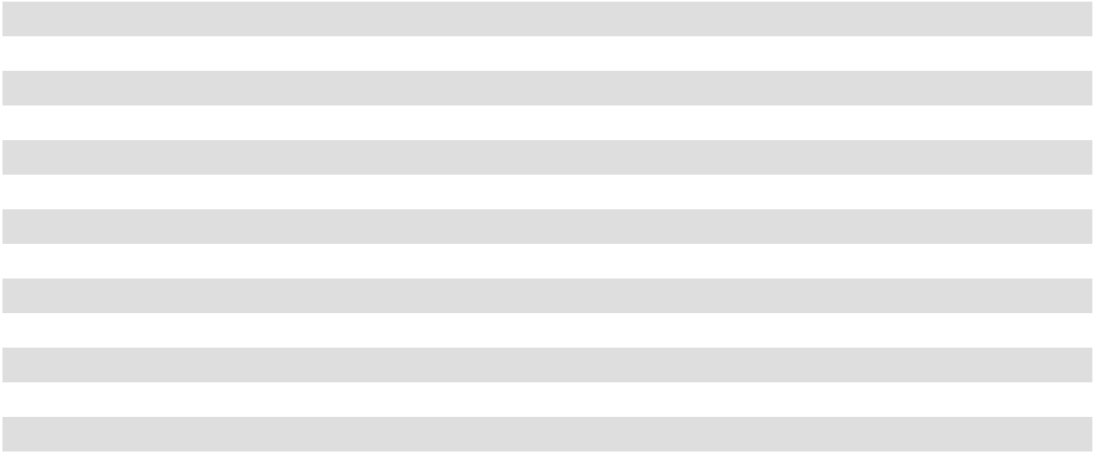
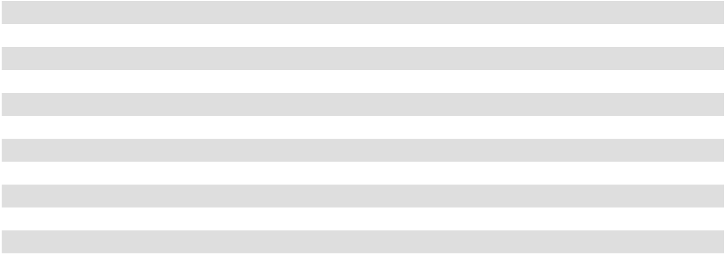
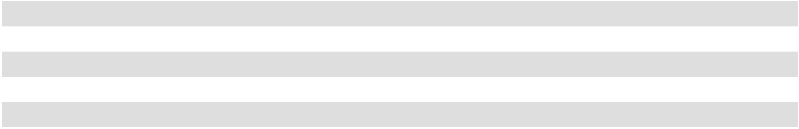

Supplier Finance Programs

In September 2022, the FASB issued ASU 2022-04: Liabilities - Supplier Finance Programs Disclosure of Supplier Finance Program Obligations. This pronouncement requires that a buyer in a supplier finance program disclose sufficient information about the program to allow a user of the financial statements to understand the program's nature, activity during the period, changes from period to period and potential magnitude. The Company adopted the new guidance as of January 29, 2023.

81

We have previously entered into a supply chain financing arrangement with a third-party financial institution, whereby certain suppliers have the ability to settle outstanding payment obligations earlier than the due date required by our original supplier terms. Subsequently, we settle invoices with the financial institution within 45 days, which approximates our original supplier terms. The Company does not have an economic interest in suppliers’ voluntary participation, does not provide any guarantees or pledge assets under these arrangements, and our rights and obligations to our suppliers, including amounts due, are not impacted. The following table shows our liability associated with these arrangements, which is presented within accounts payable on the consolidated balance sheets, and the related activity for the periods presented (amounts in thousands):

 |  | February 3, 2024 |  |  | January 28, 2023
Invoices outstanding at the beginning of the year | $ | 8,953 | $ |  | 4,430
Invoices added |  | 44,673 |  |  | 50,791
Invoices paid |  | (46,452) |  |  | (46,268)
Invoices outstanding at the end of the year | $ | 7,174 | $ |  | 8,953
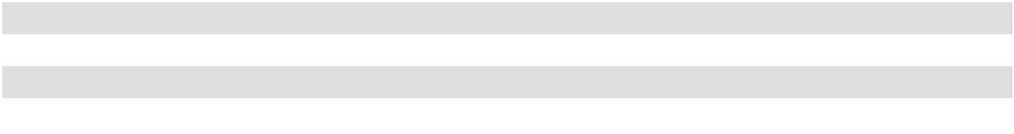

Property and Equipment

Property and equipment are recorded at cost less accumulated depreciation and amortization. Cost includes interest capitalized on borrowings used to finance the construction of stores and other significant capital projects while under construction. Depreciation and amortization is computed using the straight-line method over the asset’s useful life, which is generally determined by asset category as follows:

Leasehold improvements Lesser of asset useful life or lease term

Software and computer equipment 2–5 years

Other equipment 5–10 years

Furniture and fixtures 7–10 years

Buildings 40 years

When assets are retired or sold, the cost and accumulated depreciation are removed from our accounts, and the resulting gain or loss is reflected in the consolidated statements of income. Repair and maintenance costs are charged to expense as incurred and significant improvements that substantially enhance the useful life or enhance the functionality of an asset are capitalized and amortized.

Capitalized Computer Software Costs

We capitalize certain costs incurred in connection with developing or obtaining computer software for internal use. Capitalized computer software costs are included in property and equipment on the consolidated balance sheets and amortized on a straight-line basis when placed into service over the estimated useful lives of the software. The amounts capitalized were $33.3 million, $33.3 million and $36.7 million in 2023, 2022 and 2021, respectively.

Implementation costs for cloud-based information systems are capitalized in other non-current assets. Amortization of cloud-based software implementation costs is recognized in selling, general and administrative expenses and amortized over the longer of the contract term or expected benefit. The amounts capitalized were $23.5 million, $12.3 million and $3.7 million in 2023, 2022 and 2021, respectively.

Capitalized Interest

We capitalized interest primarily related to construction of new stores, store renovations, distribution centers and IT projects in the amount of $2.1 million, $0.6 million and $0.4 million in 2023, 2022 and 2021, respectively. Interest expense, net on the consolidated statement of income is shown net of capitalized interest.

82

Impairment of Long-Lived Assets

We review the carrying value of long-lived assets, including store assets, for indicators of impairment whenever events and circumstances indicate that the carrying value of an asset may not be recoverable. Recoverability of long-lived assets is measured by a comparison of the carrying amount of the assets to the estimated undiscounted future cash flows expected to be generated by the use of the assets, which is generally projected based on historical results. If such assets are considered to be impaired, the impairment loss recognized is the amount by which the carrying amount of the assets exceeds its estimated fair value, which is calculated using discounted expected future cash flows. As a result of our assessment, we did not record an impairment of long-lived assets in 2023, 2022 and 2021.

Goodwill

Goodwill represents the excess of the purchase price of an acquired business over the amounts assigned to assets acquired and liabilities assumed in a business combination. Goodwill is tested for impairment annually or more frequently if events or circumstances indicate that the carrying value of goodwill may not be recoverable. We test for goodwill at the reporting unit level, which is the operating segment level. We operate in one operating segment with one reporting unit.

The annual goodwill impairment test provides for the option of first performing a qualitative assessment to evaluate the existence of events and circumstances that would lead to a determination that it is more likely than not that the fair value of a reporting unit is less than its carrying amount. If such a conclusion is reached, we would then be required to perform a quantitative impairment assessment of goodwill. However, if the qualitative assessment leads to a determination that it is more likely than not that the fair value of a reporting unit is greater than its carrying amount, then no further assessments are required. In 2023, 2022 and 2021, we performed a qualitative assessment and determined a quantitative assessment was not necessary.

Our quantitative assessment for determining the fair value of our reporting unit includes using an estimated discounted cash flow model (income approach) and market value approach. The output of this assessment is an estimated fair value for our reporting unit that is compared to its carrying value to determine whether an impairment charge is necessary. The income approach uses a discounted cash flow analysis of our projected long-term future company income, and the market value approach is based on earnings multiples for a comparable set of public companies.

No impairment of goodwill existed for 2023, 2022 or 2021.

Intangible Assets

Intangible assets primarily consists of the trade name "Academy Sports + Outdoors" (the "Trade Name"). The Trade Name is expected to generate cash flows indefinitely and, therefore, is accounted for as an indefinite-lived asset not subject to amortization.

The Trade Name is tested for impairment annually or whenever events or circumstances indicate that the carrying amount of the Trade Name may not be recoverable. The annual Trade Name impairment test provides for the option of first performing a qualitative assessment to evaluate the existence of events and circumstances that would lead to a determination that it is more likely than not that the fair value of an intangible asset is less than its carrying amount. If such a conclusion is reached, we would then be required to perform a quantitative impairment assessment for the Trade Name. However, if the qualitative assessment leads to a determination that it is more likely than not that the fair value of an intangible asset is greater than its carrying amount, then no further assessments are required. In 2023, 2022 and 2021, we performed a qualitative assessment and determined a quantitative assessment was not necessary.

Impairment is calculated as the excess of the Trade Name’s carrying value over its fair value. The fair value of the Trade Name is determined using the relief-from-royalty method, a variation of the income approach. This method assumes that, in lieu of ownership, a third party would be willing to pay a royalty in order to exploit the related benefits of these types of assets. Once a supportable royalty rate is determined, the rate is then applied to the projected long-term sales over the expected remaining life of the intangible assets to estimate the royalty savings. This approach is dependent on a number of factors, including projections of long-term sales, royalty rates, discount rates and other variables.

No impairment of intangible assets existed for 2023, 2022 or 2021.

83

Deferred Loan Costs

Costs incurred to issue debt are deferred and recorded in the consolidated balance sheets. Those costs related to the issuance of our term loan and senior notes are recorded in long-term debt, net of current maturities and amortized as a component of interest expense over the terms of the related debt agreement using the effective interest method. The costs related to the issuance of our revolving credit facility is recorded in other noncurrent assets on the consolidated balance sheets and amortized as a component of interest expense over the terms of the related debt agreements using the straight-line method.

Derivative Instruments

We are exposed to interest rate risk, primarily related to changes in interest rates on our Term Loan (see Note 4) and have historically used interest rate swap agreements, which we have designated as "cash flow" hedges, to hedge against market risks relating to possible adverse changes in interest rates. We assess, both at the inception of the hedge and on an ongoing basis, whether derivatives used as hedging instruments are highly effective in offsetting the changes in the fair value or cash flow of the hedged items. If it is determined that a derivative is not highly effective as a hedge or ceases to be highly effective, we discontinue hedge accounting prospectively.

Derivative financial instruments are recognized at fair value in the consolidated balance sheets (see Note 5). The changes in the fair value of derivative instruments designated as cash flow hedges are recorded in accumulated other comprehensive income ("AOCI"), net of tax effects, and are subsequently reclassified to earnings when the hedged transaction affects earnings. On January 19, 2021, we settled our three remaining outstanding interest rate swaps, which were scheduled to expire on various dates during 2021, for $4.1 million. As of February 3, 2024, we do not have any derivative financial instruments outstanding.

Self-Insurance

We maintain deductibles or self-insurance retentions for workers' compensation, general liability and employee health benefits. Additionally, we use the services of an independent actuary to assist in determining losses associated with workers' compensation, general liability and employee health benefits. Liabilities associated with these losses are actuarially derived and estimated in part by considering historical claims experience, industry factors, severity factors, claim development, as well as other actuarial assumptions. If actual trends, including the severity or frequency of claims, medical cost inflation or fluctuations in premiums, differ from our estimates, it could have a material adverse impact on our results of operations. Changes in legal claims, claim development, trends and interpretations, variability in inflation rates, changes in the nature and method of claims settlement, benefit level changes due to changes in applicable laws, insolvency of insurance carriers and changes in discount rates could all adversely affect our ultimate expected losses. We believe the actuarial valuation provides the best estimate of the ultimate expected losses, and we have recorded the present value of the actuarially determined ultimate losses for the insurance related liabilities mentioned above.

Leases

We account for our leases in accordance with Accounting Standards Codification ("ASC") 842 which requires that lessees recognize assets and liabilities arising from operating leases on the balance sheet and disclose key information about leasing arrangements.

Nearly all of our store locations and all of our corporate office facilities, and warehouse and distribution centers are leased. We may receive reimbursement from a landlord for some or all of the cost of a construction project, which may be structured as a tenant improvement allowance or a construction allowance. Cash received from a landlord for tenant improvement allowances in store lease transactions are a reduction to the right-of-use assets on the balance sheet, which are amortized ratably over the remaining terms of the corresponding leases. Cash received for construction allowances is a reimbursement of certain spend incurred in the construction of the premises on behalf of the landlord, where the landlord owns the assets.

We account for each lease and non-lease components for our building leases as a single lease component which allows certain costs such as common area maintenance associated with these leases to be included as rent expense. We exclude leases with contract terms of 12 months or less from ASC 842 accounting treatment, which results in straight-line recognition of the cost over the lease term with no associated balance sheet lease liability or right-of-use asset.

84

Net Sales

We sell merchandise under implicit contracts whereby the transaction price is the listed sales price less any discounts or coupons applied. Our typical coupons offer a discount, which is applied immediately at the time of purchase. However, under certain circumstances we may issue a coupon, or similar incentive, which contains a material future right. In such instances, a portion of the revenue is deferred and subsequently recognized when earned.

Revenue from merchandise sales is recognized, net of sales tax, when the Company’s performance obligation to the customer is met, which is when the Company transfers control of the merchandise to the customer. Store merchandise sales are recognized at the point of sale. For e-commerce sales, significant judgment is applied in determining when the transfer of control occurs, which we believe occurs upon customer receipt, and accordingly online merchandise sales are recognized upon delivery of the merchandise to the customer. The Company does not extend a material amount of credit. The sales return allowance, which is our provision for anticipated merchandise returns, is provided through a reduction of sales and cost of goods sold on a gross basis in the period that the related sales are recorded. The sales return allowance and related liability are included in merchandise inventories and in accrued expenses and other liabilities, respectively, in our consolidated balance sheets. Merchandise returns are estimated based on historical experience.

Cost of Goods Sold

Cost of goods sold includes the direct cost of merchandise and costs related to procurement, warehousing and distribution. These costs consist primarily of payroll and benefits, occupancy costs and freight.

Shipping and Handling Costs

Shipping and handling costs billed to customers are included in net sales. Shipping and handling costs that we incur associated with shipping products to customers are included in cost of goods sold.

Vendor Allowances

Vendor allowances include volume purchase rebates, promotional and advertising allowances, cooperative advertising funds and support for new store openings. These allowances are generally determined for each fiscal year with the majority of allowances based on quantitative contract terms. Allowances related to the purchase of merchandise inventories are recorded as a reduction of cost of goods sold as the related merchandise is sold. Allowances for cooperative advertising and promotion programs and other expenses are recorded in selling, general and administrative expenses as a reduction of the related costs as the related expense is incurred. Any such allowance in excess of actual costs incurred that are included in selling, general and administrative expenses, or that do not require proof of performance, are recorded as a reduction of cost of sales. For volume purchase rebates, we record an estimate of vendor allowances earned based on the latest projected purchase volumes.

Selling, General and Administrative Expenses

Selling, general and administrative expenses include store and corporate administrative payroll and payroll benefits, store and corporate headquarters occupancy costs, depreciation, advertising, credit card processing, information technology, pre-opening costs and other store and administrative expenses.

Advertising Expenses

Advertising costs are expensed as incurred. Advertising expenses, net of specific vendor allowances, were $153.7 million, $144.5 million and $151.2 million in 2023, 2022 and 2021, respectively.

85

Pre-Opening Expenses

Non-capital expenditures associated with opening new stores and distribution centers prior to sales generation or start of operations, which consist primarily of occupancy costs, marketing, payroll and recruiting costs, are expensed as incurred. The following table summarizes our pre-opening expense activity for the periods presented:

 |  |  |  | Fiscal Year Ended
 | February 3, 2024 |  |  | January 28, 2023 |  |  | January 29, 2022
Number of new stores opened |  | 14 |  |  | 9 |  |  | —
Pre-opening expenses (in millions) | $ | 8.3 | $ |  | 5.5 | $ |  | 0.2

Equity Compensation

We account for equity compensation in accordance with ASC 718, which requires the measurement and recognition of compensation expense for all equity awards made to employees based on estimated fair values on the grant date. Option equity award fair values are estimated on the date of grant using an option-pricing model and restricted unit fair values are based on the estimated unit price on the date of the grant. For awards with service-based vesting requirements only, the fair value of the award is recognized as expense over the requisite service period, and for awards with performance-based vesting requirements, the fair value of the award ultimately expected to meet the performance target is recognized as expense over the service period. We recognize forfeitures as they occur.

Share Repurchases

On September 2, 2021, the Board of Directors of the Company authorized a share repurchase program (the "2021 Share Repurchase Program") under which the Company may purchase up to $500 million of its outstanding shares during the three-year period ending September 2, 2024. On June 2, 2022, the Board of Directors authorized a new share repurchase program (the "2022 Share Repurchase Program") under which the Company may purchase up to $600 million of its outstanding shares during the three-year period ending June 2, 2025. On November 29, 2023, the Board of Directors authorized a new share repurchase program (the "2023 Share Repurchase Program") under which the Company may purchase up to $600 million of its outstanding shares during the three-year period ending November 29, 2026. The 2023 Share Repurchase Program, the 2022 Share Repurchase Program and the 2021 Share Repurchase Program are collectively referred to as the "Share Repurchase Programs".

Under the Share Repurchase Programs, repurchases can be made using a variety of methods, which may include open market purchases, block trades, privately negotiated transactions, accelerated share repurchase programs and/or a non-discretionary trading plan, all in compliance with the rules of the SEC and other applicable legal requirements. The timing, manner, price and amount of any common share repurchases will be determined by the Company in its discretion and will depend on a variety of factors, including legal requirements, price and economic and market conditions. The Share Repurchase Programs do not obligate the Company to acquire any particular number of common shares, and the programs may be suspended, extended, modified or discontinued at any time.

The following table summarizes our share repurchases for the periods presented:

 |  |  |  | Fiscal Year Ended
 | February 3, 2024 |  |  | January 28, 2023 |  |  | January 29, 2022
Shares Repurchased ⁽¹⁾ |  | 3,651,231 |  |  | 11,903,636 |  |  | 10,566,796
Aggregate amount paid (amounts in millions) ⁽²⁾ | $ | 204.2 | $ |  | 489.5 | $ |  | 411.4

- Purchases for the fiscal year ended January 29, 2022, include purchases that were made prior to our Share Repurchase Programs.

- Includes estimated excise tax fees of $1.4 million for the fiscal year ended February 3, 2024.

86

The Company allocates the excess of the repurchase price over the par value of shares acquired to Retained Earnings and Additional Paid-in Capital. The portion allocated to Additional Paid-in Capital is determined by dividing the number of shares to be retired by the number of shares issued multiplied by the balance of Additional Paid-in Capital as of the retirement date. As of February 3, 2024, we no longer had availability under the 2021 Share Repurchase Program, and we had $696.7 million available for share repurchases pursuant to the combined 2023 Share Repurchase Program and 2022 Share Repurchase Program.

Income Taxes

The Company is subject to U.S. federal, state and foreign income taxes. We account for income taxes under the asset and liability method, which requires the recognition of deferred tax assets and liabilities for the expected future tax consequences of events that have been included in the financial statements. Under this method, deferred tax assets and liabilities are measured using enacted tax rates in effect for the year in which the temporary differences are expected to be realized or settled. The effect of a change in tax rates on deferred tax assets and liabilities is recognized in income in the period that includes the enactment date.

We recognize deferred tax assets to the extent we believe these assets are more-likely-than-not to be realized. In making such a determination, we consider all available positive and negative evidence, including recent results of operations, future reversals of existing taxable temporary differences, projected future taxable income and tax planning strategies. A valuation allowance is recorded to reduce the carrying amount of deferred tax assets if it is more-likely-than-not that all or a portion of the asset will not be realized. The Company recognizes tax benefits from uncertain tax positions only if it is more-likely-than-not the tax position will be sustained on examination by the taxing authorities based on the technical merits of the position. The tax benefits recognized from such positions are measured based on the largest benefit having a greater than 50% likelihood of being ultimately sustained. Interest and penalties from income tax matters are recognized in income tax expense.

Other Income

During the fourth quarter of 2022, the Company received and recognized approximately $7.2 million in business interruption proceeds due to the suspension of normal operations at some of our Texas store locations, as well as our e-commerce platform, for several days in February of 2021 as a result of a winter storm which had a significant impact on the energy infrastructure in the state of Texas. Additionally, during the fourth quarter of 2022 the Company completed a sale in which we factored rights to pursue a legal matter pertaining to the overpayment of certain tariffs and we received and recognized net proceeds of approximately $3.7 million. The proceeds for both events are included in Other (income), net on the Consolidated Statements of Income.

During the fourth quarter of 2023, the Company settled a legal matter with credit card companies pertaining to the overcharge of credit card interchange fees for prior periods dating back to 2004. In connection with this settlement, we recognized a net gain of approximately $15.9 million in Other (income), net on the Consolidated Statements of Income.

Comprehensive Income

Comprehensive income represents the net income for the period plus the results of certain changes to stockholders' equity (other comprehensive income) that are not reflected in the consolidated statements of income. Other comprehensive income consists of adjustments, net of tax, related to the Company’s historical ownership of interest rate swaps.

Operating Segment

Given the similar business activities, economic characteristics, products sold, customer base and methods of procurement, as well as the similar marketing and promotional activities of our stores and our academy.com website, we report our financial results as one reportable segment. Substantially all of the Company’s identifiable assets are located in the United States.

87

Recent Accounting Pronouncements

Reference Rate Reform

In March 2020, the FASB issued ASU 2020-04: Facilitation of the Effects of Reference Rate Reform on Financial Reporting. This pronouncement provides temporary optional expedients and exceptions to the current guidance on contract modifications and hedge accounting to ease the financial reporting burden related to the expected market transition from the London Interbank Offered Rate ("LIBOR") and other interbank offered rates to alternative reference rates. In December 2022, the FASB issued ASU 2022-06 which extended the effectiveness of this guidance to December 31, 2024. The Company elected to utilize these optional expedients in connection with the amendments to our ABL Facility and Term Loan, which transitioned from LIBOR to the Secured Overnight Financing Rate (“SOFR”) on March 30, 2023 and August 1, 2023, respectively (see Note 4).

Improvements to Income Tax Disclosures

In December 2023, the FASB issued ASU 2023-09: Improvements to Income Tax Disclosures. This pronouncement is intended to enhance the transparency and decision usefulness of income tax disclosures and establishes new income tax disclosure requirements, including requiring disaggregation of a reporting entity’s effective tax rate reconciliation and disaggregation of the income taxes paid based on the applicable tax jurisdiction. The new guidance is effective for fiscal years beginning after December 15, 2024 and should be applied on a prospective basis with the option to apply the standard retrospectively. The Company is currently evaluating the impact that the adoption of this accounting standard will have on its financial disclosures.

Segment Reporting

In November 2023, the FASB issued ASU 2023-07, Segment Reporting (Topic 280): Improvements to Reportable Segment Disclosures, which is intended to enhance the disclosures on reportable segments. Under this pronouncement, all public entities (including those with a single reporting segment) are required to include incremental disclosures related to a public entity’s reportable segments, including disclosure of disaggregated expense information that is regularly provided to the chief operating decision maker and included within each reported measure of segment profit or loss. The new guidance is effective for fiscal years beginning after December 15, 2023, and interim periods within fiscal years beginning after December 15, 2024, and should be adopted retrospectively. The Company is currently evaluating the impact that the adoption of this accounting standard will have on its financial disclosures.

88

- Net Sales

The following table sets forth the approximate amount of sales (all of which are based in the U.S.) by merchandise divisions for the periods presented (amounts in thousands):

 |  |  |  | Fiscal Year Ended
 | February 3, 2024 |  |  | January 28, 2023 |  |  | January 29, 2022
Merchandise division sales ⁽¹⁾ | $ | 1,727,018
Outdoors | $ | 1,727,018 | $ |  | 1,819,418 |  | $ | 2,060,046
Sports and recreation |  | 1,452,377 |  |  | 1,488,187 |  |  | 1,577,776
Apparel |  | 1,710,838 |  |  | 1,758,993 |  |  | 1,810,345
Footwear |  | 1,235,643 |  |  | 1,291,227 |  |  | 1,290,197
Total merchandise sales ⁽²⁾ |  | 6,125,876 |  |  | 6,357,825 |  |  | 6,738,364
Other sales ⁽³⁾ |  | 33,415 |  |  | 37,248 |  |  | 34,764
Net sales | $ | 6,159,291 | $ |  | 6,395,073 |  | $ | 6,773,128
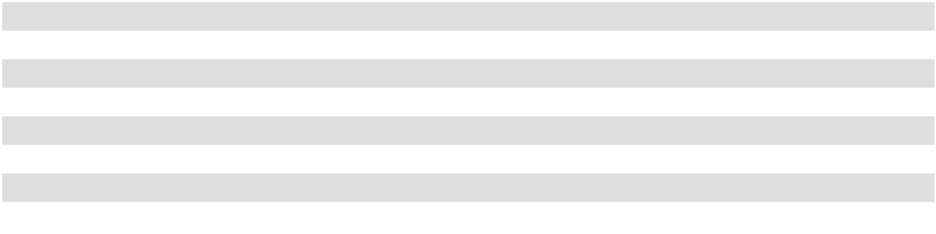

- Certain products and categories were re-categorized among various categories and divisions, respectively, during 2023 to better align with our current merchandising strategy and view of the business. As a result, we have reclassified sales between divisions for 2022 and 2021 for comparability purposes. This reclassification is in divisional presentation only and did not impact the overall net sales balances previously disclosed (see Note 2).

- E-commerce sales consisted of 10.7%, 10.7% and 9.3% of merchandise sales for 2023, 2022 and 2021, respectively.

- Other sales consists primarily of the gift card breakage income, credit card bounties and royalties, shipping income, net hunting and fishing license income, sales return allowance and other items.

We sell gift cards in stores, online and in third-party retail locations. The gift cards we sell have no expiration dates. A liability for gift cards, which is recorded in accrued expenses and other liabilities on our consolidated balance sheets, is established at the time of sale and revenues are recognized as the gift cards are redeemed in stores or on our website. Based on historical gift card redemption patterns, we believe we can reasonably estimate the amount of gift cards that have a remote likelihood of redemption. These identified amounts are recorded as net sales and recognized in proportion to historical redemption trends, which is referred to as "breakage".

The following is a reconciliation of the gift card liability (amounts in thousands):

 |  |  |  | Fiscal Year Ended
 | February 3, 2024 |  |  | January 28, 2023 |  |  | January 29, 2022
Gift card liability, beginning balance | $ | 90,650 | $ |  | 86,568 | $ |  | 74,253
Issued |  | 134,741 |  |  | 134,091 |  |  | 136,553
Redeemed |  | (124,370) |  |  | (124,463) |  |  | (119,103)
Recognized as breakage income |  | (6,866) |  |  | (5,546) |  |  | (5,135)
Gift card liability, ending balance | $ | 94,155 | $ |  | 90,650 | $ |  | 86,568
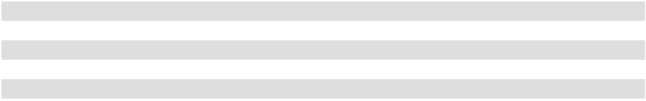

89

4. Long-Term Debt
Our debt consisted of the following (amounts in thousands) as of:
 | February 3, 2024 |  |  | January 28, 2023
ABL Facility, due November 2025 ⁽¹⁾ | $ | — | $ |  | —
Term Loan, due November 2027 |  | 91,750 |  |  | 194,750
Notes, due November 2027 |  | 400,000 |  |  | 400,000
Total debt |  | 491,750 |  |  | 594,750
Less current maturities |  | (3,000) |  |  | (3,000)
Less unamortized discount on Term Loan |  | (501) |  |  | (1,340)
Less deferred loan costs ⁽²⁾ |  | (3,698) |  |  | (5,954)
Long-term debt, net | $ | 484,551 | $ |  | 584,456
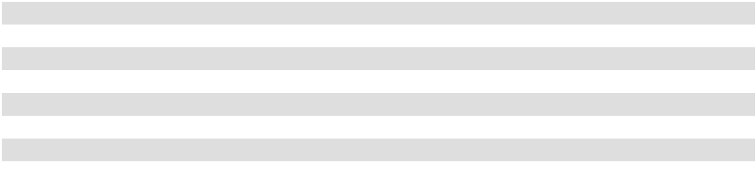
- On March 8, 2024, the Company issued a press release announcing that the Company had entered into an amendment to the First Amended and Restated ABL Credit Agreement which, among other things, extended the maturity of our asset-based revolving credit facility to March 8, 2029. See Note 17 to the accompanying financial statements for further disclosures regarding the amendment.

- Deferred loan costs are related to the Term Loan and Notes.

As of February 3, 2024 and January 28, 2023, the balance in deferred loan costs related to the ABL Facility (as defined below) was approximately $2.1 million and $3.2 million, respectively, and was included in other noncurrent assets on our consolidated balance sheets. Total amortization of deferred loan costs was $2.4 million, $2.6 million and $2.7 million in 2023, 2022 and 2021, respectively. Total expenses related to accretion of original issuance discount were $0.3 million, $0.4 million and $0.5 million in 2023, 2022 and 2021, respectively. The expenses related to amortization of deferred loan costs and accretion of original issuance discount are included in interest expense, net on the consolidated statements of income.

On November 6, 2020, the Company issued the Notes (as defined below), entered into the 2020 Term Loan (as defined below), and entered into the 2020 ABL Facility (the "Refinancing Transactions"). The Company used the net proceeds from the Notes and the net proceeds from the 2020 Term Loan, together with cash on hand, to repay in full outstanding borrowings under its then-existing term loan, in the amount of $1,431.4 million.

On May 25, 2021, the Company refinanced its 2020 Term Loan and paid down approximately $99.0 million of the 2020 Term Loan. On December 15, 2022 and February 1, 2024, the Company utilized cash on hand to voluntarily prepay $100.0 million of outstanding borrowings of the Term Loan, respectively.

Term Loan

We refer to the 2020 Term Loan and then amendments thereto collectively as the "Term Loan".

On November 6, 2020, as a part of the Refinancing Transactions, Academy, Ltd. entered into a seven-year $400.0 million senior secured term loan (the "2020 Term Loan") with Credit Suisse AG, Cayman Island Branch ("Credit Suisse"), as the administrative agent and collateral agent and the several other lenders and parties. The 2020 Term Loan bore interest, at Academy, Ltd.’s election, at either (1) LIBOR rate with a floor of 0.75%, plus a margin of 5.00%, or (2) a base rate equal to the highest of (a) the federal funds rate plus 0.50%, (b) Credit Suisse’s "prime rate", or (c) the one-month LIBOR rate plus 1.00%, plus a margin of 4.00%. In connection with the 2020 Term Loan, the Company capitalized related professional fees of $5.8 million as deferred loan costs.

On May 25, 2021, Academy, Ltd. entered into Amendment No. 4 (the “2021 Amendment”) to the Second Amended and Restated Credit Agreement, dated as of November 6, 2020, among Academy, Ltd., as Borrower, Credit Suisse AG, Cayman Islands Branch, as the administrative agent and collateral agent, the several lenders party thereto and the several other parties named therein (as previously amended, the “Existing Credit Agreement” and as amended by the 2021 Amendment, the “Amended Credit Agreement”). Pursuant to the terms of the 2021 Amendment, Academy, Ltd. (i) reduced the applicable margin on LIBOR borrowings under the Existing Credit Agreement from 5.00% to 3.75% and (ii) utilized cash on hand to repay $99.0 million of outstanding borrowings under the Existing Credit Agreement, leaving an outstanding principal balance of $300.0 million under the Amended Credit Agreement. In connection with the principal payment in the 2021 Amendment, the Company recognized a non-cash loss on early retirement of debt of $2.2 million in 2021 from the write-off of deferred loan costs related to the original issuance discount associated with our 2020 Term Loan.

90

On December 15, 2022, the Company utilized cash on hand to voluntarily prepay $100.0 million of outstanding borrowings under the Term Loan. In connection with this principal payment, the Company recognized a non-cash loss on early retirement of debt of $2.0 million in 2022 from the write-off of deferred loan costs related to the original issuance discount associated with the Term Loan.

On May 17, 2023, Academy, Ltd. entered into a Conforming Changes Amendment (the "2023 Amendment") to the Second Amended and Restated Credit Agreement, dated as of November 6, 2020, among Academy, Ltd., as Borrower, Credit Suisse AG, Cayman Islands Branch, as the administrative agent and collateral agent and the several lenders party thereto and the several other parties named therein, which updated the Term Loan benchmark base interest rate from LIBOR to Adjusted Term SOFR (as defined in the Conforming Changes Amendment to the Second Amended and Restated Credit Agreement). The transition of our Term Loan to Adjusted Term SOFR became effective on August 1, 2023. Borrowings under the Term Loan bear interest, at our election, at either (1) Adjusted Term SOFR with a floor of 0.75% rate plus a margin of 3.75% or (2) a base rate equal to the highest of (a) the federal funds rate plus 0.50%, (b) the U.S. "prime rate" announced by the administrative agent, or (c) the one-month Adjusted Term SOFR with a floor of 0.75% rate, plus a margin of 3.75%. As of February 3, 2024, the weighted average interest rate was 9.19%, with interest payable monthly. Quarterly principal payments of $750.0 thousand are required through September 30, 2027 and borrowings mature on November 6, 2027. The terms and conditions of the Term Loan also require that the outstanding balance under the Term Loan is prepaid under certain circumstances.

On February 1, 2024, the Company utilized cash on hand to voluntarily prepay $100.0 million of outstanding borrowings under the Term Loan. In connection with this principal payment, the Company recognized a non-cash loss on early retirement of debt of $1.5 million in 2023 from the write-off of deferred loan costs related to the original issuance discount associated with the Term Loan.

The Amended Credit Agreement contains customary events of default such as failure to pay principal or interest, breaches of representations and warranties, violations of affirmative or negative covenants, cross-defaults to other material indebtedness, a bankruptcy or similar proceeding, rendering of certain monetary judgments, invalidity of collateral documents and changes of control. As of February 3, 2024, no prepayment was due under the terms and conditions of the Term Loan.

Notes

On November 6, 2020, as a part of the Refinancing Transactions, Academy, Ltd. issued $400.0 million of 6.00% senior secured notes which are due November 15, 2027 (the "Notes"), pursuant to an indenture, dated as of November 6, 2020 (the "Indenture"), with Academy, Ltd. the Guarantors (as defined below) and The Bank of New York Mellon Trust Company, N.A., as trustee and collateral agent (in such capacity, the "Notes Collateral Agent"). The Notes pay interest semi-annually in arrears in cash on May 15 and November 15 of each year at a rate of 6.00% per year, which commenced on May 15, 2021. In connection with issuance of the Notes, the Company capitalized related professional fees of $5.2 million as deferred loan costs.

The Notes are fully and unconditionally guaranteed on a senior secured basis by each of NAHC, Associated Investors L.L.C. and Academy Managing Co., L.L.C., each a direct or indirect, wholly-owned subsidiary of the Company (collectively, the "Guarantors"), and each of Academy, Ltd.’s future wholly-owned domestic restricted subsidiaries, to the extent such subsidiary guarantees Academy, Ltd.’s senior secured credit facilities or certain capital markets debt.

On or after November 15, 2023, Academy, Ltd. may, at its option and on one or more occasions, redeem all or a part of the Notes at the redemption prices set forth in the Indenture, plus accrued and unpaid interest, if any, to, but excluding, the applicable redemption date. At any time prior to November 15, 2023, Academy, Ltd. may, at its option and on one or more occasions, redeem all or part of the Notes at a redemption price equal to 100% of the principal amount of the Notes to be redeemed, plus accrued and unpaid interest, if any, to, but excluding, the applicable redemption date, plus a "make-whole" premium as described in the Indenture. In addition, at any time prior to November 15, 2023, Academy, Ltd. may, at its option and on one or more occasions, redeem up to 40% of the aggregate principal amount of the Notes at a redemption price equal to 106% of the aggregate principal amount thereof, with an amount equal to or less than the net cash proceeds from one or more equity offerings to the extent such net cash proceeds are received by or contributed to Academy, Ltd., plus accrued and unpaid interest, if any, to, but excluding, the applicable redemption date.

Upon the occurrence of certain events constituting a Change of Control (as defined in the Indenture), Academy, Ltd. will be required to make an offer to repurchase all of the Notes at a price equal to 101% of the principal amount thereof, plus accrued and unpaid interest, if any, to, but excluding, the repurchase date.

91

The Indenture provides for events of default which include (subject in certain cases to customary grace and cure periods), among others, nonpayment of principal or interest, breach of other agreements in respect of the Notes, acceleration of certain other indebtedness, failure to pay certain final judgments, failure of certain guarantees to be enforceable, failure to perfect certain collateral securing the Notes and certain events of bankruptcy or insolvency, which events of default, if any occur, would permit or require the principal, premium, if any, interest and any other monetary obligations on all the then-outstanding Notes to be due and payable immediately.

ABL Facility

We refer to the 2020 ABL Facility and the amendments thereto collectively as the "ABL Facility".

On November 6, 2020, as a part of the Refinancing Transactions, Academy, Ltd., as borrower, and the Guarantors, as guarantors, amended the previously existing secured asset-based revolving credit facility by entering into an amendment to the First Amended and Restated ABL Credit Agreement, dated as of July 2, 2015, with JPMorgan Chase Bank, N.A. as the administrative agent and collateral agent, letter of credit issuer and swingline lender (the "ABL Agent") and the several lenders party thereto, which ABL amendment (the "2020 ABL Facility"), among other things, extended the maturity of Academy, Ltd.’s asset-based revolving credit facility thereunder to November 6, 2025. In connection with the 2020 ABL Facility, the Company capitalized related professional fees of $3.1 million as deferred loan costs.

On March 30, 2023, Academy, Ltd., as borrower, and the guarantors, amended the 2020 ABL Facility by entering into an amendment to the First Amended and Restated ABL Credit Agreement, dated as of July 2, 2015, with JP Morgan Chase Bank, N.A. as the ABL Agent and the several lenders party thereto, which ABL amendment updated its benchmark base interest rate from LIBOR to Adjusted Term SOFR.

The ABL Facility is used to provide financing for working capital and other general corporate purposes, as well as to support certain letters of credit requirements, and availability is subject to customary borrowing base and availability provisions. During the normal course of business, we periodically utilize letters of credit primarily for the purchase of import goods and in support of insurance contracts. As of February 3, 2024, we had outstanding letters of credit of approximately $11.6 million, all of which were issued under the ABL Facility, and we had no borrowings outstanding under the ABL Facility, leaving the available borrowing capacity under the ABL Facility of $881.4 million.

Borrowings under the ABL Facility bear interest, at our election, at either of (1) Adjusted Term SOFR plus a margin of 1.25% to 1.75%, or (2) a base rate equal to the highest of (a) the federal funds rate plus 0.50%, (b) JPMorgan Chase Bank, N.A.'s "prime rate", or (c) the one-month Adjusted Term SOFR rate plus 1.00%, plus a margin of 0.25% to 0.75%. The ABL Facility also provides a fee applicable to the unused commitments of 0.25%. The terms and conditions of the ABL Facility also require that we prepay outstanding loans under the ABL Facility under certain circumstances. As of February 3, 2024, no future prepayments of outstanding loans have been triggered under the terms and conditions of the ABL Facility.

On March 8, 2024, the Company issued a press release announcing that the Company had entered into an amendment to the First Amended and Restated ABL Credit Agreement which, among other things, extended the maturity of our asset-based revolving credit facility to March 8, 2029. See Note 17 to the accompanying financial statements for further disclosures regarding the amendment.

Liens and guarantees. The ABL Facility has a first priority lien on all Academy, Ltd.'s cash, accounts receivable, inventory, deposit and securities accounts and proceeds therefrom (the "ABL Collateral"). Additionally, the ABL Facility has a second priority lien on all other collateral of the Term Loan. All obligations under the Term Loan and the guarantees of those obligations are secured by:

- a second-priority security interest in the ABL Collateral;

- a first-priority security interest in, and mortgages on, substantially all present and after acquired tangible and intangible assets of Academy, Ltd and the Guarantors; and
- a first-priority pledge of 100% of the capital stock of Academy, Ltd. and its domestic subsidiaries and 66% of the voting capital stock of each of Academy, Ltd.'s foreign subsidiaries, if any, that are directly owned by Academy, Ltd. or a future U.S. guarantor, if any.

92

The Term Loan is guaranteed by the Guarantors on a senior secured basis. All obligations under the Term Loan and the guarantees of those obligations will be secured by:

- a second-priority security interest in the ABL Priority Collateral;

- a first-priority security interest in, and mortgages on, substantially all present and after acquired tangible and intangible assets of Academy and the Guarantors; and
- a first-priority pledge of 100% of the capital stock of Academy and its domestic subsidiaries and 66% of the voting capital stock of each of Academy’s foreign subsidiaries, if any, that are directly owned by Academy or a future U.S. guarantor, if any.

In order to secure the Notes and the guarantees, Academy, Ltd. and the Guarantors entered into certain security documents with the Notes Collateral Agent, including a security agreement and a pledge agreement, each dated as of November 6, 2020. The Notes and the guarantees are secured by:

- a first-priority lien on all of Academy, Ltd.’s and the Guarantors’ personal property that secure the Term Loan on a first-priority basis; and

- a second-priority lien on Academy, Ltd.’s and the Guarantors’ personal property consisting of accounts and all other rights to payment, inventory, tax refunds, cash, deposit accounts, securities and commodities accounts, and documents and supporting obligations, securing the ABL Facility on a first-priority basis and the Term Loan on a second-priority basis (the "ABL Priority Collateral").

Covenants. The ABL Facility, Term Loan and Notes agreements contain covenants, including, among other things, covenants that may restrict Academy, Ltd.'s ability to incur certain additional indebtedness, create or permit liens on assets, engage in mergers or consolidations, pay dividends, make other restricted payments, make loans or advances, engage in transactions with affiliates or amend material documents. Additionally, at certain times, the ABL Facility is subject to a minimum adjusted fixed charge coverage ratio. These covenants are subject to certain qualifications and limitations. We were in compliance with these covenants as of February 3, 2024.

As of February 3, 2024, scheduled principal payments on our debt are as follows (amounts in thousands):

Fiscal Year
2024 |  | $ | 3,000
2025 |  |  | 3,000
2026 |  |  | 3,000
2027 |  |  | 482,750
Total |  | $ | 491,750
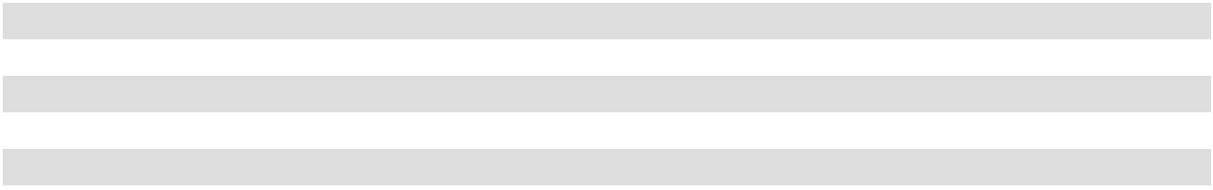

- Derivative Financial Instruments

We have historically used interest rate swap agreements to hedge market risk relating to possible adverse changes in interest rates.

All interest rate swaps had been designated as cash flow hedges of variable rate interest payments on borrowings under the Term Loan. On January 19, 2021, we settled our three outstanding interest rate swaps in full, which were scheduled to expire on various dates during 2021, for $4.1 million. As of February 3, 2024, we do not have any derivative financial instruments outstanding.

For derivatives previously designated as hedging instruments, amounts included in AOCI were reclassified to interest expense in the same period during which the hedged transaction affected earnings, which is as interest expense was recorded on the underlying Term Loan.

93

The impact of gains and losses related to interest rate swaps that were deferred into AOCI and subsequently reclassified into expense is as follows (amounts in thousands):

 |  |  |  | Fiscal Year Ended
 | February 3, 2024 |  |  | January 28, 2023 |  |  | January 29, 2022
Accumulated Other Comprehensive Loss, beginning | $ | — | $ |  | — | $ |  | (3,324)
Increase to interest expense (net of tax benefit of |  | — |  |  | — |  |  | 3,324
$980.0 million for the year ended January 29, 2022) |  | — |  |  | — |  |  | 3,324
Accumulated Other Comprehensive Loss, ending | $ | — | $ |  | — | $ |  | —
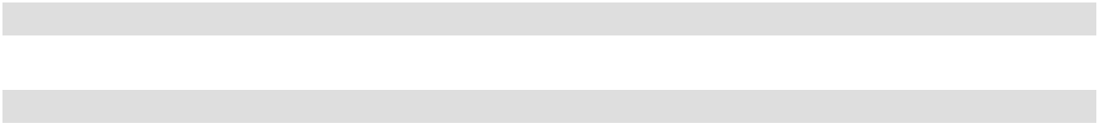

- Fair Value Measurements

Fair value is defined as an exit price that would be received from the sale of an asset or paid to transfer a liability in the principal or most advantageous market for the asset or liability in an orderly transaction between market participants on the measurement date. Authoritative guidance establishes a three-level hierarchy for disclosure that is based on the extent and level of judgment used to estimate the fair value of the assets and liabilities.

The fair value measurements are classified as either:

- Level 1 which represents valuations based on unadjusted quoted prices in active markets that are accessible at the measurement date for identical, unrestricted assets or liabilities;

- Level 2 which represents valuations based on quoted prices for similar assets and liabilities in active markets, quoted prices for identical or similar assets and liabilities in markets that are not active, or inputs that are observable, either directly or indirectly, for substantially the full term of the asset or liability; and

- Level 3 which represents valuations based on prices or valuation techniques that require inputs that are both significant to the fair value measurement and unobservable (i.e., supported by little or no market activity).

In instances where the determination of the fair value measurement is based on inputs from different levels of the fair value hierarchy, the level in the fair value hierarchy in which the fair value measurement is classified in its entirety, is based on the lowest level input that is significant to the fair value measurement. Our assessment of the significance of a particular input to the fair value measurement in its entirety requires judgment and considers factors specific to the asset or liability. There were no transfers made into or out of the Level 1, 2 or 3 categories during any period presented.

Other Financial Instruments

Periodically we make cash investments in money market funds comprised of U.S. Government treasury bills and securities, which are classified as cash and redeemable on demand. We held investments in money market funds of $303.4 million and $95.6 million as of February 3, 2024 and January 28, 2023, respectively.

The fair value of the Term Loan and Notes is estimated using a discounted cash flow analysis based on quoted market prices for the instrument in an inactive market and is therefore classified as Level 2 within the fair value hierarchy. As of February 3, 2024 and January 28, 2023, the estimated fair value of the Term Loan and Notes was $0.5 billion and $0.6 billion, respectively. As borrowings on the ABL Facility are generally repaid in less than 12 months, we believe that fair value approximates the carrying value.

94

- Property and Equipment

Property and equipment consists of the following (amounts in thousands) as of:

 | February 3, 2024 |  |  | January 28, 2023
Leasehold improvements | $ | 571,785 | $ |  | 484,930
Equipment and software |  | 688,143 |  |  | 641,387
Furniture and fixtures |  | 398,415 |  |  | 360,099
Construction in progress |  | 38,873 |  |  | 23,159
Building and land |  | 14,919 |  |  | 3,698
Total property and equipment |  | 1,712,135 |  |  | 1,513,273
Accumulated depreciation and amortization |  | (1,266,926) |  |  | (1,161,849)
Property and equipment, net | $ | 445,209 | $ |  | 351,424
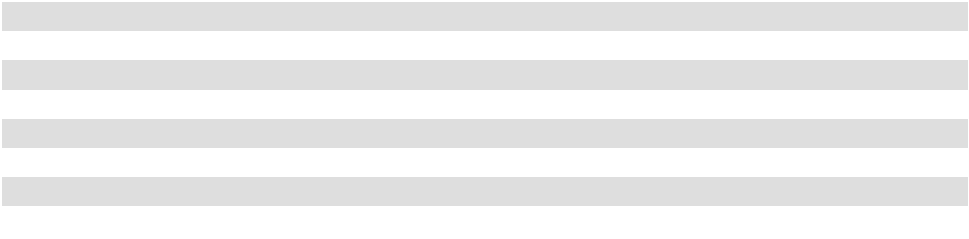

Depreciation expense was $110.9 million, $106.8 million and $105.3 million in 2023, 2022 and 2021, respectively.

- Accrued Expenses and Other Current Liabilities

Accrued expenses and other current liabilities consist of the following (amounts in thousands) as of:

 | February 3, 2024 |  |  | January 28, 2023
Accrued interest | $ | 6,717 | $ |  | 7,015
Accrued personnel costs |  | 30,899 |  |  | 57,504
Accrued professional fees |  | 1,818 |  |  | 3,943
Accrued sales and use tax |  | 14,828 |  |  | 9,302
Accrued self-insurance |  | 15,269 |  |  | 20,941
Deferred revenue - gift cards and other |  | 96,688 |  |  | 92,603
Income taxes payable |  | 9,313 |  |  | 6,195
Property taxes |  | 14,239 |  |  | 15,921
Sales return allowance |  | 6,400 |  |  | 6,100
Other |  | 21,761 |  |  | 20,645
Accrued expenses and other current liabilities | $ | 217,932 | $ |  | 240,169
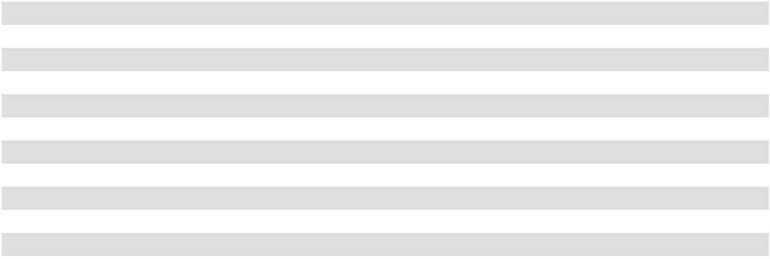

- Share-Based Compensation

On September 29, 2020, the ASO, Inc. Board of Directors adopted the 2020 Omnibus Incentive Plan (the "2020 Omnibus Incentive Plan"), which became effective on October 1, 2020. The plan reserved a total of 5,150,000 shares of common stock for issuance. Concurrent with the adoption of the 2020 Omnibus Incentive Plan, the previously existing share-based compensation plan, the NAHC 2011 Unit Incentive Plan (the "2011 Unit Incentive Plan"), was frozen and no further issuances will be permitted as part of the 2011 Unit Incentive Plan. On June 1, 2023, our stockholders approved the First Amendment to the 2020 Omnibus Incentive Plan, which, among other changes, increased the number of shares available for issuance thereunder by 2,600,000 shares. As of February 3, 2024, there were 4,534,051 shares that were authorized and available for grant under the 2020 Omnibus Incentive Plan.

On September 29, 2020, the ASO, Inc. Board of Directors adopted the 2020 Employee Stock Purchase Plan (the "ESPP"), which became effective on October 1, 2020. We have reserved a total of 2,000,000 shares and as of February 3, 2024, there were 1,593,760 shares authorized and available for future issuance under the ESPP.

95

The following table provides total stock-based compensation recognized in the consolidated statements of income (amounts in thousands):

 |  |  |  |  | Fiscal Year Ended
 |  | February 3, 2024 |  |  | January 28, 2023 |  | January 29, 2022
Equity compensation expense ⁽¹⁾ | $ | 24,377 | $ |  | 21,175 | $ | 39,264 | (2)
Total related tax benefit | $ | 5,245 | $ |  | 4,494 | $ | 9,075

- These costs are included within selling, general and administrative expenses in the consolidated statements of income.

- These costs include approximately $24.9 million in non-cash expenses related to the 2021 Vesting Event, which occurred during the 2021 second quarter (see Note 1).

As of February 3, 2024, unrecognized compensation cost related to non-vested share-based compensation awards of $28.6 million is expected to be recognized over a weighted average life of two years. The grant date fair value of Restricted Units and Restricted Stock Units vested was $11.7 million, $3.9 million and $24.4 million for 2023, 2022 and 2021, respectively.

2011 Unit Incentive Plan

The 2011 Unit Incentive Plan provides for the grant of certain equity incentive awards (each, an "Award"), such as options to purchase ASO, Inc. common stock (each, a "Unit Option") and restricted units that may settle in ASO, Inc. common stock (each, a "Restricted Unit") to our directors, executives, and eligible employees of the Company.

Unit Options granted under the 2011 Unit Incentive Plan consist of Unit Options that vest upon the satisfaction of time-based requirements (each, a "Service Unit Option") and Unit Options that vest upon the satisfaction of both time-based requirements and Company performance-based requirements (each, a "Performance Unit Option").

Restricted Units granted under the 2011 Unit Incentive Plan consist of Restricted Units that vest upon the satisfaction of time-based requirements (each, a "Service Restricted Unit") and Restricted Units that vest upon the satisfaction of a liquidity event-based requirement together with a time-based requirement and/or a performance-based requirement (each, a "Liquidity Event Restricted Unit"). In each case, vesting of the Company’s outstanding and unvested Unit Options and Restricted Units is contingent upon the holder’s continued service through the date of each applicable vesting event.

Concurrent with the adoption of the 2020 Omnibus Incentive Plan on October 1, 2020, no further Awards are authorized to be granted under the 2011 Unit Incentive Plan.

2020 Omnibus Incentive Plan

The 2020 Omnibus Incentive plan provides for the grant of Awards such as options to purchase ASO, Inc. common stock (each, a "Stock Option") and restricted stock units which may settle in ASO, Inc. common stock (each, a "Restricted Stock Unit") to our directors, executives, and eligible employees of the Company.

Stock Options granted under the 2020 Omnibus Incentive Plan consist of Stock Options that vest upon the satisfaction of time-based requirements, each, a "Service Stock Option" (Service Unit Options and Service Stock Options together are "Service Options").

Restricted Stock Units granted under the 2020 Omnibus Incentive Plan consist of Restricted Stock Units that vest upon the satisfaction of time-based requirements (each, a "Service Restricted Stock Unit") and Restricted Stock Units that vest upon the satisfaction of a time-based requirement and performance-based and/or market-based requirements (each, a "Performance Restricted Stock Unit"). In each case, vesting of the Company’s outstanding and unvested Stock Options and Restricted Stock Units is contingent upon the holder’s continued service through the date of each applicable vesting event.

ESPP

Our ESPP allows eligible employees to contribute up to 15% of their eligible earnings toward the semi-annual purchase of the Company's shares of common stock at a discount of 15% of the closing stock price on the first or last day of the six-month offering period, whichever is lower.

96

The number of shares reserved for issuance under the ESPP will be increased automatically on the first day of each fiscal year, beginning in fiscal year 2021, by a number equal to the lesser of (1) 1,000,000 shares of common stock, (2) 2.0% of the total number of all classes of the company's common stock outstanding on the last day of the immediately preceding fiscal year, or (3) a lower number of shares determined by the ASO, Inc. Board of Directors.

Distribution

On August 28, 2020, NAHC paid a $257.0 million distribution to its members of record as of August 25, 2020. Holders of the outstanding granted equity Awards were entitled to receive value equal to $3.546 per share on a post-IPO basis, which was made in the form of cash payments, additional Restricted Unit grants or Unit Option exercise price adjustments. Cash payments due for unvested Awards were paid upon vesting of such Awards. Cash payments for vested Unit Options and vested Restricted Units ("Share-Based Award Payments") of $32.2 million were paid in-full as of July 31, 2021.

Service Option Fair Value Assumptions

The fair value for Service Options granted was estimated using a Black-Scholes option-pricing model. The expected lives of the Service Options granted were based on the "SEC simplified" method. Expected price volatility was determined based on our own volatility and the implied volatilities of comparable companies over a historical period that matches the expected life of the Service Options. The risk-free interest rate was based on the expected U.S. Treasury rate over the expected life. In 2022 and 2023, the dividend yield was based on the most recent annualized quarterly dividend and the valuation date closing stock price. In 2021, the dividend yield was based on the expectation that no dividends will be paid. The assumptions used to calculate the fair value of Service Options granted are evaluated and modified, as necessary, to reflect current market conditions and experience.

The following table presents the assumptions and grant date fair values for Service Options granted in 2023, 2022 and 2021:

 |  |  | Fiscal Year Ended
 | February 3, 2024 |  | January 28, 2023 |  | January 29, 2022
Expected life in years | 6.0 | 6.2 |  | 6.2
Expected volatility | 46% to 51% |  | 43% to 45% |  | 42% to 44%
Weighted-average volatility | 47.8% | 43.0% |  | 43.7%
Risk-free interest rate | 3.7% to 4.4% |  | 2.4% to 4.1% |  | 1.0% to 1.3%
Dividend yield | 0.6% | 0.8% |  |  | —
Weighted-average grant date fair value - Service Options | $27.60 | $16.36 |  | $11.92
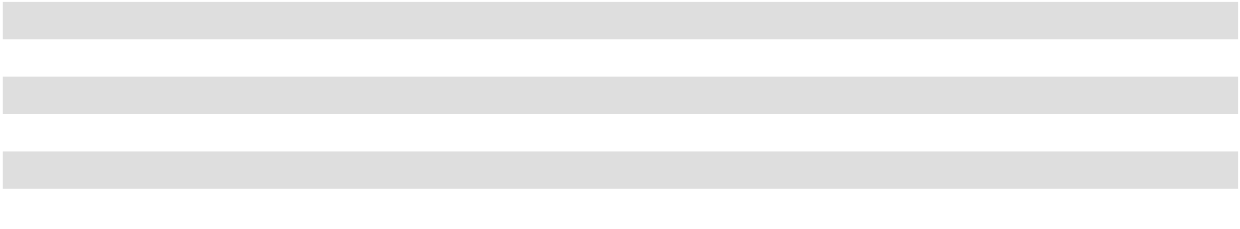

97

Option Activity

Option activity is as follows:
Service Options
 |  |  |  |  | Weighted |  | Weighted Average |  |  | Aggregate
 |  |  |  |  | Weighted |  | Remaining |  |  | Aggregate
 |  | Options |  |  | Average |  | Contractual Life |  | Intrinsic Value
Outstanding as of January 30, 2021 |  | Options |  |  | Exercise Price |  | (in years) |  | (in thousands)
 |  | 6,282,782 |  | $ | 13.53 |  | 5.5 |  | $ | 50,055
Granted or modified |  | 915,017 |  |  | 27.41
Canceled or modified |  | (1,499) |  |  | 16.84
Forfeited |  | (39,757) |  |  | 23.19
Exercised |  | (3,258,329) |  |  | 10.62 |  |  | $ |  | 81,782
Outstanding as of January 29, 2022 |  | 3,898,214 | $ |  | 19.12 | 7.4 |  | $ |  | 72,345
Granted or modified |  | 817,618 |  |  | 39.22
Canceled or modified |  | (3,378) |  |  | 17.06
Forfeited |  | (51,027) |  |  | 30.32
Exercised |  | (1,090,733) |  |  | 16.83 |  |  | $ |  | 34,611
Outstanding as of January 28, 2023 |  | 3,570,694 | $ |  | 24.27 | 7.3 |  | $ |  | 112,050
Granted or modified |  | 262,640 |  |  | 58.13
Canceled or modified |  | (694) |  |  | 13.00
Forfeited |  | (228,160) |  |  | 39.14
Exercised |  | (988,682) |  |  | 20.00 |  |  | $ |  | 36,277
Outstanding as of February 3, 2024 ⁽¹⁾ |  | 2,615,798 | $ |  | 27.99 | 6.7 |  | $ |  | 95,479
Exercisable as of February 3, 2024 |  | 1,633,434 | $ |  | 21.53 | 5.9 |  | $ |  | 70,154
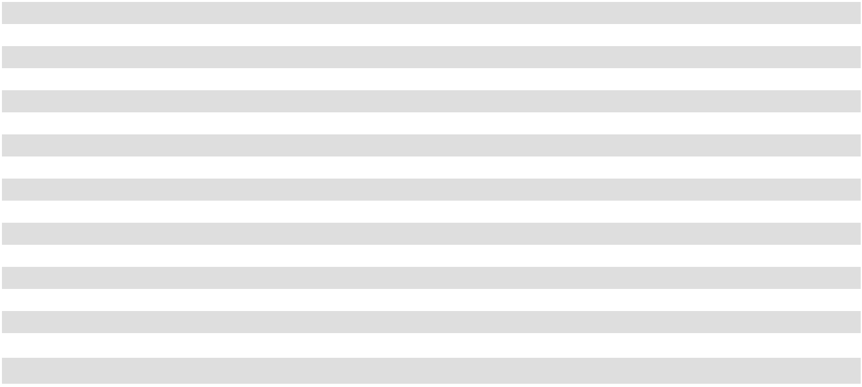
- The Company has elected to recognize forfeitures as they occur. Therefore, the number of awards vested and expected to vest is equal to the awards outstanding.

Performance Unit Options
 |  |  |  |  | Weighted |  | Weighted Average |  |  | Aggregate
 |  | Unit |  |  | Weighted |  | Remaining |  |  | Aggregate
 |  | Unit |  |  | Average |  | Contractual Life |  | Intrinsic Value
Outstanding as of January 30, 2021 |  | Options |  |  | Exercise Price |  | (in years) |  | (in thousands)
 |  | 2,948,621 |  | $ | 8.81 |  | 2.5 |  | $ | 37,422
Granted or modified |  | — |  |  | —
Canceled or modified |  | — |  |  | —
Forfeited |  | (295,932) |  |  | 16.72
Exercised |  | (2,255,780) |  |  | 6.42 |  |  | $ |  | 55,865
Outstanding as of January 29, 2022 |  | 396,909 | $ |  | 16.48 | 5.8 |  | $ |  | 8,406
Granted or modified |  | — |  |  | —
Canceled or modified |  | — |  |  | —
Forfeited |  | — |  |  | —
Exercised |  | (178,432) |  |  | 16.35 |  |  | $ |  | 5,570
Outstanding as of January 28, 2023 |  | 218,477 | $ |  | 16.59 | 5.5 |  | $ |  | 8,534
Granted or modified |  | — |  |  | —
Canceled or modified |  | — |  |  | —
Forfeited |  | — |  |  | —
Exercised |  | (95,915) |  |  | 16.63 |  |  | $ |  | 3,656
Outstanding as of February 3, 2024 ⁽¹⁾ |  | 122,562 | $ |  | 16.55 | 5.0 |  | $ |  | 5,874
Exercisable as of February 3, 2024 |  | 122,562 | $ |  | 16.55 | 5.0 |  | $ |  | 5,874
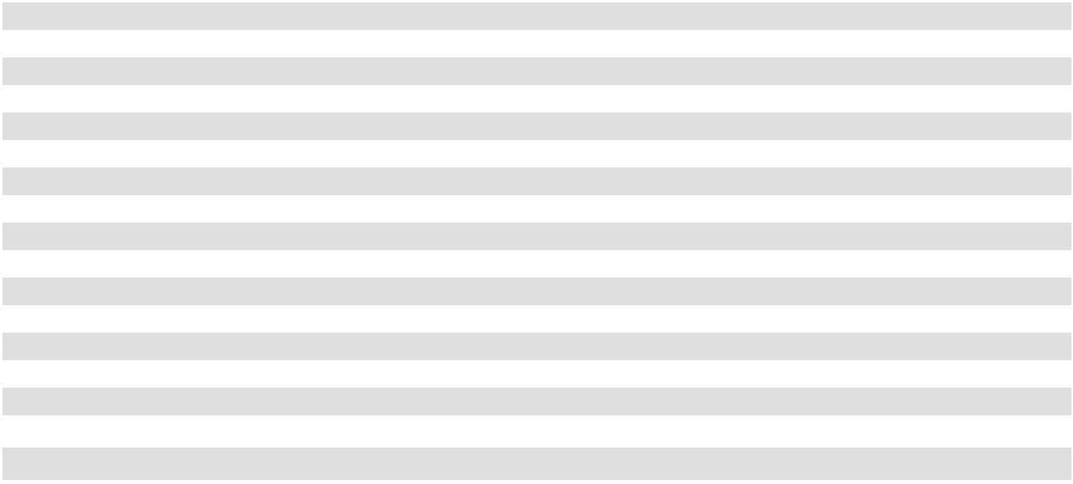
- The Company has elected to recognize forfeitures as they occur. Therefore, the number of awards vested and expected to vest is equal to the awards outstanding.

The total income tax benefit recognized from the exercise of stock options was $3.9 million, $4.2 million and $18.5 million for the fiscal years ended February 3, 2024, January 28, 2023 and January 29, 2022, respectively.

98

Restricted Unit Activity

Restricted Unit activity is as follows:

 | Service Restricted Units |  |  |  |  | Liquidity Event |  |  |  |  | Performance Restricted
 |  |  |  |  |  | Restricted Units |  |  |  |  | Units
 |  |  |  | Weighted |  |  |  |  | Weighted |  |  |  |  | Weighted
 |  |  |  | Average |  |  |  |  | Average |  |  |  |  | Average
 | Units |  | Grant Date |  |  | Units |  | Grant Date |  |  | Units |  | Grant Date
 | Units |  |  | Fair Value |  | Units |  |  | Fair Value |  | Units |  |  | Fair Value
Non-vested as of January 30, 2021 | 32,049 | $ |  | 17.01 | 1,339,330 |  | $ |  | 17.74 | 16,328 |  | $ |  | 13.87
Granted | 358,960 |  |  | 36.64 |  | — |  |  | — | 196,056 |  |  |  | 27.41
Vested | (33,389) |  |  | 17.34 | (1,339,330) |  |  |  | 17.74 | (4,079) |  |  |  | 13.87
Forfeited | (18,741) |  |  | 27.62 |  | — |  |  | — |  | (4,387) |  |  | 30.07
Non-vested as of January 29, 2022 | 338,879 | $ |  | 37.18 |  | — | $ |  | — | 203,918 |  | $ |  | 26.54
Granted | 198,346 |  |  | 39.40 |  | — |  |  | — | 170,250 |  |  |  | 37.36
Vested | (66,980) |  |  | 32.46 |  | — |  |  | — | (65,979) |  |  |  | 26.44
Forfeited | (33,137) |  |  | 34.63 |  | — |  |  | — |  | (9,260) |  |  | 32.20
Non-vested as of January 28, 2023 | 437,108 | $ |  | 39.11 |  | — | $ |  | — | 298,929 |  | $ |  | 32.55
Granted | 393,131 |  |  | 60.37 |  | — |  |  | — | 250,384 |  |  |  | 57.91
Vested | (173,225) |  |  | 39.48 |  | — |  |  | — | (149,190) |  |  |  | 32.82
Forfeited | (92,151) |  |  | 51.32 |  | — |  |  | — |  | (88,301) |  |  | 47.94
Non-vested as of February 3, 2024 | 564,863 | $ |  | 51.80 |  | — | $ |  | — | 311,822 |  | $ |  | 48.85
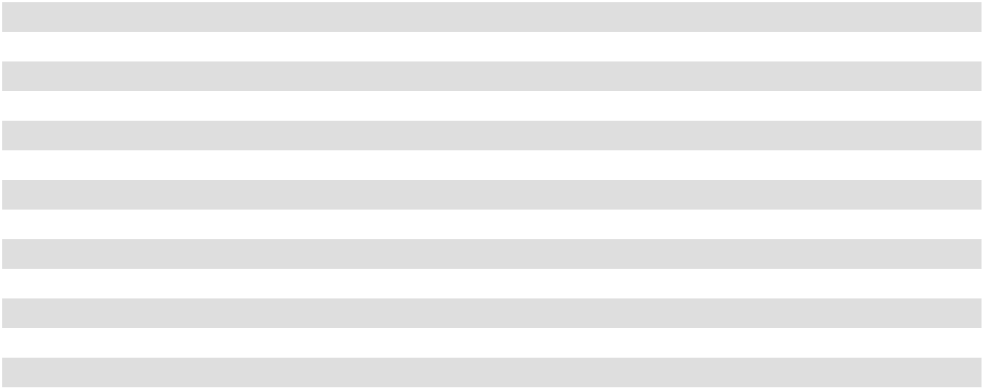

Vesting

The Company's outstanding and unvested Service Options typically vest ratably over a three or four-year period, on each anniversary of their grant date.

The Company’s outstanding and unvested Service Restricted Units generally vest ratably over a three of four-year period on each anniversary of their grant date. In more limited grants, Service Restricted Units vest 100% on the first anniversary of the grant date, or, if earlier, the business day immediately preceding the following annual meeting of stockholders.

The Company’s outstanding and unvested Performance Restricted Units typically vest either (i) if granted during 2023, on the third anniversary of the Performance Restricted Unit holder's vesting commencement date, or (ii) if granted prior to 2023, ratably over a four-year period on each anniversary of the Performance Restricted Unit holder’s vesting commencement date, so long as the Company achieved (a) the performance metric for the performance period or (b) achieves a stated target share price.

In the event of certain Company change of control transactions, the Company's then-outstanding and unvested Awards will become fully vested and exercisable subject to certain criteria (as defined in the award agreements). For certain Awards granted in 2022 and all Awards granted in 2023, for team members that meet the age and service requirement for retirement eligibility (as defined in the award agreement), such Awards do not require the continued employment of the team member for vesting eligibility. In such cases, expensing of Awards is accelerated through the retirement eligibility date.

99

10. Earnings per Common Share

Basic earnings per common share is calculated based on net income divided by the basic weighted average common shares outstanding during the period, and diluted earnings per common share is calculated based on net income divided by the diluted weighted average common shares outstanding. Diluted weighted average common shares outstanding is based on the basic weighted average common shares outstanding plus any potential dilutive effect of stock-based awards outstanding during the period using the treasury stock method, which assumes the potential proceeds received from the dilutive stock options are used to purchase treasury stock. Anti-dilutive stock-based awards do not include awards which have a performance or liquidity event target which has yet to be achieved.

Basic and dilutive weighted average common shares outstanding and basic and diluted earnings per common share are calculated as follows (amounts in thousands except per share amounts):

 |  |  |  |  | Fiscal Year Ended
 |  | February 3, 2024 |  |  | January 28, 2023 |  |  | January 29, 2022
Net income | $ | 519,190 | $ |  | 628,001 | $ |  | 671,381
Weighted average common shares outstanding |  | 75,389 |  |  | 81,590 |  |  | 90,956
- basic |  | 75,389 |  |  | 81,590 |  |  | 90,956
Dilutive effect of Service Restricted Units |  | 327 |  |  | 165 |  |  | 70
and Service Restricted Stock Units |  | 327 |  |  | 165 |  |  | 70
Dilutive effect of Performance Restricted
Stock Units and Liquidity Event Restricted |  | 165 |  |  | 207 |  |  | 313
Units |  | 165 |  |  | 207 |  |  | 313
Dilutive effect of Service Options |  | 1,439 |  |  | 1,678 |  |  | 2,300
Dilutive effect of Performance Unit |  | 112 |  |  | 202 |  |  | 637
Options |  | 112 |  |  | 202 |  |  | 637
Dilutive effect of ESPP Shares |  | 37 |  |  | 53 |  |  | 8
Weighted average common shares outstanding |  | 77,469 |  |  | 83,895 |  |  | 94,284
- diluted |  | 77,469 |  |  | 83,895 |  |  | 94,284
Earnings per common share - basic | $ | 6.89 | $ |  | 7.70 | $ |  | 7.38
Earnings per common share - diluted | $ | 6.70 | $ |  | 7.49 | $ |  | 7.12
Anti-dilutive stock-based awards excluded |  | 128 |  |  | 24 |  |  | 24
from diluted calculation |  | 128 |  |  | 24 |  |  | 24
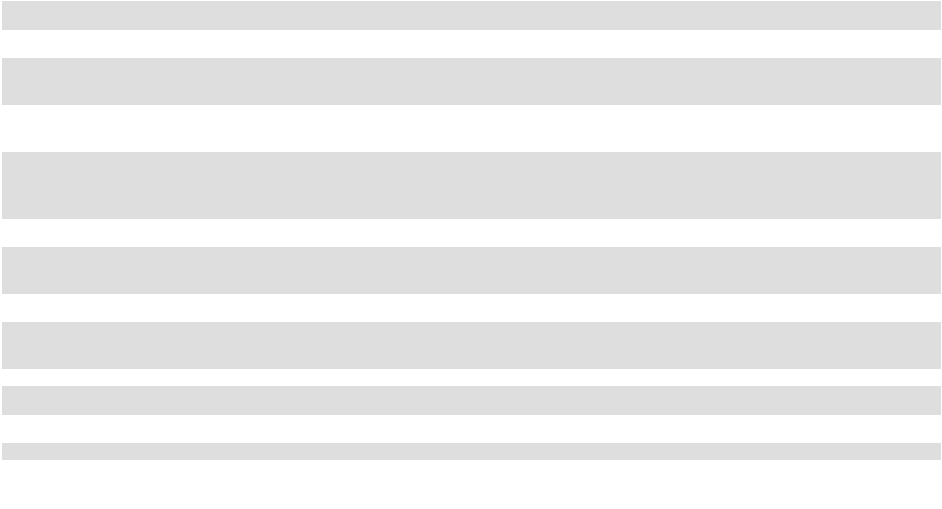

100

11. Income Taxes
The income tax provision consists of the following (amounts in thousands) as of:
 |  |  |  | Fiscal Year Ended
 | February 3, 2024 |  |  | January 28, 2023 |  |  | January 29, 2022
Current expense:
Federal | $ | 125,325 | $ |  | 127,823 | $ |  | 93,373
State |  | 22,869 |  |  | 20,645 |  |  | 15,270
Foreign |  | 19 |  |  | 20 |  |  | 26
Total current expense |  | 148,213 |  |  | 148,488 |  |  | 108,669
Deferred expense (benefit):
Federal |  | (3,395) |  |  | 37,971 |  |  | 69,353
State |  | (817) |  |  | 3,853 |  |  | 10,139
Foreign |  | (35) |  |  | 7 |  |  | (2)
Total deferred expense |  | (4,247) |  |  | 41,831 |  |  | 79,490
Income tax expense | $ | 143,966 | $ |  | 190,319 | $ |  | 188,159
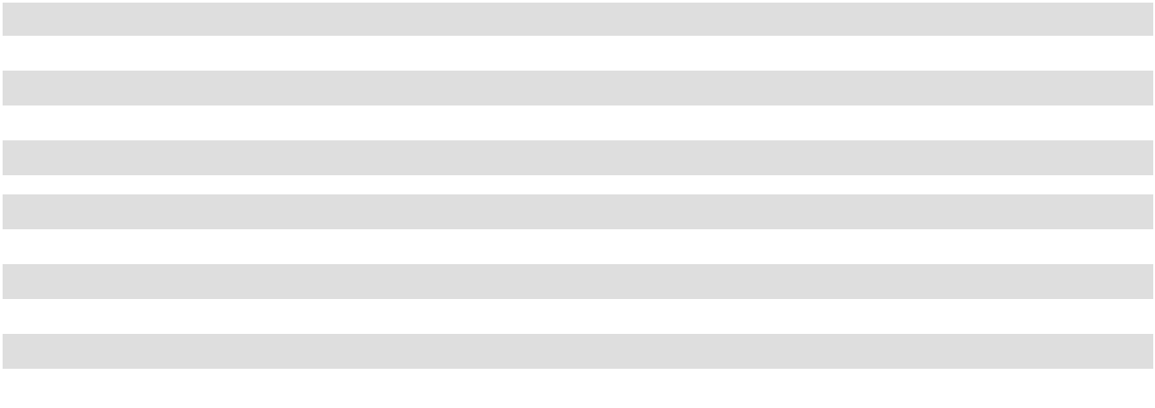

A reconciliation of the statutory U.S. federal income tax rate to our effective income tax rate is as follows:

 |  |  | Fiscal Year Ended
 | February 3, 2024 |  | January 28, 2023 |  | January 29, 2022
Federal income tax at the statutory rate | 21.0 % | 21.0 % |  | 21.0 |  | %
State income tax, net of federal benefit | 2.5 | 2.5 |  | 2.6
Nondeductible excess compensation | 0.5 | 0.6 |  | 1.3
Excess tax benefit for share-based compensation | (1.1) | (0.7) |  | (2.6)
Effect of other permanent items | (1.2) |  | (0.1) |  | (0.4)
Effective income tax rate | 21.7 % | 23.3 % |  | 21.9 %
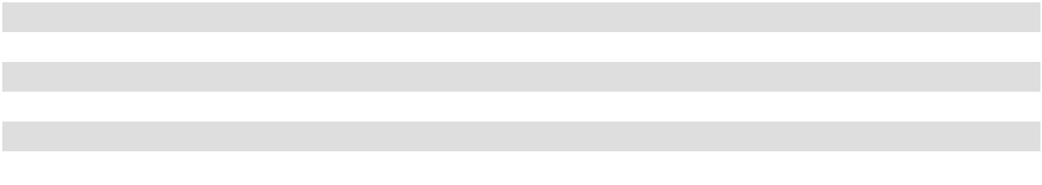

Components of deferred tax assets and liabilities consist of the following (amounts in thousands) as of:

 | February 3, 2024 |  |  | January 28, 2023
Deferred tax assets:
Accounts receivable | $ | 620 | $ |  | 570
Accrued liabilities and reserves |  | 18,810 |  |  | 17,905
Equity compensation |  | 7,672 |  |  | 7,947
Total deferred tax assets |  | 27,102 |  |  | 26,422
Deferred tax liabilities:
Inventory |  | (34,313) |  |  | (49,995)
Prepaid items |  | (6,554) |  |  | (5,143)
Property and equipment |  | (13,983) |  |  | (15,496)
Intangible assets |  | (227,027) |  |  | (214,292)
Other |  | (21) |  |  | (539)
Total deferred tax liabilities |  | (281,898) |  |  | (285,465)
Net deferred tax liability | $ | (254,796) | $ |  | (259,043)
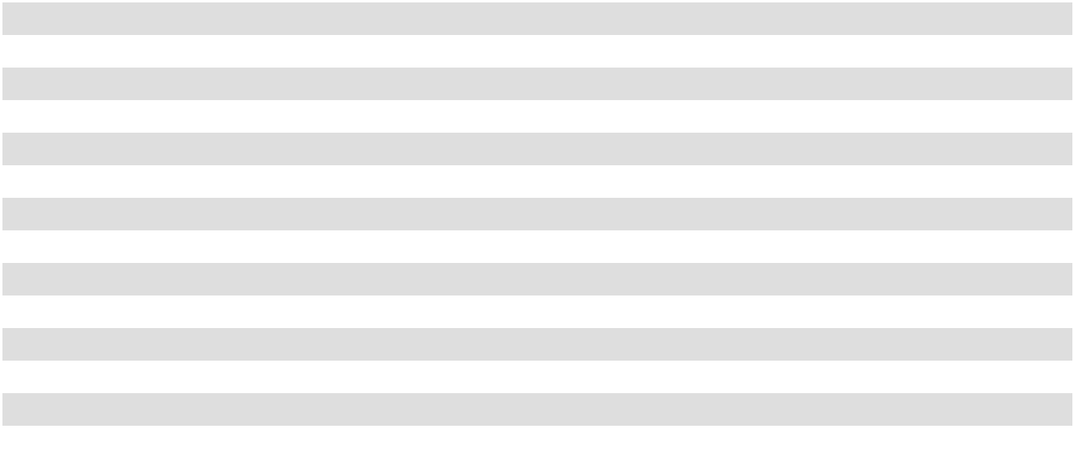

Management evaluates the realizability of the deferred tax assets and the need for additional valuation allowances annually. As of February 3, 2024, based on current facts and circumstances, management believes that it is more likely than not that the Company will realize benefit for its gross deferred tax assets.

101

As of February 3, 2024, we had no unrecognized tax benefits and we do not anticipate that unrecognized tax benefits will significantly increase or decrease over the next twelve months. The Company files a consolidated federal income tax return and files tax returns in various state and local jurisdictions. The statute of limitations is open for federal and state tax audits for the tax fiscal years ending 2021 through 2023, and 2020 through 2023, respectively.

12. Leases

With the exception of one retail store which we own, we lease all of our retail stores, distribution centers and corporate offices. Our leases primarily relate to building leases, which generally include options to renew at our sole discretion for five years or more. We regularly extend options for our building leases, which constitutes a lease modification and such events require a re-measurement of the lease liability at current discount rates. The life of leasehold improvement assets are limited by the expected lease term. Additionally, we have certain agreements for equipment rentals, which are typically 12 months or less in duration. As of February 3, 2024, all of our leases are classified as operating leases. In addition, in certain situations, we may sublease real estate to third parties. Our sublease portfolio consists mainly of former store locations for which we are still under lease and existing store leases in which we have excess or unused space.

The components of lease expense and sublease income included in selling, general and administrative ("SG&A")

expenses on our statement of income is as follows (amounts in thousands):

 |  |  |  | Fiscal Year Ended
 | February 3, 2024 |  |  | January 28, 2023 |  |  | January 29, 2022
Operating lease expense | $ | 214,672 | $ |  | 201,398 | $ |  | 197,321
Short-term lease expense |  | — |  |  | — |  |  | —
Variable lease expense |  | 10,405 |  |  | 8,398 |  |  | 7,757
Sublease income |  | (463) |  |  | (442) |  |  | (486)
Net lease expense | $ | 224,614 | $ |  | 209,354 | $ |  | 204,592

Information about our operating leases is as follows (dollar amounts in thousands):

 |  |  |  | Fiscal Year Ended
 | February 3, 2024 |  |  | January 28, 2023 |  |  | January 29, 2022
Right-of-use assets obtained in exchange for new | $ | 134,181 | $ |  | 116,652 | $ |  | 26,253
operating lease liabilities
Cash paid for amounts included in the measurement of | $ | 213,860 | $ |  | 204,159 | $ |  | 203,554
operating lease liabilities
 |  |  |  | February 3, 2024 |  |  | January 28, 2023
Weighted-average remaining lease term in years |  |  |  |  | 9.5 |  |  | 9.8
Weighted-average incremental borrowing rate |  |  |  |  | 8.9 % |  |  | 9.0 %


As most of our leases do not provide an implicit rate of interest, we use our incremental borrowing rate, which is based on the market lending rates for companies with comparable credit ratings, to determine the present value of lease payments on lease commencement or remeasurement.

102

The remaining maturities of lease liabilities by fiscal year as of February 3, 2024 are as follows (amounts in thousands):
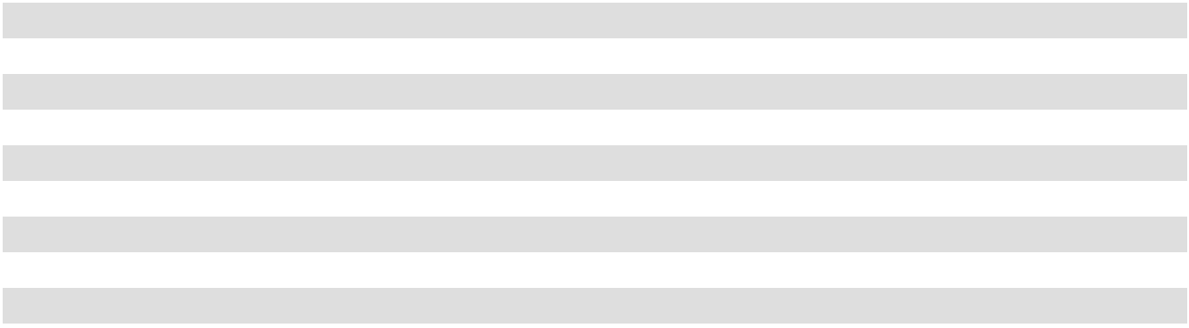

2024 | $ | 200,494
2025 |  | 214,244
2026 |  | 205,944
2027 |  | 191,893
2028 |  | 173,835
After 2028 |  | 810,337
Total lease payments ⁽¹⁾ |  | 1,796,747
Less: Interest |  | (587,604)
Present value of lease liabilities | $ | 1,209,143

  - Minimum lease payments have not been reduced by sublease rentals of $2.3 million due in the future under non-cancelable subleases. The Company has entered into operating leases related to future store locations for which we have not yet taken possession of the location. As of February 3, 2024, the future minimum lease payments on these leases approximated $159.3 million.

- Related Party Transactions

On May 5, 2021, and September 14, 2021, in connection with the May 2021 Secondary Offering and the September 2021 Secondary Offering, respectively, the Company entered into Underwriting Agreements with affiliates of KKR (as selling stockholders), several other selling stockholders named therein, and several underwriters named therein, including KCM (as underwriter). The May 2021 Secondary Offering and September 2021 Secondary Offering were completed on May 10, 2021, and September 17, 2021, respectively. The Company did not pay KCM any fees in connection with these secondary offerings.

In connection with the May 2021 Secondary Offering, we repurchased from the underwriters 3,229,974 shares of ASO, Inc. common stock at $30.96 per share for approximately $100.0 million. In connection with the September 2021 Secondary Offering, we repurchased from the underwriters 4,500,000 shares of ASO, Inc. common stock at approximately $43.52 for approximately $195.8 million. The shares repurchased in both the May 2021 Secondary Offering and the September 2021 Secondary Offering were immediately retired by the Company (see Note 1 and Note 2).

14. Commitments and Contingencies

Technology Related Commitments and Other

As of February 3, 2024, we have obligations under technology-related, construction and other contractual commitments in the amount of $68.0 million. Of such commitments, approximately $40.9 million is payable in the next 12 months.

Financial Guarantees

During the normal course of business, we enter into contracts that contain a variety of representations and warranties and provide general indemnifications. The maximum exposure under these arrangements is unknown as this would involve future claims that may be made against us that have not yet occurred. However, based on experience, we believe the risk of loss to be remote.

103

Legal Proceedings

We are a defendant or co-defendant in lawsuits, claims and demands brought by various parties relating to matters normally incident to our business. No individual case, or group of cases against us, presenting substantially similar issues of law or fact, is expected to have a material effect on the manner in which we conduct our business or on our consolidated results of operations, financial position or liquidity. The majority of these cases are alleging product, premises, employment and/or commercial liability. Reserves have been established that we believe to be adequate based on our current evaluations and experience in these types of claim situations; however, the ultimate outcome of these cases cannot be determined at this time. We believe, taking into consideration our indemnities, defenses, insurance and reserves, the ultimate resolution of these matters will not have a material impact on our financial position, results of operations or cash flows. In addition, government agencies and self-regulatory organizations have the ability to conduct periodic examinations of and administrative proceedings regarding our business. In May and December 2023, U.S. Customs and Border Protection ("CBP") notified us that we owed additional duties relating to certain products that we imported from China that CBP believes are subject to certain anti-dumping and/or countervailing duties. We do not believe that these products are subject to such duties and are contesting CBP’s determination vigorously. While we contest CBP’s determination, we were required to deposit with CBP an amount of duties relating to these products, which are included in prepaid expenses and other current assets on the Company’s consolidated balance sheet while this matter is pending. We anticipate that this matter will be resolved without a material adverse effect on our financial position, results of operations or cash flows. However, the ultimate outcome of this matter cannot be determined at this time, and we cannot assure you that we will be successful in contesting CBP's determination or that we will not need to accrue or pay additional amounts in the future.

During 2023, the Company settled a legal matter pertaining to the overcharge of interchange feeds with certain financial institutions for prior periods dating back to 2004. In connection with this settlement, we recognized a net gain of approximately $15.9 million in Other (income), net on the Consolidated Statements of Income, when the gain became realizable.

We are not currently party to any other legal proceedings that we believe would have a material adverse effect on our financial position, results of operations or cash flows.

Sponsorship Agreement and Intellectual Property Commitments

We periodically enter into sponsorship agreements generally with professional sports teams, associations, events, networks or individual professional players and collegiate athletic programs in exchange for marketing and advertising promotions. We also enter into intellectual property agreements whereby the Company receives the right to use third-party owned trademarks typically in exchange for royalties on sales. These agreements typically contain a one to three-year term and contractual payment amounts required to be paid by the Company. As of February 3, 2024, we have $13.7 million in related commitments through 2027, of which $5.6 million is payable in next 12 months.

- Employee Benefit Plans 401(k) Plan

We sponsor a safe harbor defined contribution 401(k) profit sharing plan (the "401(k) Plan") for our eligible employees. The 401(k) Plan includes an eligible employee compensation deferral feature, Company matching contributions and a Company profit sharing component. Eligible employees are permitted to contribute up to 75% of their eligible compensation on a pretax basis to the 401(k) Plan, subject to Internal Revenue Service limitations. We match 100% of the money contributed by a plan participant to the 401(k) Plan each pay period, on a dollar-for-dollar basis, up to 6% of a plan participant’s eligible compensation during such pay period. Annual Company profit sharing contributions are made at the discretion of our Board of Directors, subject to certain limitations. The 401(k) Plan may be amended or terminated at our discretion. Employer contributions related to the 401(k) Plan totaled $15.5 million, $15.5 million and $15.6 million in 2023, 2022 and 2021, respectively.

104

16. Selected Quarterly Financial Data (Unaudited)

The summarized quarterly financial information for the fiscal years ended 2023 and 2022 are reflected in the table below (amounts in thousands, except earnings per share data):

 |  | 1st |  |  | 2nd |  |  | 3rd |  |  | 4th
 | Quarter |  |  |  | Quarter |  |  | Quarter |  |  | Quarter
2023: | $ | 1,383,609 | $ |  | 1,583,077 | $ |  | 1,397,777 | $ |  | 1,794,828
Net sales
Gross margin |  | 467,115 |  |  | 563,446 |  |  | 482,641 |  |  | 597,009
Operating income |  | 126,196 |  |  | 210,963 |  |  | 136,731 |  |  | 203,965
Net income ⁽¹⁾ |  | 93,970 |  |  | 157,075 |  |  | 99,978 |  |  | 168,167
Earnings per common share:
Basic | $ | 1.22 | $ |  | 2.06 | $ |  | 1.34 | $ |  | 2.27
Diluted | $ | 1.19 | $ |  | 2.01 | $ |  | 1.31 | $ |  | 2.21
Weighted average common shares outstanding:
Basic |  | 76,862 |  |  | 76,104 |  |  | 74,461 |  |  | 74,219
Diluted |  | 79,288 |  |  | 78,091 |  |  | 76,057 |  |  | 76,035
2022:
Net sales | $ | 1,467,730 | $ |  | 1,686,915 | $ |  | 1,493,925 | $ |  | 1,746,503
Gross margin |  | 521,424 |  |  | 596,063 |  |  | 522,471 |  |  | 572,544
Operating income |  | 205,493 |  |  | 256,734 |  |  | 179,522 |  |  | 204,800
Net income ⁽²⁾ | $ | 149,806 | $ |  | 188,801 | $ |  | 131,741 | $ |  | 157,653
Earnings per common share:
Basic | $ | 1.73 | $ |  | 2.28 | $ |  | 1.67 | $ |  | 2.03
Diluted | $ | 1.69 | $ |  | 2.22 | $ |  | 1.62 | $ |  | 1.97
Weighted average common shares outstanding:
Basic |  | 86,658 |  |  | 82,960 |  |  | 79,085 |  |  | 77,657
Diluted |  | 88,614 |  |  | 84,906 |  |  | 81,379 |  |  | 80,074
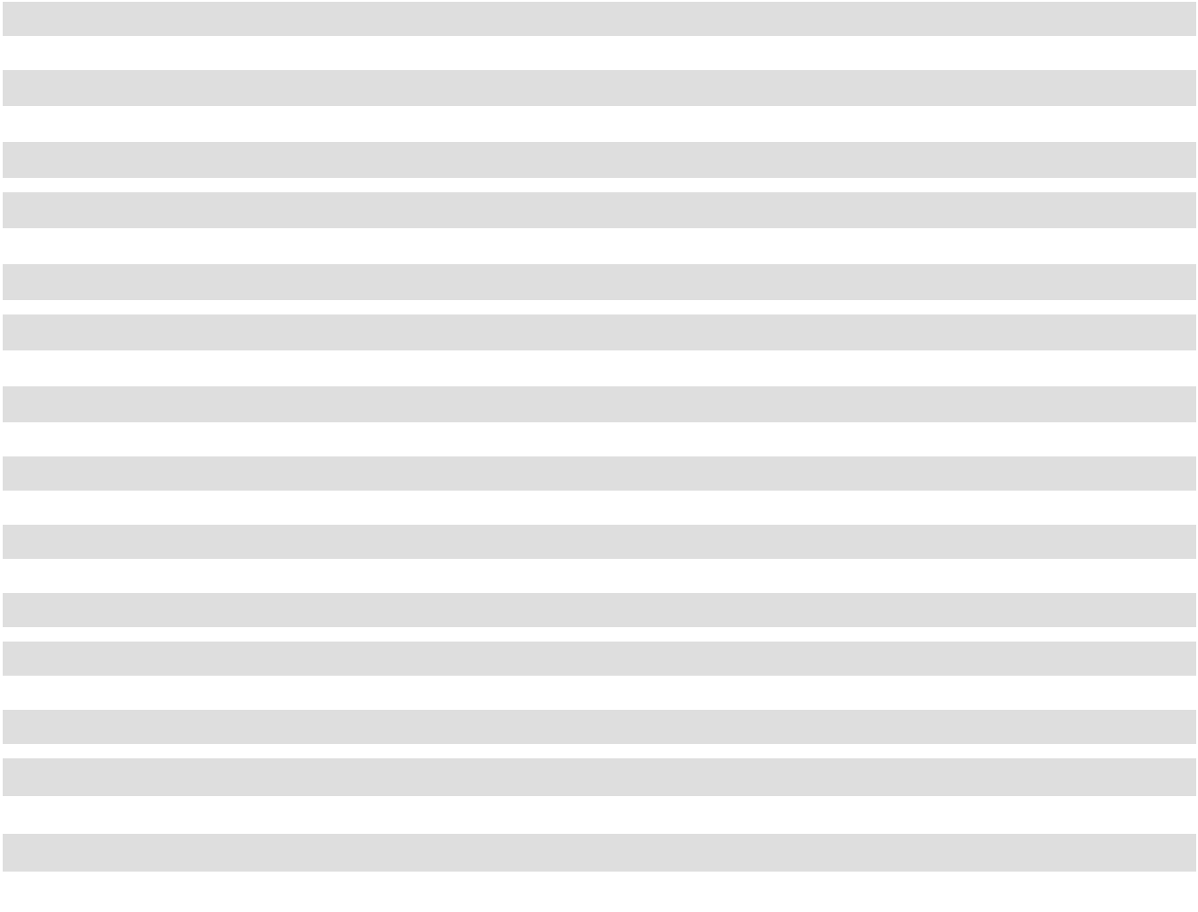

- Net income for the quarter ended February 3, 2024, includes a $15.9 million net gain relative to a credit card fee litigation settlement which occurred in the fourth quarter of 2023 (see Note 2).

- Net income for the year ended January 28, 2023, included a $7.2 million gain from a business interruption insurance recovery and a $3.7 million gain from the sale of a tariff relief litigation claim, both of which occurred in the fourth quarter of 2022 (see Note 2).

105

17. Subsequent Events

Our management evaluated events or transactions that occurred after February 3, 2024 through March 21, 2024, the issuance date of the consolidated financial statements, and identified the following matter to report:

On March 7, 2024, the Company's Board of Directors declared a quarterly cash dividend in the amount of $0.11 per share on the Company's common stock, payable on April 18, 2024 to stockholders of record as of the close of business on March 26, 2024.

On March 8, 2024 Academy, Ltd. (“Academy”), a wholly-owned subsidiary of Academy Sports and Outdoors, Inc., as borrower, New Academy Holding Company, LLC, Associated Investors, L.L.C. and Academy Managing Co., L.L.C., each a direct or indirect, wholly-owned subsidiary of the Company, as guarantors, entered into an amendment (the “ABL Amendment”) to the First Amended and Restated ABL Credit Agreement, dated as of July 2, 2015, with JPMorgan Chase Bank, N.A. as the administrative agent and collateral agent, letter of credit issuer and swingline lender, and the several lenders party thereto, which ABL Amendment, among other things, extended the maturity of Academy’s asset-based revolving credit facility (the “ABL Credit Facility”) to March 8, 2029, unless if (i) more than $100 million of the aggregate principal amount of the 2027 Senior Notes (as defined in the ABL Amendment) or the Term Loans (as defined in the ABL Amendment), or any refinancing thereof, in each case, is outstanding on the date that is 91 days prior to the earliest maturity date of any such indebtedness or (ii) equal to or less than $100 million of the aggregate principal amount of the 2027 Senior Notes or the Term Loans, in either case, is outstanding on the date that is 91 days prior to the earliest maturity date of any such indebtedness and a Reserve (as defined in the ABL Amendment) in the ABL Credit Facility has not been taken for such amount, then the maturity date of the ABL Credit Facility will be the date that is 91 days earlier than the earlier maturity date of the 2027 Senior Notes and the Term Loans.

Item 16. Form 10–K Summary

None.

106

Index to Exhibits
Exhibit Number |  | Description of Exhibit
3.1 |  | Amended and Restated Certificate of Incorporation of the Registrant (incorporated by reference to
 |  | Exhibit 3.1 to the Registrant’s Current Report on Form 8-K filed on October 6, 2020).
3.2 |  | Certificate of Change of Registered Agent and/or Registered Office of the Registrant (incorporated
 |  | by reference to Exhibit 3.1 to the Registrant’s Current Report on Form 8-K filed on June 1, 2023).
3.3 |  | Amended and Restated Bylaws of the Registrant (incorporated by reference to Exhibit 3.2 to the
 |  | Registrant’s Quarterly Report on Form 10-Q filed on December 6, 2022).
4.1 |  | Indenture, dated as of November 6, 2020, by and among Academy, Ltd., as issuer, the guarantors
 |  | named therein and The Bank of New York Mellon Trust Company, N.A., as trustee and notes
 |  | collateral agent (incorporated by reference to Exhibit 4.1 to the Registrant’s Current Report on
 |  | Form 8-K filed on November 6, 2020).
4.2 |  | Description of Securities Registered Under Section 12 of the Exchange Act (incorporated by
 |  | reference to Exhibit 4.2 to the Registrant’s Annual Report on Form 10-K filed on March 16, 2023).
10.1 |  | Second Amended and Restated Credit Agreement, dated as of November 6, 2020, among
 |  | Academy, Ltd., as Borrower, New Academy Holding Company, LLC, as Holdings, Associated
 |  | Investors L.L.C. and Academy Managing Co., L.L.C., as Texas Intermediate Holdcos, the several
 |  | lenders from time to time party thereto, Credit Suisse AG, Cayman Islands Branch, as the
 |  | administrative agent and collateral agent and the several other parties named therein (incorporated
 |  | by reference to Exhibit 10.1 to the Registrant’s Current Report on Form 8-K filed on November 6,
 | 2020).
10.2 |  | Amendment No. 4, dated May 25, 2021, to the Second Amended and Restated Credit Agreement
 |  | among Academy, Ltd., as Borrower, Credit Suisse AG, Cayman Islands Branch, as the
 |  | administrative agent and collateral agent, the several lenders party thereto and the several other
 |  | parties named therein (incorporated by reference to Exhibit 10.1 to the Registrant’s Current Report
 |  | on Form 8-K filed on May 25, 2021).
10.3 |  | Conforming Changes Amendment to the Credit Agreement, dated May 17, 2023, which amends
 |  | that certain Second Amended and Restated Credit Agreement, dated November 6, 2020 (as
 |  | amended, restated, amended and restated, supplemented or otherwise modified from time to time),
 |  | by and among Academy, Ltd., as Borrower, New Academy Holding Company, LLC, as Holdings,
 |  | Associated Investors, L.L.C. and Academy Managing Co., L.L.C., as Texas Intermediate Holdcos,
 |  | the lending institutions from time to time party thereto and Credit Suisse AG, Cayman Island
 |  | Branch, as the Administrative Agent and the Collateral Agent and the several other parties named
 |  | therein (incorporated by reference to Exhibit 10.1 to the Registrant’s Quarterly Report on Form 10-
 |  | Q filed on August 31, 2023).
10.4 |  | Amended and Restated Term Loan Security Agreement, dated as of July 2, 2015, among Academy,
 |  | Ltd., as Borrower, each of the subsidiaries listed on the signature pages thereto, and Morgan
 |  | Stanley Senior Funding, Inc., as collateral agent for the benefit of the secured parties (incorporated
 |  | by reference to Exhibit 10.2 to the Registrant’s Registration Statement on Form S-1 filed on
 |  | September 23, 2020).
10.5 |  | Amended and Restated Term Loan Pledge Agreement, dated as of July 2, 2015, among New
 |  | Academy Holding Company, LLC, as Holdings, Associated Investors L.L.C. and Academy
 |  | Managing Co., L.L.C, as Texas Intermediate Holdcos, Academy, Ltd., as Borrower, each of the
 |  | subsidiaries listed on the signature pages thereto and Morgan Stanley Senior Funding, Inc., as
 |  | collateral agent for the benefit of the secured parties (incorporated by reference to Exhibit 10.3 to
 |  | the Registrant’s Registration Statement on Form S-1 filed on September 23, 2020).
10.6 |  | ABL Intercreditor Agreement, dated July 2, 2015, among JPMorgan Chase Bank, N.A., as agent
 |  | for the ABL Secured Parties referred to therein, Morgan Stanley Senior Funding, Inc., as
 |  | administrative agent and collateral agent for the Term Loan Secured Parties referred to therein,
 |  | New Academy Holding Company, LLC, as Holdings, Associated Investors L.L.C. and Academy
 |  | Managing Co., L.L.C, as Texas Intermediate Holdcos, Academy, Ltd., as Borrower, and each of
 |  | the subsidiaries of the Borrower listed on the signature pages thereto (incorporated by reference to
 |  | Exhibit 10.4 to the Registrant’s Registration Statement on Form S-1 filed on September 23, 2020).
10.7 |  | Joinder to ABL Intercreditor Agreement, dated November 6, 2020, among JPMorgan Chase Bank,
 |  | N.A., as agent for the ABL Secured Parties referred to therein, Credit Suisse AG, Cayman Islands
 |  | Branch, as agent for the Term Loan Secured Parties referred to therein, and The Bank of New York
 |  | Mellon Trust Company, N.A., as collateral agent for the Additional Debt Secured Parties referred
 |  | to therein (incorporated by reference to Exhibit 10.5 to the Registrant’s Registration Statement on
 |  | Form S-1 filed on January 25, 2021).


107

Exhibit Number |  | Description of Exhibit
10.8 |  | Joinder to ABL Intercreditor Agreement, dated November 6, 2020, among JPMorgan Chase Bank,
 |  | N.A., as agent for the ABL Secured Parties referred to therein, and Credit Suisse AG, Cayman
 |  | Islands Branch, as agent for the Term Loan Secured Parties referred to therein (incorporated by
 |  | reference to Exhibit 10.6 to the Registrant’s Registration Statement on Form S-1 filed on January
 | 25, 2021).
10.9 |  | First Lien Intercreditor Agreement, dated November 6, 2020, among Credit Suisse AG, Cayman
 |  | Islands Branch, as First Lien Collateral Agent and Authorized Representative for the Credit
 |  | Agreement Secured Parties referred to therein, The Bank of New York Mellon Trust (incorporated
 |  | by reference to Exhibit 10.7 to the Registrant’s Registration Statement on Form S-1 filed on
 |  | January 25, 2021).
10.10 |  | Amended and Restated ABL Security Agreement, dated as of July 2, 2015, among Academy, Ltd.,
 |  | as Borrower, each of the subsidiaries listed on the signature pages thereto, and JPMorgan Chase
 |  | Bank, N.A., as collateral agent for the benefit of the secured parties (incorporated by reference to
 |  | Exhibit 10.7 to the Registrant’s Registration Statement on Form S-1 filed on September 23, 2020).
10.11 |  | Amended and Restated ABL Pledge Agreement, dated July 2, 2015, among New Academy
 |  | Holding Company, LLC, as Holdings, Associated Investors L.L.C. and Academy Managing Co.,
 |  | L.L.C, as Texas Intermediate Holdcos, Academy, Ltd., as Borrower, each of the subsidiaries listed
 |  | on the signature pages thereto and JPMorgan Chase Bank, N.A., as collateral agent for the benefit
 |  | of the secured parties (incorporated by reference to Exhibit 10.8 to the Registrant’s Registration
 |  | Statement on Form S-1 filed on September 23, 2020).
10.12 |  | First Amended and Restated ABL Credit Agreement, dated July 2, 2015, among Academy, Ltd., as
 |  | Borrower, New Academy Holding Company, LLC, as Holdings, Associated Investors L.L.C. and
 |  | Academy Managing Co., L.L.C, as Texas Intermediate Holdcos, the lending institutions from time
 |  | to time party thereto and JPMorgan Chase Bank, N.A., as the Administrative Agent, the Collateral
 |  | Agent, the Letter of Credit Issuer and the Swingline Lender (incorporated by reference to Exhibit
 |  | 10.5 to the Registrant’s Registration Statement on Form S-1 filed on September 23, 2020).
10.13 |  | Amendment No. 1 to First Amended and Restated ABL Credit Agreement, dated as of May 22,
 |  | 2018, among Academy, Ltd., as Borrower, New Academy Holding Company, LLC, as Holdings,
 |  | Associated Investors L.L.C. and Academy Managing Co., L.L.C, as Texas Intermediate Holdcos,
 |  | each of the Guarantors party thereto, each of the lenders party thereto and JPMorgan Chase Bank,
 |  | N.A., as the Administrative Agent, the Collateral Agent, the Letter of Credit Issuer and the
 |  | Swingline Lender (incorporated by reference to Exhibit 10.6 to the Registrant’s Registration
 |  | Statement on Form S-1 filed on September 23, 2020).
10.14 |  | Amendment No. 2 to First Amended and Restated ABL Credit Agreement, dated as of November
 |  | 6, 2020, among Academy, Ltd., as Borrower, New Academy Holding Company, LLC, as
 |  | Holdings, Associated Investors, L.L.C. and Academy Managing Co., L.L.C., as Texas Intermediate
 |  | Holdcos, the several lenders from time to time party thereto, JPMorgan Chase Bank, N.A., as the
 |  | letter of credit issuer, administrative agent and collateral agent (incorporated by reference to
 |  | Exhibit 10.2 to the Registrant’s Current Report on Form 8-K filed on November 6, 2020).


10.15

10.16

10.17

Amendment No. 3, dated March 30, 2023, to First Amended and Restated ABL Credit Agreement, among Academy, Ltd., as Borrower, New Academy Holding Company, LLC, as Holdings, Associated Investors, L.L.C. and Academy Managing Co., L.L.C., as Texas Intermediate Holdcos, the lending institutions from time to time party thereto and JPMorgan Chase Bank, N.A., as the Administrative Agent, the Collateral Agent, the Letter of Credit Issuer and the Swingline Lender (incorporated by reference to Exhibit 10.1 to the Registrant’s Quarterly Report on Form 10-Q filed on June 6, 2023)

Amendment No. 4, dated March 8, 2024, to the First Amended and Restated ABL Credit agreement, dated as of July 2, 2015, among Academy, Ltd., as borrower, New Academy Holding Company, LLC, Associated Investors, L.L.C., and Academy Managing Co., L.L.C., as guarantors, the several lenders from time to time party thereto and JPMorgan Chase Bank, N.A., as the letter of credit issuer, swingline lender, administrative agent and collateral agent (incorporated by reference to Exhibit 10.1 of the Registrant's Current Report on Form 8-K filed on March 8, 2024).

Notes Security Agreement, dated as of November 6, 2020, among Academy, Ltd., as Issuer, each of the guarantors listed on the signature pages thereto, and The Bank of New York Mellon Trust Company, N.A., as collateral agent for the benefit of the Secured Parties referred to therein (incorporated by reference to Exhibit 10.13 to the Registrant’s Registration Statement on Form S-1 filed on January 25, 2021).

10.18 | Notes Pledge Agreement, dated as of November 6, 2020, among Academy, Ltd., as Issuer, each of
 | the guarantors listed on the signature pages thereto, and The Bank of New York Mellon Trust
 | Company, N.A., as collateral agent for the benefit of the Secured Parties referred to therein
 | (incorporated by reference to Exhibit 10.14 to the Registrant’s Registration Statement on Form S-1
 | filed on January 25, 2021).

108

Exhibit Number |  | Description of Exhibit
10.19† |  | Form of Non-Employee Director Time-Based Restricted Stock Unit Agreement (incorporated by
 |  | reference to Exhibit 10.2 to the Registrant’s Quarterly Report on Form 10-Q filed on September 7,
 | 2022).
10.20† |  | Form of Q1 2023 CEO Performance-Based Restricted Stock Unit Agreement (incorporated by
 |  | reference to Exhibit 10.5 to the Registrant’s Quarterly Report on Form 10-Q filed on August 31,
 | 2023).
10.21† |  | Form of Q1 2023 CEO Time-Based Restricted Stock Unit Agreement (incorporated by reference to
 |  | Exhibit 10.6 to the Registrant’s Quarterly Report on Form 10-Q filed on August 31, 2023).
10.22† |  | Form of Q1 2023 CEO Time-Based Option Agreement (incorporated by reference to Exhibit 10.7
 |  | to the Registrant’s Quarterly Report on Form 10-Q filed on August 31, 2023).
10.23† |  | Form of 2022 CEO Performance-Based Restricted Stock Unit Agreement (incorporated by
 |  | reference to Exhibit 10.1 to the Registrant’s Quarterly Report on Form 10-Q filed on June 7, 2022).
10.24† |  | Form of 2022 CEO Time-Based Option Agreement (incorporated by reference to Exhibit 10.2 to
 |  | the Registrant’s Quarterly Report on Form 10-Q filed on June 7, 2022).
10.25† |  | Form of Q2 2023 Executive Performance-Based Restricted Stock Unit Agreement (incorporated by
 |  | reference to Exhibit 10.2 to the Registrant’s Quarterly Report on Form 10-Q filed on August 31,
 | 2023).
10.26† |  | Form of Q2 2023 Executive Time-Based Restricted Stock Unit Agreement (incorporated by
 |  | reference to Exhibit 10.3 to the Registrant’s Quarterly Report on Form 10-Q filed on August 31,
 | 2023).
10.27† |  | Form of Q2 2023 Executive Time-Based Option Agreement (incorporated by reference to Exhibit
 |  | 10.4 to the Registrant’s Quarterly Report on Form 10-Q filed on August 31, 2023).
10.28† |  | Form of 2023 Executive Performance-Based Restricted Stock Unit Agreement (incorporated by
 |  | reference to Exhibit 10.2 to the Registrant’s Quarterly Report on Form 10-Q filed on June 6, 2023).
10.29† |  | Form of 2023 Executive Time-Based Restricted Stock Unit Agreement (incorporated by reference
 |  | to Exhibit 10.3 to the Registrant’s Quarterly Report on Form 10-Q filed on June 6, 2023).
10.30† |  | Form of 2023 Executive Time-Based Option Agreement (incorporated by reference to Exhibit 10.4
 |  | to the Registrant’s Quarterly Report on Form 10-Q filed on June 6, 2023).
10.31† |  | Form of 2022 Executive Performance-Based Restricted Stock Unit Agreement (incorporated by
 |  | reference to Exhibit 10.3 to the Registrant’s Quarterly Report on Form 10-Q filed on June 7, 2022).
10.32† |  | Form of 2022 Executive Time-Based Restricted Stock Unit Agreement (incorporated by reference
 |  | to Exhibit 10.4 to the Registrant’s Quarterly Report on Form 10-Q filed on June 7, 2022).
10.33† |  | Form of 2022 Executive Time-Based Option Agreement (incorporated by reference to Exhibit 10.5
 |  | to the Registrant’s Quarterly Report on Form 10-Q filed on June 7, 2022).
10.34† |  | Form of 2021 RSU Executive Retention Award Agreement (incorporated by reference to Exhibit
 |  | 10.01 to the Registrant's Quarterly Report on From 10-Q filed on December 10, 2021).
10.35† |  | 2021 Form of Performance-Based Restricted Stock Unit Agreement under the 2020 Omnibus
 |  | Incentive Plan. Plan (incorporated by reference to Exhibit 10.19 to the Registrant’s Annual Report
 |  | on Form 10-K filed on April 7, 2021).
10.36† |  | 2020 Omnibus Incentive Plan (incorporated by reference to Exhibit 10.2 to the Registrant’s
 |  | Quarterly Report on Form 10-Q filed on December 10, 2020).
10.37† |  | 2020 Omnibus Incentive Plan, as amended by the First Amendment (incorporated by reference to
 |  | Exhibit 10.1 to the Registrant’s Current Report on Form 8-K filed on June 1, 2023).
10.38† |  | Form of Time-Based Option Agreement under 2020 Omnibus Incentive Plan (incorporated by
 |  | reference to Exhibit 10.10 to Amendment No. 1 to the Registrant’s Registration Statement on Form
 |  | S-1 filed on September 23, 2020).
10.39† |  | Form of Non-Employee Director Restricted Stock Unit Agreement under 2020 Omnibus Incentive
 |  | Plan (incorporated by reference to Exhibit 10.11 to Amendment No. 1 to the Registrant’s
 |  | Registration Statement on Form S-1 filed on September 23, 2020).
10.40† |  | 2020 Form of Performance-Based Restricted Stock Unit Agreement under 2020 Omnibus Incentive
 |  | Plan (incorporated by reference to Exhibit 10.12 to Amendment No. 1 to the Registrant’s
 |  | Registration Statement on Form S-1 filed on September 23, 2020).
10.41† |  | 2011 Unit Incentive Plan (incorporated by reference to Exhibit 10.13 to the Registrant’s
 |  | Registration Statement on Form S-1 filed on September 23, 2020).
10.42† |  | Form of 2020 CEO Option Agreement under 2011 Unit Incentive Plan (incorporated by reference
 |  | to Exhibit 10.14 to the Registrant’s Registration Statement on Form S-1 filed on September 23,
 | 2020).


109

Exhibit Number |  | Description of Exhibit
10.43† |  | Form of 2020 Executive Option Agreement under 2011 Unit Incentive Plan (incorporated by
 |  | reference to Exhibit 10.15 to the Registrant’s Registration Statement on Form S-1 filed on
 |  | September 23, 2020).
10.44† |  | Form of 2019 CEO Option Agreement under 2011 Unit Incentive Plan (incorporated by reference
 |  | to Exhibit 10.16 to the Registrant’s Registration Statement on Form S-1 filed on September 23,
 | 2020).
10.45† |  | Form of 2019 Executive Option Agreement under 2011 Unit Incentive Plan (incorporated by
 |  | reference to Exhibit 10.17 to the Registrant’s Registration Statement on Form S-1 filed on
 |  | September 23, 2020).
10.46† |  | Form of 2018 CEO Option Agreement under 2011 Unit Incentive Plan (incorporated by reference
 |  | to Exhibit 10.18 to the Registrant’s Registration Statement on Form S-1 filed on September 23,
 | 2020).
10.47† |  | Form of 2018 Executive Option Agreement under 2011 Unit Incentive Plan (incorporated by
 |  | reference to Exhibit 10.19 to the Registrant’s Registration Statement on Form S-1 filed on
 |  | September 23, 2020).
10.48† |  | Form of 2018 Non Executive Option Agreement under 2011 Unit Incentive Plan (incorporated by
 |  | reference to Exhibit 10.27 to the Registrant’s Annual Report on Form 10-K filed on April 7, 2021).
10.49† |  | Form of 2017 Executive Option Agreement under 2011 Unit Incentive Plan (incorporated by
 |  | reference to Exhibit 10.20 to the Registrant’s Registration Statement on Form S-1 filed on
 |  | September 23, 2020).
10.50† |  | Form of 2016 Executive Option Agreement under 2011 Unit Incentive Plan (incorporated by
 |  | reference to Exhibit 10.21 to the Registrant’s Registration Statement on Form S-1 filed on
 |  | September 23, 2020).
10.51† |  | Form of August 2020 Restricted Unit Agreement under 2011 Unit Incentive Plan (incorporated by
 |  | reference to Exhibit 10.22 to the Registrant’s Registration Statement on Form S-1 filed on
 |  | September 23, 2020).
10.52† |  | Form of 2020 CEO Restricted Unit Agreement under 2011 Unit Incentive Plan (incorporated by
 |  | reference to Exhibit 10.23 to the Registrant’s Registration Statement on Form S-1 filed on
 |  | September 23, 2020).
10.53† |  | Form of 2020 Executive Restricted Unit Agreement under 2011 Unit Incentive Plan (incorporated
 |  | by reference to Exhibit 10.24 to the Registrant’s Registration Statement on Form S-1 filed on
 |  | September 23, 2020).
10.54† |  | Form of 2019 Executive Restricted Unit Agreement under 2011 Unit Incentive Plan (incorporated
 |  | by reference to Exhibit 10.25 to the Registrant’s Registration Statement on Form S-1 filed on
 |  | September 23, 2020).
10.55† |  | Form of 2018 CEO Restricted Unit Agreement under 2011 Unit Incentive Plan (as amended)
 |  | (incorporated by reference to Exhibit 10.26 to the Registrant’s Registration Statement on Form S-1
 |  | filed on September 23, 2020).
10.56† |  | Form of Independent Non-Employee Director Restricted Unit Agreement under 2011 Unit
 |  | Incentive Plan (incorporated by reference to Exhibit 10.27 to the Registrant’s Registration
 |  | Statement on Form S-1 filed on September 23, 2020).
10.57† |  | Form of 2018 Executive Restricted Unit Agreement under 2011 Unit Incentive Plan (incorporated
 |  | by reference to Exhibit 10.28 to the Registrant’s Registration Statement on Form S-1 filed on
 |  | September 23, 2020).
10.58† |  | Ken C. Hicks Amended and Restated Employment Agreement, dated April 26, 2023 (incorporated
 |  | by reference to Exhibit 10.1 to the Registrant’s Current Report on Form 8-K filed on April 27,
 | 2023).
10.59† |  | Michael P. Mullican Amended and Restated Employment Agreement, dated April 26, 2023
 |  | (incorporated by reference to Exhibit 10.3 to the Registrant’s Current Report on Form 8-K filed on
 |  | April 27, 2023).
10.60† |  | Steven (Steve) P. Lawrence Amended and Restated Employment Agreement, dated April 26, 2023
 |  | (incorporated by reference to Exhibit 10.2 to the Registrant’s Current Report on Form 8-K filed on
 |  | April 27, 2023).
10.61† |  | Samuel (Sam) J. Johnson Amended and Restated Employment Agreement, dated October 23, 2023
 |  | (incorporated by reference to Exhibit 10.1 to the Registrant’s Current Report on Form 8-K filed on
 |  | October 23, 2023).
10.62† |  | Earl Carlton (Carl) Ford, IV Employment Agreement, dated July 6, 2023 (incorporated by
 |  | reference to Exhibit 10.1 to the Registrant’s Current Report on Form 8-K filed on July 11, 2023).


110

Exhibit Number |  | Description of Exhibit
10.63† |  | Manish Maini Employment Agreement, dated May 25, 2017 (incorporated by reference to Exhibit
 |  | 10.3 to the Registrant’s Quarterly Report on Form 10-Q filed on September 7, 2022).
10.64† |  | 2020 Employee Stock Purchase Plan (incorporated by reference to Exhibit 10.34 to Amendment
 |  | No. 1 to the Registrant’s Registration Statement on Form S-1 filed on September 23, 2020).
10.65† |  | Form of Director and Officer Indemnification Agreement (incorporated by reference to Exhibit
 |  | 10.37 to Amendment No. 1 to the Registrant’s Registration Statement on Form S-1 filed on
 |  | September 23, 2020).
10.66†* |  | Non-Employee Director Compensation Policy, effective March 18, 2024.
21.1* |  | Subsidiaries of the Registrant.
23.1* |  | Consent of Deloitte & Touche LLP (with respect to the financial statements of Academy Sports
 |  | and Outdoors, Inc.).
31.1* |  | Certification of Periodic Report by Chief Executive Officer under Section 302 of the Sarbanes-
 |  | Oxley Act of 2002.
31.2* |  | Certification of Periodic Report by Chief Financial Officer under Section 302 of the Sarbanes-
 |  | Oxley Act of 2002.
32.1** |  | Certification of Chief Executive Officer Pursuant to 18 U.S.C. Section 1350 as Adopted Pursuant
 |  | to Section 906 of the Sarbanes-Oxley Act of 2002.
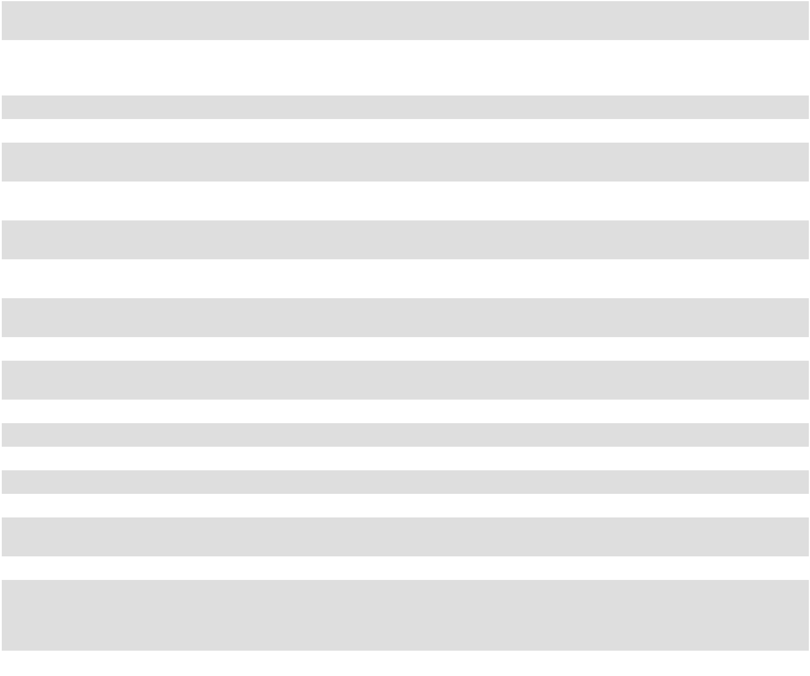

32.2**

97.1†*

101.INS

101.SCH

101.CAL

101.DEF

101.LAB

101.PRE

104

*

**

Certification of Chief Financial Officer Pursuant to 18 U.S.C. Section 1350 as Adopted Pursuant to Section 906 of the Sarbanes-Oxley Act of 2002.

Policy Relating to Recovery of Erroneously Awarded Compensation.

XBRL Instance Document - The instance document does not appear in the Interactive Data File because its XBRL tags are embedded within the Inline XBRL document.

Inline XBRL Taxonomy Extension Schema Document

Inline XBRL Taxonomy Calculation Linkbase Document

Inline XBRL Taxonomy Definition Linkbase Document

Inline XBRL Taxonomy Label Linkbase Document

Inline XBRL Taxonomy Presentation Linkbase Document

The cover page for the Company’s Annual Report on Form 10-K for the fiscal year ended February 3, 2024 has been formatted in Inline XBRL.

Filed herewith

This certification accompanies each report pursuant to Section 906 of the Sarbanes-Oxley Act of 2002 and shall not, except to the extent required by the Sarbanes-Oxley Act of 2002, be deemed filed by the Company for purposes of Section 18 of the Securities Exchange Act of 1934, as amended.

† Management contract or compensatory plan or arrangement

The agreements and other documents filed as exhibits to this Annual Report are not intended to provide factual information or other disclosure other than with respect to the terms of the agreements or other documents themselves, and you should not rely on them for that purpose. In particular, any representations and warranties made by us in these agreements or other documents were made solely within the specific context of the relevant agreement or document and may not describe the actual state of affairs as of the date they were made or at any other time.

111

SIGNATURES

Pursuant to the requirements of Section 13 or 15(d) of the Securities Exchange Act of 1934, as amended, the Registrant has duly caused this Annual Report on Form 10-K to be signed on March 21, 2024 on its behalf by the undersigned, thereto duly authorized.

ACADEMY SPORTS AND OUTDOORS, INC.

By: /s/ EARL CARLTON FORD, IV

Earl Carlton Ford, IV

Executive Vice President and Chief Financial Officer

(principal financial officer and principal accounting officer)

Pursuant to the requirements of the Securities Exchange Act of 1934, this Annual Report on Form 10-K has been signed below by the following persons on behalf of the Registrant and in the capacities and on the dates indicated:

 |  | Signature |  |  | Title |  |  | Date
/s/ | STEVEN LAWRENCE |  |  | Chief Executive Officer and Director |  |  | March 21, 2024
 | Steven Lawrence |  |  | (principal executive officer)
/s/ | EARL CARLTON FORD, IV |  |  | Executive Vice President and Chief Financial Officer |  |  | March 21, 2024
 | Earl Carlton Ford, IV |  |  | (principal financial officer and principal accounting officer)
/s/ | KEN C. HICKS |  |  | Executive Chairman |  |  | March 21, 2024
 | Ken C. Hicks
/s/ | WENDY A. BECK |  |  | Director |  |  | March 21, 2024
 | Wendy A. Beck
/s/ | BRIAN T. MARLEY |  |  | Director |  |  | March 21, 2024
 | Brian T. Marley
/s/ | TOM M. NEALON |  |  | Director |  |  | March 21, 2024
 | Tom M. Nealon
/s/ | THERESA E. PALERMO |  |  | Director |  |  | March 21, 2024
 | Theresa E. Palermo
/s/ | BERYL B. RAFF |  |  | Director |  |  | March 21, 2024
 | Beryl B. Raff
/s/ | CHRIS L. TURNER |  |  | Director |  |  | March 21, 2024
 | Chris L. Turner
/s/ | JEFF C. TWEEDY |  |  | Director |  |  | March 21, 2024
 | Jeff C. Tweedy

112

ACADEMY SPORTS AND OUTDOORS, INC.

SCHEDULE II

VALUATION AND QUALIFYING ACCOUNTS

(in thousands)

 |  | Balance at |  |  | Charged to |  |  |  |  | Balance at end
 |  | beginning of |  |  | costs and |  |  | Deductions
 |  | period |  |  | expenses |  |  | Deductions |  |  | of period
February 3, 2024:
Allowance for doubtful accounts | $ | 2,004 | $ |  | 1,107 | $ |  | (894) | (1) | $ | 2,217
Sales return allowance |  | 6,100 |  |  | 11,200 | (2) |  | (10,900) | (2) |  | 6,400
Inventory shrink adjustments |  | 4,960 |  |  | 99,444 |  |  | (92,582) | (3) |  | 11,822
Self-insurance reserves |  | 30,170 |  |  | 70,509 |  |  | (75,669) | (4) |  | 25,010
January 28, 2023:
Allowance for doubtful accounts | $ | 732 | $ |  | 1,426 | $ |  | (154) | (1) | $ | 2,004
Sales return allowance |  | 6,200 |  |  | 11,900 | (2) |  | (12,000) | (2) |  | 6,100
Inventory shrink adjustments |  | 11,696 |  |  | 79,150 |  |  | (85,886) | (3) |  | 4,960
Self-insurance reserves |  | 24,509 |  |  | 74,292 |  |  | (68,631) | (4) |  | 30,170
January 29, 2022:
Allowance for doubtful accounts | $ | 1,172 | $ |  | 74 | $ |  | (514) | (1) | $ | 732
Sales return allowance |  | 5,800 |  |  | 13,200 | (2) |  | (12,800) | (2) |  | 6,200
Inventory shrink adjustments |  | 8,504 |  |  | 74,441 |  |  | (71,249) | (3) |  | 11,696
Self-insurance reserves |  | 22,065 |  |  | 72,313 |  |  | (69,869) | (4) |  | 24,509
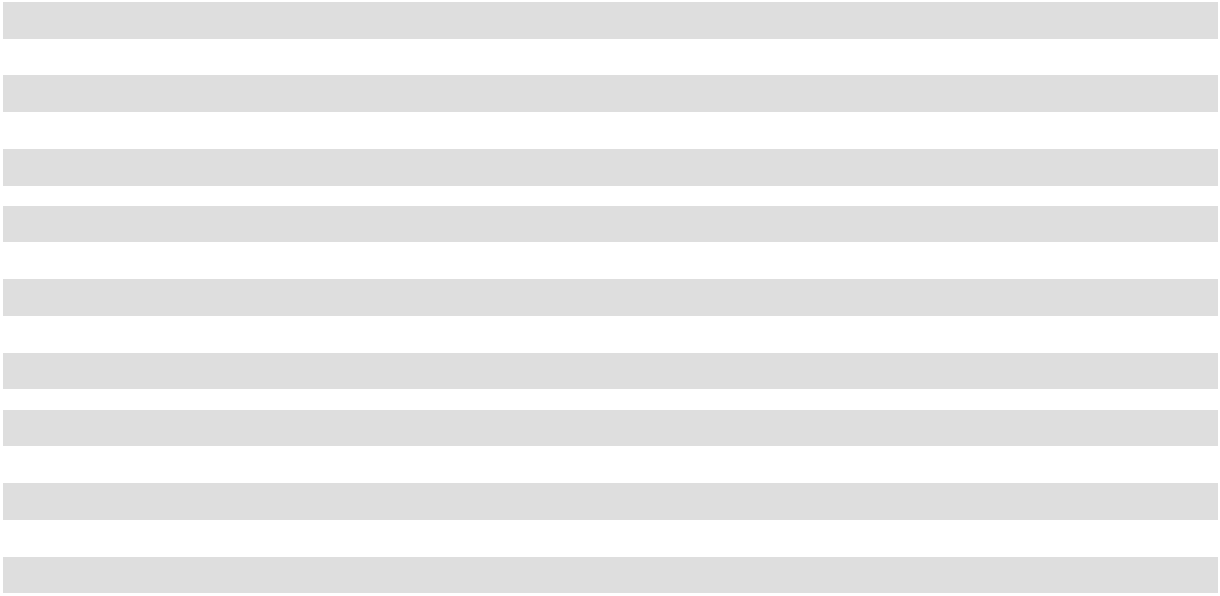

- Represents write-offs to the reserve.

- Represents the monthly increase (decrease) in the required reserve based on the Company's evaluation of anticipated merchandise returns.

- Represents the actual inventory shrinkage experienced at the time of physical inventories.

- Represents claim payments for self-insured claims.

113

[This page intentionally left blank]

Shareholder Information

Nasdaq: ASO

For information about our company, stock symbol,

filings, press releases, or other financial information,

please visit: https://investors.academy.com

Corporate Headquarters

Academy Sports and Outdoors, Inc.

1800 N. Mason Rd.

Katy, Texas 77449

281.646.5200

Transfer Agent and Registrar

Broadridge Corporate Issuer Solutions, Inc.

51 Mercedes Way

Edgewood, New York 11717

Shareholder Services: 877.830.4936

SPECIAL NOTE REGARDING FORWARD-LOOKING STATEMENTS

2023 Annual Report

These materials contain forward-looking statements within the meaning of Section 27A of the Securities Act of 1933, as amended, and Section 21E of the Securities Exchange Act of 1934, as amended. These forward-looking statements are based on Academy’s current expectations and are not guarantees of future performance. Words such as “believes,” “forward,” “opportunities,” “plans,” “priorities,” “goals,” “future,” “will,” or the negative version of these words or other comparable words or similar expressions are used to identify these forward-looking statements. Actual results may differ materially from these expectations due to changes in global, regional, or local economic, business, competitive, market, regulatory and other factors,

many of which are beyond Academy’s control. Important factors that could cause actual results to differ materially from those in the forward-looking statements are set forth in Academy’s filings with the U.S. Securities and Exchange Commission (the “SEC”), including Academy’s Annual Report on Form 10-K under the caption “Risk Factors,” as may be updated from time to time in our periodic filings with the SEC. Any forward-looking statement in these materials speaks only as of the date released. Academy’s undertakes no obligation to publicly update or review any forward-looking statement, whether as a result of new information, future developments, or otherwise, except as may be required by any applicable securities laws.



